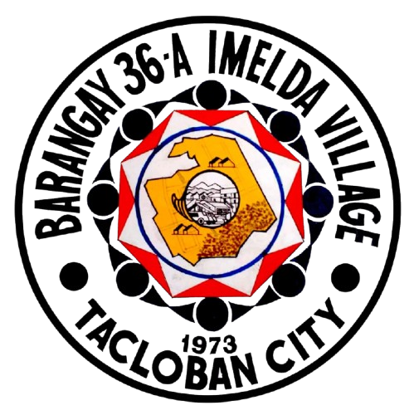
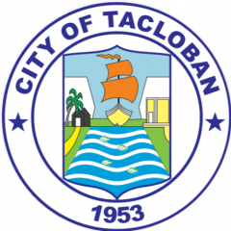
Republic of the Philippines Department of Interior of Local Government OFFICE OF THE BARANGAY COUNCIL
Imelda Village, Barangay 36-A Tacloban City

BARANGAY CERTIFICATE

Date:

TO WHOM IT MAY CONCERN

____________________________________
Punong Barangay

____________________________________
Barangay Secretary

