Instructions:

This program will build Autogui Scripts for you based on your actions.

Run build_gui.py

A control box will open up

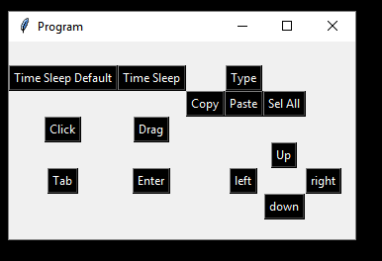

Time Sleep Default: adds a 1 second delay to your code

Time Sleep: will prompt you for a number in seconds to add that many seconds delay to your code.

Click press this and move the mouse to where you want the program to click. 2 seconds and the location will be recorded, ‘saved’ will appear in the Shell

Drag. Is a 2 stage click. Once clicked move the mouse to the first location, stage 1 will appear after 2 seconds to denote the location has been saved. Move the mouse to the second location within 2 seconds. This will record a click and drag.

Tab : tab key

Enter: Enter Key

Up/Down/Left/Right: arrow keys.

Copy paste select all. Take a guess.

Type. Will prompt you for a text input. This is what the program will type out.

Once finished close the program, copy the content of the txt into GUI.py and run.