Bloggy Storm

Welcome, this project was done whit Laravel, Javascript, Jquery and Bootstrap 4. I implemented laravel login and just 2 controller. I used the fetch API to send info to the backend, and javascript classes for the render on the frontend. To import from the REST API I used PHP, i placed a button in the drop-down menu that activates it, and every 60 minutes the aplication call to the external feed line.

Instructions.
1.- Create a folder on desktop
2.- Open a terminal and get to the folder we just create.
3.- Type in terminal “git clone https://github.com/jorge-58507/bloggystorm.git”

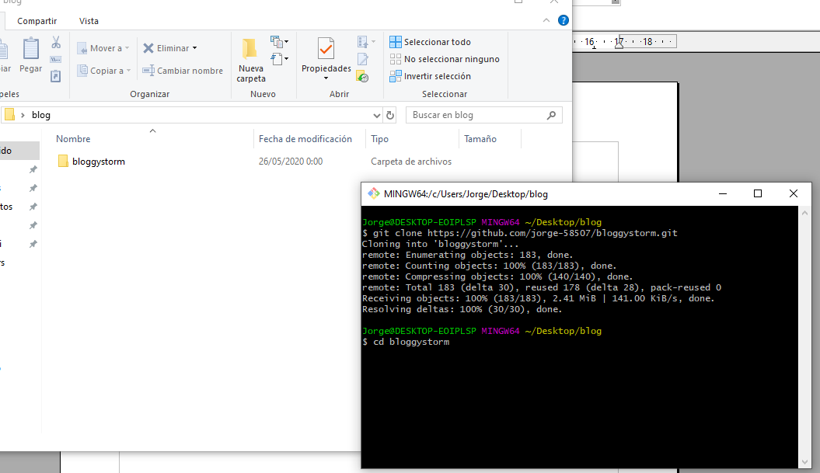
4.- Through the terminal enter to the folder that we clone and type “composer install”
5.- Duplicate the file “.env.example” and rename it to “.env”
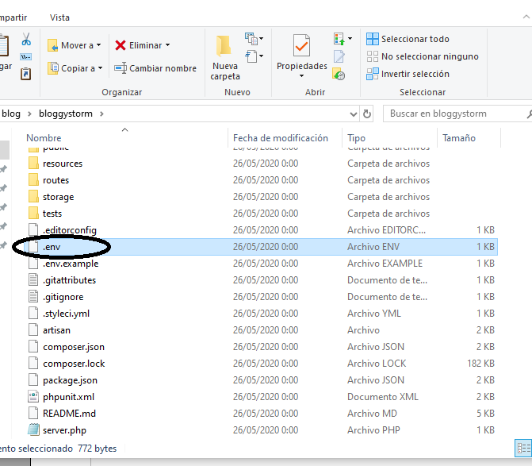
6.- Create a database in MySQL named “bloggystorm”

7.- Open the file “.env”, on the line “DB_DATABASE” replace “laravel” for “bloggystorm” and save the changes.
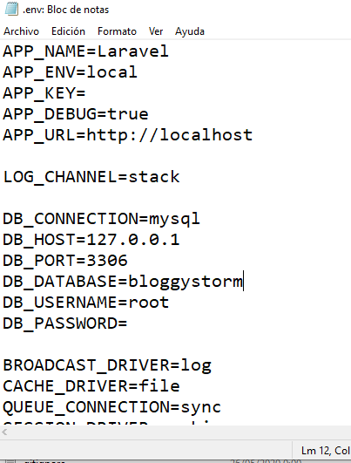

8.- Type in console “php artisan key:generate”

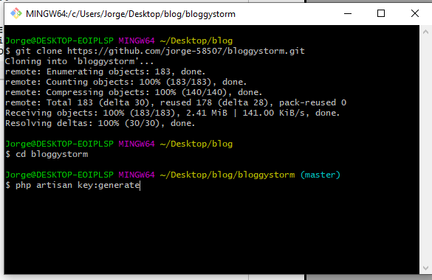
9.- Type in console “php artisan migrate”
10.- Type in console “php artisan db:seed”
11,- Type in console “php artisan serve” and enjoy it.
Administrator
User is admin@mail.com,
Password: admin

