Article
From Regime Detection to Decision Rules: A Data-Driven Macro-Financial CVaR Framework for European Multi-Asset Portfolios
Jorge Grube
1 Faculty of Economics and Business, Universidad Francisco de Vitoria, Carretera Pozuelo-Majadahonda, km. 1.800, Pozuelo de Alarcon, 28223 Madrid, Spain; jorgegrubeml@gmail.com
* Correspondence: jorgegrubeml@gmail.com
Abstract: Weekly macro-financial and financial-market data, combined with machine-learning methods, offer new possibilities for identifying latent economic states in real time, but the portfolio value of regime detection depends critically on how detected states are translated into allocation rules. This paper develops and evaluates a data-driven macro-financial framework that combines a four-state Gaussian Hidden Markov Model (HMM), estimated on eight weekly macro-financial features, with Conditional Value-at-Risk (CVaR) portfolio optimization across European multi-asset portfolios from January 2000 to April 2026. Using a strictly out-of-sample walk-forward design, we show that naive regime-conditional CVaR allocation generates excessive turnover that erodes net performance under any realistic transaction cost, while implementation-aware alternatives recover the performance gap substantially. Expanding the universe to include sovereign bonds improves drawdown control but introduces duration risk that materializes in rate-hiking episodes. These findings demonstrate that, in data-driven macro-financial systems, the bottleneck is not regime detection but transparent, stable, and cost-aware decision-rule design.
Keywords: data-driven macroeconomics; macro-financial regimes; Hidden Markov Model; Conditional Value-at-Risk; systemic risk; interest rates; portfolio allocation; implementation frictions
JEL Classification: G11; G12; C22

1. Introduction
The increasing availability of weekly macro-financial and financial-market data and the development of machine-learning methods for economic analysis have opened new possibilities for identifying latent economic states in real time (Gu et al., 2020). From traditional Hamilton (1989) and Rabiner (1989) Hidden Markov Models for business-cycle identification to data-rich macroeconomic nowcasting frameworks (Bernanke and Boivin, 2003), the common premise is that financial and economic processes cycle through distinct regimes with different statistical properties. In the context of portfolio risk management, such regime information is potentially valuable: an allocation framework that can adapt to changing macroeconomic conditions, such as volatile-stress episodes, sovereign-spread crises, or inflation surges, may achieve better risk-adjusted outcomes than a static, regime-unconditional approach. Yet the empirical evidence on whether regime-conditioned portfolio strategies deliver out-of-sample improvements remains mixed, and implementation frictions have received comparatively little systematic attention in the data-driven macroeconomics literature.
Regime detection is directly relevant to macro-financial surveillance and systemic risk monitoring (Billio et al., 2012; Adrian and Brunnermeier, 2016). The states identified by Hidden Markov Models (HMMs) estimated on macro-financial features such as implied volatility indices, sovereign credit spreads, yield-curve slope, and inflation measures, correspond to recognizable economic episodes: low-volatility expansion phases, broad risk-on regimes, neutral moderate states, and elevated-risk stress periods characterized by financial market distress and widening peripheral spreads. Such classifications provide a transparent, data-driven taxonomy of macro-financial conditions that complements traditional business-cycle dating and can be computed in near-real time. From a systemic risk perspective, the ability to characterize stress regimes, and quantify the uncertainty in those labels, is a prerequisite for adaptive risk management in next-generation macro-financial systems.
However, regime detection is not equivalent to regime-based decision-making. The central question is not only whether regimes can be detected, but whether detected regimes can be translated into transparent, stable, and low-turnover decision rules. In portfolio optimization, regime transitions can trigger discontinuous changes in the optimization problem, generating excessive rebalancing that erodes any gross performance advantage through transaction costs. This implementation friction is a structural feature of regime-conditional allocation, not an incidental artifact: it arises because the optimal solution for one regime's scenario set may differ substantially from the optimal solution for an adjacent regime's set, and because the HMM assigns new labels at every rebalance step. Understanding exactly when and why this friction dominates detection quality, and how implementation-aware design can overcome it, is the central methodological contribution of this paper.
The European multi-asset setting provides a particularly demanding test environment. Europe has experienced four structurally distinct macro episodes within a single 26-year window studied here: the post-dot-com normalization of 2002 to 2006; the Global Financial Crisis of 2008 to 2009, during which European equity indices lost approximately 50% to 60%; the European sovereign debt crisis of 2011 to 2012, characterized by peripheral spread widening and ECB unconventional policy interventions; and the COVID-19 crash of March 2020, followed by the post-zero-interest-rate transition of 2022 in which ECB rate hikes by 250 basis points imposed severe losses on long-duration bonds. Each episode rewarded a different defensive allocation: commodities and gold in 2008, government bonds in 2011, and commodity positions again in 2022. This structural instability in the cross-asset correlation regime (Longin and Solnik, 2001), combined with the presence of rate-shock and sovereign-spread dynamics absent in typical US-centric analyses, makes Europe an informative and challenging test bed for evaluating data-driven macro-financial allocation frameworks.
This paper develops and evaluates a transparent data-driven regime framework combining Conditional Value-at-Risk (CVaR) portfolio optimization with a four-state Gaussian HMM estimated on eight weekly macro-financial features, applied to ten risky European assets over January 2000 to April 2026. The HMM generates strictly out-of-sample regime labels via an expanding walk-forward procedure that re-estimates the model at each four-week rebalance step, ensuring no forward-looking information enters portfolio construction. We evaluate naive regime-conditioned CVaR (restricting the scenario set to regime-matched historical returns), implementation-aware alternatives (turnover-penalized LP and regime-constrained weight bands), and a 14-asset fixed-income expansion adding sovereign bond indices from Germany, Spain, and Italy.
The results indicate that the main bottleneck is not the identification of regimes, but their translation into stable, low-cost allocation rules. The walk-forward HMM produces locally stable, economically interpretable labels, yet naive regime-conditional scenario filtering generates implementation frictions that erode out-of-sample performance. Implementation-aware designs reduce this friction substantially. The fixed-income expansion shows that the defensive channel depends strongly on the asset universe and the prevailing interest-rate environment.
This paper makes three distinct contributions to the literature on next-generation data-driven macroeconomic systems. First, it provides the first strictly out-of-sample evaluation of regime-conditional CVaR specifically designed to isolate the role of implementation friction, extending Guidolin and Timmermann (2007) and Ang and Bekaert (2004) to the question of decision-rule design, an aspect almost entirely absent from prior empirical regime-portfolio work. Second, it identifies the LP scenario discontinuity as the structural mechanism behind regime CVaR failure: this diagnostic insight directly informs the design of AI-assisted macro-financial monitoring systems, where accurate state detection alone is not sufficient and the decision layer must be explicitly engineered for cost efficiency and stability. Third, it introduces regime-constrained weight bands as an institutionally viable bridge between macro-state detection and portfolio implementation, achieving near-benchmark risk-adjusted performance at a fraction of the turnover cost. Together, these contributions provide a practical blueprint for the next generation of data-driven allocation frameworks operating under real-world transaction costs and macro-financial regime uncertainty.
The remainder of this paper is organized as follows. Section 2 describes the data, features, model specifications, and backtesting design. Section 3 reports the empirical results across six subsections covering regime characterization, baseline performance, turnover analysis, implementation-aware variants, fixed-income expansion, and robustness checks. Section 4 discusses the findings in relation to data-driven macroeconomics, AI/machine-learning systems, systemic risk, and implementation-cost transparency. Section 5 concludes.

2. Materials and Methods
2.1. Data and Asset Universe
The baseline investable universe consists of ten risky assets and one risk-free rate, all denominated in or converted to euros. The risky universe spans European equities (six indices: CAC 40, DAX, EuroStoxx 50, FTSE MIB, IBEX 35, and STOXX Europe 600), listed real estate (FTSE EPRA/NAREIT Europe), broad commodities (Bloomberg Commodity Index), energy (Brent crude oil front-month futures), and precious metals (gold spot, EUR-converted from USD). The risk-free instrument is the EURIBOR 3-month rate, used as the cash return benchmark and excluded from risky portfolio optimization. All series are sourced from LSEG Workspace (Refinitiv) as weekly Friday-close prices. Exceptions: Brent is a front-month futures price (RIC: LCOc1); gold is a USD spot price (XAU=) converted at weekly prevailing FX rates; and EURIBOR 3M (EUR3MD=) is a rate series converted to a weekly simple return. A 14-asset FI-expanded universe for robustness adds Germany, Spain, and Italy government bond total-return indices from FTSE Russell. Table 1 summarizes the complete universe.
All series are aligned to weekly Friday-close observations over January 14, 2000 to April 3, 2026, yielding 1,369 weekly observations before burn-in exclusions. We use simple (arithmetic) weekly returns throughout; all strategy statistics are annualized using a factor of 52. Missing values from national holidays are forward-filled for up to five consecutive business days. Raw source files are subject to LSEG data licensing restrictions and cannot be distributed publicly; all results are reproducible from the processed parquet files accompanying this paper (see Data Availability Statement).
Table 1. Asset Universe
The table reports the 11-asset baseline investable universe. RICs are LSEG Workspace identifiers. All return series are in EUR. TR = total return index. Brent crude oil and gold are price series, not total-return indices. EURIBOR 3M is excluded from the optimized risky portfolio. A 14-asset FI-expanded universe adds Germany, Spain, and Italy government bond TR indices from FTSE Russell; the Italy series (RIC .FTIT_TSYUSDT) is EUR-converted by LSEG.
Asset | Type | RIC | Notes
EURIBOR 3M | Risk-free proxy | EUR3MD= | Rate; weekly simple return; excluded from optimization
Bloomberg Commodity | Commodity (broad) | BCOM | Total return index
Brent Crude Oil | Energy | LCOc1 | Front-month futures price
Gold | Precious metals | XAU= | USD spot; EUR-converted at weekly FX
CAC 40 | Equity (FR) | .FCHI | Total return
DAX | Equity (DE) | .GDAXI | Total return
EuroStoxx 50 | Equity (Eurozone) | .STOXX50E | Total return
FTSE MIB | Equity (IT) | .FTMIB | Total return
IBEX 35 | Equity (ES) | .IBEX | Total return
STOXX Europe 600 | Equity (broad EU) | .STOXX | Total return; single-asset benchmark
FTSE EPRA/NAREIT Europe | Listed real estate | .FTEPRAEUR | Total return

2.2. Macro-Financial Regime Features
The HMM is estimated on eight macro-financial features, each transformed to a 52-week rolling z-score to ensure comparable scale. The features are: VIX implied volatility (z52_VIX, primary anchor for state ordering); VSTOXX European implied volatility (z52_VSTOXX); MOVE fixed-income volatility index (z52_MOVE); Germany 10-year yield minus ECB deposit rate slope (z52_germany_10y_2y_slope); average sovereign spread of Spain, Portugal, and Italy over Germany (z52_peripheral_spread_avg); DXY dollar index (z52_DXY_USD_Index); Eurozone Economic Sentiment Indicator (z52_ESI, monthly, interpolated to weekly); and HICP headline-minus-core inflation gap (z52_hicp_headline_core_gap, approximately 4-week publication lag). Sample coverage ranges from 78% (ESI, HICP) to 100% (VIX). For a given week, the feature vector is constructed using the most recently available observation, with HICP subject to publication-lag risk (see Section 3.6).
This feature set is designed to capture the primary macro-financial dimensions relevant to European multi-asset allocation: volatility and tail-risk sentiment (VIX, VSTOXX, MOVE), fixed-income market stress (sovereign spreads, yield-curve slope), macro growth and inflation pressure (ESI, HICP gap), and global risk appetite (DXY). Together these features encode the macro-financial information that historically differentiates crisis, recovery, expansion, and stress periods in European markets.

2.3. Hidden Markov Model Specification
We model the evolution of market states using a four-state Gaussian Hidden Markov Model (HMM; Hamilton, 1989; Rabiner, 1989; Kim, 1994) with diagonal covariance matrices, estimated via the Expectation-Maximization (EM) algorithm implemented in the hmmlearn library. We use 15 random restarts and up to 500 EM iterations per restart, selecting the solution with the highest log-likelihood. The four-state specification is selected by Bayesian Information Criterion (BIC) from a grid of two to five states; in all walk-forward windows, four states is consistently preferred. States are ordered post-estimation by ascending mean z52_VIX, so that State 0 has the lowest equity-volatility signature (Low-vol / Subdued) and State 3 the highest (Elevated-risk / Stress).
All regime labels used in portfolio construction are strictly out-of-sample. We implement an expanding walk-forward procedure: at each four-week rebalance step, the HMM is re-estimated from scratch on all available history up to the rebalance date, subject to a minimum of 156 weeks (three years) of training data. Panel B evaluation begins from October 15, 2010, to ensure stable four-state estimates. The walk-forward design contrasts with the partial in-sample evaluations common in earlier regime-switching portfolio work (Guidolin and Timmermann, 2007) and ensures that all reported performance metrics reflect genuine predictive content. Posterior state probabilities are soft assignments; the hard-assignment regime label is the argmax state at each week.

2.4. CVaR Portfolio Optimization
For a portfolio weight vector w, the Conditional Value-at-Risk (CVaR) at confidence level α = 0.95 is the expected loss conditional on being in the worst (1 - α) = 5% tail of the return distribution. CVaR is a coherent risk measure (Acerbi and Tasche, 2002) with superior tail-sensitivity relative to VaR-based approaches (Engle and Manganelli, 2004). Following Rockafellar and Uryasev (2000) and Krokhmal et al. (2002), CVaR is minimized via a linear program (LP) over a scenario set of T_s = 260 historical weekly returns. The LP takes the form:
$$\min_{w, ζ, u} ζ + \frac{1}{(1 - α) · T_{s}} · \sum_{t = 1}^{T_{s}}{u_{t}}$$
$$s.t. u_{t} ≥ -r_{t}^{'}w - ζ, u_{t} ≥ 0, \sum_{i}{w_{i}} = 1, 0 ≤ w_{i} ≤ 0.25$$
where ζ is the VaR threshold and u_t are auxiliary loss exceedance variables. The 25% maximum weight per asset prevents concentration risk. The scenario window is a rolling 260-week (5-year) history. We solve the LP using scipy.optimize.linprog at each four-week rebalance. As an additional benchmark, a Markowitz (1952) minimum-variance portfolio is estimated with a Ledoit-Wolf shrinkage covariance matrix (Ledoit and Wolf, 2004) and the same 25% weight cap.

2.5. Regime-Conditioned and Implementation-Aware Allocation Rules
We evaluate four allocation rules that use the HMM regime signal. Static CVaR uses all 260 scenarios without regime conditioning and serves as the primary benchmark. Regime CVaR-A (naive conditioning) restricts the scenario set to historical weeks in which the current walk-forward regime label was active; if fewer than 30 such weeks are available, it falls back to the full 260-week window. Weighted CVaR assigns scenario weights proportional to the current week's HMM posterior, using all 260 scenarios.
Two implementation-aware rules address the turnover friction. TC-aware CVaR augments the LP objective with an L1 turnover penalty: the modified objective is CVaR(w) + λ * Σ_i |w_i - w_{i,prev}|. A turnover-budget variant replaces the penalty with a hard bound: Σ_i |w_i - w_{i,prev}| <= τ. Both preserve LP linearity via auxiliary variables (see Appendix A). Regime-constrained CVaR uses the full 260-week scenario set but imposes regime-dependent group weight bounds on equity (six indices) and defensive assets (gold, Bloomberg Commodity, Brent): equity cap 45% and defensive floor 30% in Stress states; 75% equity cap and 10% floor in Risk-on states. This approach encodes investment policy beliefs as transparent guardrails without altering the scenario optimization problem.

2.6. Backtesting Design, Transaction Costs, and Statistical Inference
All strategies are rebalanced every four weeks. Panel A evaluates the long-horizon period from January 10, 2003 to April 3, 2026 (1,213 weeks) for non-regime strategies. Panel B evaluates from October 15, 2010 to April 3, 2026 (808 weeks) and includes all regime-conditioned strategies. Performance metrics include: annualized CAGR (weekly compounding, factor 52), annualized volatility (factor sqrt(52)), Sharpe ratio (mean excess return over EURIBOR 3M divided by standard deviation, times sqrt(52)), maximum drawdown (peak-to-trough on the cumulative wealth curve), 95% CVaR, Calmar ratio, and annualized turnover (mean weekly one-way turnover times 52). Transaction costs are modeled as TC_rate * Σ_i |w_{i,t} - w_{i,t-1}^+|, where w_{i,t-1}^+ is the post-drift pre-rebalance weight. We evaluate TC rates of 0, 5, 10, and 25 basis points.
We report two complementary statistical tests. First, a pairwise HAC/Newey-West t-test (Newey and West, 1987) of mean excess-return differentials (strategy minus equal-weight benchmark) with lag = 13 weeks (one quarter). Second, a circular block-bootstrap Sharpe confidence interval with block length 13 weeks and 5,000 draws, accounting for return autocorrelation without distributional assumptions. We caution that bootstrap intervals report individual strategy Sharpe uncertainty; they do not constitute pairwise Sharpe equality tests. Given 808 weekly observations and a 13-week HAC lag, effective degrees of freedom are substantially below nominal, and Sharpe differences of 0.1 to 0.2 cannot be conclusively attributed to skill versus sampling variation at conventional significance levels (Lo, 2002).
Figure 1. Methodological workflow: from LSEG/Refinitiv raw data to mechanism diagnosis. HMM = Hidden Markov Model; CVaR = Conditional Value-at-Risk; TC = transaction cost; FI = fixed income; LP = linear program.
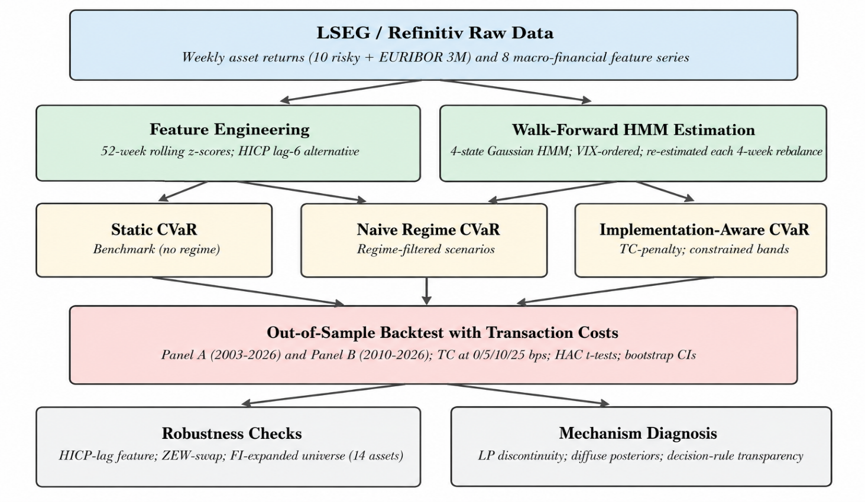

3. Results
3.1. Macro-Financial Regime Characterization
The four HMM states are ordered by ascending mean implied volatility z-score (z-VIX), yielding an economically intuitive volatility ladder: State 0 (Low-vol / Subdued) to State 3 (Elevated-risk / Stress). Figure 2 displays the mean 52-week z-scores of the four key macro-financial features across states; Table 2 provides full descriptive statistics. The state characteristics are consistent with recognizable European macro-financial episodes: State 1 (Risk-on / Expansion) captures broad growth phases, while State 3 identifies the Global Financial Crisis of 2008 to 2009, the European sovereign crisis of 2011 to 2012, and the COVID-19 crash of March 2020. These labels are interpretive, not model constraints; portfolio construction uses exclusively out-of-sample walk-forward labels (Figure 3).
Table 2. HMM Market-State Characteristics
Four-state Gaussian HMM estimated on eight macro-financial z-score features (full-sample descriptive; portfolio construction uses strictly out-of-sample walk-forward labels). States ordered by ascending mean z52_VIX. Freq = share of weekly observations. Avg Dur = average episode duration (weeks). ESI = Economic Sentiment Indicator; Spread = average ES/PT/IT peripheral spread to Germany. HMM: Hidden Markov Model; VIX: CBOE Volatility Index.
State | Label | Freq% | Avg Dur(w) | z52 VIX | z52 ESI | z52 Spread | z52 Slope
0 | Low-vol / Subdued | 24.8 | 13.3 | -0.96 | -0.33 | -0.31 | -1.31
1 | Risk-on / Expansion | 28.5 | 18.8 | -0.59 | +1.49 | -0.57 | +0.70
2 | Neutral / Moderate | 26.9 | 7.9 | +0.05 | -0.73 | +0.15 | -0.36
3 | Elevated-risk / Stress | 19.8 | 7.2 | +1.84 | -0.74 | +0.45 | +0.10
Figure 2. Mean 52-week z-scores of key macro-financial features by HMM state (full-sample descriptive). States ordered by ascending z-VIX; colours match Figure 3.
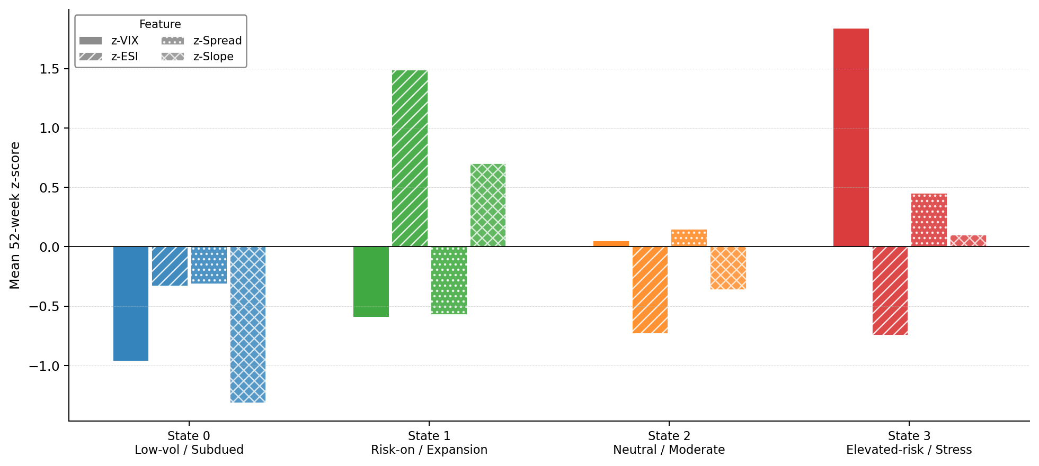

Figure 3. Full-sample HMM regime timeline (2000 to 2026); in-sample labels for descriptive characterization only.
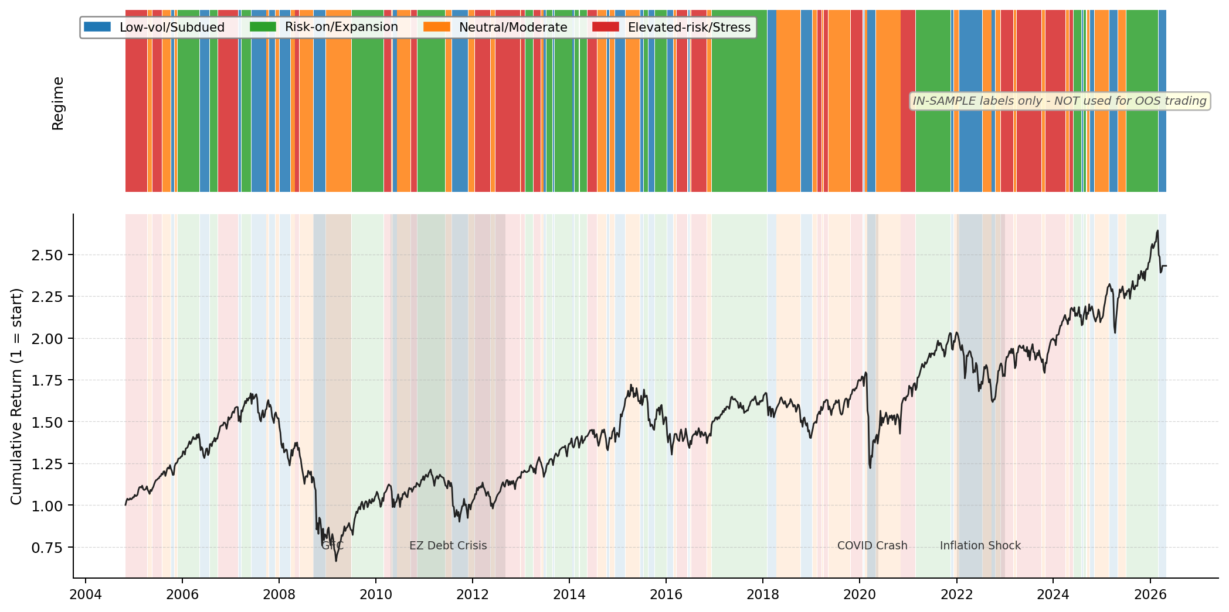
3.2. Static CVaR and Naive Regime Conditioning
Table 3 reports Panel A performance (1,213 weeks, 2003 to 2026). Static CVaR achieves the highest Sharpe ratio (0.513) and the lowest maximum drawdown (-39.5%) among all non-regime strategies, substantially better than the equal-weight (1/N) benchmark (DeMiguel et al., 2009) (-50.1%) and the STOXX Europe 600 single-asset benchmark (-60.2%). The risk reduction reflects the CVaR LP systematically concentrating in gold and Bloomberg Commodity (approximately 50% combined weight), which function as tail-risk dampeners in the absence of sovereign bonds. No strategy achieves a statistically significant excess-return differential over the equal-weight benchmark (HAC t-statistics below 1).
Table 4 presents Panel B results (808 weeks, 2010 to 2026). Static CVaR remains the most robust benchmark with a Sharpe of 0.530. The naive Regime CVaR-A generates a gross Sharpe of only 0.365, and Weighted CVaR 0.368, both below the equal-weight benchmark (0.409). The underperformance is not attributable to poor regime detection but to the implementation friction documented in the next subsection.

Table 3. Panel A Performance: Long-Horizon Evaluation, 2003 to 2026
Weekly simple returns, 1,213 observations (10 January 2003 to 3 April 2026). Gross performance at 0 bps transaction costs. Annualization factor 52. CAGR = compound annual growth rate. Vol = annualized standard deviation. Sharpe = (mean excess weekly return / SD excess) x sqrt(52) relative to EURIBOR 3M. MaxDD = maximum drawdown. CVaR 95% = average of worst 5% weekly returns. Ann. TO = annualized one-way portfolio turnover. Bootstrap 95% CI: circular block bootstrap, block = 13 weeks, 5,000 draws.
Strategy | CAGR% | Vol% | Sharpe | MaxDD% | CVaR95% | Calmar | Ann.TO%
Equal-Weight Risky (1/N) | 5.89 | 15.24 | 0.368 | -50.1 | -5.24 | 0.118 | 36.3
STOXX Europe 600 | 4.47 | 17.50 | 0.265 | -60.2 | -5.94 | 0.074 | 0.0
Static CVaR | 7.05 | 12.22 | 0.513 | -39.5 | -4.19 | 0.179 | 24.9
Markowitz (Min-Var) | 5.65 | 12.02 | 0.409 | -45.6 | -4.27 | 0.124 | 16.8
Table 4. Panel B Performance: Regime-Aware Out-of-Sample Evaluation, 2010 to 2026
Weekly simple returns, 808 observations (15 October 2010 to 3 April 2026). Gross performance at 0 bps transaction costs. HMM MIN_TRAIN_OBS = 156 weeks; all regime labels are strictly out-of-sample (walk-forward expanding window). Definitions as in Table 3. CVaR: Conditional Value-at-Risk; HMM: Hidden Markov Model.
Strategy | CAGR% | Vol% | Sharpe | MaxDD% | CVaR95% | Ann.TO%
Equal-Weight Risky (1/N) | 5.65 | 14.43 | 0.409 | -32.8 | -4.81 | 35.2
STOXX Europe 600 | 5.28 | 15.86 | 0.363 | -31.9 | -5.33 | 0.0
Static CVaR | 6.03 | 10.97 | 0.530 | -25.3 | -3.60 | 21.4
Markowitz (Min-Var) | 5.03 | 10.85 | 0.447 | -24.9 | -3.64 | 12.3
Regime CVaR-A | 4.35 | 11.78 | 0.365 | -25.8 | -3.96 | 225.8
Weighted CVaR | 4.35 | 11.62 | 0.368 | -25.4 | -3.88 | 232.5
Note on the Static CVaR Sharpe reference value: Table 4 reports Static CVaR at 0.530 gross Sharpe (808-week Panel B grid). Table 7, which reports implementation-aware experiments run on a different rebalance grid anchored from January 2000, reports Static CVaR at 0.553. The two values are both correct within their respective scopes: the 0.530 figure uses only rebalance dates that overlap with available HMM walk-forward labels (the label-intersected grid), while the 0.553 figure uses the full 2000-to-2026 rebalance grid and therefore covers a longer effective horizon. The difference of 0.023 reflects different sets of rebalance dates, not different empirical outcomes. All within-panel comparisons are internally consistent.

Figure 4. Cumulative wealth of 1 EUR invested in October 2010 across all Panel B strategies at 0 bps transaction costs.
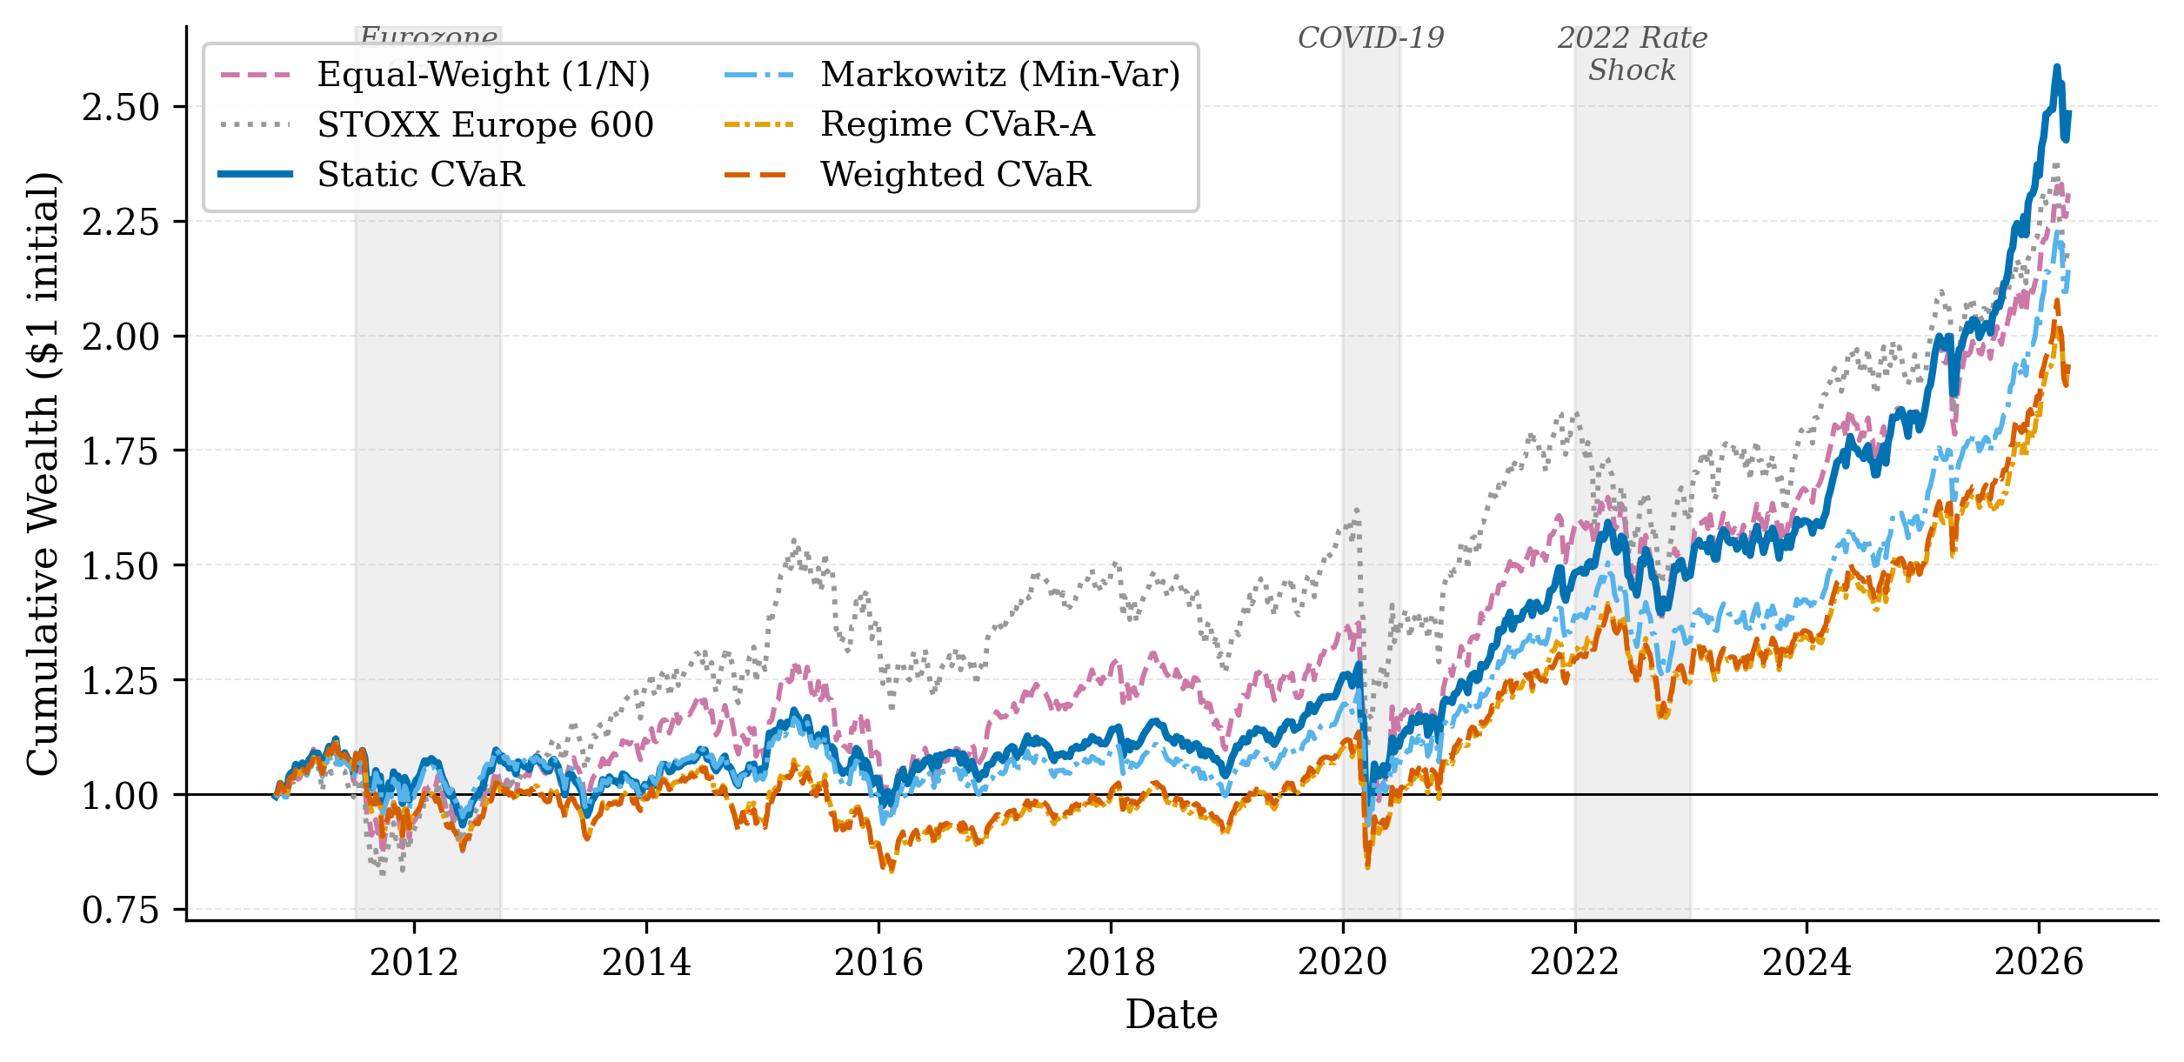
3.3. Turnover and the Transaction-Cost Channel
Table 5 reports the transaction-cost sensitivity of all strategies. Regime CVaR-A annual turnover is 225.8%, approximately 17.4% per four-week rebalance. Weighted CVaR is similar at 232.5%. By contrast, Static CVaR turns over only 21.4% annually. At 10 basis points of transaction cost, the net Sharpe of Regime CVaR-A falls to 0.346, and Weighted CVaR to 0.348, compared to 0.528 for Static CVaR and 0.406 for Equal-Weight. At 25 bps the regime strategies register net Sharpe ratios of 0.317 and 0.318, respectively. The performance degradation is approximately linear in TC_rate times the turnover differential, confirming that turnover, not scenario filtering per se, is the dominant driver of net performance differences.
This tenfold turnover differential arises because each regime transition causes the CVaR LP scenario set to change discontinuously, producing abrupt portfolio reconstitution at every state switch. Table 6 confirms that no pairwise HAC/Newey-West test achieves conventional significance: bootstrap Sharpe confidence intervals span approximately +-0.4 units for all strategies, so that point estimate differences of 0.1 to 0.2 cannot be conclusively attributed to skill versus sampling variation over the 808-week evaluation window.

Table 5. Transaction-Cost Sensitivity, Panel B (Net Sharpe Ratio)
Net Sharpe ratios at four transaction-cost (TC) levels (0, 5, 10, 25 bps per one-way unit of turnover). Annual turnover reported at gross (TC = 0) level. TC is subtracted from gross weekly returns before computing Sharpe. CVaR: Conditional Value-at-Risk.
Strategy | 0 bps | 5 bps | 10 bps | 25 bps | Ann.TO%
Equal-Weight Risky (1/N) | 0.409 | 0.407 | 0.406 | 0.403 | 35.2
STOXX Europe 600 | 0.363 | 0.363 | 0.363 | 0.363 | 0.0
Static CVaR | 0.530 | 0.529 | 0.528 | 0.525 | 21.4
Markowitz (Min-Var) | 0.447 | 0.446 | 0.445 | 0.444 | 12.3
Regime CVaR-A | 0.365 | 0.355 | 0.346 | 0.317 | 225.8
Weighted CVaR | 0.368 | 0.358 | 0.348 | 0.318 | 232.5
Table 6. Statistical Tests, Panel B (2010 to 2026)
Panel A: HAC/Newey-West one-sided t-test on weekly excess-return differentials (strategy minus Equal-Weight), Newey-West lag = 13 weeks. H_1: strategy mean excess return > benchmark. Panel B: Circular block-bootstrap 95% Sharpe confidence intervals, block = 13 weeks, 5,000 draws. Bootstrap CIs report individual strategy Sharpe uncertainty. No test achieves conventional significance. HAC: Heteroskedasticity and autocorrelation consistent.
Strategy | Ann.Diff | t-stat | p(1-sided) | Sig | Sharpe | CI Lo | CI Hi
Equal-Weight (1/N) | - | - | - | - | 0.409 | -0.054 | 0.926
STOXX Europe 600 | -0.13% | -0.096 | 0.538 |  | 0.363 | -0.056 | 0.833
Static CVaR | -0.09% | -0.059 | 0.523 |  | 0.530 | +0.068 | 1.058
Markowitz (Min-Var) | -1.05% | -0.682 | 0.752 |  | 0.447 | -0.004 | 0.962
Regime CVaR-A | -1.60% | -1.227 | 0.890 |  | 0.365 | -0.079 | 0.880
Weighted CVaR | -1.62% | -1.193 | 0.883 |  | 0.368 | -0.074 | 0.891

3.4. Implementation-Aware Regime Translation
Table 7 reports results for the two implementation-aware strategies. Panel A presents TC-aware CVaR specifications. The turnover-constrained specification at τ = 0.10 reduces Regime CVaR-A annual turnover from 225.8% to 59.9%, a reduction of 166 percentage points. Net Sharpe at 10 bps improves from 0.346 to 0.486. Despite these improvements, no TC-aware variant consistently surpasses Static CVaR (net Sharpe 0.551 at 10 bps in this experiment context; see Table 7 note for the scope difference relative to Table 4). The ZEW-swap penalized variant (ZEW+λ=0.005) produces an exploratory net Sharpe of 0.567, which should not be interpreted as evidence of general outperformance: label agreement with the canonical HMM is only 47.9%, and this result is not confirmed in any other specification.
Panel B of Table 7 presents regime-constrained CVaR results. This approach achieves near-static performance at 0.522 gross Sharpe (baseline HMM) and 0.519 (ZEW-swap HMM), with annual turnover of 29.2% and 27.0%, respectively, a substantial improvement over the 226% turnover of Regime CVaR-A. Net Sharpe at 10 bps reaches 0.519 and 0.517, within 0.009 of Static CVaR. This approach is also more transparent to a risk committee: it encodes a clear investment policy (reduce equity in stress, maintain defensive floor) rather than a less visible adjustment to the LP scenario set. Figure 5 illustrates the turnover versus net Sharpe frontier across all evaluated specifications.
Table 7 uses experiment-specific rebalance grids and is intended for within-experiment comparison only. The Static CVaR row in Table 7 reflects the full 2000 to 2026 rebalance grid (Sharpe 0.553) and is not directly comparable to Table 4 (Sharpe 0.530, label-intersected grid). The main Panel B benchmark for cross-strategy comparison remains Table 4.
Table 7. TC-Aware CVaR and Regime-Constrained CVaR: Selected Results
Panel A: TC-aware CVaR with turnover budget (τ) and L1 penalty (λ). Panel B: Regime-constrained CVaR with group-level weight bands varying by HMM state. Evaluation window: 2010 to 2026, 808 weeks. ZEW-swap replaces z52_VSTOXX with z52_ZEW_Germany. Ann.TO = annualized one-way turnover. The ZEW+λ=0.005 result is exploratory (see text). Static CVaR in this table uses the full 2000-2026 rebalance grid (gross Sharpe 0.553 vs. 0.530 in Table 4 which uses the label-intersected grid; see Section 3.2 note). CVaR: Conditional Value-at-Risk; TC: transaction cost; HMM: Hidden Markov Model.
Strategy | Gross Sharpe | Net @10bps | Ann.TO%
Panel A: TC-Aware CVaR
Static CVaR, experiment-grid benchmark | 0.553 | 0.551 | 20.6%
Regime CVaR-A, unconstrained | 0.365 | 0.346 | 225.8%
Regime CVaR-A, τ=0.10 | 0.491 | 0.486 | 59.9%
Regime CVaR-A, τ=0.20 | 0.449 | 0.440 | 101.2%
Weighted CVaR, τ=0.10 | 0.492 | 0.486 | 61.5%
Weighted CVaR, ZEW+λ=0.005* | 0.572 | 0.567 | 64.8% | *Exploratory
Panel B: Regime-Constrained CVaR (Weight-Band Approach)
Static CVaR, experiment-grid benchmark | 0.553 | 0.551 | 20.6%
Regime-Constrained CVaR (baseline HMM) | 0.522 | 0.519 | 29.2%
Regime-Constrained CVaR (ZEW-swap HMM) | 0.519 | 0.517 | 27.0%
Regime CVaR-A (baseline, for reference) | 0.365 | 0.346 | 225.8%

Figure 5. Turnover vs. net Sharpe frontier (Panel B, 10 bps) for all evaluated strategies and implementation-aware variants.
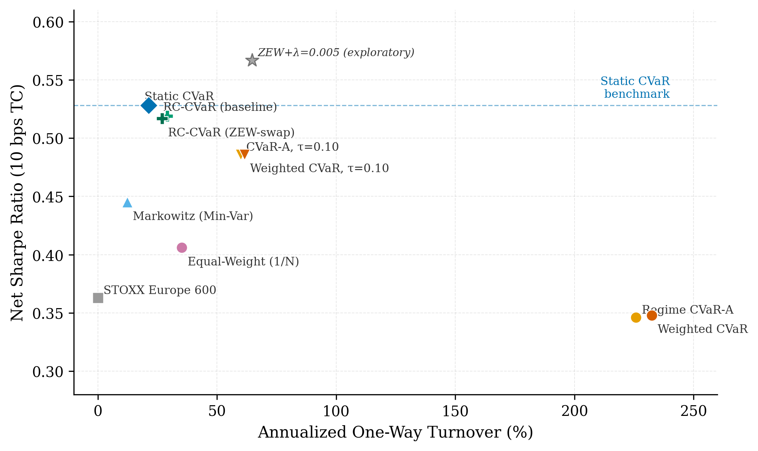
3.5. Sovereign Fixed-Income Expansion
Table 8 summarizes FI-expanded results. Panel A (2003 to 2026): adding three government bond total-return indices raises Static CVaR Sharpe from 0.513 to 0.547 (+0.034) while reducing maximum drawdown from -39.5% to -14.8% and annualized volatility from 12.2% to 5.0%. The bond addition triggers a substantial allocation substitution: the CVaR LP reallocates approximately 73% of the portfolio to sovereign bonds, reducing equity to 3% and gold and commodities combined to 23.5%. This reflects the lower weekly CVaR of government bonds relative to equities and commodities, not a general recommendation to overweight bonds regardless of rate environment.
Panel B (2010 to 2026): Static CVaR Sharpe declines slightly (-0.026) despite a material maximum drawdown improvement (-25.3% to -14.6%). The Sharpe decline is explained by the 2022 ECB rate-hiking cycle: with the FI-expanded portfolio holding approximately 75% in sovereign bonds entering 2022, the portfolio recorded losses of approximately -10% while the baseline portfolio held commodities and gold, which rose on energy inflation. This illustrates a key practical point: opportunity set design implicitly takes positions on macro risk factors, and the choice of whether to include fixed income constitutes an implicit bet on rate stability.

Table 8. FI-Expanded Universe: Performance Comparison
Baseline = 11-asset universe. FI-Expanded = 14-asset universe adding Germany, Spain, and Italy government bond TR indices. Gross performance at 0 bps TC. Panel A: 2003 to 2026. Panel B: 2010 to 2026. Delta = FI-Expanded minus Baseline. The 2022 ECB rate-hiking episode was adverse for FI-expanded portfolios. FI: fixed income; TR: total return; TC: transaction cost.
Strategy | Sharpe Base | Sharpe FI-Exp | Delta Sharpe | MaxDD Base | MaxDD FI-Exp | Delta MaxDD
Panel A: 2003 to 2026
Equal-Weight Risky | 0.368 | 0.313 | -0.055 | -50.1% | -38.9% | +11.2pp
Static CVaR | 0.513 | 0.547 | +0.034 | -39.5% | -14.8% | +24.7pp
Markowitz (Min-Var) | 0.409 | 0.447 | +0.038 | -45.6% | -14.2% | +31.4pp
Panel B: 2010 to 2026
Static CVaR | 0.530 | 0.504 | -0.026 | -25.3% | -14.6% | +10.7pp
Markowitz (Min-Var) | 0.447 | 0.463 | +0.016 | -24.9% | -14.4% | +10.5pp
Regime CVaR-A | 0.365 | 0.430 | +0.065 | -25.8% | -17.2% | +8.6pp
Weighted CVaR | 0.368 | 0.378 | +0.010 | -25.4% | -16.3% | +9.1pp
Figure 6. Average asset-group weights of Static CVaR over Panel B (2010 to 2026), baseline vs. FI-expanded universe.
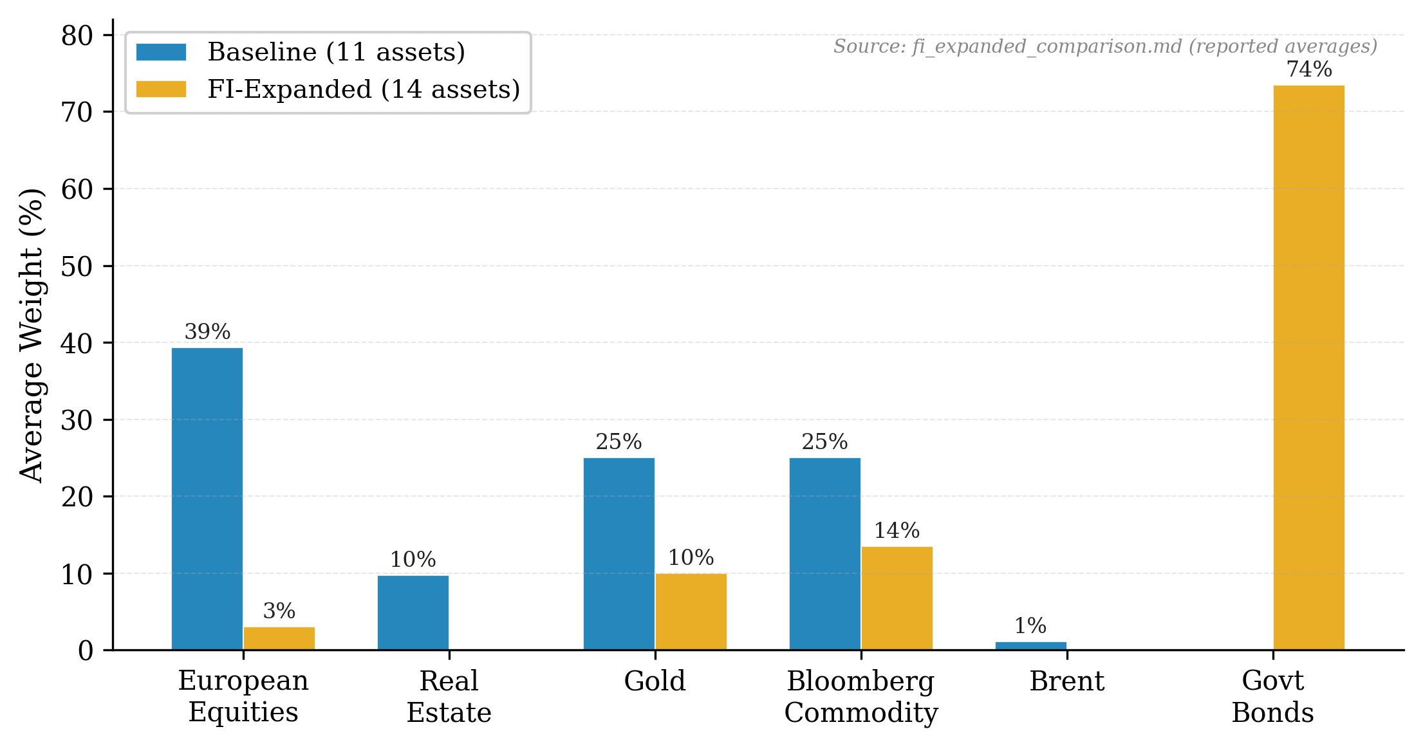
Figure 7. Drawdown curves for Static CVaR under the baseline and FI-expanded universes; the 2022 ECB rate-hiking cycle generates approximately -14.6% drawdown for the FI-expanded strategy.
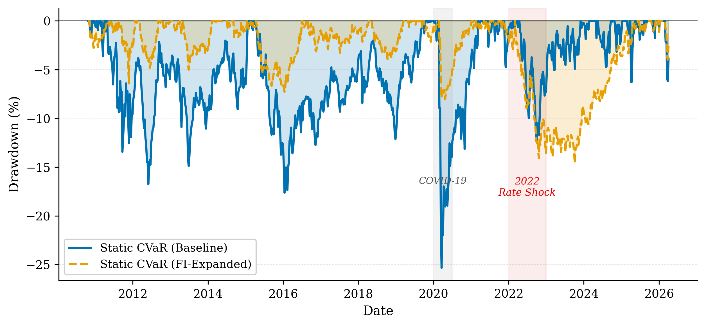
3.6. Robustness Checks
We conduct five robustness checks, summarized in Table 9. First, a 6-week HICP publication-lag correction addresses the risk that HICP data timestamps in LSEG reflect the reference period rather than the release date (approximately 17 days after month end). Label agreement between baseline and lagged specifications is approximately 55%, confirming that HICP timing is a meaningful but not outcome-determining assumption. The Regime CVaR-A Sharpe changes by up to +0.068, within the bootstrap confidence band.
Second, a ZEW feature swap replaces z52_VSTOXX with z52_ZEW_Germany (unconditional correlation with z52_ESI: r approximately 0.02). This improves Regime CVaR-A point estimates (Sharpe 0.365 to 0.483) but label agreement with the baseline is only 47.9%, and no test achieves statistical significance. These results are exploratory. Third, rebalance frequencies of 1, 2, 4, 8, and 13 weeks are tested; no frequency overturns Static CVaR as the most robust benchmark. Fourth, exponential weight averaging (EWA) blending reduces turnover approximately 30% and improves net Sharpe versus naive regime baseline, but does not surpass Static CVaR. Fifth, the FI-expanded universe robustness is reported in Section 3.5. Across all five checks, the main conclusion is unchanged.

Table 9. Robustness Check Summary
All checks use the Panel B evaluation window (2010 to 2026, 808 weeks). Key metric is net Sharpe at 10 bps for Regime CVaR-A. Delta Sharpe = change vs. baseline. HICP: Harmonised Index of Consumer Prices; ZEW: Zentrum fuer Europaeische Wirtschaftsforschung; EWA: exponential weight averaging; CVaR: Conditional Value-at-Risk.
Check | Key Finding | Magnitude | Conclusion
HICP lag 6 weeks | Label agreement ~55%; Regime CVaR-A Sharpe changes up to +0.068 | Within bootstrap noise | Unchanged
ZEW feature swap | Regime CVaR-A Sharpe: 0.365 to 0.483 (+0.118); label agreement 47.9%; exploratory | No test significant | Unchanged
Rebalance frequency | Lower frequency reduces turnover; 4-week baseline reasonable | No cadence overturns Static CVaR | Unchanged
Turnover smoothing (EWA) | EWA blending reduces turnover ~30%; improves net Sharpe vs. naive regime | Does not surpass Static CVaR | Unchanged
FI-expanded universe | Panel A Sharpe +0.034; Panel B -0.026; MaxDD improved in both panels; 2022 rate-shock adverse | -10% to -13% portfolio loss in 2022 | Unchanged
3.7. Mechanism Summary
Table 10 synthesizes the six mechanisms through which naive regime-conditional CVaR underperforms the static benchmark, together with the implementation fix pursued in this paper and the remaining performance gap. The table serves as a diagnostic map connecting the theoretical mechanism (LP scenario discontinuity, estimation noise, hard label assignment, label sensitivity, macro-portfolio signal mismatch, and rate-shock exposure) to the empirical evidence and the practical resolution.
Table 10. Why Regime CVaR-A Fails: Mechanism Summary
Six mechanisms linking regime detection to portfolio implementation failure. Empirical signatures refer to Panel B evaluation window (2010 to 2026, 808 weeks). Ann. TO = annualized one-way turnover. Net SR = net Sharpe at 10 bps. CVaR: Conditional Value-at-Risk; LP: linear program; HMM: Hidden Markov Model; HICP: Harmonised Index of Consumer Prices; ECB: European Central Bank.
Mechanism | Root Cause | Empirical Signature | Implementation Fix | Remaining Gap
LP scenario discontinuity | Regime switch replaces entire 260-scenario set with 30-80 matched scenarios | 226% annual turnover; tenfold vs. static benchmark | L1 turnover penalty in LP objective reduces TO to 60% | Net SR 0.486 vs. 0.528 for Static CVaR
Small scenario set | CVaR tail estimated from handful of regime-matched observations | Higher OOS estimation error; lower gross Sharpe (0.365 vs. 0.530) | Regime constraints retain full 260-scenario set | Net SR 0.519 vs. 0.528; not statistically significant
Hard label assignment | Argmax discards posterior uncertainty (e.g., 40% / 35% / 25% spread) | Weighted CVaR soft-weights scenarios but still underperforms static | Soft-weighting (Weighted CVaR) partially addresses uncertainty | No improvement over static in any specification
Label sensitivity | HICP-lag6: 55% label agreement; ZEW swap: 47.9% label agreement with baseline | Robustness Sharpe spread <0.02; conclusions unchanged | Feature robustness checks (ZEW swap, HICP lag) | No dominant feature set identified
Macro-portfolio mismatch | Regime signal estimated on macro features; traded assets are financial returns | No asset-level signal decomposition possible with current design | Factor-orthogonal HMM design (not pursued in this paper) | Open research question
Rate-shock exposure (FI) | Bond inclusion changes risk factor profile toward duration | -10% to -13% FI-expanded portfolio losses in 2022 ECB cycle | Explicit duration constraint on bond allocation | Not pursued; opportunity-set design trade-off
4. Discussion
4.1. Implications for Next-Generation Macro-Financial Systems
This result is directly relevant to the Special Issue theme of next-generation data-driven macroeconomic systems: the bottleneck is not forecasting or state detection, but the design of transparent and implementable decision rules. An AI or machine-learning system that accurately identifies macro-financial regimes but translates those labels via naive scenario filtering will systematically underperform a simpler static optimizer due to implementation friction (Gu et al., 2020; Campbell and Viceira, 2002). The European context studied here, spanning the GFC, the sovereign debt crisis, the COVID shock, and the 2022 rate-hiking cycle, provides a stringent real-world test of this principle: detection works, but naive implementation does not.
The HMM states identified here map onto recognizable European macro-financial episodes and are consistent across walk-forward windows, offering interpretability that black-box detectors cannot provide. For systemic risk monitoring, the stress state (State 3) identifies periods of elevated sovereign spread widening, VIX spikes, and deteriorating sentiment, subject to the caveat that state assignments are sensitive to feature construction choices. Three structural mechanisms explain the failure of naive regime conditioning to improve performance. First, restricting to 30 to 80 regime-matched scenarios replaces a well-conditioned optimization with a fragile problem based on a small, historically idiosyncratic sample; estimation error propagates directly to higher turnover. Second, regime transitions cause the entire CVaR scenario set to change discontinuously at each rebalance, generating portfolio reconstitution that is not compensated by return improvements. Third, HMM posteriors are often diffuse in moderate conditions: the hard argmax assignment discards this uncertainty, and even soft-weighted CVaR fails to recover performance, indicating that signal content, not assignment rule, is the binding constraint.
4.2. Implications for Practice and Sovereign Risk Management
The regime-constraints approach is the most practically viable regime-aware mechanism identified in this study. By encoding investment policy beliefs as group-level weight guardrails while keeping the full CVaR scenario set intact, it achieves near-static performance at moderate turnover and produces a policy that can be audited by a risk committee. This approach aligns with how institutional investors use macro views in practice: as overlays on allocation rather than wholesale replacements of the optimization framework. The regime-constrained design also generates more stable portfolio sequences over time, reducing operational complexity and capacity constraints that would otherwise further reduce the gross performance advantage of regime-conditioned strategies at scale.
The FI-expanded results highlight a second practical implication related to sovereign risk and interest-rate sensitivity. When sovereign bonds are unavailable, the CVaR optimizer concentrates in commodities and gold, which provided effective hedges in the 2022 inflationary episode but performed poorly in the 2008 initial phase of the GFC. Adding bonds produces a more conventional allocation but introduces duration risk that materializes in rate-hiking cycles. Practitioners should be explicit about which macro risk factors their opportunity-set design is implicitly accepting, particularly in a European context where ECB policy and peripheral sovereign spread dynamics create risk exposures absent in typical US-centric frameworks.
A related implication concerns the choice of evaluation benchmark. Static CVaR is a disciplined, systematic strategy with strong risk-control properties; it represents a genuinely demanding bar. Practitioners comparing regime-conditioned CVaR to a 60/40 portfolio or an equal-weight benchmark may reach more favorable conclusions, but such comparisons conflate the value of the CVaR optimization framework with the incremental value of regime conditioning, making performance attribution ambiguous.
4.3. Limitations
HMM regime labels are statistical constructs, not causal economic states. The model identifies recurring distributional patterns in the feature vector that need not correspond to structurally distinct regimes in any fundamental sense. The 55% label agreement between baseline and HICP-lagged specifications, and the 47.9% agreement with the ZEW feature swap, suggest that regime assignments are sensitive to feature construction choices in ways that likely reflect measurement uncertainty rather than genuine economic state differences. All downstream portfolio conclusions inherit this uncertainty.
Feature sensitivity is a material concern. The ZEW-swap specification has only 47.9% label agreement with the baseline HMM, indicating that swapping a single feature substantially reorganises the regime classification. Regime assignments are sensitive to feature construction choices in ways that likely reflect measurement uncertainty rather than genuine economic state differences. Macro release timing introduces potential look-ahead risk for HICP (approximately 4-week publication lag) and ESI (approximately 3-week lag); the HICP-lag6 robustness check addresses HICP specifically, but ESI publication lag is not separately corrected. Practitioners implementing this design should apply publication-lag buffers to all macro features.
The transaction-cost model is simplified: 10 bps one-way covers a range of institutional scenarios but does not model bid-ask spreads on futures contracts, market impact for large trades, or the operational costs of frequent rebalancing. The asset universe excludes corporate credit and inflation-linked bonds, which would add additional dimensions to the diversification and TC modeling. Raw LSEG source data are proprietary. Results are out-of-sample within the 2000 to 2026 European sample but remain sample-specific; generalization to other geographic markets or time periods requires further validation.
Statistical power is a binding constraint. With 808 weekly observations and a Newey-West HAC lag of 13 weeks, effective degrees of freedom are substantially below nominal. Bootstrap confidence intervals for Sharpe ratios span approximately +-0.4 units, meaning point estimate differences of 0.1 to 0.2 cannot be conclusively attributed to regime-conditioning skill versus sampling variation. The failure to detect statistically significant outperformance is consistent with both "regime conditioning adds no value" and "the sample is too short to detect realistic Sharpe differences at conventional power." A longer or geographically diversified replication would sharpen these inferences.
5. Conclusions
This paper shows that, in data-driven macro-financial systems, the binding constraint is not regime detection but decision-rule design. A four-state Gaussian HMM estimated on eight weekly macro-financial features produces economically interpretable, auditable states over a 26-year European sample, but naive translation of those states into CVaR portfolio allocation fails: regime-conditional scenario filtering generates annual turnover of 226%, eroding net performance below the equal-weight benchmark at any realistic transaction cost.
Implementation-aware design substantially closes the gap. Regime-constrained weight bands achieve a net Sharpe of 0.519 at 29% annual turnover, within 0.009 of the static CVaR benchmark (0.530 gross Sharpe) at a fraction of the rebalancing cost. Expanding the universe to include sovereign bonds improves drawdown control but introduces duration risk that materializes sharply in rate-hiking episodes. Opportunity-set design is itself an implicit macro bet and must be treated as such.
These findings provide a practical blueprint for next-generation AI-assisted allocation frameworks: regime classifiers should be evaluated not only on detection accuracy but on the cost-efficiency and stability of the decision layer they enable. Future research should explore ensemble regime detectors, richer feature engineering, and replication in non-European markets to assess generalizability.

Supplementary Materials:
The following supporting materials can be made available upon request or deposited as supplementary files, subject to LSEG/Refinitiv licensing restrictions: Python scripts (data pipeline, HMM estimation, CVaR LP, backtesting), processed weekly return and regime label parquet files, robustness tables, and figure-generation scripts. Raw LSEG/Refinitiv source files cannot be redistributed.
Author Contributions:
Conceptualization, J.G.; methodology, J.G.; software, J.G.; validation, J.G.; formal analysis, J.G.; investigation, J.G.; data curation, J.G.; writing, original draft preparation, J.G.; writing, review and editing, J.G.; visualization, J.G.; project administration, J.G. The author has read and agreed to the published version of the manuscript.
Funding:
This research received no external funding.
Institutional Review Board Statement:
Not applicable.
Informed Consent Statement:
Not applicable.
Data Availability Statement:
Restrictions apply to the availability of the raw data. The data were obtained from LSEG Workspace/Refinitiv and are available from LSEG subject to license. Processed datasets and code sufficient to reproduce the reported tables and figures can be made available by the author upon reasonable request, subject to licensing restrictions.
Acknowledgments:
The author thanks colleagues and academic supervisors for helpful comments and feedback on earlier drafts of this work.
AI Tools Disclosure: During the preparation of this manuscript, the author used ChatGPT (OpenAI) and Claude (Anthropic) for language editing, code review, document formatting support, and research workflow assistance. The author reviewed and edited all AI-assisted outputs and takes full responsibility for the content of the publication.
Conflicts of Interest:
The author declares no conflicts of interest.
Abbreviations:
The following abbreviations are used in this manuscript:
CVaR: Conditional Value-at-Risk
HMM: Hidden Markov Model
ESI: Economic Sentiment Indicator (Eurozone)
HICP: Harmonised Index of Consumer Prices
HAC: Heteroskedasticity and autocorrelation consistent
TC: Transaction cost
ECB: European Central Bank
FI: Fixed income
VIX: CBOE Volatility Index
GFC: Global Financial Crisis
LP: Linear program
BIC: Bayesian Information Criterion
EM: Expectation-Maximization
OOS: Out-of-sample
LSEG: London Stock Exchange Group
References
Acerbi, C., and Tasche, D. (2002). On the coherence of expected shortfall. Journal of Banking and Finance, 26, 1487-1503. https://doi.org/10.1016/S0378-4266(02)00283-2
Adrian, T., and Brunnermeier, M. K. (2016). CoVaR. American Economic Review, 106, 1705-1741. https://doi.org/10.1257/aer.20120555
Ang, A., and Bekaert, G. (2002). International asset allocation with regime shifts. Review of Financial Studies, 15, 1137-1187. https://doi.org/10.1093/rfs/15.4.1137
Ang, A., and Bekaert, G. (2004). How regimes affect asset allocation. Financial Analysts Journal, 60, 86-99. https://doi.org/10.2469/faj.v60.n2.2612
Bernanke, B. S., and Boivin, J. (2003). Monetary policy in a data-rich environment. Journal of Monetary Economics, 50, 525-546. https://doi.org/10.1016/S0304-3932(03)00024-2
Billio, M., Getmansky, M., Lo, A. W., and Pelizzon, L. (2012). Econometric measures of connectedness and systemic risk in the finance and insurance sectors. Journal of Financial Economics, 104, 535-559. https://doi.org/10.1016/j.jfineco.2011.12.010
Black, F., and Litterman, R. (1992). Global portfolio optimization. Financial Analysts Journal, 48, 28-43. https://doi.org/10.2469/faj.v48.n5.28
Campbell, J. Y., and Viceira, L. M. (2002). Strategic Asset Allocation: Portfolio Choice for Long-Term Investors. Oxford University Press. https://doi.org/10.1093/0198296940.001.0001
DeMiguel, V., Garlappi, L., and Uppal, R. (2009). Optimal versus naive diversification: How inefficient is the 1/N portfolio strategy? Review of Financial Studies, 22, 1915-1953. https://doi.org/10.1093/rfs/hhm075
Engle, R. F., and Manganelli, S. (2004). CAViaR: Conditional autoregressive value at risk by regression quantiles. Journal of Business and Economic Statistics, 22, 367-381. https://doi.org/10.1198/073500104000000370
Frazzini, A., Israel, R., and Moskowitz, T. J. (2015). Trading costs of asset pricing anomalies. Working Paper, AQR Capital Management. Available at SSRN: https://ssrn.com/abstract=2294498
Guidolin, M., and Timmermann, A. (2007). Asset allocation under multivariate regime switching. Journal of Economic Dynamics and Control, 31, 3503-3544. https://doi.org/10.1016/j.jedc.2006.11.007
Gu, S., Kelly, B., and Xiu, D. (2020). Empirical asset pricing via machine learning. Review of Financial Studies, 33, 2223-2273. https://doi.org/10.1093/rfs/hhaa009
Hamilton, J. D. (1989). A new approach to the economic analysis of nonstationary time series and the business cycle. Econometrica, 57, 357-384. https://doi.org/10.2307/1912559
Kim, C.-J. (1994). Dynamic linear models with Markov-switching. Journal of Econometrics, 60, 1-22. https://doi.org/10.1016/0304-4076(94)90036-1
Krokhmal, P., Palmquist, J., and Uryasev, S. (2002). Portfolio optimization with conditional value-at-risk objective and constraints. Journal of Risk, 4, 43-68. https://doi.org/10.21314/JOR.2002.057
Ledoit, O., and Wolf, M. (2004). A well-conditioned estimator for large-dimensional covariance matrices. Journal of Multivariate Analysis, 88, 365-411. https://doi.org/10.1016/S0047-259X(03)00096-4
Lo, A. W. (2002). The statistics of Sharpe ratios. Financial Analysts Journal, 58, 36-52. https://doi.org/10.2469/faj.v58.n4.2453
Longin, F., and Solnik, B. (2001). Extreme correlation of international equity markets. Journal of Finance, 56, 649-676. https://doi.org/10.1111/0022-1082.00340
Markowitz, H. (1952). Portfolio selection. Journal of Finance, 7, 77-91. https://doi.org/10.2307/2975974
Newey, W., and West, K. (1987). A simple, positive semi-definite, heteroskedasticity and autocorrelation consistent covariance matrix. Econometrica, 55, 703-708. https://doi.org/10.2307/1913610
Novy-Marx, R., and Velikov, M. (2016). A taxonomy of anomalies and their trading costs. Review of Financial Studies, 29, 104-147. https://doi.org/10.1093/rfs/hhv063
Rabiner, L. R. (1989). A tutorial on hidden Markov models and selected applications in speech recognition. Proceedings of the IEEE, 77, 257-286. https://doi.org/10.1109/5.18626
Rockafellar, R. T., and Uryasev, S. (2000). Optimization of conditional value-at-risk. Journal of Risk, 2, 21-41. https://doi.org/10.21314/JOR.2000.038

APPENDIX
Appendix A: CVaR LP Formulation with Transaction Costs
The TC-aware CVaR LP is formulated as follows. Let w^prev denote the portfolio weights after drift from the previous rebalance, before trading. Define auxiliary variables v_i^+ = max(w_i - w_i^prev, 0) and v_i^- = max(w_i^prev - w_i, 0). The L1 turnover is sum_i (v_i^+ + v_i^-). The penalized LP minimizes:
$$min CVaR(w) + λ · \sum_{i}{(v_{i}^{+} + v_{i}^{-})}$$
$$s.t. w_{i} - w_{i}^{prev} = v_{i}^{+} - v_{i}^{-}, v_{i}^{+}, v_{i}^{-} ≥ 0$$
plus the standard CVaR constraints (see Section 2.4). The constrained formulation replaces the penalty term with a hard bound: sum_i (v_i^+ + v_i^-) <= τ. Both are linear in all decision variables and implementable with scipy.optimize.linprog.
Appendix B: HMM Feature Construction
All eight HMM features are computed as 52-week rolling z-scores of their underlying macro-financial time series. For a series x_t, the z-score at week t is z_t = (x_t - mu_{t,52}) / sigma_{t,52}, where mu and sigma are the sample mean and standard deviation of the preceding 52 weeks (excluding the current observation). Features with fewer than 52 observations of history receive a NaN assignment and are excluded from that week's training sample.
Appendix C: Regime-Constrained CVaR, Constraint Map
Equity assets are the six European equity indices. Defensive assets are gold, Bloomberg Commodity Index, and Brent crude oil. The regime-specific constraint bands are as follows:
State | Label | Max Equity (sum) | Min Defensive (sum)
0 | Low-vol / Subdued | 65% | 15%
1 | Risk-on / Expansion | 75% | 10%
2 | Neutral / Moderate | 60% | 15%
3 | Elevated-risk / Stress | 45% | 30%
Appendix D: Data Sources and Series Details
All price series are sourced from LSEG Workspace (Refinitiv) as weekly Friday-close values unless noted. EURIBOR 3M is sourced from the ECB Statistical Data Warehouse. Eurozone Economic Sentiment Indicator is published monthly by the European Commission and interpolated to weekly frequency. HICP data are sourced from Eurostat. The Italy government bond series (RIC .FTIT_TSYUSDT) is denominated in EUR via LSEG currency conversion; the LSEG metadata field "Currency Conversion: EUR" confirms EUR delivery. All series are expressed in or converted to euros prior to return computation.
Appendix E: Reproducibility
All results are generated from a Python codebase (Python 3.11, hmmlearn 0.3.2, scipy 1.13, scikit-learn 1.5, pandas 2.2). The canonical run order is: (1) data pipeline and validation, (2) walk-forward HMM regime estimation, (3) Panel A backtest, (4) Panel B backtest, (5) statistical tests, (6) robustness checks (scripts 10 to 15), (7) FI-expanded universe (scripts 16 to 18). Random seeds are fixed (numpy seed = 42); HMM initialization uses 15 restarts with fixed seed. Raw LSEG source files are subject to data licensing restrictions and cannot be publicly shared; processed parquet files should be treated with equivalent care.
Appendix F: Asset Return Descriptive Statistics and Correlations
Table F.1 reports annualized summary statistics for the ten risky assets in the baseline investable universe. Statistics are computed from weekly simple returns over January 2000 to April 2026 (approximately 1,370 weekly observations). CAGR and volatility are annualized by factors of 52 and sqrt(52), respectively. Excess kurtosis is reported relative to the normal distribution (kurtosis = 0 for normal). MaxDD is peak-to-trough drawdown over the full sample. All six European equity indices exhibit negative skewness and excess kurtosis consistent with fat-tailed return distributions. Brent crude oil has the highest volatility (35.95%) and the most extreme kurtosis (9.51), reflecting periodic supply-shock spikes. Gold and Bloomberg Commodity exhibit near-zero skewness, consistent with their role as diversifying assets in the CVaR LP.
Table A1. Descriptive Statistics: Risky Asset Returns, January 2000 to April 2026
Weekly simple returns, approximately 1,370 observations. CAGR = compound annual growth rate (weekly compounding, factor 52). Vol = annualized standard deviation (* sqrt(52)). Skewness and excess kurtosis computed from weekly return distribution. MaxDD = peak-to-trough maximum drawdown over full sample. Annualization factor: 52 weeks per year.
Asset | CAGR% | Vol% | Skewness | Ex. Kurt | MaxDD%
Bloomberg Commodity | 2.25 | 15.44 | -0.10 | 5.36 | -63.6
Brent Crude Oil | 12.22 | 35.95 | +0.26 | 9.51 | -79.4
Gold | 12.08 | 16.77 | -0.06 | 5.33 | -43.8
CAC 40 | 3.47 | 20.64 | -0.73 | 8.78 | -62.8
DAX | 7.03 | 21.97 | -0.54 | 8.31 | -69.9
EuroStoxx 50 | 2.94 | 21.08 | -0.68 | 8.56 | -66.7
FTSE MIB | 2.98 | 22.62 | -0.80 | 9.80 | -74.2
IBEX 35 | 4.00 | 21.63 | -0.61 | 7.84 | -61.7
STOXX Europe 600 | 3.48 | 17.99 | -0.95 | 11.49 | -60.4
FTSE EPRA/NAREIT EU | 3.64 | 19.61 | -1.02 | 10.00 | -76.9
Table F.2 reports pairwise return correlations for the same period. The six European equity indices are highly co-integrated, with pairwise correlations ranging from 0.82 (DAX-IBEX) to 0.98 (CAC-EuroStoxx 50). Gold has near-zero or slightly negative correlation with all equity indices (range: -0.02 to +0.08), explaining its persistent presence in CVaR-optimal portfolios as a tail-risk diversifier. Brent and Bloomberg Commodity are moderately correlated (0.67), reflecting shared energy exposure. The STOXX Europe 600 has high correlation with the individual European equity indices (0.60 to 0.71), consistent with its role as a cap-weighted aggregate of those markets.
Table A2. Pairwise Return Correlations: Risky Asset Returns, January 2000 to April 2026
Pairwise Pearson correlations of weekly simple returns, approximately 1,370 observations. Asset abbreviations: BCOM = Bloomberg Commodity Index; Brent = Brent Crude Oil (front month); Gold = Gold Spot USD/oz; CAC = CAC 40; DAX = DAX 40; ESTX = EuroStoxx 50; MIB = FTSE MIB; IBEX = IBEX 35; STOXX = STOXX Europe 600; SDAX = SDAX Small Cap.
 | BComm | Brent | Gold | CAC | DAX | EuroSx | MIB | IBEX | STOXX | EPRA
BComm | 1.00 | 0.67 | 0.17 | 0.25 | 0.23 | 0.24 | 0.22 | 0.18 | 0.30 | 0.26
Brent | 0.67 | 1.00 | 0.06 | 0.21 | 0.17 | 0.20 | 0.21 | 0.18 | 0.24 | 0.17
Gold | 0.17 | 0.06 | 1.00 | 0.00 | 0.00 | -0.01 | -0.02 | -0.01 | 0.00 | 0.08
CAC | 0.25 | 0.21 | 0.00 | 1.00 | 0.92 | 0.98 | 0.89 | 0.86 | 0.96 | 0.65
DAX | 0.23 | 0.17 | 0.00 | 0.92 | 1.00 | 0.95 | 0.85 | 0.82 | 0.93 | 0.62
EuroSx | 0.24 | 0.20 | -0.01 | 0.98 | 0.95 | 1.00 | 0.91 | 0.89 | 0.96 | 0.64
MIB | 0.22 | 0.21 | -0.02 | 0.89 | 0.85 | 0.91 | 1.00 | 0.87 | 0.88 | 0.63
IBEX | 0.18 | 0.18 | -0.01 | 0.86 | 0.82 | 0.89 | 0.87 | 1.00 | 0.85 | 0.60
STOXX | 0.30 | 0.24 | 0.00 | 0.96 | 0.93 | 0.96 | 0.88 | 0.85 | 1.00 | 0.71
EPRA | 0.26 | 0.17 | 0.08 | 0.65 | 0.62 | 0.64 | 0.63 | 0.60 | 0.71 | 1.00
Appendix F: Asset Return Descriptive Statistics and Correlations
Table F.1 reports annualized summary statistics for the ten risky assets in the baseline investable universe. Statistics are computed from weekly simple returns over January 2000 to April 2026 (approximately 1,370 weekly observations). CAGR and volatility are annualized by factors of 52 and sqrt(52), respectively. Excess kurtosis is reported relative to the normal distribution (kurtosis = 0 for normal). MaxDD is peak-to-trough drawdown over the full sample. All six European equity indices exhibit negative skewness and excess kurtosis consistent with fat-tailed return distributions. Brent crude oil has the highest volatility (35.95%) and the most extreme kurtosis (9.51), reflecting periodic supply-shock spikes. Gold and Bloomberg Commodity exhibit near-zero skewness, consistent with their role as diversifying assets in the CVaR LP.
Table A1. Descriptive Statistics: Risky Asset Returns, January 2000 to April 2026
Weekly simple returns, approximately 1,370 observations. CAGR = compound annual growth rate (weekly compounding, factor 52). Vol = annualized standard deviation (* sqrt(52)). Skewness and excess kurtosis computed from weekly return distribution. MaxDD = peak-to-trough maximum drawdown over full sample. Annualization factor: 52 weeks per year.
Asset | CAGR% | Vol% | Skewness | Ex. Kurt | MaxDD%
Bloomberg Commodity | 2.25 | 15.44 | -0.10 | 5.36 | -63.6
Brent Crude Oil | 12.22 | 35.95 | +0.26 | 9.51 | -79.4
Gold | 12.08 | 16.77 | -0.06 | 5.33 | -43.8
CAC 40 | 3.47 | 20.64 | -0.73 | 8.78 | -62.8
DAX | 7.03 | 21.97 | -0.54 | 8.31 | -69.9
EuroStoxx 50 | 2.94 | 21.08 | -0.68 | 8.56 | -66.7
FTSE MIB | 2.98 | 22.62 | -0.80 | 9.80 | -74.2
IBEX 35 | 4.00 | 21.63 | -0.61 | 7.84 | -61.7
STOXX Europe 600 | 3.48 | 17.99 | -0.95 | 11.49 | -60.4
FTSE EPRA/NAREIT EU | 3.64 | 19.61 | -1.02 | 10.00 | -76.9
Table F.2 reports pairwise return correlations for the same period. The six European equity indices are highly co-integrated, with pairwise correlations ranging from 0.82 (DAX-IBEX) to 0.98 (CAC-EuroStoxx 50). Gold has near-zero or slightly negative correlation with all equity indices (range: -0.02 to +0.08), explaining its persistent presence in CVaR-optimal portfolios as a tail-risk diversifier. Brent and Bloomberg Commodity are moderately correlated (0.67), reflecting shared energy exposure. The STOXX Europe 600 has high correlation with the individual European equity indices (0.60 to 0.71), consistent with its role as a cap-weighted aggregate of those markets.
Table A2. Pairwise Return Correlations: Risky Asset Returns, January 2000 to April 2026
Pairwise Pearson correlations of weekly simple returns, approximately 1,370 observations. Asset abbreviations: BCOM = Bloomberg Commodity Index; Brent = Brent Crude Oil (front month); Gold = Gold Spot USD/oz; CAC = CAC 40; DAX = DAX 40; ESTX = EuroStoxx 50; MIB = FTSE MIB; IBEX = IBEX 35; STOXX = STOXX Europe 600; SDAX = SDAX Small Cap.
 | BComm | Brent | Gold | CAC | DAX | EuroSx | MIB | IBEX | STOXX | EPRA
BComm | 1.00 | 0.67 | 0.17 | 0.25 | 0.23 | 0.24 | 0.22 | 0.18 | 0.30 | 0.26
Brent | 0.67 | 1.00 | 0.06 | 0.21 | 0.17 | 0.20 | 0.21 | 0.18 | 0.24 | 0.17
Gold | 0.17 | 0.06 | 1.00 | 0.00 | 0.00 | -0.01 | -0.02 | -0.01 | 0.00 | 0.08
CAC | 0.25 | 0.21 | 0.00 | 1.00 | 0.92 | 0.98 | 0.89 | 0.86 | 0.96 | 0.65
DAX | 0.23 | 0.17 | 0.00 | 0.92 | 1.00 | 0.95 | 0.85 | 0.82 | 0.93 | 0.62
EuroSx | 0.24 | 0.20 | -0.01 | 0.98 | 0.95 | 1.00 | 0.91 | 0.89 | 0.96 | 0.64
MIB | 0.22 | 0.21 | -0.02 | 0.89 | 0.85 | 0.91 | 1.00 | 0.87 | 0.88 | 0.63
IBEX | 0.18 | 0.18 | -0.01 | 0.86 | 0.82 | 0.89 | 0.87 | 1.00 | 0.85 | 0.60
STOXX | 0.30 | 0.24 | 0.00 | 0.96 | 0.93 | 0.96 | 0.88 | 0.85 | 1.00 | 0.71
EPRA | 0.26 | 0.17 | 0.08 | 0.65 | 0.62 | 0.64 | 0.63 | 0.60 | 0.71 | 1.00

