Supplementary Materials
Layer-Wise and Class-Specific Analysis of VGG-16 Representational Sensitivity to Controlled Image Transformations
The primary analysis used all 2,527 TrashNet images with transformed images stored in PNG. Figures S1–S4 and Tables S1–S3 document the historical balanced 822-image analyses, the detailed intensity and block comparisons, and the matched JPG–PNG storage-format analysis. Figures S5–S8 and Tables S4–S10 provide the additional block-specific baseline, brightness-clipping, object-extent, peripheral-gradient, cross-class, and interaction analyses requested during editorial pre-review.

Supplementary Figures
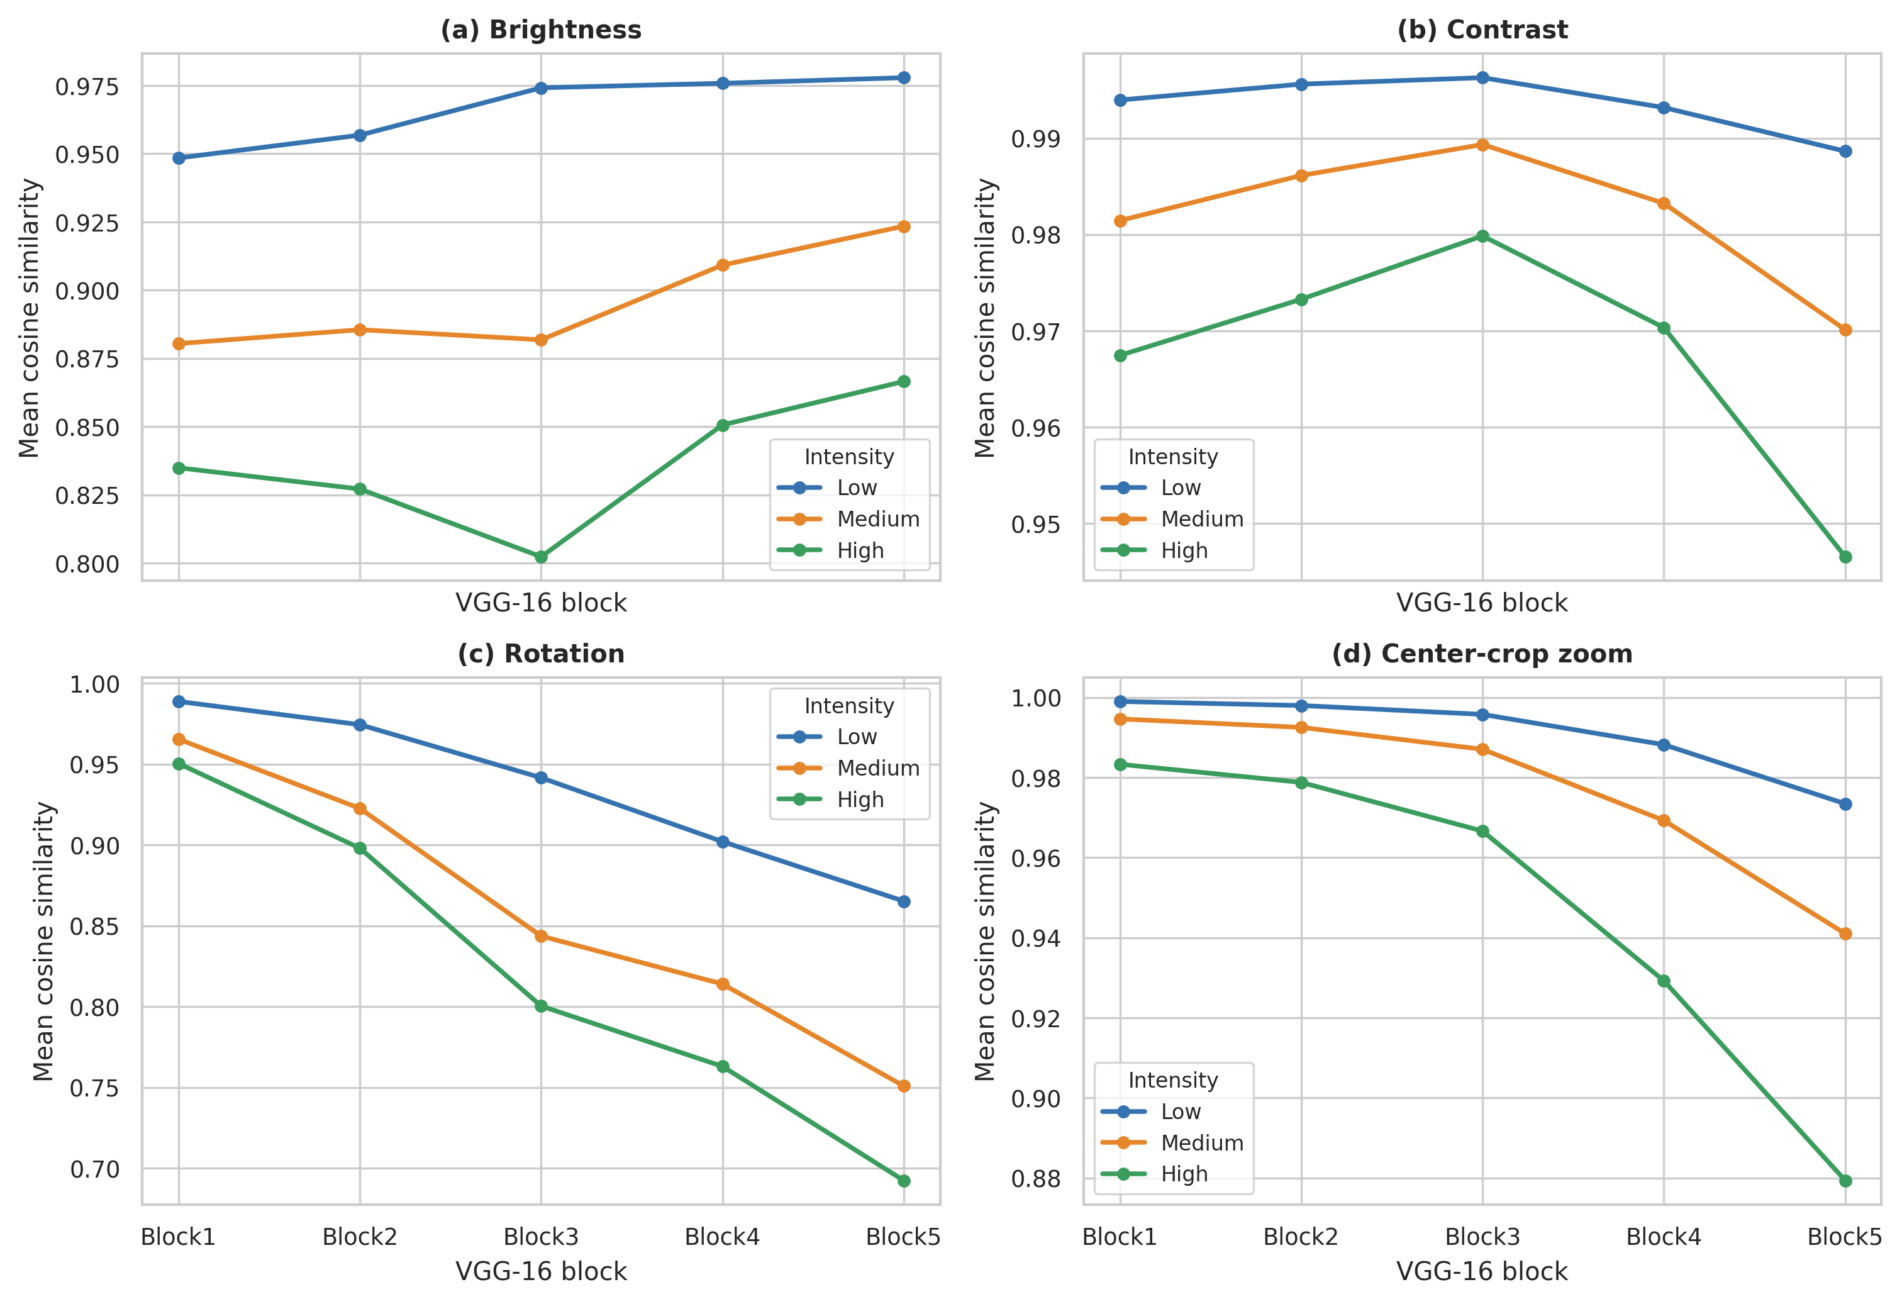
Figure S1. Layer-wise cosine similarity in the balanced 822-image JPG dataset. Panels show (a) brightness, (b) contrast, (c) rotation, and (d) center-crop zoom at low, medium, and high intensity.

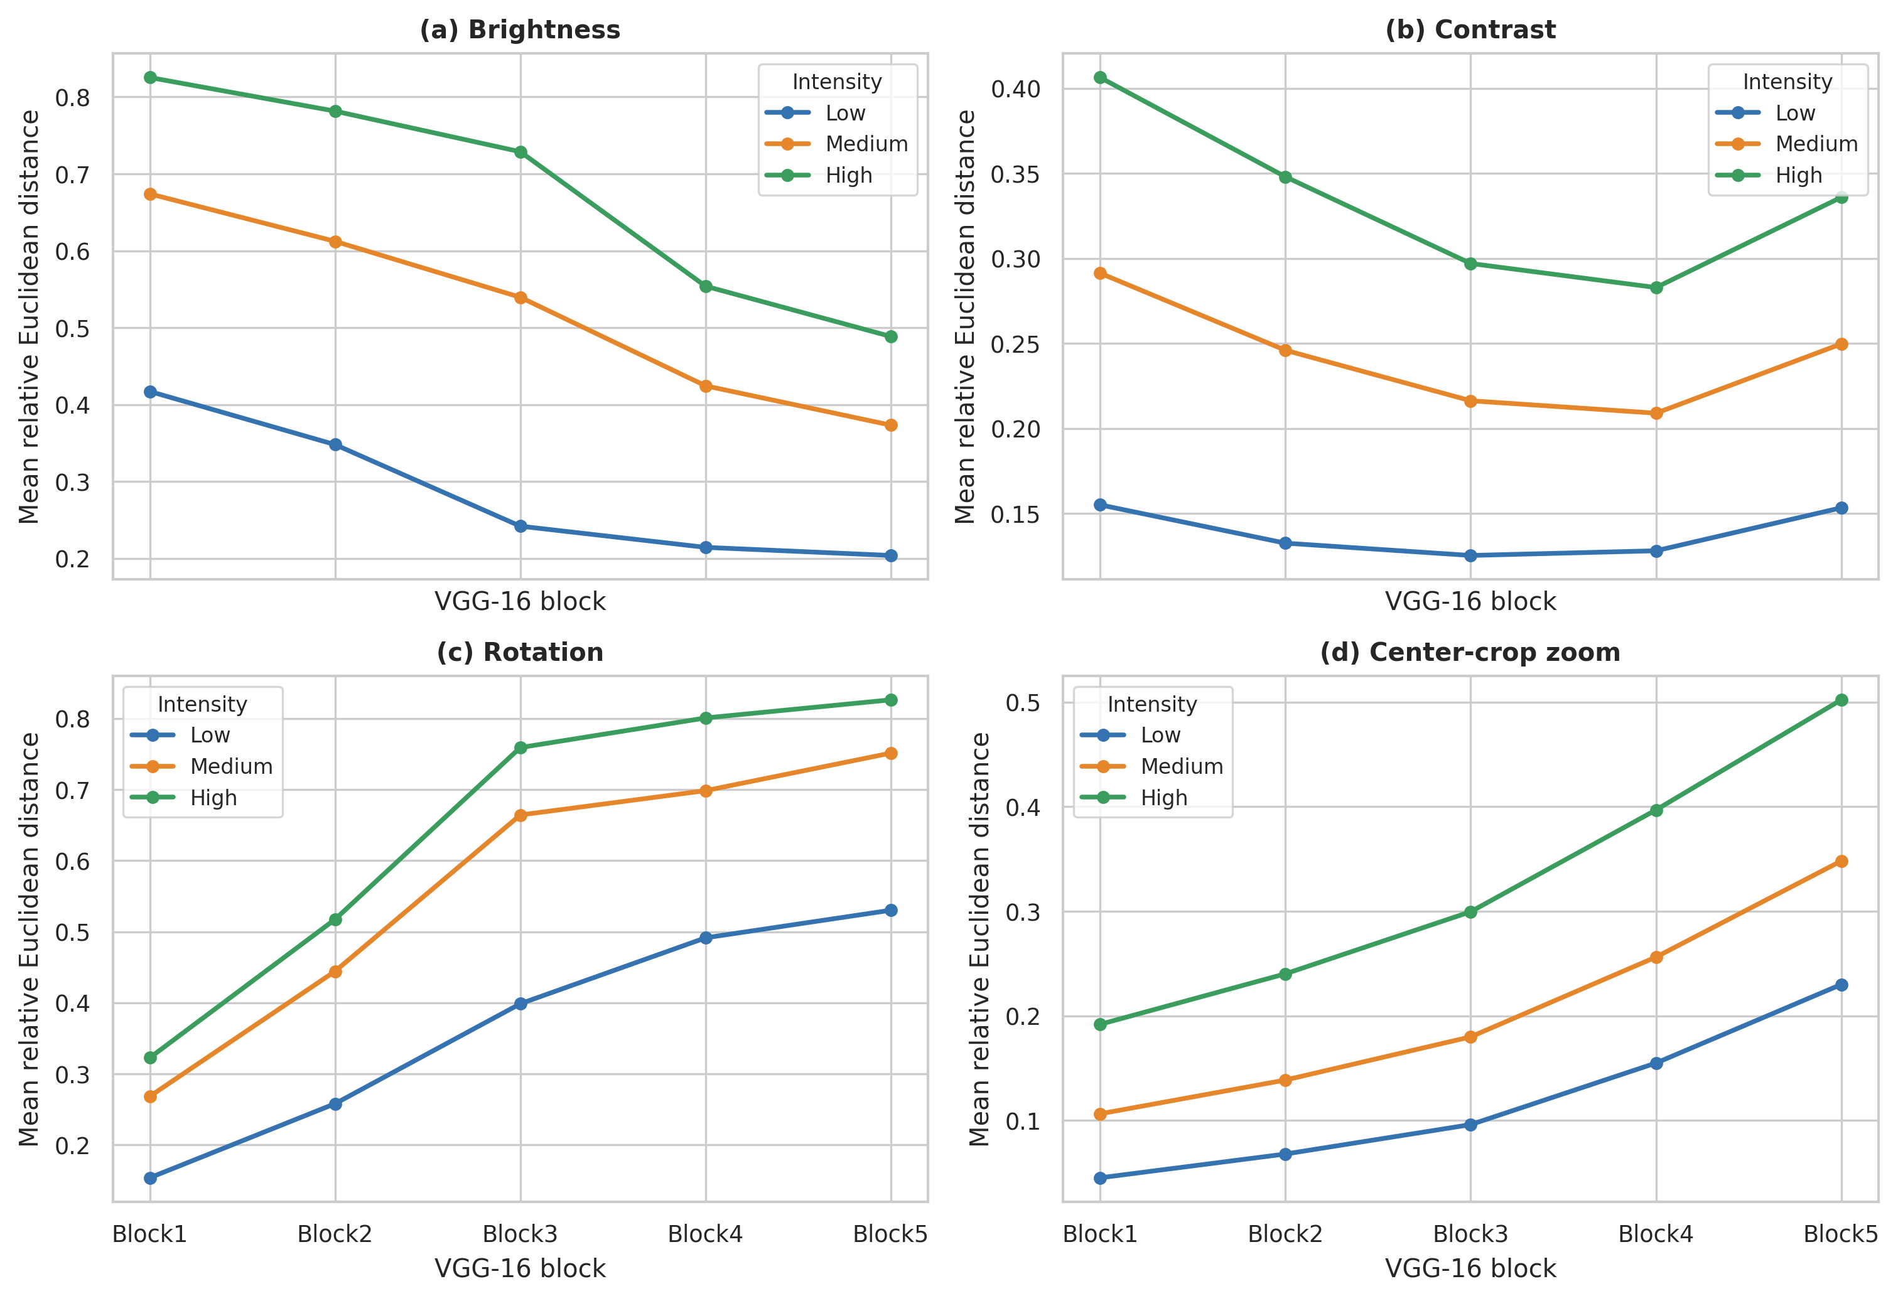
Figure S2. Layer-wise relative Euclidean distance in the balanced 822-image JPG dataset. Panels show (a) brightness, (b) contrast, (c) rotation, and (d) center-crop zoom at low, medium, and high intensity.

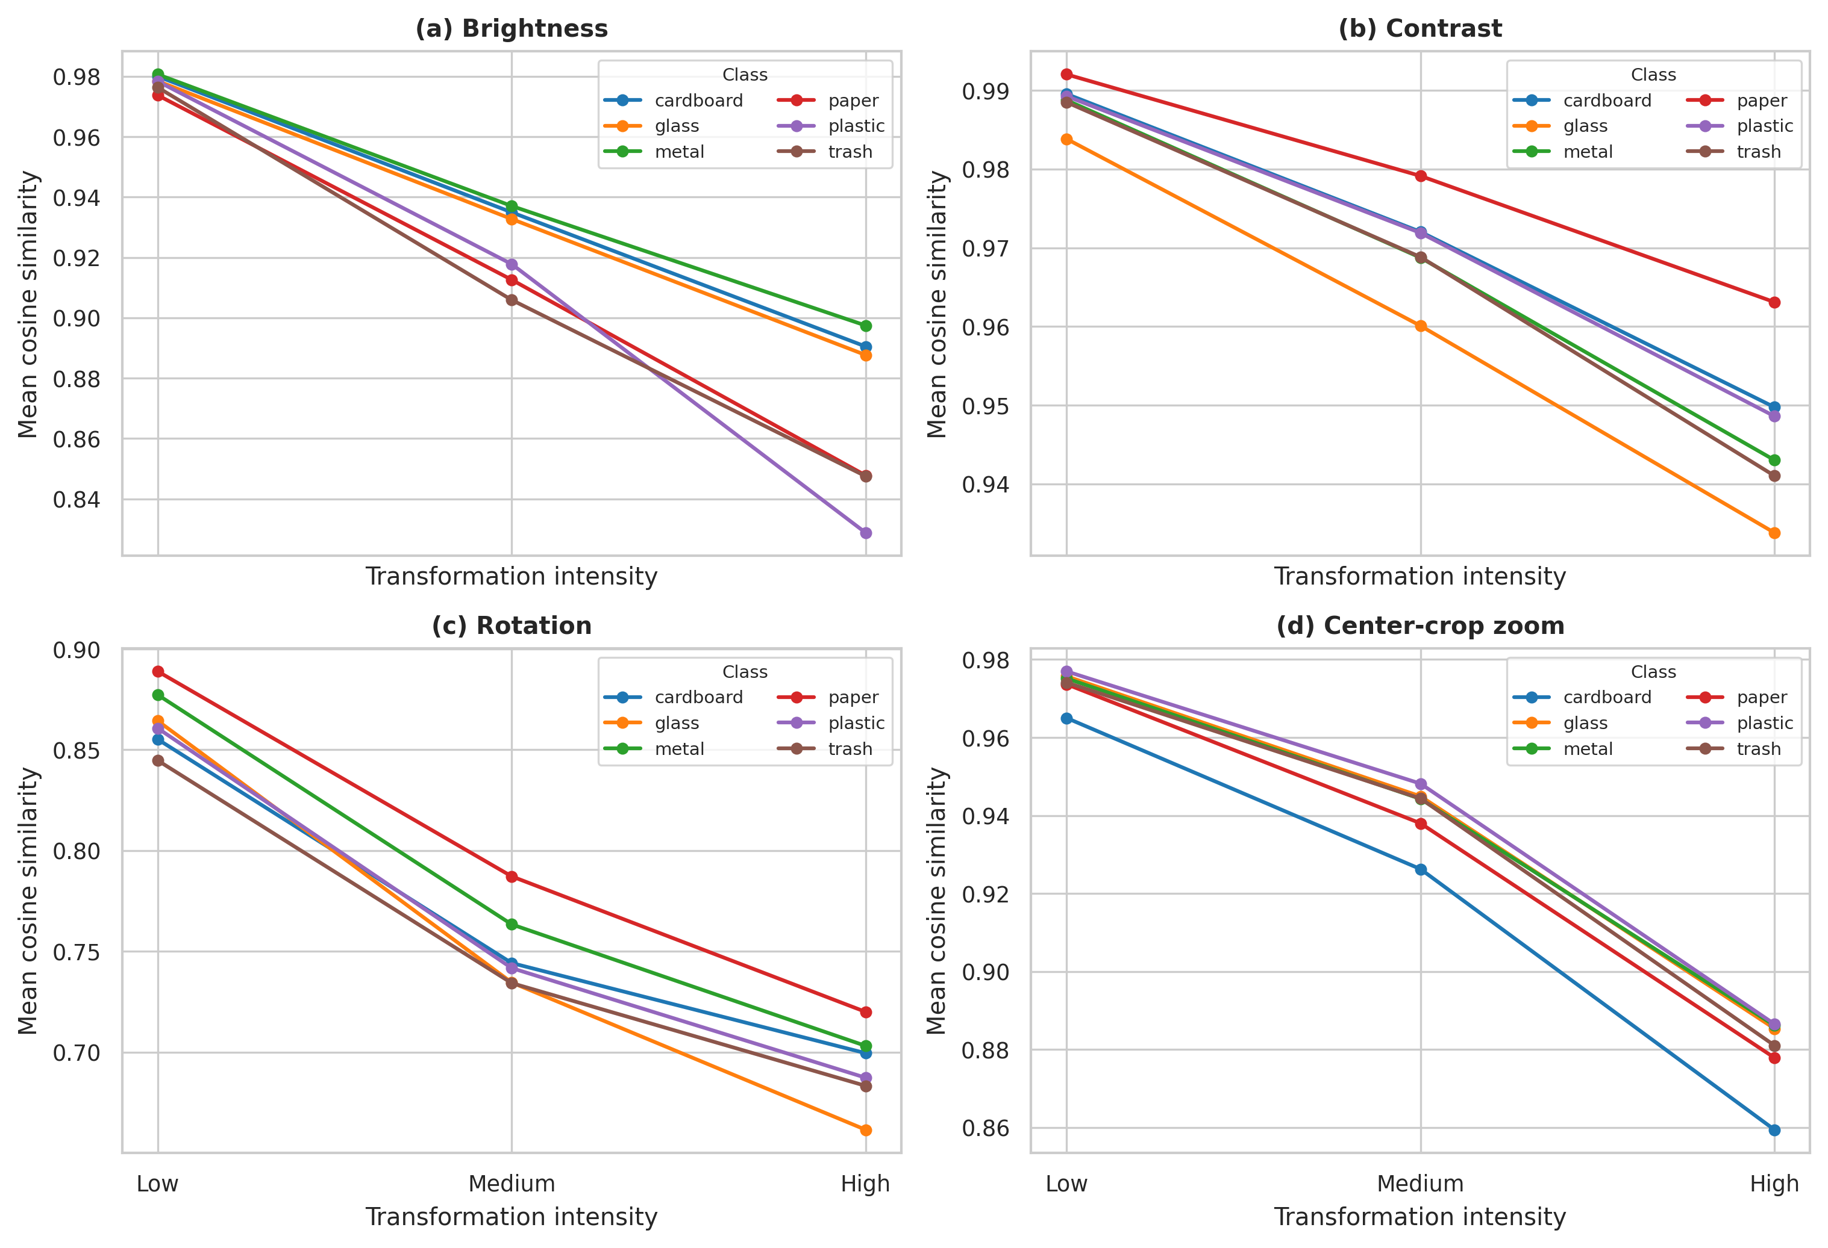
Figure S3. Class-specific cosine similarity at Block5 in the balanced 822-image JPG dataset. Panels show all six TrashNet classes under (a) brightness, (b) contrast, (c) rotation, and (d) center-crop zoom.

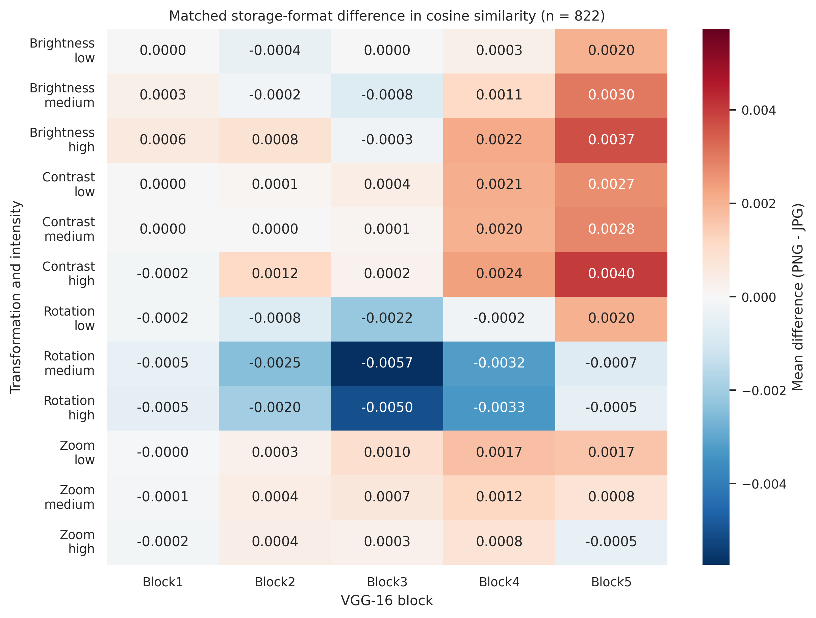
Figure S4. Mean paired difference in cosine similarity between PNG and JPG storage for the same 822 transformed images. Positive values indicate slightly higher cosine similarity for PNG; negative values indicate slightly higher cosine similarity for JPG.

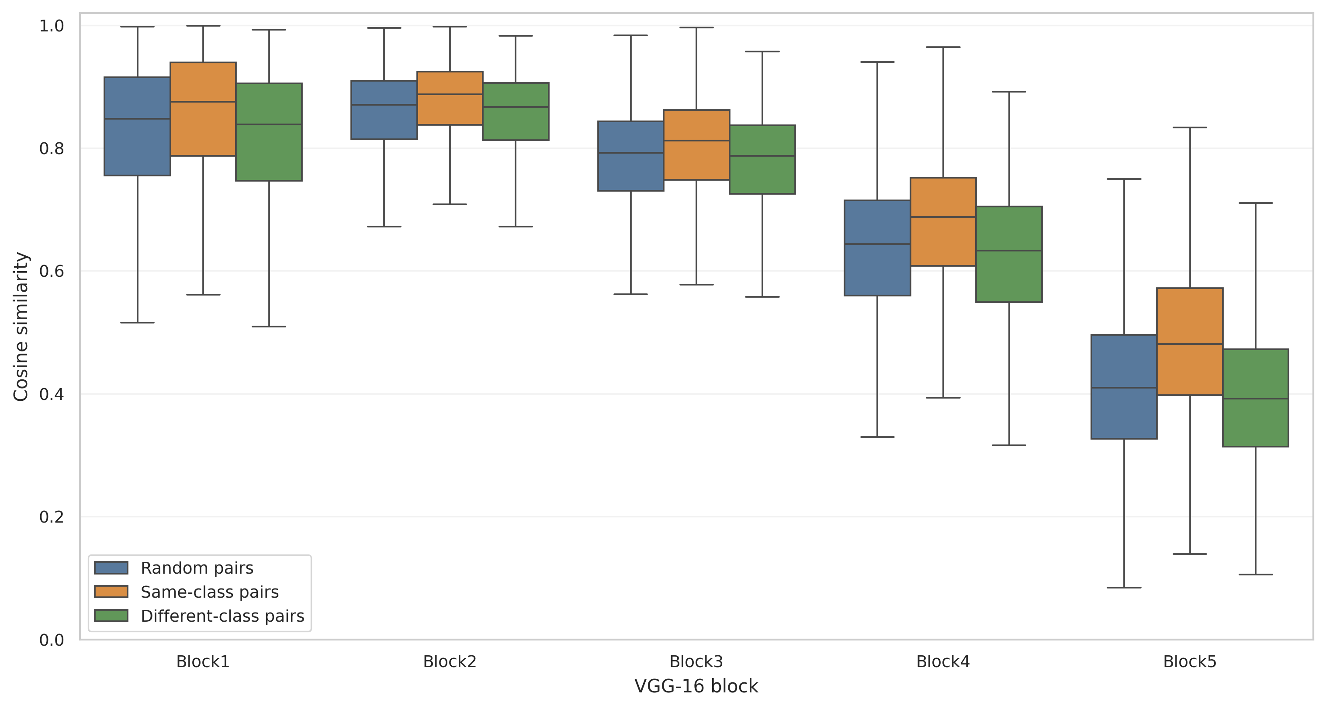
Figure S5. Block-specific cosine-similarity distributions between distinct original images. Random, same-class, and different-class pairs were sampled without replacement using the same fixed pair indices across the five VGG-16 blocks.

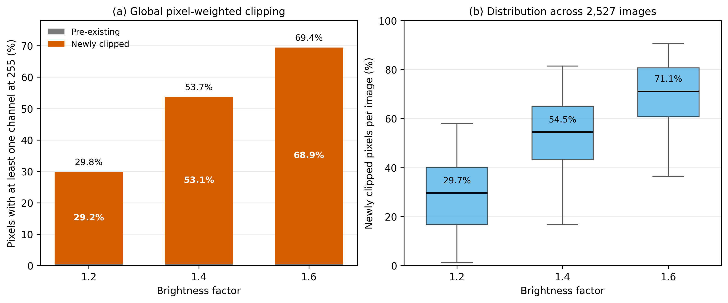
Figure S6. Brightness-induced pixel saturation in the complete TrashNet dataset. The plot distinguishes pixels already saturated in the source images from pixels newly clipped after application of each brightness factor.

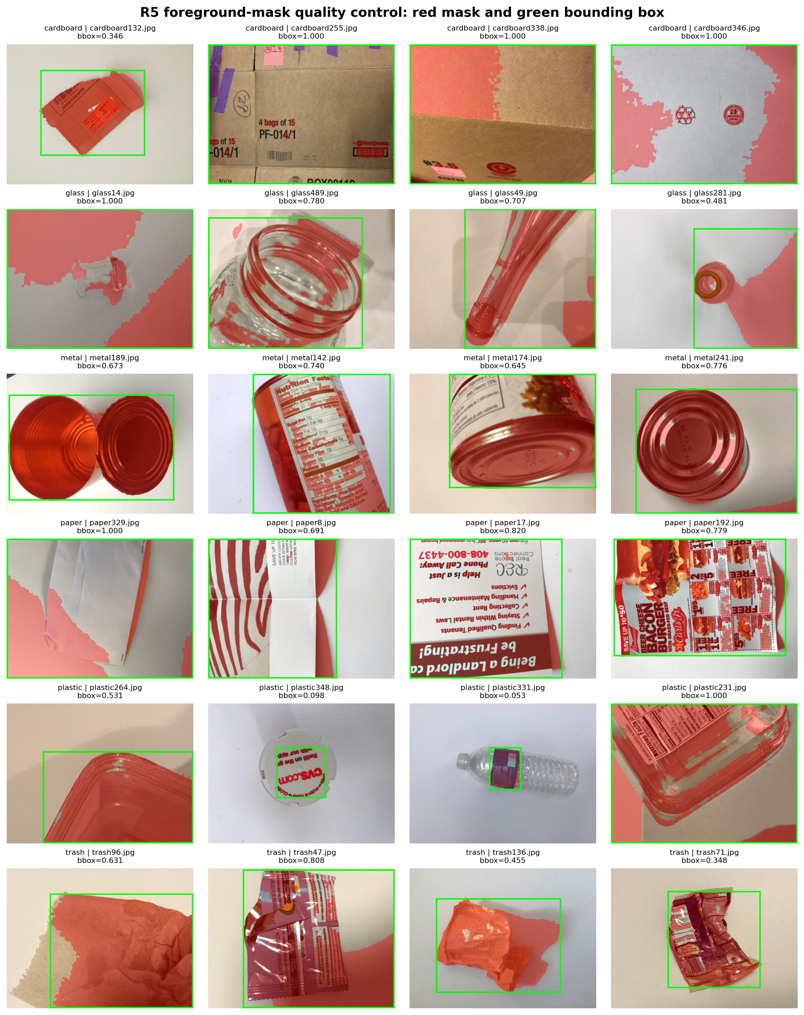
Figure S7. Visual quality-control examples for the automatic object-extent proxy. The masks were obtained by background-referenced RGB-distance thresholding followed by morphological cleaning and small-component removal; bounding-box area fraction was used as the primary extent covariate.

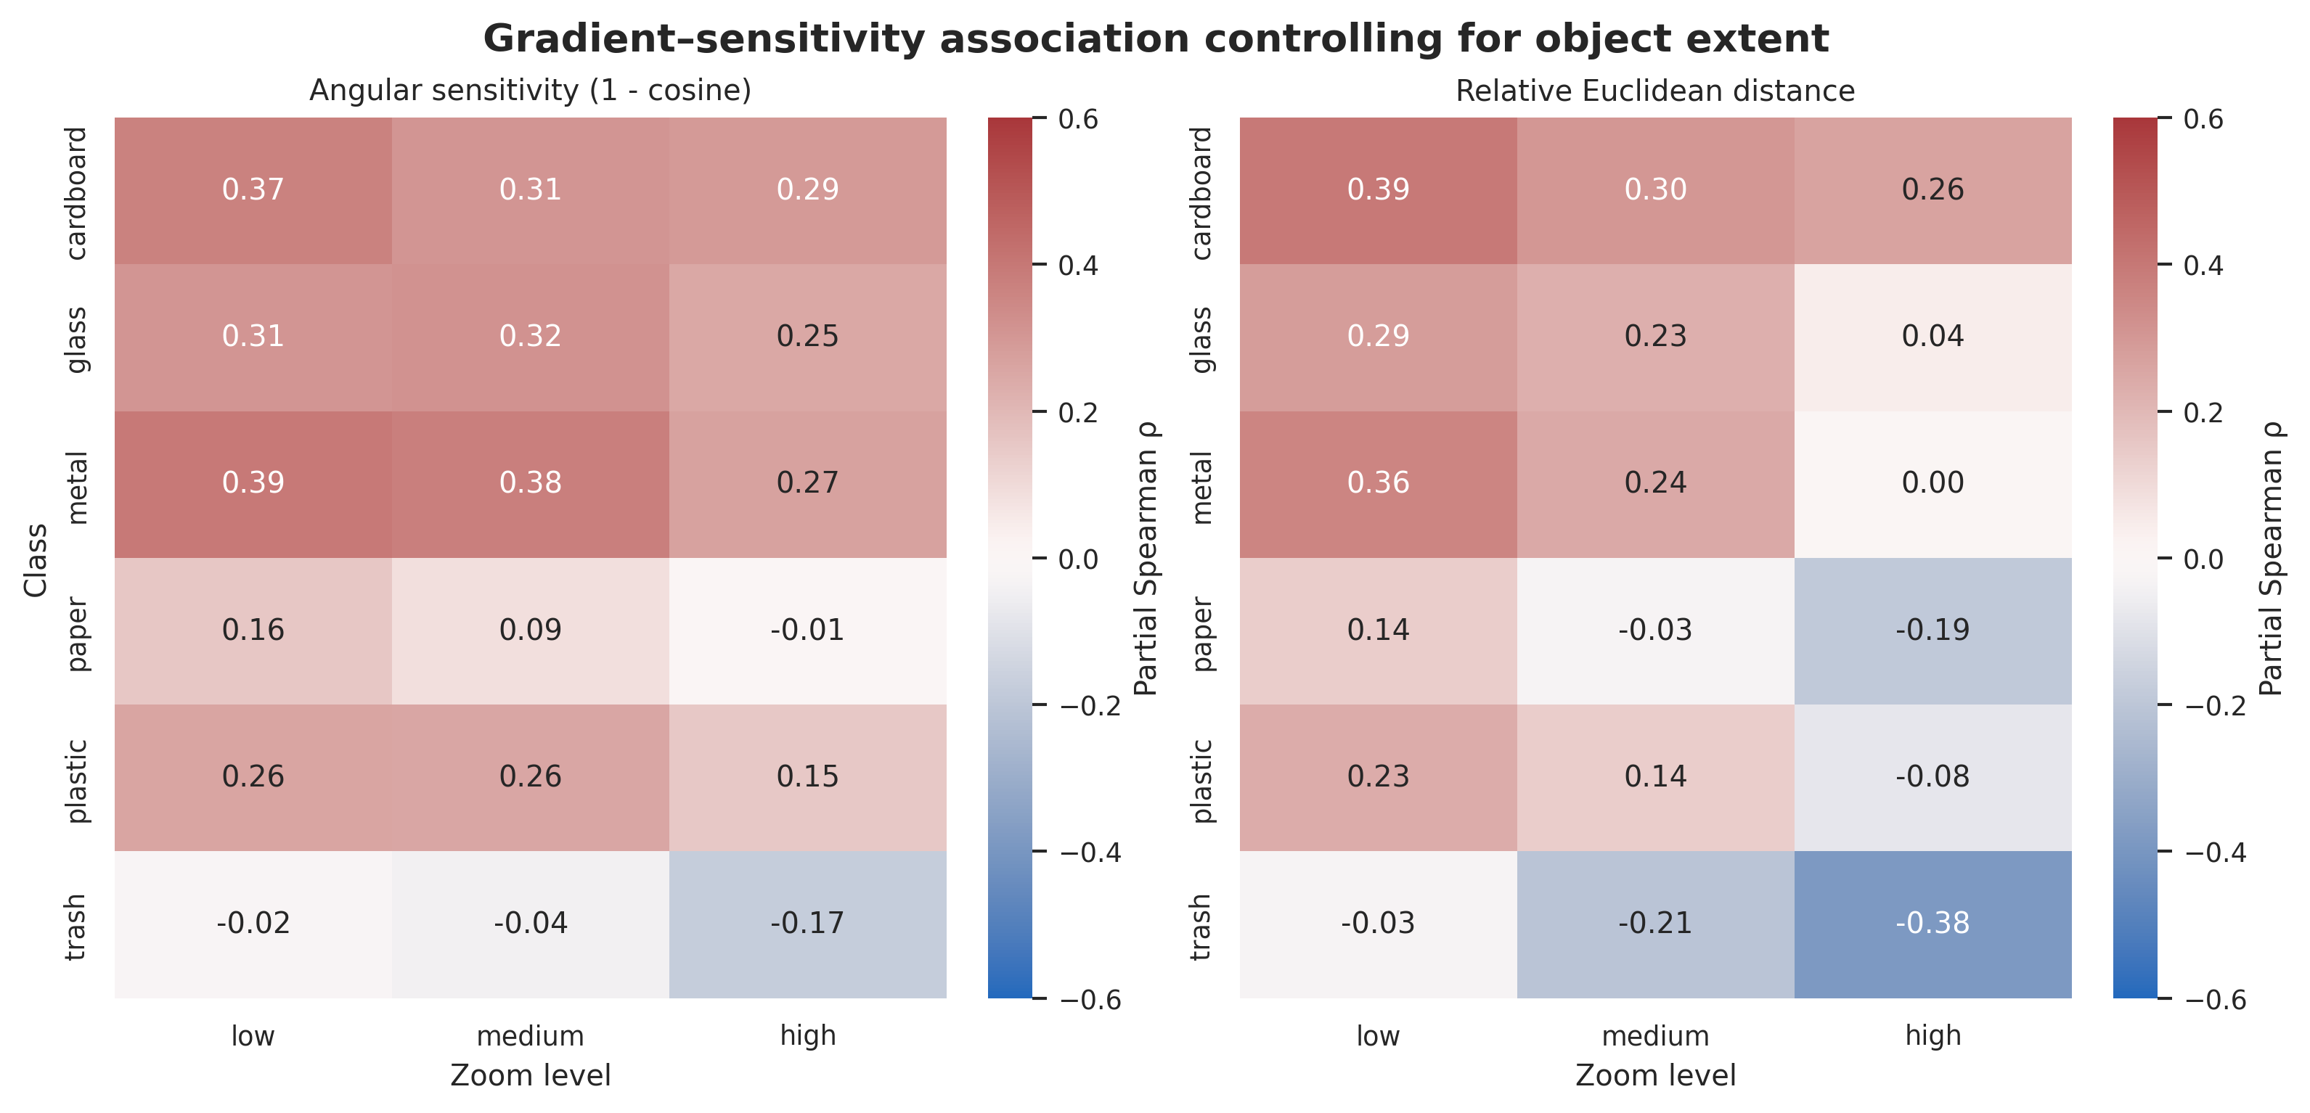
Figure S8. Object-extent-adjusted Spearman correlations between peripheral-gradient removal and Block5 sensitivity for all six TrashNet classes, two representational metrics, and three center-crop zoom levels. Confidence intervals and multiplicity-adjusted results are reported in Table S8.

Supplementary Tables
Table S1. Complete block-specific intensity statistics, paired effect sizes, and image-level ordering in the complete 2,527-image PNG dataset.
Transformation | Metric | Block | n | Low | Medium | High | Δ L–M | Δ M–H | Expected order (%) | M–H inversions (%) | Kendall W | Friedman Holm p | L–M Holm p | M–H Holm p | L–H Holm p
brightness | Angular sensitivity (1 - cosine) | Block1 | 2527 | 0.049 | 0.117 | 0.162 | 0.063 | 0.039 | 99.723 | 0.277 | 0.996 | 0 | 0 | 0 | 0
brightness | Angular sensitivity (1 - cosine) | Block2 | 2527 | 0.038 | 0.111 | 0.170 | 0.066 | 0.049 | 99.960 | 0.040 | 1.000 | 0 | 0 | 0 | 0
brightness | Angular sensitivity (1 - cosine) | Block3 | 2527 | 0.016 | 0.095 | 0.177 | 0.068 | 0.057 | 99.604 | 0.396 | 0.996 | 0 | 0 | 0 | 0
brightness | Angular sensitivity (1 - cosine) | Block4 | 2527 | 0.018 | 0.075 | 0.133 | 0.052 | 0.046 | 99.921 | 0.079 | 0.999 | 0 | 0 | 0 | 0
brightness | Angular sensitivity (1 - cosine) | Block5 | 2527 | 0.016 | 0.060 | 0.113 | 0.042 | 0.045 | 99.683 | 0.198 | 0.996 | 0 | 0 | 0 | 0
brightness | Relative Euclidean distance | Block1 | 2527 | 0.414 | 0.684 | 0.831 | 0.246 | 0.132 | 99.763 | 0.237 | 0.998 | 0 | 0 | 0 | 0
brightness | Relative Euclidean distance | Block2 | 2527 | 0.345 | 0.616 | 0.796 | 0.260 | 0.155 | 99.960 | 0.040 | 1.000 | 0 | 0 | 0 | 0
brightness | Relative Euclidean distance | Block3 | 2527 | 0.217 | 0.509 | 0.707 | 0.256 | 0.156 | 99.802 | 0.198 | 0.998 | 0 | 0 | 0 | 0
brightness | Relative Euclidean distance | Block4 | 2527 | 0.201 | 0.412 | 0.549 | 0.193 | 0.118 | 99.921 | 0.079 | 0.999 | 0 | 0 | 0 | 0
brightness | Relative Euclidean distance | Block5 | 2527 | 0.184 | 0.354 | 0.476 | 0.160 | 0.106 | 99.565 | 0.396 | 0.994 | 0 | 0 | 0 | 0
contrast | Angular sensitivity (1 - cosine) | Block1 | 2527 | 0.005 | 0.016 | 0.030 | 0.011 | 0.013 | 100.000 | 0 | 1 | 0 | 0 | 0 | 0
contrast | Angular sensitivity (1 - cosine) | Block2 | 2527 | 0.003 | 0.011 | 0.021 | 0.008 | 0.010 | 100.000 | 0 | 1 | 0 | 0 | 0 | 0
contrast | Angular sensitivity (1 - cosine) | Block3 | 2527 | 0.003 | 0.008 | 0.015 | 0.005 | 0.007 | 100.000 | 0 | 1 | 0 | 0 | 0 | 0
contrast | Angular sensitivity (1 - cosine) | Block4 | 2527 | 0.004 | 0.013 | 0.024 | 0.008 | 0.011 | 100.000 | 0 | 1 | 0 | 0 | 0 | 0
contrast | Angular sensitivity (1 - cosine) | Block5 | 2527 | 0.007 | 0.021 | 0.039 | 0.014 | 0.018 | 99.960 | 0.040 | 1.000 | 0 | 0 | 0 | 0
contrast | Relative Euclidean distance | Block1 | 2527 | 0.149 | 0.280 | 0.390 | 0.130 | 0.104 | 100.000 | 0 | 1 | 0 | 0 | 0 | 0
contrast | Relative Euclidean distance | Block2 | 2527 | 0.127 | 0.239 | 0.337 | 0.111 | 0.097 | 100.000 | 0 | 1 | 0 | 0 | 0 | 0
contrast | Relative Euclidean distance | Block3 | 2527 | 0.118 | 0.211 | 0.290 | 0.092 | 0.078 | 100.000 | 0 | 1 | 0 | 0 | 0 | 0
contrast | Relative Euclidean distance | Block4 | 2527 | 0.111 | 0.197 | 0.272 | 0.087 | 0.073 | 100.000 | 0 | 1 | 0 | 0 | 0 | 0
contrast | Relative Euclidean distance | Block5 | 2527 | 0.125 | 0.223 | 0.304 | 0.096 | 0.078 | 99.842 | 0.158 | 0.998 | 0 | 0 | 0 | 0
rotation | Angular sensitivity (1 - cosine) | Block1 | 2527 | 0.011 | 0.036 | 0.051 | 0.024 | 0.015 | 100.000 | 0 | 1 | 0 | 0 | 0 | 0
rotation | Angular sensitivity (1 - cosine) | Block2 | 2527 | 0.026 | 0.079 | 0.102 | 0.050 | 0.020 | 97.824 | 2.176 | 0.979 | 0 | 0 | 0 | 0
rotation | Angular sensitivity (1 - cosine) | Block3 | 2527 | 0.056 | 0.157 | 0.201 | 0.099 | 0.040 | 91.057 | 8.943 | 0.919 | 0 | 0 | 0 | 0
rotation | Angular sensitivity (1 - cosine) | Block4 | 2527 | 0.092 | 0.185 | 0.241 | 0.090 | 0.048 | 96.161 | 3.641 | 0.963 | 0 | 0 | 0 | 0
rotation | Angular sensitivity (1 - cosine) | Block5 | 2527 | 0.121 | 0.242 | 0.304 | 0.115 | 0.053 | 87.693 | 12.109 | 0.891 | 0 | 0 | 0 | 0
rotation | Relative Euclidean distance | Block1 | 2527 | 0.161 | 0.279 | 0.334 | 0.117 | 0.055 | 99.960 | 0.040 | 1.000 | 0 | 0 | 0 | 0
rotation | Relative Euclidean distance | Block2 | 2527 | 0.269 | 0.459 | 0.530 | 0.186 | 0.067 | 98.021 | 1.979 | 0.981 | 0 | 0 | 0 | 0
rotation | Relative Euclidean distance | Block3 | 2527 | 0.412 | 0.698 | 0.790 | 0.289 | 0.092 | 93.866 | 6.134 | 0.942 | 0 | 0 | 0 | 0
rotation | Relative Euclidean distance | Block4 | 2527 | 0.496 | 0.724 | 0.829 | 0.227 | 0.104 | 96.359 | 3.443 | 0.965 | 0 | 0 | 0 | 0
rotation | Relative Euclidean distance | Block5 | 2527 | 0.501 | 0.731 | 0.816 | 0.228 | 0.071 | 82.430 | 17.452 | 0.854 | 0 | 0 | 5.79e-274 | 0
zoom | Angular sensitivity (1 - cosine) | Block1 | 2527 | 8.32e-04 | 0.004 | 0.013 | 0.003 | 0.009 | 99.921 | 0.079 | 0.999 | 0 | 0 | 0 | 0
zoom | Angular sensitivity (1 - cosine) | Block2 | 2527 | 0.002 | 0.006 | 0.018 | 0.005 | 0.012 | 100.000 | 0 | 1 | 0 | 0 | 0 | 0
zoom | Angular sensitivity (1 - cosine) | Block3 | 2527 | 0.003 | 0.011 | 0.029 | 0.008 | 0.018 | 100.000 | 0 | 1 | 0 | 0 | 0 | 0
zoom | Angular sensitivity (1 - cosine) | Block4 | 2527 | 0.009 | 0.027 | 0.066 | 0.018 | 0.038 | 100.000 | 0 | 1 | 0 | 0 | 0 | 0
zoom | Angular sensitivity (1 - cosine) | Block5 | 2527 | 0.023 | 0.055 | 0.116 | 0.032 | 0.059 | 99.842 | 0.119 | 0.998 | 0 | 0 | 0 | 0
zoom | Relative Euclidean distance | Block1 | 2527 | 0.044 | 0.101 | 0.178 | 0.057 | 0.076 | 99.881 | 0.119 | 0.999 | 0 | 0 | 0 | 0
zoom | Relative Euclidean distance | Block2 | 2527 | 0.061 | 0.127 | 0.218 | 0.066 | 0.091 | 99.960 | 0.040 | 1.000 | 0 | 0 | 0 | 0
zoom | Relative Euclidean distance | Block3 | 2527 | 0.082 | 0.171 | 0.283 | 0.087 | 0.112 | 100.000 | 0 | 1 | 0 | 0 | 0 | 0
zoom | Relative Euclidean distance | Block4 | 2527 | 0.139 | 0.246 | 0.386 | 0.107 | 0.136 | 100.000 | 0 | 1 | 0 | 0 | 0 | 0
zoom | Relative Euclidean distance | Block5 | 2527 | 0.218 | 0.344 | 0.496 | 0.124 | 0.153 | 99.763 | 0.158 | 0.998 | 0 | 0 | 0 | 0
Angular sensitivity was defined as 1 − cosine similarity. Positive paired differences indicate greater alteration at the higher intensity. Exact unrounded values are retained in the accompanying derived-data file.

Table S2. Pairwise block comparisons in the complete 2,527-image PNG dataset.
Metric | Transformation | Intensity | Block A | Block B | n | Median A | Median B | Median difference B-A | Rank-biserial r | Holm-adjusted p
cosine_similarity | brightness | high | Block1 | Block2 | 2527 | 0.838 | 0.830 | -0.006 | -0.340 | <0.001
cosine_similarity | brightness | high | Block1 | Block3 | 2527 | 0.838 | 0.823 | -0.027 | -0.424 | <0.001
cosine_similarity | brightness | high | Block1 | Block4 | 2527 | 0.838 | 0.867 | 0.013 | 0.252 | <0.001
cosine_similarity | brightness | high | Block1 | Block5 | 2527 | 0.838 | 0.887 | 0.025 | 0.418 | <0.001
cosine_similarity | brightness | high | Block2 | Block3 | 2527 | 0.830 | 0.823 | -0.017 | -0.379 | <0.001
cosine_similarity | brightness | high | Block2 | Block4 | 2527 | 0.830 | 0.867 | 0.020 | 0.487 | <0.001
cosine_similarity | brightness | high | Block2 | Block5 | 2527 | 0.830 | 0.887 | 0.036 | 0.596 | <0.001
cosine_similarity | brightness | high | Block3 | Block4 | 2527 | 0.823 | 0.867 | 0.045 | 0.870 | <0.001
cosine_similarity | brightness | high | Block3 | Block5 | 2527 | 0.823 | 0.887 | 0.053 | 0.691 | <0.001
cosine_similarity | brightness | high | Block4 | Block5 | 2527 | 0.867 | 0.887 | 0.008 | 0.276 | <0.001
cosine_similarity | brightness | low | Block1 | Block2 | 2527 | 0.951 | 0.962 | 0.007 | 0.660 | <0.001
cosine_similarity | brightness | low | Block1 | Block3 | 2527 | 0.951 | 0.984 | 0.023 | 0.771 | <0.001
cosine_similarity | brightness | low | Block1 | Block4 | 2527 | 0.951 | 0.982 | 0.026 | 0.871 | <0.001
cosine_similarity | brightness | low | Block1 | Block5 | 2527 | 0.951 | 0.984 | 0.029 | 0.884 | <0.001
cosine_similarity | brightness | low | Block2 | Block3 | 2527 | 0.962 | 0.984 | 0.014 | 0.759 | <0.001
cosine_similarity | brightness | low | Block2 | Block4 | 2527 | 0.962 | 0.982 | 0.016 | 0.879 | <0.001
cosine_similarity | brightness | low | Block2 | Block5 | 2527 | 0.962 | 0.984 | 0.019 | 0.842 | <0.001
cosine_similarity | brightness | low | Block3 | Block4 | 2527 | 0.984 | 0.982 | -0.000 | 0.090 | <0.001
cosine_similarity | brightness | low | Block3 | Block5 | 2527 | 0.984 | 0.984 | 0.001 | 0.184 | <0.001
cosine_similarity | brightness | low | Block4 | Block5 | 2527 | 0.982 | 0.984 | 0.000 | 0.210 | <0.001
cosine_similarity | brightness | medium | Block1 | Block2 | 2527 | 0.883 | 0.889 | 0.002 | 0.143 | <0.001
cosine_similarity | brightness | medium | Block1 | Block3 | 2527 | 0.883 | 0.905 | 0.006 | 0.053 | 0.044
cosine_similarity | brightness | medium | Block1 | Block4 | 2527 | 0.883 | 0.925 | 0.027 | 0.600 | <0.001
cosine_similarity | brightness | medium | Block1 | Block5 | 2527 | 0.883 | 0.940 | 0.040 | 0.710 | <0.001
cosine_similarity | brightness | medium | Block2 | Block3 | 2527 | 0.889 | 0.905 | 0.005 | 0.017 | 0.447
cosine_similarity | brightness | medium | Block2 | Block4 | 2527 | 0.889 | 0.925 | 0.024 | 0.683 | <0.001
cosine_similarity | brightness | medium | Block2 | Block5 | 2527 | 0.889 | 0.940 | 0.038 | 0.753 | <0.001
cosine_similarity | brightness | medium | Block3 | Block4 | 2527 | 0.905 | 0.925 | 0.019 | 0.766 | <0.001
cosine_similarity | brightness | medium | Block3 | Block5 | 2527 | 0.905 | 0.940 | 0.027 | 0.628 | <0.001
cosine_similarity | brightness | medium | Block4 | Block5 | 2527 | 0.925 | 0.940 | 0.006 | 0.351 | <0.001
cosine_similarity | contrast | high | Block1 | Block2 | 2527 | 0.970 | 0.979 | 0.006 | 0.664 | <0.001
cosine_similarity | contrast | high | Block1 | Block3 | 2527 | 0.970 | 0.985 | 0.012 | 0.805 | <0.001
cosine_similarity | contrast | high | Block1 | Block4 | 2527 | 0.970 | 0.976 | 0.005 | 0.407 | <0.001
cosine_similarity | contrast | high | Block1 | Block5 | 2527 | 0.970 | 0.961 | -0.012 | -0.680 | <0.001
cosine_similarity | contrast | high | Block2 | Block3 | 2527 | 0.979 | 0.985 | 0.006 | 0.749 | <0.001
cosine_similarity | contrast | high | Block2 | Block4 | 2527 | 0.979 | 0.976 | -0.002 | -0.274 | <0.001
cosine_similarity | contrast | high | Block2 | Block5 | 2527 | 0.979 | 0.961 | -0.017 | -0.936 | <0.001
cosine_similarity | contrast | high | Block3 | Block4 | 2527 | 0.985 | 0.976 | -0.007 | -0.813 | <0.001
cosine_similarity | contrast | high | Block3 | Block5 | 2527 | 0.985 | 0.961 | -0.022 | -0.972 | <0.001
cosine_similarity | contrast | high | Block4 | Block5 | 2527 | 0.976 | 0.961 | -0.015 | -0.978 | <0.001
cosine_similarity | contrast | low | Block1 | Block2 | 2527 | 0.995 | 0.997 | 0.001 | 0.733 | <0.001
cosine_similarity | contrast | low | Block1 | Block3 | 2527 | 0.995 | 0.997 | 0.002 | 0.825 | <0.001
cosine_similarity | contrast | low | Block1 | Block4 | 2527 | 0.995 | 0.996 | 0.001 | 0.404 | <0.001
cosine_similarity | contrast | low | Block1 | Block5 | 2527 | 0.995 | 0.993 | -0.002 | -0.573 | <0.001
cosine_similarity | contrast | low | Block2 | Block3 | 2527 | 0.997 | 0.997 | 0.001 | 0.761 | <0.001
cosine_similarity | contrast | low | Block2 | Block4 | 2527 | 0.997 | 0.996 | -0.000 | -0.342 | <0.001
cosine_similarity | contrast | low | Block2 | Block5 | 2527 | 0.997 | 0.993 | -0.003 | -0.926 | <0.001
cosine_similarity | contrast | low | Block3 | Block4 | 2527 | 0.997 | 0.996 | -0.001 | -0.913 | <0.001
cosine_similarity | contrast | low | Block3 | Block5 | 2527 | 0.997 | 0.993 | -0.004 | -0.989 | <0.001
cosine_similarity | contrast | low | Block4 | Block5 | 2527 | 0.996 | 0.993 | -0.003 | -0.976 | <0.001
cosine_similarity | contrast | medium | Block1 | Block2 | 2527 | 0.984 | 0.989 | 0.004 | 0.715 | <0.001
cosine_similarity | contrast | medium | Block1 | Block3 | 2527 | 0.984 | 0.992 | 0.007 | 0.860 | <0.001
cosine_similarity | contrast | medium | Block1 | Block4 | 2527 | 0.984 | 0.987 | 0.003 | 0.464 | <0.001
cosine_similarity | contrast | medium | Block1 | Block5 | 2527 | 0.984 | 0.979 | -0.006 | -0.609 | <0.001
cosine_similarity | contrast | medium | Block2 | Block3 | 2527 | 0.989 | 0.992 | 0.003 | 0.806 | <0.001
cosine_similarity | contrast | medium | Block2 | Block4 | 2527 | 0.989 | 0.987 | -0.001 | -0.246 | <0.001
cosine_similarity | contrast | medium | Block2 | Block5 | 2527 | 0.989 | 0.979 | -0.009 | -0.929 | <0.001
cosine_similarity | contrast | medium | Block3 | Block4 | 2527 | 0.992 | 0.987 | -0.004 | -0.868 | <0.001
cosine_similarity | contrast | medium | Block3 | Block5 | 2527 | 0.992 | 0.979 | -0.012 | -0.978 | <0.001
cosine_similarity | contrast | medium | Block4 | Block5 | 2527 | 0.987 | 0.979 | -0.008 | -0.979 | <0.001
cosine_similarity | rotation | high | Block1 | Block2 | 2527 | 0.949 | 0.898 | -0.046 | -1.000 | <0.001
cosine_similarity | rotation | high | Block1 | Block3 | 2527 | 0.949 | 0.799 | -0.147 | -1.000 | <0.001
cosine_similarity | rotation | high | Block1 | Block4 | 2527 | 0.949 | 0.759 | -0.187 | -1.000 | <0.001
cosine_similarity | rotation | high | Block1 | Block5 | 2527 | 0.949 | 0.696 | -0.251 | -1.000 | <0.001
cosine_similarity | rotation | high | Block2 | Block3 | 2527 | 0.898 | 0.799 | -0.098 | -0.997 | <0.001
cosine_similarity | rotation | high | Block2 | Block4 | 2527 | 0.898 | 0.759 | -0.134 | -0.995 | <0.001
cosine_similarity | rotation | high | Block2 | Block5 | 2527 | 0.898 | 0.696 | -0.196 | -0.997 | <0.001
cosine_similarity | rotation | high | Block3 | Block4 | 2527 | 0.799 | 0.759 | -0.040 | -0.616 | <0.001
cosine_similarity | rotation | high | Block3 | Block5 | 2527 | 0.799 | 0.696 | -0.099 | -0.885 | <0.001
cosine_similarity | rotation | high | Block4 | Block5 | 2527 | 0.759 | 0.696 | -0.062 | -0.880 | <0.001
cosine_similarity | rotation | low | Block1 | Block2 | 2527 | 0.989 | 0.974 | -0.015 | -1.000 | <0.001
cosine_similarity | rotation | low | Block1 | Block3 | 2527 | 0.989 | 0.944 | -0.044 | -1.000 | <0.001
cosine_similarity | rotation | low | Block1 | Block4 | 2527 | 0.989 | 0.908 | -0.079 | -1.000 | <0.001
cosine_similarity | rotation | low | Block1 | Block5 | 2527 | 0.989 | 0.879 | -0.109 | -1.000 | <0.001
cosine_similarity | rotation | low | Block2 | Block3 | 2527 | 0.974 | 0.944 | -0.028 | -1.000 | <0.001
cosine_similarity | rotation | low | Block2 | Block4 | 2527 | 0.974 | 0.908 | -0.065 | -0.999 | <0.001
cosine_similarity | rotation | low | Block2 | Block5 | 2527 | 0.974 | 0.879 | -0.095 | -0.999 | <0.001
cosine_similarity | rotation | low | Block3 | Block4 | 2527 | 0.944 | 0.908 | -0.036 | -0.893 | <0.001
cosine_similarity | rotation | low | Block3 | Block5 | 2527 | 0.944 | 0.879 | -0.065 | -0.974 | <0.001
cosine_similarity | rotation | low | Block4 | Block5 | 2527 | 0.908 | 0.879 | -0.030 | -0.892 | <0.001
cosine_similarity | rotation | medium | Block1 | Block2 | 2527 | 0.964 | 0.921 | -0.040 | -1.000 | <0.001
cosine_similarity | rotation | medium | Block1 | Block3 | 2527 | 0.964 | 0.843 | -0.120 | -1.000 | <0.001
cosine_similarity | rotation | medium | Block1 | Block4 | 2527 | 0.964 | 0.815 | -0.148 | -1.000 | <0.001
cosine_similarity | rotation | medium | Block1 | Block5 | 2527 | 0.964 | 0.758 | -0.206 | -1.000 | <0.001
cosine_similarity | rotation | medium | Block2 | Block3 | 2527 | 0.921 | 0.843 | -0.077 | -0.997 | <0.001
cosine_similarity | rotation | medium | Block2 | Block4 | 2527 | 0.921 | 0.815 | -0.105 | -0.995 | <0.001
cosine_similarity | rotation | medium | Block2 | Block5 | 2527 | 0.921 | 0.758 | -0.160 | -0.998 | <0.001
cosine_similarity | rotation | medium | Block3 | Block4 | 2527 | 0.843 | 0.815 | -0.037 | -0.488 | <0.001
cosine_similarity | rotation | medium | Block3 | Block5 | 2527 | 0.843 | 0.758 | -0.087 | -0.802 | <0.001
cosine_similarity | rotation | medium | Block4 | Block5 | 2527 | 0.815 | 0.758 | -0.055 | -0.909 | <0.001
cosine_similarity | zoom | high | Block1 | Block2 | 2527 | 0.987 | 0.982 | -0.004 | -0.367 | <0.001
cosine_similarity | zoom | high | Block1 | Block3 | 2527 | 0.987 | 0.971 | -0.014 | -0.781 | <0.001
cosine_similarity | zoom | high | Block1 | Block4 | 2527 | 0.987 | 0.934 | -0.049 | -0.996 | <0.001
cosine_similarity | zoom | high | Block1 | Block5 | 2527 | 0.987 | 0.884 | -0.099 | -1.000 | <0.001
cosine_similarity | zoom | high | Block2 | Block3 | 2527 | 0.982 | 0.971 | -0.010 | -0.924 | <0.001
cosine_similarity | zoom | high | Block2 | Block4 | 2527 | 0.982 | 0.934 | -0.046 | -1.000 | <0.001
cosine_similarity | zoom | high | Block2 | Block5 | 2527 | 0.982 | 0.884 | -0.096 | -1.000 | <0.001
cosine_similarity | zoom | high | Block3 | Block4 | 2527 | 0.971 | 0.934 | -0.036 | -0.995 | <0.001
cosine_similarity | zoom | high | Block3 | Block5 | 2527 | 0.971 | 0.884 | -0.085 | -1.000 | <0.001
cosine_similarity | zoom | high | Block4 | Block5 | 2527 | 0.934 | 0.884 | -0.049 | -0.982 | <0.001
cosine_similarity | zoom | low | Block1 | Block2 | 2527 | 0.999 | 0.998 | -0.001 | -0.653 | <0.001
cosine_similarity | zoom | low | Block1 | Block3 | 2527 | 0.999 | 0.997 | -0.002 | -0.943 | <0.001
cosine_similarity | zoom | low | Block1 | Block4 | 2527 | 0.999 | 0.991 | -0.008 | -1.000 | <0.001
cosine_similarity | zoom | low | Block1 | Block5 | 2527 | 0.999 | 0.977 | -0.022 | -1.000 | <0.001
cosine_similarity | zoom | low | Block2 | Block3 | 2527 | 0.998 | 0.997 | -0.001 | -0.974 | <0.001
cosine_similarity | zoom | low | Block2 | Block4 | 2527 | 0.998 | 0.991 | -0.007 | -1.000 | <0.001
cosine_similarity | zoom | low | Block2 | Block5 | 2527 | 0.998 | 0.977 | -0.021 | -1.000 | <0.001
cosine_similarity | zoom | low | Block3 | Block4 | 2527 | 0.997 | 0.991 | -0.006 | -1.000 | <0.001
cosine_similarity | zoom | low | Block3 | Block5 | 2527 | 0.997 | 0.977 | -0.020 | -1.000 | <0.001
cosine_similarity | zoom | low | Block4 | Block5 | 2527 | 0.991 | 0.977 | -0.013 | -1.000 | <0.001
cosine_similarity | zoom | medium | Block1 | Block2 | 2527 | 0.996 | 0.994 | -0.002 | -0.437 | <0.001
cosine_similarity | zoom | medium | Block1 | Block3 | 2527 | 0.996 | 0.989 | -0.006 | -0.839 | <0.001
cosine_similarity | zoom | medium | Block1 | Block4 | 2527 | 0.996 | 0.973 | -0.022 | -0.999 | <0.001
cosine_similarity | zoom | medium | Block1 | Block5 | 2527 | 0.996 | 0.945 | -0.049 | -1.000 | <0.001
cosine_similarity | zoom | medium | Block2 | Block3 | 2527 | 0.994 | 0.989 | -0.004 | -0.943 | <0.001
cosine_similarity | zoom | medium | Block2 | Block4 | 2527 | 0.994 | 0.973 | -0.020 | -1.000 | <0.001
cosine_similarity | zoom | medium | Block2 | Block5 | 2527 | 0.994 | 0.945 | -0.048 | -1.000 | <0.001
cosine_similarity | zoom | medium | Block3 | Block4 | 2527 | 0.989 | 0.973 | -0.016 | -0.996 | <0.001
cosine_similarity | zoom | medium | Block3 | Block5 | 2527 | 0.989 | 0.945 | -0.044 | -1.000 | <0.001
cosine_similarity | zoom | medium | Block4 | Block5 | 2527 | 0.973 | 0.945 | -0.027 | -0.996 | <0.001
relative_euclidean_distance | brightness | high | Block1 | Block2 | 2527 | 0.831 | 0.796 | -0.031 | -0.434 | <0.001
relative_euclidean_distance | brightness | high | Block1 | Block3 | 2527 | 0.831 | 0.707 | -0.101 | -0.426 | <0.001
relative_euclidean_distance | brightness | high | Block1 | Block4 | 2527 | 0.831 | 0.549 | -0.257 | -0.967 | <0.001
relative_euclidean_distance | brightness | high | Block1 | Block5 | 2527 | 0.831 | 0.476 | -0.340 | -0.980 | <0.001
relative_euclidean_distance | brightness | high | Block2 | Block3 | 2527 | 0.796 | 0.707 | -0.068 | -0.363 | <0.001
relative_euclidean_distance | brightness | high | Block2 | Block4 | 2527 | 0.796 | 0.549 | -0.223 | -0.979 | <0.001
relative_euclidean_distance | brightness | high | Block2 | Block5 | 2527 | 0.796 | 0.476 | -0.305 | -0.975 | <0.001
relative_euclidean_distance | brightness | high | Block3 | Block4 | 2527 | 0.707 | 0.549 | -0.161 | -0.944 | <0.001
relative_euclidean_distance | brightness | high | Block3 | Block5 | 2527 | 0.707 | 0.476 | -0.222 | -0.862 | <0.001
relative_euclidean_distance | brightness | high | Block4 | Block5 | 2527 | 0.549 | 0.476 | -0.060 | -0.581 | <0.001
relative_euclidean_distance | brightness | low | Block1 | Block2 | 2527 | 0.414 | 0.345 | -0.061 | -0.918 | <0.001
relative_euclidean_distance | brightness | low | Block1 | Block3 | 2527 | 0.414 | 0.217 | -0.168 | -0.910 | <0.001
relative_euclidean_distance | brightness | low | Block1 | Block4 | 2527 | 0.414 | 0.201 | -0.197 | -0.976 | <0.001
relative_euclidean_distance | brightness | low | Block1 | Block5 | 2527 | 0.414 | 0.184 | -0.225 | -0.981 | <0.001
relative_euclidean_distance | brightness | low | Block2 | Block3 | 2527 | 0.345 | 0.217 | -0.101 | -0.859 | <0.001
relative_euclidean_distance | brightness | low | Block2 | Block4 | 2527 | 0.345 | 0.201 | -0.130 | -0.972 | <0.001
relative_euclidean_distance | brightness | low | Block2 | Block5 | 2527 | 0.345 | 0.184 | -0.151 | -0.960 | <0.001
relative_euclidean_distance | brightness | low | Block3 | Block4 | 2527 | 0.217 | 0.201 | -0.018 | -0.573 | <0.001
relative_euclidean_distance | brightness | low | Block3 | Block5 | 2527 | 0.217 | 0.184 | -0.033 | -0.550 | <0.001
relative_euclidean_distance | brightness | low | Block4 | Block5 | 2527 | 0.201 | 0.184 | -0.013 | -0.356 | <0.001
relative_euclidean_distance | brightness | medium | Block1 | Block2 | 2527 | 0.684 | 0.616 | -0.050 | -0.704 | <0.001
relative_euclidean_distance | brightness | medium | Block1 | Block3 | 2527 | 0.684 | 0.509 | -0.139 | -0.661 | <0.001
relative_euclidean_distance | brightness | medium | Block1 | Block4 | 2527 | 0.684 | 0.412 | -0.245 | -0.969 | <0.001
relative_euclidean_distance | brightness | medium | Block1 | Block5 | 2527 | 0.684 | 0.354 | -0.313 | -0.983 | <0.001
relative_euclidean_distance | brightness | medium | Block2 | Block3 | 2527 | 0.616 | 0.509 | -0.091 | -0.569 | <0.001
relative_euclidean_distance | brightness | medium | Block2 | Block4 | 2527 | 0.616 | 0.412 | -0.190 | -0.975 | <0.001
relative_euclidean_distance | brightness | medium | Block2 | Block5 | 2527 | 0.616 | 0.354 | -0.253 | -0.972 | <0.001
relative_euclidean_distance | brightness | medium | Block3 | Block4 | 2527 | 0.509 | 0.412 | -0.096 | -0.896 | <0.001
relative_euclidean_distance | brightness | medium | Block3 | Block5 | 2527 | 0.509 | 0.354 | -0.139 | -0.807 | <0.001
relative_euclidean_distance | brightness | medium | Block4 | Block5 | 2527 | 0.412 | 0.354 | -0.043 | -0.547 | <0.001
relative_euclidean_distance | contrast | high | Block1 | Block2 | 2527 | 0.390 | 0.337 | -0.033 | -0.603 | <0.001
relative_euclidean_distance | contrast | high | Block1 | Block3 | 2527 | 0.390 | 0.290 | -0.097 | -0.788 | <0.001
relative_euclidean_distance | contrast | high | Block1 | Block4 | 2527 | 0.390 | 0.272 | -0.109 | -0.905 | <0.001
relative_euclidean_distance | contrast | high | Block1 | Block5 | 2527 | 0.390 | 0.304 | -0.073 | -0.624 | <0.001
relative_euclidean_distance | contrast | high | Block2 | Block3 | 2527 | 0.337 | 0.290 | -0.055 | -0.752 | <0.001
relative_euclidean_distance | contrast | high | Block2 | Block4 | 2527 | 0.337 | 0.272 | -0.069 | -0.906 | <0.001
relative_euclidean_distance | contrast | high | Block2 | Block5 | 2527 | 0.337 | 0.304 | -0.035 | -0.429 | <0.001
relative_euclidean_distance | contrast | high | Block3 | Block4 | 2527 | 0.290 | 0.272 | -0.018 | -0.572 | <0.001
relative_euclidean_distance | contrast | high | Block3 | Block5 | 2527 | 0.290 | 0.304 | 0.009 | 0.209 | <0.001
relative_euclidean_distance | contrast | high | Block4 | Block5 | 2527 | 0.272 | 0.304 | 0.031 | 0.672 | <0.001
relative_euclidean_distance | contrast | low | Block1 | Block2 | 2527 | 0.149 | 0.127 | -0.014 | -0.622 | <0.001
relative_euclidean_distance | contrast | low | Block1 | Block3 | 2527 | 0.149 | 0.118 | -0.031 | -0.655 | <0.001
relative_euclidean_distance | contrast | low | Block1 | Block4 | 2527 | 0.149 | 0.111 | -0.036 | -0.768 | <0.001
relative_euclidean_distance | contrast | low | Block1 | Block5 | 2527 | 0.149 | 0.125 | -0.018 | -0.384 | <0.001
relative_euclidean_distance | contrast | low | Block2 | Block3 | 2527 | 0.127 | 0.118 | -0.015 | -0.531 | <0.001
relative_euclidean_distance | contrast | low | Block2 | Block4 | 2527 | 0.127 | 0.111 | -0.020 | -0.716 | <0.001
relative_euclidean_distance | contrast | low | Block2 | Block5 | 2527 | 0.127 | 0.125 | -0.003 | -0.080 | <0.001
relative_euclidean_distance | contrast | low | Block3 | Block4 | 2527 | 0.118 | 0.111 | -0.007 | -0.529 | <0.001
relative_euclidean_distance | contrast | low | Block3 | Block5 | 2527 | 0.118 | 0.125 | 0.007 | 0.399 | <0.001
relative_euclidean_distance | contrast | low | Block4 | Block5 | 2527 | 0.111 | 0.125 | 0.014 | 0.772 | <0.001
relative_euclidean_distance | contrast | medium | Block1 | Block2 | 2527 | 0.280 | 0.239 | -0.028 | -0.650 | <0.001
relative_euclidean_distance | contrast | medium | Block1 | Block3 | 2527 | 0.280 | 0.211 | -0.068 | -0.770 | <0.001
relative_euclidean_distance | contrast | medium | Block1 | Block4 | 2527 | 0.280 | 0.197 | -0.075 | -0.878 | <0.001
relative_euclidean_distance | contrast | medium | Block1 | Block5 | 2527 | 0.280 | 0.223 | -0.046 | -0.553 | <0.001
relative_euclidean_distance | contrast | medium | Block2 | Block3 | 2527 | 0.239 | 0.211 | -0.036 | -0.693 | <0.001
relative_euclidean_distance | contrast | medium | Block2 | Block4 | 2527 | 0.239 | 0.197 | -0.044 | -0.857 | <0.001
relative_euclidean_distance | contrast | medium | Block2 | Block5 | 2527 | 0.239 | 0.223 | -0.019 | -0.302 | <0.001
relative_euclidean_distance | contrast | medium | Block3 | Block4 | 2527 | 0.211 | 0.197 | -0.013 | -0.548 | <0.001
relative_euclidean_distance | contrast | medium | Block3 | Block5 | 2527 | 0.211 | 0.223 | 0.011 | 0.300 | <0.001
relative_euclidean_distance | contrast | medium | Block4 | Block5 | 2527 | 0.197 | 0.223 | 0.025 | 0.723 | <0.001
relative_euclidean_distance | rotation | high | Block1 | Block2 | 2527 | 0.334 | 0.530 | 0.194 | 1.000 | <0.001
relative_euclidean_distance | rotation | high | Block1 | Block3 | 2527 | 0.334 | 0.790 | 0.458 | 1.000 | <0.001
relative_euclidean_distance | rotation | high | Block1 | Block4 | 2527 | 0.334 | 0.829 | 0.495 | 1.000 | <0.001
relative_euclidean_distance | rotation | high | Block1 | Block5 | 2527 | 0.334 | 0.816 | 0.489 | 1.000 | <0.001
relative_euclidean_distance | rotation | high | Block2 | Block3 | 2527 | 0.530 | 0.790 | 0.257 | 0.998 | <0.001
relative_euclidean_distance | rotation | high | Block2 | Block4 | 2527 | 0.530 | 0.829 | 0.293 | 0.996 | <0.001
relative_euclidean_distance | rotation | high | Block2 | Block5 | 2527 | 0.530 | 0.816 | 0.291 | 0.995 | <0.001
relative_euclidean_distance | rotation | high | Block3 | Block4 | 2527 | 0.790 | 0.829 | 0.045 | 0.376 | <0.001
relative_euclidean_distance | rotation | high | Block3 | Block5 | 2527 | 0.790 | 0.816 | 0.039 | 0.258 | <0.001
relative_euclidean_distance | rotation | high | Block4 | Block5 | 2527 | 0.829 | 0.816 | -0.000 | -0.026 | 0.267
relative_euclidean_distance | rotation | low | Block1 | Block2 | 2527 | 0.161 | 0.269 | 0.110 | 1.000 | <0.001
relative_euclidean_distance | rotation | low | Block1 | Block3 | 2527 | 0.161 | 0.412 | 0.251 | 1.000 | <0.001
relative_euclidean_distance | rotation | low | Block1 | Block4 | 2527 | 0.161 | 0.496 | 0.335 | 1.000 | <0.001
relative_euclidean_distance | rotation | low | Block1 | Block5 | 2527 | 0.161 | 0.501 | 0.344 | 1.000 | <0.001
relative_euclidean_distance | rotation | low | Block2 | Block3 | 2527 | 0.269 | 0.412 | 0.138 | 1.000 | <0.001
relative_euclidean_distance | rotation | low | Block2 | Block4 | 2527 | 0.269 | 0.496 | 0.226 | 1.000 | <0.001
relative_euclidean_distance | rotation | low | Block2 | Block5 | 2527 | 0.269 | 0.501 | 0.243 | 0.999 | <0.001
relative_euclidean_distance | rotation | low | Block3 | Block4 | 2527 | 0.412 | 0.496 | 0.089 | 0.837 | <0.001
relative_euclidean_distance | rotation | low | Block3 | Block5 | 2527 | 0.412 | 0.501 | 0.110 | 0.847 | <0.001
relative_euclidean_distance | rotation | low | Block4 | Block5 | 2527 | 0.496 | 0.501 | 0.022 | 0.316 | <0.001
relative_euclidean_distance | rotation | medium | Block1 | Block2 | 2527 | 0.279 | 0.459 | 0.180 | 1.000 | <0.001
relative_euclidean_distance | rotation | medium | Block1 | Block3 | 2527 | 0.279 | 0.698 | 0.420 | 1.000 | <0.001
relative_euclidean_distance | rotation | medium | Block1 | Block4 | 2527 | 0.279 | 0.724 | 0.447 | 1.000 | <0.001
relative_euclidean_distance | rotation | medium | Block1 | Block5 | 2527 | 0.279 | 0.731 | 0.458 | 1.000 | <0.001
relative_euclidean_distance | rotation | medium | Block2 | Block3 | 2527 | 0.459 | 0.698 | 0.235 | 0.999 | <0.001
relative_euclidean_distance | rotation | medium | Block2 | Block4 | 2527 | 0.459 | 0.724 | 0.263 | 0.995 | <0.001
relative_euclidean_distance | rotation | medium | Block2 | Block5 | 2527 | 0.459 | 0.731 | 0.283 | 0.997 | <0.001
relative_euclidean_distance | rotation | medium | Block3 | Block4 | 2527 | 0.698 | 0.724 | 0.039 | 0.266 | <0.001
relative_euclidean_distance | rotation | medium | Block3 | Block5 | 2527 | 0.698 | 0.731 | 0.071 | 0.362 | <0.001
relative_euclidean_distance | rotation | medium | Block4 | Block5 | 2527 | 0.724 | 0.731 | 0.031 | 0.299 | <0.001
relative_euclidean_distance | zoom | high | Block1 | Block2 | 2527 | 0.178 | 0.218 | 0.047 | 0.552 | <0.001
relative_euclidean_distance | zoom | high | Block1 | Block3 | 2527 | 0.178 | 0.283 | 0.102 | 0.830 | <0.001
relative_euclidean_distance | zoom | high | Block1 | Block4 | 2527 | 0.178 | 0.386 | 0.203 | 0.961 | <0.001
relative_euclidean_distance | zoom | high | Block1 | Block5 | 2527 | 0.178 | 0.496 | 0.316 | 0.991 | <0.001
relative_euclidean_distance | zoom | high | Block2 | Block3 | 2527 | 0.218 | 0.283 | 0.055 | 0.922 | <0.001
relative_euclidean_distance | zoom | high | Block2 | Block4 | 2527 | 0.218 | 0.386 | 0.160 | 0.997 | <0.001
relative_euclidean_distance | zoom | high | Block2 | Block5 | 2527 | 0.218 | 0.496 | 0.273 | 0.997 | <0.001
relative_euclidean_distance | zoom | high | Block3 | Block4 | 2527 | 0.283 | 0.386 | 0.103 | 0.969 | <0.001
relative_euclidean_distance | zoom | high | Block3 | Block5 | 2527 | 0.283 | 0.496 | 0.213 | 0.986 | <0.001
relative_euclidean_distance | zoom | high | Block4 | Block5 | 2527 | 0.386 | 0.496 | 0.111 | 0.921 | <0.001
relative_euclidean_distance | zoom | low | Block1 | Block2 | 2527 | 0.044 | 0.061 | 0.018 | 0.733 | <0.001
relative_euclidean_distance | zoom | low | Block1 | Block3 | 2527 | 0.044 | 0.082 | 0.037 | 0.939 | <0.001
relative_euclidean_distance | zoom | low | Block1 | Block4 | 2527 | 0.044 | 0.139 | 0.093 | 1.000 | <0.001
relative_euclidean_distance | zoom | low | Block1 | Block5 | 2527 | 0.044 | 0.218 | 0.173 | 1.000 | <0.001
relative_euclidean_distance | zoom | low | Block2 | Block3 | 2527 | 0.061 | 0.082 | 0.020 | 0.965 | <0.001
relative_euclidean_distance | zoom | low | Block2 | Block4 | 2527 | 0.061 | 0.139 | 0.077 | 1.000 | <0.001
relative_euclidean_distance | zoom | low | Block2 | Block5 | 2527 | 0.061 | 0.218 | 0.156 | 1.000 | <0.001
relative_euclidean_distance | zoom | low | Block3 | Block4 | 2527 | 0.082 | 0.139 | 0.057 | 0.999 | <0.001
relative_euclidean_distance | zoom | low | Block3 | Block5 | 2527 | 0.082 | 0.218 | 0.135 | 1.000 | <0.001
relative_euclidean_distance | zoom | low | Block4 | Block5 | 2527 | 0.139 | 0.218 | 0.078 | 0.999 | <0.001
relative_euclidean_distance | zoom | medium | Block1 | Block2 | 2527 | 0.101 | 0.127 | 0.030 | 0.602 | <0.001
relative_euclidean_distance | zoom | medium | Block1 | Block3 | 2527 | 0.101 | 0.171 | 0.067 | 0.874 | <0.001
relative_euclidean_distance | zoom | medium | Block1 | Block4 | 2527 | 0.101 | 0.246 | 0.142 | 0.989 | <0.001
relative_euclidean_distance | zoom | medium | Block1 | Block5 | 2527 | 0.101 | 0.344 | 0.240 | 0.999 | <0.001
relative_euclidean_distance | zoom | medium | Block2 | Block3 | 2527 | 0.127 | 0.171 | 0.037 | 0.956 | <0.001
relative_euclidean_distance | zoom | medium | Block2 | Block4 | 2527 | 0.127 | 0.246 | 0.116 | 1.000 | <0.001
relative_euclidean_distance | zoom | medium | Block2 | Block5 | 2527 | 0.127 | 0.344 | 0.215 | 1.000 | <0.001
relative_euclidean_distance | zoom | medium | Block3 | Block4 | 2527 | 0.171 | 0.246 | 0.079 | 0.989 | <0.001
relative_euclidean_distance | zoom | medium | Block3 | Block5 | 2527 | 0.171 | 0.344 | 0.173 | 0.998 | <0.001
relative_euclidean_distance | zoom | medium | Block4 | Block5 | 2527 | 0.246 | 0.344 | 0.096 | 0.984 | <0.001
Wilcoxon signed-rank tests compare VGG-16 blocks within each transformation, intensity, and metric. P values were adjusted with the Holm procedure within each comparison family.

Table S3. Matched comparison of JPG and PNG storage in the balanced 822-image subset.
Metric | Transformation | Intensity | Block | n | JPG mean | PNG mean | Mean difference PNG-JPG | Mean absolute difference | Rank-biserial r | Holm-adjusted p | Significant after Holm
cosine | brightness | high | Block1 | 822 | 0.835 | 0.836 | 0.001 | 0.001 | 0.289 | <0.001 | Yes
cosine | brightness | high | Block2 | 822 | 0.827 | 0.828 | 0.001 | 0.002 | 0.390 | <0.001 | Yes
cosine | brightness | high | Block3 | 822 | 0.802 | 0.802 | -0.000 | 0.003 | -0.213 | <0.001 | Yes
cosine | brightness | high | Block4 | 822 | 0.851 | 0.853 | 0.002 | 0.004 | 0.492 | <0.001 | Yes
cosine | brightness | high | Block5 | 822 | 0.867 | 0.870 | 0.004 | 0.006 | 0.484 | <0.001 | Yes
cosine | brightness | low | Block1 | 822 | 0.948 | 0.948 | 0.000 | 0.000 | 0.009 | 0.828 | No
cosine | brightness | low | Block2 | 822 | 0.957 | 0.956 | -0.000 | 0.001 | -0.548 | <0.001 | Yes
cosine | brightness | low | Block3 | 822 | 0.974 | 0.974 | 0.000 | 0.001 | 0.097 | 0.066 | No
cosine | brightness | low | Block4 | 822 | 0.976 | 0.976 | 0.000 | 0.002 | 0.227 | <0.001 | Yes
cosine | brightness | low | Block5 | 822 | 0.978 | 0.980 | 0.002 | 0.003 | 0.746 | <0.001 | Yes
cosine | brightness | medium | Block1 | 822 | 0.880 | 0.881 | 0.000 | 0.001 | 0.214 | <0.001 | Yes
cosine | brightness | medium | Block2 | 822 | 0.886 | 0.885 | -0.000 | 0.001 | -0.231 | <0.001 | Yes
cosine | brightness | medium | Block3 | 822 | 0.882 | 0.881 | -0.001 | 0.003 | -0.360 | <0.001 | Yes
cosine | brightness | medium | Block4 | 822 | 0.909 | 0.910 | 0.001 | 0.003 | 0.320 | <0.001 | Yes
cosine | brightness | medium | Block5 | 822 | 0.923 | 0.927 | 0.003 | 0.005 | 0.599 | <0.001 | Yes
cosine | contrast | high | Block1 | 822 | 0.967 | 0.967 | -0.000 | 0.001 | -0.319 | <0.001 | Yes
cosine | contrast | high | Block2 | 822 | 0.973 | 0.974 | 0.001 | 0.002 | 0.458 | <0.001 | Yes
cosine | contrast | high | Block3 | 822 | 0.980 | 0.980 | 0.000 | 0.001 | 0.125 | 0.014 | Yes
cosine | contrast | high | Block4 | 822 | 0.970 | 0.973 | 0.002 | 0.003 | 0.805 | <0.001 | Yes
cosine | contrast | high | Block5 | 822 | 0.947 | 0.951 | 0.004 | 0.005 | 0.756 | <0.001 | Yes
cosine | contrast | low | Block1 | 822 | 0.994 | 0.994 | 0.000 | 0.000 | -0.179 | <0.001 | Yes
cosine | contrast | low | Block2 | 822 | 0.996 | 0.996 | 0.000 | 0.000 | 0.164 | <0.001 | Yes
cosine | contrast | low | Block3 | 822 | 0.996 | 0.997 | 0.000 | 0.001 | 0.675 | <0.001 | Yes
cosine | contrast | low | Block4 | 822 | 0.993 | 0.995 | 0.002 | 0.002 | 0.984 | <0.001 | Yes
cosine | contrast | low | Block5 | 822 | 0.989 | 0.991 | 0.003 | 0.003 | 0.955 | <0.001 | Yes
cosine | contrast | medium | Block1 | 822 | 0.981 | 0.981 | 0.000 | 0.001 | -0.181 | <0.001 | Yes
cosine | contrast | medium | Block2 | 822 | 0.986 | 0.986 | 0.000 | 0.001 | -0.107 | 0.041 | Yes
cosine | contrast | medium | Block3 | 822 | 0.989 | 0.989 | 0.000 | 0.001 | 0.130 | 0.012 | Yes
cosine | contrast | medium | Block4 | 822 | 0.983 | 0.985 | 0.002 | 0.002 | 0.880 | <0.001 | Yes
cosine | contrast | medium | Block5 | 822 | 0.970 | 0.973 | 0.003 | 0.004 | 0.758 | <0.001 | Yes
cosine | rotation | high | Block1 | 822 | 0.950 | 0.950 | -0.001 | 0.001 | -0.930 | <0.001 | Yes
cosine | rotation | high | Block2 | 822 | 0.898 | 0.896 | -0.002 | 0.002 | -0.942 | <0.001 | Yes
cosine | rotation | high | Block3 | 822 | 0.800 | 0.795 | -0.005 | 0.005 | -0.968 | <0.001 | Yes
cosine | rotation | high | Block4 | 822 | 0.763 | 0.760 | -0.003 | 0.004 | -0.714 | <0.001 | Yes
cosine | rotation | high | Block5 | 822 | 0.692 | 0.692 | -0.001 | 0.005 | -0.081 | 0.087 | No
cosine | rotation | low | Block1 | 822 | 0.989 | 0.989 | -0.000 | 0.000 | -0.677 | <0.001 | Yes
cosine | rotation | low | Block2 | 822 | 0.974 | 0.974 | -0.001 | 0.001 | -0.920 | <0.001 | Yes
cosine | rotation | low | Block3 | 822 | 0.942 | 0.939 | -0.002 | 0.002 | -0.891 | <0.001 | Yes
cosine | rotation | low | Block4 | 822 | 0.902 | 0.902 | -0.000 | 0.002 | 0.089 | 0.082 | No
cosine | rotation | low | Block5 | 822 | 0.865 | 0.867 | 0.002 | 0.004 | 0.410 | <0.001 | Yes
cosine | rotation | medium | Block1 | 822 | 0.965 | 0.965 | -0.000 | 0.001 | -0.948 | <0.001 | Yes
cosine | rotation | medium | Block2 | 822 | 0.923 | 0.920 | -0.002 | 0.003 | -0.957 | <0.001 | Yes
cosine | rotation | medium | Block3 | 822 | 0.844 | 0.838 | -0.006 | 0.006 | -0.975 | <0.001 | Yes
cosine | rotation | medium | Block4 | 822 | 0.814 | 0.811 | -0.003 | 0.004 | -0.635 | <0.001 | Yes
cosine | rotation | medium | Block5 | 822 | 0.751 | 0.750 | -0.001 | 0.006 | -0.114 | 0.027 | Yes
cosine | zoom | high | Block1 | 822 | 0.983 | 0.983 | -0.000 | 0.000 | -0.418 | <0.001 | Yes
cosine | zoom | high | Block2 | 822 | 0.979 | 0.979 | 0.000 | 0.001 | 0.372 | <0.001 | Yes
cosine | zoom | high | Block3 | 822 | 0.967 | 0.967 | 0.000 | 0.002 | 0.295 | <0.001 | Yes
cosine | zoom | high | Block4 | 822 | 0.929 | 0.930 | 0.001 | 0.002 | 0.298 | <0.001 | Yes
cosine | zoom | high | Block5 | 822 | 0.879 | 0.879 | -0.000 | 0.004 | -0.127 | 0.013 | Yes
cosine | zoom | low | Block1 | 822 | 0.999 | 0.999 | -0.000 | 0.000 | -0.423 | <0.001 | Yes
cosine | zoom | low | Block2 | 822 | 0.998 | 0.998 | 0.000 | 0.000 | 0.891 | <0.001 | Yes
cosine | zoom | low | Block3 | 822 | 0.996 | 0.997 | 0.001 | 0.001 | 0.953 | <0.001 | Yes
cosine | zoom | low | Block4 | 822 | 0.988 | 0.990 | 0.002 | 0.002 | 0.975 | <0.001 | Yes
cosine | zoom | low | Block5 | 822 | 0.973 | 0.975 | 0.002 | 0.002 | 0.633 | <0.001 | Yes
cosine | zoom | medium | Block1 | 822 | 0.995 | 0.995 | -0.000 | 0.000 | -0.373 | <0.001 | Yes
cosine | zoom | medium | Block2 | 822 | 0.993 | 0.993 | 0.000 | 0.001 | 0.786 | <0.001 | Yes
cosine | zoom | medium | Block3 | 822 | 0.987 | 0.988 | 0.001 | 0.001 | 0.598 | <0.001 | Yes
cosine | zoom | medium | Block4 | 822 | 0.969 | 0.970 | 0.001 | 0.002 | 0.718 | <0.001 | Yes
cosine | zoom | medium | Block5 | 822 | 0.941 | 0.942 | 0.001 | 0.003 | 0.218 | <0.001 | Yes
relative_euclidean | brightness | high | Block1 | 822 | 0.825 | 0.829 | 0.004 | 0.004 | 0.892 | <0.001 | Yes
relative_euclidean | brightness | high | Block2 | 822 | 0.781 | 0.795 | 0.014 | 0.014 | 0.970 | <0.001 | Yes
relative_euclidean | brightness | high | Block3 | 822 | 0.729 | 0.742 | 0.013 | 0.016 | 0.826 | <0.001 | Yes
relative_euclidean | brightness | high | Block4 | 822 | 0.554 | 0.561 | 0.007 | 0.011 | 0.643 | <0.001 | Yes
relative_euclidean | brightness | high | Block5 | 822 | 0.489 | 0.486 | -0.003 | 0.013 | -0.171 | <0.001 | Yes
relative_euclidean | brightness | low | Block1 | 822 | 0.417 | 0.420 | 0.003 | 0.004 | 0.824 | <0.001 | Yes
relative_euclidean | brightness | low | Block2 | 822 | 0.348 | 0.354 | 0.006 | 0.007 | 0.890 | <0.001 | Yes
relative_euclidean | brightness | low | Block3 | 822 | 0.242 | 0.242 | 0.000 | 0.009 | 0.081 | 0.266 | No
relative_euclidean | brightness | low | Block4 | 822 | 0.214 | 0.216 | 0.001 | 0.011 | 0.155 | 0.001 | Yes
relative_euclidean | brightness | low | Block5 | 822 | 0.204 | 0.194 | -0.010 | 0.013 | -0.676 | <0.001 | Yes
relative_euclidean | brightness | medium | Block1 | 822 | 0.674 | 0.677 | 0.004 | 0.004 | 0.866 | <0.001 | Yes
relative_euclidean | brightness | medium | Block2 | 822 | 0.612 | 0.623 | 0.011 | 0.011 | 0.950 | <0.001 | Yes
relative_euclidean | brightness | medium | Block3 | 822 | 0.540 | 0.549 | 0.009 | 0.015 | 0.707 | <0.001 | Yes
relative_euclidean | brightness | medium | Block4 | 822 | 0.424 | 0.430 | 0.006 | 0.011 | 0.564 | <0.001 | Yes
relative_euclidean | brightness | medium | Block5 | 822 | 0.373 | 0.368 | -0.005 | 0.012 | -0.356 | <0.001 | Yes
relative_euclidean | contrast | high | Block1 | 822 | 0.406 | 0.409 | 0.003 | 0.010 | 0.394 | <0.001 | Yes
relative_euclidean | contrast | high | Block2 | 822 | 0.348 | 0.354 | 0.006 | 0.015 | 0.464 | <0.001 | Yes
relative_euclidean | contrast | high | Block3 | 822 | 0.297 | 0.301 | 0.004 | 0.013 | 0.406 | <0.001 | Yes
relative_euclidean | contrast | high | Block4 | 822 | 0.283 | 0.281 | -0.002 | 0.013 | 0.060 | 0.435 | No
relative_euclidean | contrast | high | Block5 | 822 | 0.336 | 0.325 | -0.011 | 0.017 | -0.623 | <0.001 | Yes
relative_euclidean | contrast | low | Block1 | 822 | 0.155 | 0.157 | 0.002 | 0.006 | 0.489 | <0.001 | Yes
relative_euclidean | contrast | low | Block2 | 822 | 0.133 | 0.136 | 0.003 | 0.007 | 0.433 | <0.001 | Yes
relative_euclidean | contrast | low | Block3 | 822 | 0.125 | 0.121 | -0.004 | 0.008 | -0.290 | <0.001 | Yes
relative_euclidean | contrast | low | Block4 | 822 | 0.128 | 0.115 | -0.013 | 0.015 | -0.753 | <0.001 | Yes
relative_euclidean | contrast | low | Block5 | 822 | 0.153 | 0.135 | -0.018 | 0.019 | -0.909 | <0.001 | Yes
relative_euclidean | contrast | medium | Block1 | 822 | 0.291 | 0.295 | 0.003 | 0.007 | 0.493 | <0.001 | Yes
relative_euclidean | contrast | medium | Block2 | 822 | 0.246 | 0.253 | 0.007 | 0.010 | 0.664 | <0.001 | Yes
relative_euclidean | contrast | medium | Block3 | 822 | 0.216 | 0.218 | 0.002 | 0.009 | 0.341 | <0.001 | Yes
relative_euclidean | contrast | medium | Block4 | 822 | 0.209 | 0.205 | -0.004 | 0.012 | -0.065 | 0.435 | No
relative_euclidean | contrast | medium | Block5 | 822 | 0.250 | 0.240 | -0.010 | 0.015 | -0.606 | <0.001 | Yes
relative_euclidean | rotation | high | Block1 | 822 | 0.323 | 0.324 | 0.002 | 0.002 | 0.959 | <0.001 | Yes
relative_euclidean | rotation | high | Block2 | 822 | 0.517 | 0.525 | 0.008 | 0.008 | 0.933 | <0.001 | Yes
relative_euclidean | rotation | high | Block3 | 822 | 0.759 | 0.788 | 0.029 | 0.029 | 1.000 | <0.001 | Yes
relative_euclidean | rotation | high | Block4 | 822 | 0.801 | 0.827 | 0.026 | 0.026 | 0.999 | <0.001 | Yes
relative_euclidean | rotation | high | Block5 | 822 | 0.826 | 0.837 | 0.010 | 0.013 | 0.708 | <0.001 | Yes
relative_euclidean | rotation | low | Block1 | 822 | 0.154 | 0.155 | 0.001 | 0.001 | 0.813 | <0.001 | Yes
relative_euclidean | rotation | low | Block2 | 822 | 0.258 | 0.263 | 0.005 | 0.006 | 0.904 | <0.001 | Yes
relative_euclidean | rotation | low | Block3 | 822 | 0.399 | 0.412 | 0.014 | 0.014 | 0.991 | <0.001 | Yes
relative_euclidean | rotation | low | Block4 | 822 | 0.491 | 0.500 | 0.009 | 0.010 | 0.889 | <0.001 | Yes
relative_euclidean | rotation | low | Block5 | 822 | 0.530 | 0.531 | 0.001 | 0.008 | 0.064 | 0.435 | No
relative_euclidean | rotation | medium | Block1 | 822 | 0.268 | 0.270 | 0.002 | 0.002 | 0.960 | <0.001 | Yes
relative_euclidean | rotation | medium | Block2 | 822 | 0.444 | 0.453 | 0.009 | 0.010 | 0.948 | <0.001 | Yes
relative_euclidean | rotation | medium | Block3 | 822 | 0.664 | 0.695 | 0.030 | 0.030 | 1.000 | <0.001 | Yes
relative_euclidean | rotation | medium | Block4 | 822 | 0.698 | 0.722 | 0.023 | 0.023 | 0.998 | <0.001 | Yes
relative_euclidean | rotation | medium | Block5 | 822 | 0.751 | 0.763 | 0.012 | 0.015 | 0.739 | <0.001 | Yes
relative_euclidean | zoom | high | Block1 | 822 | 0.192 | 0.193 | 0.001 | 0.002 | 0.386 | <0.001 | Yes
relative_euclidean | zoom | high | Block2 | 822 | 0.240 | 0.239 | -0.001 | 0.006 | -0.111 | 0.045 | Yes
relative_euclidean | zoom | high | Block3 | 822 | 0.300 | 0.301 | 0.001 | 0.007 | 0.093 | 0.142 | No
relative_euclidean | zoom | high | Block4 | 822 | 0.397 | 0.396 | -0.001 | 0.007 | -0.080 | 0.266 | No
relative_euclidean | zoom | high | Block5 | 822 | 0.502 | 0.505 | 0.002 | 0.009 | 0.253 | <0.001 | Yes
relative_euclidean | zoom | low | Block1 | 822 | 0.045 | 0.046 | 0.001 | 0.002 | 0.459 | <0.001 | Yes
relative_euclidean | zoom | low | Block2 | 822 | 0.068 | 0.064 | -0.004 | 0.005 | -0.672 | <0.001 | Yes
relative_euclidean | zoom | low | Block3 | 822 | 0.096 | 0.086 | -0.010 | 0.011 | -0.866 | <0.001 | Yes
relative_euclidean | zoom | low | Block4 | 822 | 0.155 | 0.143 | -0.012 | 0.013 | -0.935 | <0.001 | Yes
relative_euclidean | zoom | low | Block5 | 822 | 0.230 | 0.223 | -0.007 | 0.011 | -0.565 | <0.001 | Yes
relative_euclidean | zoom | medium | Block1 | 822 | 0.106 | 0.107 | 0.001 | 0.002 | 0.400 | <0.001 | Yes
relative_euclidean | zoom | medium | Block2 | 822 | 0.139 | 0.136 | -0.002 | 0.004 | -0.441 | <0.001 | Yes
relative_euclidean | zoom | medium | Block3 | 822 | 0.180 | 0.178 | -0.002 | 0.008 | -0.193 | <0.001 | Yes
relative_euclidean | zoom | medium | Block4 | 822 | 0.256 | 0.253 | -0.004 | 0.007 | -0.421 | <0.001 | Yes
relative_euclidean | zoom | medium | Block5 | 822 | 0.348 | 0.348 | -0.000 | 0.009 | -0.031 | 0.442 | No
euclidean | brightness | high | Block1 | 822 | 2.921 | 2.938 | 0.017 | 0.018 | 0.882 | <0.001 | Yes
euclidean | brightness | high | Block2 | 822 | 5.087 | 5.195 | 0.108 | 0.110 | 0.973 | <0.001 | Yes
euclidean | brightness | high | Block3 | 822 | 7.922 | 8.086 | 0.164 | 0.193 | 0.854 | <0.001 | Yes
euclidean | brightness | high | Block4 | 822 | 4.144 | 4.199 | 0.055 | 0.084 | 0.643 | <0.001 | Yes
euclidean | brightness | high | Block5 | 822 | 2.459 | 2.442 | -0.017 | 0.066 | -0.181 | <0.001 | Yes
euclidean | brightness | low | Block1 | 822 | 1.495 | 1.507 | 0.012 | 0.014 | 0.829 | <0.001 | Yes
euclidean | brightness | low | Block2 | 822 | 2.306 | 2.357 | 0.051 | 0.055 | 0.907 | <0.001 | Yes
euclidean | brightness | low | Block3 | 822 | 2.734 | 2.748 | 0.014 | 0.095 | 0.147 | 0.002 | Yes
euclidean | brightness | low | Block4 | 822 | 1.643 | 1.653 | 0.011 | 0.076 | 0.162 | <0.001 | Yes
euclidean | brightness | low | Block5 | 822 | 1.027 | 0.981 | -0.047 | 0.064 | -0.680 | <0.001 | Yes
euclidean | brightness | medium | Block1 | 822 | 2.396 | 2.412 | 0.015 | 0.017 | 0.871 | <0.001 | Yes
euclidean | brightness | medium | Block2 | 822 | 4.012 | 4.098 | 0.086 | 0.089 | 0.957 | <0.001 | Yes
euclidean | brightness | medium | Block3 | 822 | 5.914 | 6.036 | 0.121 | 0.167 | 0.751 | <0.001 | Yes
euclidean | brightness | medium | Block4 | 822 | 3.188 | 3.233 | 0.045 | 0.083 | 0.572 | <0.001 | Yes
euclidean | brightness | medium | Block5 | 822 | 1.876 | 1.850 | -0.026 | 0.062 | -0.356 | <0.001 | Yes
euclidean | contrast | high | Block1 | 822 | 1.539 | 1.556 | 0.017 | 0.039 | 0.445 | <0.001 | Yes
euclidean | contrast | high | Block2 | 822 | 2.464 | 2.535 | 0.071 | 0.117 | 0.519 | <0.001 | Yes
euclidean | contrast | high | Block3 | 822 | 3.548 | 3.634 | 0.087 | 0.163 | 0.482 | <0.001 | Yes
euclidean | contrast | high | Block4 | 822 | 2.248 | 2.255 | 0.008 | 0.100 | 0.132 | 0.007 | Yes
euclidean | contrast | high | Block5 | 822 | 1.712 | 1.660 | -0.052 | 0.081 | -0.611 | <0.001 | Yes
euclidean | contrast | low | Block1 | 822 | 0.596 | 0.605 | 0.009 | 0.022 | 0.508 | <0.001 | Yes
euclidean | contrast | low | Block2 | 822 | 0.947 | 0.978 | 0.031 | 0.053 | 0.476 | <0.001 | Yes
euclidean | contrast | low | Block3 | 822 | 1.488 | 1.465 | -0.022 | 0.086 | -0.208 | <0.001 | Yes
euclidean | contrast | low | Block4 | 822 | 1.006 | 0.926 | -0.080 | 0.102 | -0.715 | <0.001 | Yes
euclidean | contrast | low | Block5 | 822 | 0.778 | 0.694 | -0.084 | 0.092 | -0.903 | <0.001 | Yes
euclidean | contrast | medium | Block1 | 822 | 1.110 | 1.126 | 0.016 | 0.029 | 0.543 | <0.001 | Yes
euclidean | contrast | medium | Block2 | 822 | 1.756 | 1.819 | 0.063 | 0.080 | 0.699 | <0.001 | Yes
euclidean | contrast | medium | Block3 | 822 | 2.593 | 2.646 | 0.053 | 0.112 | 0.435 | <0.001 | Yes
euclidean | contrast | medium | Block4 | 822 | 1.664 | 1.654 | -0.010 | 0.084 | -0.003 | 1.000 | No
euclidean | contrast | medium | Block5 | 822 | 1.273 | 1.228 | -0.045 | 0.071 | -0.602 | <0.001 | Yes
euclidean | rotation | high | Block1 | 822 | 1.167 | 1.172 | 0.006 | 0.006 | 0.936 | <0.001 | Yes
euclidean | rotation | high | Block2 | 822 | 3.522 | 3.575 | 0.053 | 0.057 | 0.941 | <0.001 | Yes
euclidean | rotation | high | Block3 | 822 | 8.851 | 9.162 | 0.311 | 0.311 | 1.000 | <0.001 | Yes
euclidean | rotation | high | Block4 | 822 | 6.158 | 6.344 | 0.186 | 0.186 | 0.999 | <0.001 | Yes
euclidean | rotation | high | Block5 | 822 | 4.158 | 4.205 | 0.048 | 0.064 | 0.710 | <0.001 | Yes
euclidean | rotation | low | Block1 | 822 | 0.551 | 0.554 | 0.003 | 0.004 | 0.787 | <0.001 | Yes
euclidean | rotation | low | Block2 | 822 | 1.722 | 1.757 | 0.036 | 0.040 | 0.908 | <0.001 | Yes
euclidean | rotation | low | Block3 | 822 | 4.590 | 4.741 | 0.152 | 0.156 | 0.982 | <0.001 | Yes
euclidean | rotation | low | Block4 | 822 | 3.726 | 3.785 | 0.059 | 0.068 | 0.858 | <0.001 | Yes
euclidean | rotation | low | Block5 | 822 | 2.628 | 2.630 | 0.002 | 0.041 | 0.051 | 0.612 | No
euclidean | rotation | medium | Block1 | 822 | 0.969 | 0.975 | 0.006 | 0.006 | 0.939 | <0.001 | Yes
euclidean | rotation | medium | Block2 | 822 | 3.027 | 3.090 | 0.063 | 0.066 | 0.956 | <0.001 | Yes
euclidean | rotation | medium | Block3 | 822 | 7.795 | 8.122 | 0.327 | 0.328 | 1.000 | <0.001 | Yes
euclidean | rotation | medium | Block4 | 822 | 5.350 | 5.514 | 0.165 | 0.166 | 0.996 | <0.001 | Yes
euclidean | rotation | medium | Block5 | 822 | 3.749 | 3.803 | 0.053 | 0.069 | 0.734 | <0.001 | Yes
euclidean | zoom | high | Block1 | 822 | 0.727 | 0.730 | 0.004 | 0.007 | 0.405 | <0.001 | Yes
euclidean | zoom | high | Block2 | 822 | 1.692 | 1.689 | -0.003 | 0.037 | -0.087 | 0.187 | No
euclidean | zoom | high | Block3 | 822 | 3.599 | 3.605 | 0.006 | 0.081 | 0.060 | 0.547 | No
euclidean | zoom | high | Block4 | 822 | 3.203 | 3.198 | -0.005 | 0.051 | -0.079 | 0.245 | No
euclidean | zoom | high | Block5 | 822 | 2.607 | 2.620 | 0.013 | 0.044 | 0.257 | <0.001 | Yes
euclidean | zoom | low | Block1 | 822 | 0.175 | 0.178 | 0.004 | 0.008 | 0.460 | <0.001 | Yes
euclidean | zoom | low | Block2 | 822 | 0.486 | 0.463 | -0.023 | 0.033 | -0.635 | <0.001 | Yes
euclidean | zoom | low | Block3 | 822 | 1.150 | 1.046 | -0.104 | 0.120 | -0.849 | <0.001 | Yes
euclidean | zoom | low | Block4 | 822 | 1.245 | 1.159 | -0.085 | 0.091 | -0.932 | <0.001 | Yes
euclidean | zoom | low | Block5 | 822 | 1.192 | 1.161 | -0.032 | 0.053 | -0.554 | <0.001 | Yes
euclidean | zoom | medium | Block1 | 822 | 0.406 | 0.410 | 0.004 | 0.007 | 0.407 | <0.001 | Yes
euclidean | zoom | medium | Block2 | 822 | 0.987 | 0.974 | -0.012 | 0.030 | -0.396 | <0.001 | Yes
euclidean | zoom | medium | Block3 | 822 | 2.175 | 2.155 | -0.020 | 0.091 | -0.193 | <0.001 | Yes
euclidean | zoom | medium | Block4 | 822 | 2.079 | 2.054 | -0.025 | 0.055 | -0.409 | <0.001 | Yes
euclidean | zoom | medium | Block5 | 822 | 1.809 | 1.809 | -0.000 | 0.047 | -0.015 | 1.000 | No
Each row summarizes the same source images, transformation, intensity, and VGG-16 block. Positive differences indicate larger values for PNG. Holm adjustment was applied across the 60 cells within each metric.

Table S4. Complete block-specific cosine-similarity baselines between distinct original images.
Block | Pair type | Eligible pairs | Sampled pairs | Mean | SD | Median | 2.5% | Q1 | Q3 | 97.5% | Min | Max
Block1 | random | 3191601 | 100000 | 0.822 | 0.117 | 0.845 | 0.539 | 0.752 | 0.914 | 0.977 | 0.235 | 0.999
Block1 | same class | 591456 | 100000 | 0.851 | 0.113 | 0.877 | 0.573 | 0.786 | 0.941 | 0.987 | 0.257 | 0.999
Block1 | different class | 2600145 | 100000 | 0.816 | 0.117 | 0.838 | 0.533 | 0.747 | 0.907 | 0.972 | 0.239 | 0.996
Block2 | random | 3191601 | 100000 | 0.855 | 0.075 | 0.870 | 0.671 | 0.815 | 0.909 | 0.959 | 0.347 | 0.997
Block2 | same class | 591456 | 100000 | 0.872 | 0.072 | 0.887 | 0.692 | 0.837 | 0.924 | 0.971 | 0.398 | 1.000
Block2 | different class | 2600145 | 100000 | 0.851 | 0.075 | 0.866 | 0.666 | 0.812 | 0.906 | 0.955 | 0.372 | 0.992
Block3 | random | 3191601 | 100000 | 0.779 | 0.086 | 0.791 | 0.582 | 0.729 | 0.842 | 0.912 | 0.347 | 0.996
Block3 | same class | 591456 | 100000 | 0.797 | 0.088 | 0.810 | 0.588 | 0.747 | 0.860 | 0.931 | 0.290 | 0.999
Block3 | different class | 2600145 | 100000 | 0.776 | 0.085 | 0.787 | 0.580 | 0.726 | 0.839 | 0.906 | 0.307 | 0.973
Block4 | random | 3191601 | 100000 | 0.631 | 0.113 | 0.643 | 0.387 | 0.558 | 0.715 | 0.818 | 0.124 | 0.996
Block4 | same class | 591456 | 100000 | 0.675 | 0.109 | 0.688 | 0.426 | 0.609 | 0.753 | 0.855 | 0.165 | 0.995
Block4 | different class | 2600145 | 100000 | 0.621 | 0.111 | 0.633 | 0.379 | 0.549 | 0.705 | 0.804 | 0.103 | 0.931
Block5 | random | 3191601 | 100000 | 0.414 | 0.119 | 0.408 | 0.203 | 0.327 | 0.494 | 0.661 | 0.039 | 0.987
Block5 | same class | 591456 | 100000 | 0.485 | 0.127 | 0.483 | 0.243 | 0.396 | 0.571 | 0.737 | 0.055 | 0.992
Block5 | different class | 2600145 | 100000 | 0.398 | 0.111 | 0.394 | 0.199 | 0.317 | 0.474 | 0.625 | 0.033 | 0.828
For each block, 100,000 random, same-class, and different-class unordered pairs were sampled without replacement using random seed 2026. The same pair indices were used across blocks.

Table S5. Complete baseline-adjusted angular sensitivity and centered linear CKA results.
Transformation | Level | Block | n | Adjusted mean | Adjusted SD | Adjusted median | 2.5% | 97.5% | Linear CKA
brightness | low | Block1 | 2527 | 0.332 | 0.201 | 0.316 | 0.037 | 0.779 | 0.938
brightness | low | Block2 | 2527 | 0.333 | 0.229 | 0.290 | 0.039 | 0.877 | 0.971
brightness | low | Block3 | 2527 | 0.135 | 0.173 | 0.077 | 0.014 | 0.598 | 0.973
brightness | low | Block4 | 2527 | 0.070 | 0.073 | 0.049 | 0.011 | 0.251 | 0.991
brightness | low | Block5 | 2527 | 0.035 | 0.030 | 0.027 | 0.009 | 0.114 | 0.985
brightness | medium | Block1 | 2527 | 0.769 | 0.422 | 0.754 | 0.097 | 1.615 | 0.804
brightness | medium | Block2 | 2527 | 0.892 | 0.511 | 0.855 | 0.120 | 1.974 | 0.930
brightness | medium | Block3 | 2527 | 0.588 | 0.487 | 0.453 | 0.052 | 1.862 | 0.884
brightness | medium | Block4 | 2527 | 0.258 | 0.198 | 0.210 | 0.036 | 0.797 | 0.966
brightness | medium | Block5 | 2527 | 0.129 | 0.094 | 0.102 | 0.030 | 0.390 | 0.945
brightness | high | Block1 | 2527 | 1.061 | 0.561 | 1.041 | 0.154 | 2.202 | 0.727
brightness | high | Block2 | 2527 | 1.346 | 0.734 | 1.309 | 0.211 | 2.944 | 0.903
brightness | high | Block3 | 2527 | 0.995 | 0.704 | 0.846 | 0.099 | 2.568 | 0.836
brightness | high | Block4 | 2527 | 0.430 | 0.287 | 0.372 | 0.067 | 1.115 | 0.942
brightness | high | Block5 | 2527 | 0.230 | 0.151 | 0.192 | 0.057 | 0.644 | 0.894
contrast | low | Block1 | 2527 | 0.037 | 0.022 | 0.033 | 0.011 | 0.090 | 0.993
contrast | low | Block2 | 2527 | 0.033 | 0.022 | 0.026 | 0.014 | 0.094 | 0.997
contrast | low | Block3 | 2527 | 0.016 | 0.012 | 0.013 | 0.007 | 0.043 | 0.999
contrast | low | Block4 | 2527 | 0.013 | 0.007 | 0.011 | 0.006 | 0.035 | 0.998
contrast | low | Block5 | 2527 | 0.014 | 0.011 | 0.011 | 0.005 | 0.046 | 0.994
contrast | medium | Block1 | 2527 | 0.114 | 0.056 | 0.105 | 0.040 | 0.248 | 0.976
contrast | medium | Block2 | 2527 | 0.105 | 0.062 | 0.088 | 0.047 | 0.287 | 0.991
contrast | medium | Block3 | 2527 | 0.050 | 0.040 | 0.039 | 0.022 | 0.155 | 0.994
contrast | medium | Block4 | 2527 | 0.040 | 0.021 | 0.035 | 0.019 | 0.100 | 0.995
contrast | medium | Block5 | 2527 | 0.044 | 0.030 | 0.035 | 0.015 | 0.127 | 0.981
contrast | high | Block1 | 2527 | 0.201 | 0.089 | 0.191 | 0.077 | 0.422 | 0.954
contrast | high | Block2 | 2527 | 0.191 | 0.101 | 0.164 | 0.090 | 0.474 | 0.985
contrast | high | Block3 | 2527 | 0.095 | 0.077 | 0.072 | 0.040 | 0.329 | 0.987
contrast | high | Block4 | 2527 | 0.075 | 0.036 | 0.066 | 0.033 | 0.169 | 0.990
contrast | high | Block5 | 2527 | 0.079 | 0.048 | 0.067 | 0.028 | 0.207 | 0.966
rotation | low | Block1 | 2527 | 0.075 | 0.031 | 0.073 | 0.024 | 0.139 | 0.997
rotation | low | Block2 | 2527 | 0.206 | 0.087 | 0.199 | 0.063 | 0.374 | 0.989
rotation | low | Block3 | 2527 | 0.291 | 0.148 | 0.270 | 0.079 | 0.619 | 0.982
rotation | low | Block4 | 2527 | 0.273 | 0.116 | 0.257 | 0.095 | 0.545 | 0.972
rotation | low | Block5 | 2527 | 0.219 | 0.087 | 0.204 | 0.089 | 0.430 | 0.936
rotation | medium | Block1 | 2527 | 0.232 | 0.084 | 0.229 | 0.092 | 0.394 | 0.987
rotation | medium | Block2 | 2527 | 0.626 | 0.251 | 0.610 | 0.234 | 1.119 | 0.962
rotation | medium | Block3 | 2527 | 0.785 | 0.343 | 0.750 | 0.219 | 1.538 | 0.930
rotation | medium | Block4 | 2527 | 0.532 | 0.184 | 0.519 | 0.212 | 0.924 | 0.921
rotation | medium | Block5 | 2527 | 0.418 | 0.134 | 0.408 | 0.188 | 0.715 | 0.858
rotation | high | Block1 | 2527 | 0.332 | 0.120 | 0.327 | 0.135 | 0.553 | 0.981
rotation | high | Block2 | 2527 | 0.813 | 0.323 | 0.786 | 0.326 | 1.518 | 0.948
rotation | high | Block3 | 2527 | 0.987 | 0.374 | 0.963 | 0.340 | 1.756 | 0.924
rotation | high | Block4 | 2527 | 0.675 | 0.211 | 0.677 | 0.289 | 1.105 | 0.907
rotation | high | Block5 | 2527 | 0.516 | 0.157 | 0.513 | 0.234 | 0.830 | 0.827
zoom | low | Block1 | 2527 | 0.007 | 0.007 | 0.005 | 9.17e-04 | 0.027 | 0.990
zoom | low | Block2 | 2527 | 0.013 | 0.009 | 0.012 | 0.004 | 0.034 | 0.989
zoom | low | Block3 | 2527 | 0.016 | 0.010 | 0.013 | 0.007 | 0.038 | 0.989
zoom | low | Block4 | 2527 | 0.028 | 0.014 | 0.025 | 0.014 | 0.057 | 0.989
zoom | low | Block5 | 2527 | 0.042 | 0.019 | 0.038 | 0.018 | 0.085 | 0.977
zoom | medium | Block1 | 2527 | 0.038 | 0.036 | 0.027 | 0.004 | 0.136 | 0.950
zoom | medium | Block2 | 2527 | 0.055 | 0.035 | 0.048 | 0.016 | 0.133 | 0.945
zoom | medium | Block3 | 2527 | 0.058 | 0.033 | 0.051 | 0.025 | 0.140 | 0.948
zoom | medium | Block4 | 2527 | 0.083 | 0.035 | 0.076 | 0.042 | 0.170 | 0.953
zoom | medium | Block5 | 2527 | 0.100 | 0.038 | 0.093 | 0.048 | 0.192 | 0.936
zoom | high | Block1 | 2527 | 0.115 | 0.105 | 0.084 | 0.014 | 0.399 | 0.855
zoom | high | Block2 | 2527 | 0.160 | 0.097 | 0.139 | 0.048 | 0.385 | 0.842
zoom | high | Block3 | 2527 | 0.158 | 0.084 | 0.140 | 0.065 | 0.370 | 0.853
zoom | high | Block4 | 2527 | 0.198 | 0.079 | 0.184 | 0.101 | 0.401 | 0.875
zoom | high | Block5 | 2527 | 0.206 | 0.071 | 0.195 | 0.107 | 0.378 | 0.857
Baseline-adjusted angular sensitivity expresses the original–transformed angular change relative to the median random-pair separation within the same block. CKA evaluates preservation of the joint representational organization of all 2,527 images.

Table S6. Brightness-induced pixel clipping in the complete TrashNet dataset.
Panel A. Overall clipping summary.
Level | Factor | n | Pre-existing saturated (%) | Saturated after (%) | Newly clipped (%) | Per-image Q1 (%) | Per-image median (%) | Per-image Q3 (%)
low | 1.200 | 2527 | 0.586 | 29.811 | 29.225 | 16.646 | 29.664 | 40.151
medium | 1.400 | 2527 | 0.586 | 53.668 | 53.082 | 43.325 | 54.494 | 65.004
high | 1.600 | 2527 | 0.586 | 69.444 | 68.858 | 60.735 | 71.135 | 80.694
Panel B. Class-specific clipping summary.
Level | Factor | Class | n | Newly clipped global (%) | Per-image Q1 (%) | Per-image median (%) | Per-image Q3 (%)
low | 1.200 | cardboard | 403 | 24.658 | 14.540 | 24.161 | 32.442
low | 1.200 | glass | 501 | 36.738 | 27.797 | 38.377 | 47.292
low | 1.200 | metal | 410 | 31.698 | 15.022 | 33.408 | 44.783
low | 1.200 | paper | 594 | 26.545 | 15.493 | 26.198 | 36.161
low | 1.200 | plastic | 482 | 25.387 | 14.846 | 26.285 | 35.182
low | 1.200 | trash | 137 | 32.907 | 15.223 | 35.269 | 48.654
medium | 1.400 | cardboard | 403 | 47.701 | 37.018 | 48.539 | 59.140
medium | 1.400 | glass | 501 | 59.458 | 53.510 | 61.943 | 70.834
medium | 1.400 | metal | 410 | 51.745 | 38.152 | 54.858 | 66.824
medium | 1.400 | paper | 594 | 53.151 | 44.364 | 52.179 | 63.536
medium | 1.400 | plastic | 482 | 51.572 | 42.292 | 52.646 | 61.354
medium | 1.400 | trash | 137 | 54.608 | 48.038 | 57.865 | 68.035
high | 1.600 | cardboard | 403 | 63.913 | 54.184 | 66.784 | 77.188
high | 1.600 | glass | 501 | 72.965 | 67.389 | 75.053 | 81.446
high | 1.600 | metal | 410 | 63.280 | 51.757 | 65.351 | 78.089
high | 1.600 | paper | 594 | 68.926 | 59.896 | 69.449 | 80.552
high | 1.600 | plastic | 482 | 73.144 | 66.766 | 75.501 | 82.993
high | 1.600 | trash | 137 | 69.699 | 63.947 | 71.304 | 80.565

Table S7. Class-specific peripheral-gradient removal and object-extent summaries.
Level | Class | n | Median gradient removed (%) | Bootstrap CI low | Bootstrap CI high | Median bounding-box fraction
low | cardboard | 403 | 14.293 | 13.916 | 14.895 | 0.901
low | glass | 501 | 7.632 | 7.132 | 7.982 | 0.518
low | metal | 410 | 6.460 | 5.498 | 7.064 | 0.536
low | paper | 594 | 7.219 | 6.665 | 7.879 | 0.777
low | plastic | 482 | 6.055 | 5.613 | 6.874 | 0.568
low | trash | 137 | 4.279 | 3.637 | 5.235 | 0.567
medium | cardboard | 403 | 31.343 | 30.521 | 32.354 | 0.901
medium | glass | 501 | 17.417 | 16.515 | 18.456 | 0.518
medium | metal | 410 | 15.942 | 14.346 | 17.193 | 0.536
medium | paper | 594 | 18.057 | 16.823 | 19.489 | 0.777
medium | plastic | 482 | 14.738 | 13.187 | 16.636 | 0.568
medium | trash | 137 | 9.965 | 8.339 | 11.817 | 0.567
high | cardboard | 403 | 50.761 | 49.950 | 51.838 | 0.901
high | glass | 501 | 30.917 | 29.426 | 32.999 | 0.518
high | metal | 410 | 29.609 | 27.917 | 31.946 | 0.536
high | paper | 594 | 35.951 | 33.717 | 37.629 | 0.777
high | plastic | 482 | 28.783 | 26.829 | 30.467 | 0.568
high | trash | 137 | 20.005 | 15.992 | 22.368 | 0.567
Bootstrap confidence intervals used 1,000 resamples. Bounding-box area fraction is an automatic image-based proxy for apparent object extent, not a manual segmentation measurement.

Table S8. Complete class-specific raw and object-extent-adjusted correlations for both representational metrics.
Metric | Level | Class | n | Raw ρ | Partial ρ bbox | CI low | CI high | Holm p bbox | Partial ρ foreground | Holm p foreground
Angular sensitivity (1 - cosine) | low | cardboard | 403 | 0.395 | 0.369 | 0.272 | 0.449 | 1.09e-13 | 0.395 | 1.05e-15
Angular sensitivity (1 - cosine) | low | glass | 501 | 0.315 | 0.306 | 0.216 | 0.387 | 1.11e-11 | 0.315 | 2.13e-12
Angular sensitivity (1 - cosine) | low | metal | 410 | 0.409 | 0.395 | 0.309 | 0.472 | 6.40e-16 | 0.386 | 3.05e-15
Angular sensitivity (1 - cosine) | low | paper | 594 | 0.221 | 0.158 | 0.076 | 0.237 | 2.16e-04 | 0.174 | 4.14e-05
Angular sensitivity (1 - cosine) | low | plastic | 482 | 0.302 | 0.258 | 0.168 | 0.347 | 2.88e-08 | 0.273 | 3.68e-09
Angular sensitivity (1 - cosine) | low | trash | 137 | -0.008 | -0.019 | -0.190 | 0.152 | 0.825 | -8.43e-04 | 0.992
Angular sensitivity (1 - cosine) | medium | cardboard | 403 | 0.330 | 0.306 | 0.216 | 0.386 | 1.56e-09 | 0.332 | 3.32e-11
Angular sensitivity (1 - cosine) | medium | glass | 501 | 0.320 | 0.318 | 0.242 | 0.398 | 1.71e-12 | 0.320 | 1.20e-12
Angular sensitivity (1 - cosine) | medium | metal | 410 | 0.416 | 0.377 | 0.293 | 0.458 | 1.85e-14 | 0.361 | 3.20e-13
Angular sensitivity (1 - cosine) | medium | paper | 594 | 0.140 | 0.087 | 0.006 | 0.167 | 0.070 | 0.072 | 0.157
Angular sensitivity (1 - cosine) | medium | plastic | 482 | 0.296 | 0.256 | 0.167 | 0.343 | 3.47e-08 | 0.272 | 3.75e-09
Angular sensitivity (1 - cosine) | medium | trash | 137 | -0.009 | -0.044 | -0.200 | 0.116 | 0.613 | -0.016 | 0.851
Angular sensitivity (1 - cosine) | high | cardboard | 403 | 0.279 | 0.291 | 0.201 | 0.372 | 1.59e-08 | 0.277 | 1.01e-07
Angular sensitivity (1 - cosine) | high | glass | 501 | 0.237 | 0.252 | 0.169 | 0.330 | 5.32e-08 | 0.241 | 2.31e-07
Angular sensitivity (1 - cosine) | high | metal | 410 | 0.332 | 0.270 | 0.175 | 0.361 | 1.21e-07 | 0.256 | 6.37e-07
Angular sensitivity (1 - cosine) | high | paper | 594 | 0.014 | -0.007 | -0.090 | 0.074 | 0.872 | -0.051 | 0.215
Angular sensitivity (1 - cosine) | high | plastic | 482 | 0.211 | 0.154 | 0.053 | 0.242 | 0.002 | 0.171 | 4.74e-04
Angular sensitivity (1 - cosine) | high | trash | 137 | -0.137 | -0.174 | -0.331 | 0.004 | 0.087 | -0.145 | 0.184
Relative Euclidean distance | low | cardboard | 403 | 0.424 | 0.394 | 0.307 | 0.474 | 1.34e-15 | 0.424 | 3.31e-18
Relative Euclidean distance | low | glass | 501 | 0.298 | 0.286 | 0.207 | 0.374 | 2.96e-10 | 0.297 | 5.01e-11
Relative Euclidean distance | low | metal | 410 | 0.377 | 0.361 | 0.276 | 0.447 | 2.61e-13 | 0.352 | 1.09e-12
Relative Euclidean distance | low | paper | 594 | 0.195 | 0.138 | 0.055 | 0.217 | 0.001 | 0.153 | 3.60e-04
Relative Euclidean distance | low | plastic | 482 | 0.279 | 0.235 | 0.143 | 0.323 | 5.86e-07 | 0.250 | 8.32e-08
Relative Euclidean distance | low | trash | 137 | -0.016 | -0.028 | -0.190 | 0.148 | 0.742 | -0.008 | 0.922
Relative Euclidean distance | medium | cardboard | 403 | 0.328 | 0.303 | 0.218 | 0.392 | 3.28e-09 | 0.330 | 7.32e-11
Relative Euclidean distance | medium | glass | 501 | 0.228 | 0.227 | 0.143 | 0.313 | 1.43e-06 | 0.229 | 1.10e-06
Relative Euclidean distance | medium | metal | 410 | 0.268 | 0.244 | 0.148 | 0.340 | 2.30e-06 | 0.226 | 1.64e-05
Relative Euclidean distance | medium | paper | 594 | 0.003 | -0.029 | -0.109 | 0.050 | 0.474 | -0.053 | 0.195
Relative Euclidean distance | medium | plastic | 482 | 0.162 | 0.137 | 0.050 | 0.223 | 0.008 | 0.149 | 0.003
Relative Euclidean distance | medium | trash | 137 | -0.173 | -0.211 | -0.363 | -0.054 | 0.027 | -0.181 | 0.070
Relative Euclidean distance | high | cardboard | 403 | 0.237 | 0.263 | 0.178 | 0.357 | 5.06e-07 | 0.235 | 9.51e-06
Relative Euclidean distance | high | glass | 501 | 0.012 | 0.045 | -0.041 | 0.133 | 0.636 | 0.030 | 1
Relative Euclidean distance | high | metal | 410 | 0.021 | 0.003 | -0.087 | 0.102 | 0.956 | -0.015 | 1
Relative Euclidean distance | high | paper | 594 | -0.214 | -0.191 | -0.272 | -0.105 | 1.44e-05 | -0.252 | 2.84e-09
Relative Euclidean distance | high | plastic | 482 | -0.063 | -0.084 | -0.176 | 0.007 | 0.198 | -0.068 | 0.405
Relative Euclidean distance | high | trash | 137 | -0.366 | -0.385 | -0.522 | -0.231 | 1.52e-05 | -0.363 | 5.71e-05
Partial Spearman correlations were calculated after rank transformation and adjustment for bounding-box area fraction. Foreground-pixel fraction was used as a sensitivity covariate. Holm correction was applied within predefined families.

Table S9. Cardboard-versus-other-class comparisons of peripheral-gradient removal.
Level | Comparison | Cardboard median | Other median | Median difference | CI low | CI high | Rank-biserial r | Holm p
low | cardboard vs glass | 14.293 | 7.632 | 6.661 | 6.169 | 7.462 | 0.601 | 5.37e-54
low | cardboard vs metal | 14.293 | 6.460 | 7.833 | 7.137 | 9.019 | 0.668 | 2.44e-60
low | cardboard vs paper | 14.293 | 7.219 | 7.073 | 6.357 | 7.913 | 0.614 | 2.63e-60
low | cardboard vs plastic | 14.293 | 6.055 | 8.237 | 7.372 | 9.022 | 0.595 | 2.91e-52
low | cardboard vs trash | 14.293 | 4.279 | 10.014 | 9.024 | 10.913 | 0.784 | 8.93e-43
medium | cardboard vs glass | 31.343 | 17.417 | 13.925 | 12.544 | 15.228 | 0.648 | 1.77e-62
medium | cardboard vs metal | 31.343 | 15.942 | 15.401 | 13.841 | 17.178 | 0.691 | 1.95e-64
medium | cardboard vs paper | 31.343 | 18.057 | 13.286 | 11.587 | 14.785 | 0.619 | 1.87e-61
medium | cardboard vs plastic | 31.343 | 14.738 | 16.605 | 14.727 | 18.337 | 0.621 | 7.79e-57
medium | cardboard vs trash | 31.343 | 9.965 | 21.377 | 19.109 | 23.262 | 0.815 | 3.95e-46
high | cardboard vs glass | 50.761 | 30.917 | 19.844 | 17.501 | 21.430 | 0.691 | 9.76e-71
high | cardboard vs metal | 50.761 | 29.609 | 21.152 | 18.515 | 23.260 | 0.702 | 1.27e-66
high | cardboard vs paper | 50.761 | 35.951 | 14.811 | 12.862 | 17.080 | 0.602 | 2.27e-58
high | cardboard vs plastic | 50.761 | 28.783 | 21.979 | 19.814 | 23.977 | 0.634 | 5.62e-59
high | cardboard vs trash | 50.761 | 20.005 | 30.756 | 27.904 | 34.803 | 0.833 | 3.93e-48
Positive median differences indicate greater peripheral-gradient removal for cardboard. Confidence intervals were obtained by bootstrap resampling.

Table S10. Pooled class-by-gradient interaction models and foreground-area sensitivity analysis.
Panel A. Pooled rank-based models adjusted for bounding-box area fraction with HC3 robust standard errors.
Metric | Level | n | R² | Adjusted R² | Wald statistic | df | Interaction Holm p | Extent β | Robust SE | Extent Holm p
Angular sensitivity (1 - cosine) | low | 2527 | 0.156 | 0.152 | 21.597 | 5 | 0.001 | 0.055 | 0.022 | 0.053
Angular sensitivity (1 - cosine) | medium | 2527 | 0.145 | 0.141 | 37.664 | 5 | 1.32e-06 | 0.040 | 0.023 | 0.292
Angular sensitivity (1 - cosine) | high | 2527 | 0.076 | 0.072 | 43.594 | 5 | 1.68e-07 | 0.004 | 0.024 | 0.912
Relative Euclidean distance | low | 2527 | 0.148 | 0.144 | 20.683 | 5 | 0.001 | 0.060 | 0.022 | 0.035
Relative Euclidean distance | medium | 2527 | 0.090 | 0.085 | 40.548 | 5 | 4.63e-07 | 0.036 | 0.023 | 0.360
Relative Euclidean distance | high | 2527 | 0.038 | 0.034 | 41.570 | 5 | 3.60e-07 | -0.018 | 0.024 | 0.912
Panel B. Adjusted class-specific gradient slopes derived from the pooled interaction models.
Metric | Level | Class | Adjusted slope | Robust SE | CI low | CI high | p
Angular sensitivity (1 - cosine) | low | cardboard | 0.292 | 0.058 | 0.178 | 0.406 | 5.18e-07
Angular sensitivity (1 - cosine) | low | glass | 0.357 | 0.051 | 0.258 | 0.457 | 2.04e-12
Angular sensitivity (1 - cosine) | low | metal | 0.429 | 0.048 | 0.334 | 0.523 | 4.71e-19
Angular sensitivity (1 - cosine) | low | paper | 0.200 | 0.041 | 0.119 | 0.280 | 1.15e-06
Angular sensitivity (1 - cosine) | low | plastic | 0.323 | 0.044 | 0.237 | 0.408 | 1.27e-13
Angular sensitivity (1 - cosine) | low | trash | 0.038 | 0.104 | -0.165 | 0.241 | 0.715
Angular sensitivity (1 - cosine) | medium | cardboard | 0.285 | 0.058 | 0.170 | 0.400 | 1.09e-06
Angular sensitivity (1 - cosine) | medium | glass | 0.385 | 0.050 | 0.288 | 0.482 | 7.44e-15
Angular sensitivity (1 - cosine) | medium | metal | 0.426 | 0.045 | 0.339 | 0.514 | 1.23e-21
Angular sensitivity (1 - cosine) | medium | paper | 0.119 | 0.043 | 0.035 | 0.202 | 0.005
Angular sensitivity (1 - cosine) | medium | plastic | 0.317 | 0.043 | 0.233 | 0.400 | 1.05e-13
Angular sensitivity (1 - cosine) | medium | trash | 0.011 | 0.109 | -0.203 | 0.226 | 0.916
Angular sensitivity (1 - cosine) | high | cardboard | 0.228 | 0.062 | 0.106 | 0.350 | 2.54e-04
Angular sensitivity (1 - cosine) | high | glass | 0.307 | 0.052 | 0.206 | 0.408 | 2.91e-09
Angular sensitivity (1 - cosine) | high | metal | 0.340 | 0.046 | 0.249 | 0.431 | 2.14e-13
Angular sensitivity (1 - cosine) | high | paper | 0.008 | 0.046 | -0.081 | 0.098 | 0.855
Angular sensitivity (1 - cosine) | high | plastic | 0.234 | 0.045 | 0.146 | 0.323 | 2.07e-07
Angular sensitivity (1 - cosine) | high | trash | -0.144 | 0.111 | -0.361 | 0.074 | 0.195
Relative Euclidean distance | low | cardboard | 0.314 | 0.057 | 0.203 | 0.426 | 3.11e-08
Relative Euclidean distance | low | glass | 0.338 | 0.051 | 0.238 | 0.437 | 2.98e-11
Relative Euclidean distance | low | metal | 0.396 | 0.049 | 0.299 | 0.492 | 9.87e-16
Relative Euclidean distance | low | paper | 0.172 | 0.041 | 0.091 | 0.252 | 2.86e-05
Relative Euclidean distance | low | plastic | 0.295 | 0.044 | 0.209 | 0.382 | 1.82e-11
Relative Euclidean distance | low | trash | 0.024 | 0.106 | -0.183 | 0.231 | 0.820
Relative Euclidean distance | medium | cardboard | 0.262 | 0.060 | 0.145 | 0.379 | 1.15e-05
Relative Euclidean distance | medium | glass | 0.278 | 0.052 | 0.176 | 0.379 | 7.68e-08
Relative Euclidean distance | medium | metal | 0.269 | 0.050 | 0.172 | 0.367 | 5.55e-08
Relative Euclidean distance | medium | paper | -0.017 | 0.044 | -0.104 | 0.069 | 0.697
Relative Euclidean distance | medium | plastic | 0.176 | 0.045 | 0.087 | 0.265 | 1.02e-04
Relative Euclidean distance | medium | trash | -0.194 | 0.112 | -0.413 | 0.026 | 0.083
Relative Euclidean distance | high | cardboard | 0.112 | 0.067 | -0.019 | 0.244 | 0.095
Relative Euclidean distance | high | glass | 0.043 | 0.054 | -0.064 | 0.150 | 0.431
Relative Euclidean distance | high | metal | 0.038 | 0.052 | -0.064 | 0.139 | 0.468
Relative Euclidean distance | high | paper | -0.225 | 0.046 | -0.316 | -0.134 | 1.21e-06
Relative Euclidean distance | high | plastic | -0.026 | 0.049 | -0.122 | 0.070 | 0.599
Relative Euclidean distance | high | trash | -0.452 | 0.108 | -0.663 | -0.240 | 2.87e-05
The complete foreground-area-adjusted sensitivity analysis is reported in Table S8. These models assess class heterogeneity and do not establish a causal effect of peripheral-gradient removal.

