Create IAM Roles and Permissions

Apply necessary persmissions and role name

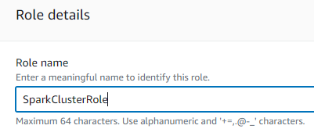

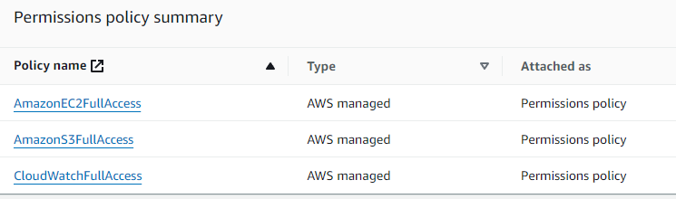

Attaching IAM Role to EACH Instance:

Make sure to download java and docker on to prediction node:

Install and verify docker is running on prediction node:

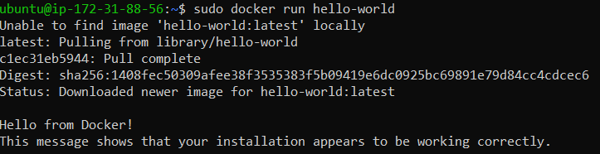

Download Spark on Master Instance

Make sure to set the Environment variables and verify them, after you do that start the Spark Shell

Start the Master Script:



Verify Spark Master by opening web browser and typing your public dns of the master:

SSH into the worker nodes and update package list, install java, download and extract SPARK, set the environment variables and then start the worker nodes:

IF YOU ARE HAVING TROUBLE ACCESSING YOUR UI MAKE SURE YOUR SECURITY GROUP HAS THE INBOUND RULES UPDATED

Now lets verify the worker connection by checking the Spark Master UI at:  
http://ec2-.......compute-1.amazonaws.com:8080

Make sure your S3 bucket has the 2 data sets provided and is accessible:

Now its time to set up and develop the Wine Quality Prediction Model Using Java in Eclipse and Maven to package it for the prediction node:

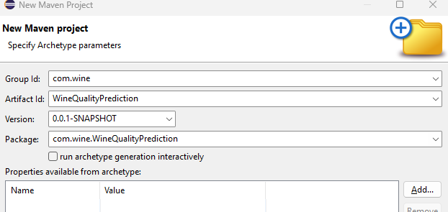

Once it is cleaned and packaged you will upload the .

Download the Jar File to the Prediction Node EC2 using the SCP command on your local terminal



Make sure your worker nodes are on and have spark running

Create and clone repository:

Go back to the Prediction node:  
