Team members: Peter Chen ,Jeremy Guo, Jorge Cotillo,

Tutorial 9A is located at: [https://drive.google.com/file/d/12PKoAWxY0ybYM4wIHTK38FpYUkwXVqOI/view (Links to an external site.)](https://drive.google.com/file/d/12PKoAWxY0ybYM4wIHTK38FpYUkwXVqOI/view)

Please complete and submit the Assignment: Motion Sensing Filter Design in page 37 of 37

1. Then examine the code in main.c and change the HIGH_PASS_FILTER_FREQUENCY from 0.2 Hz to 0.02 Hz.

1. Then, with the SensorTile motionless and level, observe the X- an Y-axis acceleration signals.

Note the drift in the signals.

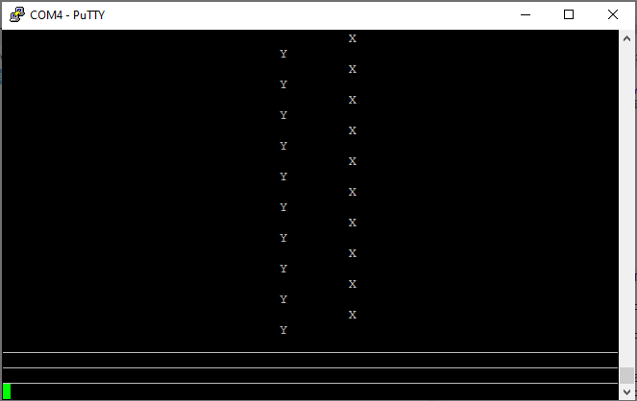

1. Then, perform the same motions you had performed previously. Note that indications of accurate displacement are degraded.

1. Now change the HIGH_PASS_FILTER_FREQUENCY from 0.02 Hz to 0.002 Hz and evaluate again.

Tutorial 9B is located

Show the data using an screenshot as in item 10 page 25 of 28 of this tutorial

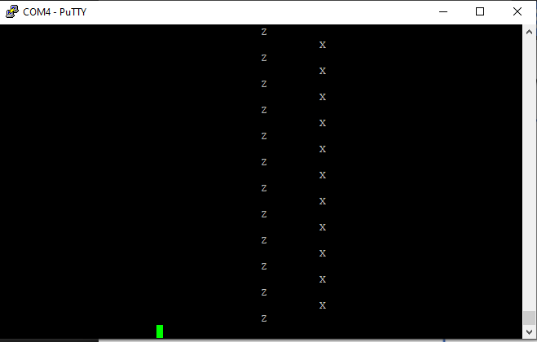

Submit a demo video testing as described in Real Time Rotation Angle Visualization: Demonstration of Angle Sensing (item 10 page 26 of 28)

<https://drive.google.com/file/d/1XjjmKz19dj4IvzjIFWLGTxMTmfbFP1Pm/view?usp=sharing>

Make videos to demonstrate:

Figure 5. Real time display of computed angle.

<https://drive.google.com/file/d/1XnnYcQZdsF59DM37pPYrhQLFOBKoB7LV/view?usp=sharing>

Figure 6. Real time display of computed angle as in page 27 of 28

<https://drive.google.com/file/d/1XsXil1aKbkmYitsr1-YgTfc1LIJMiyR-/view?usp=sharing>