What happens in the browser?

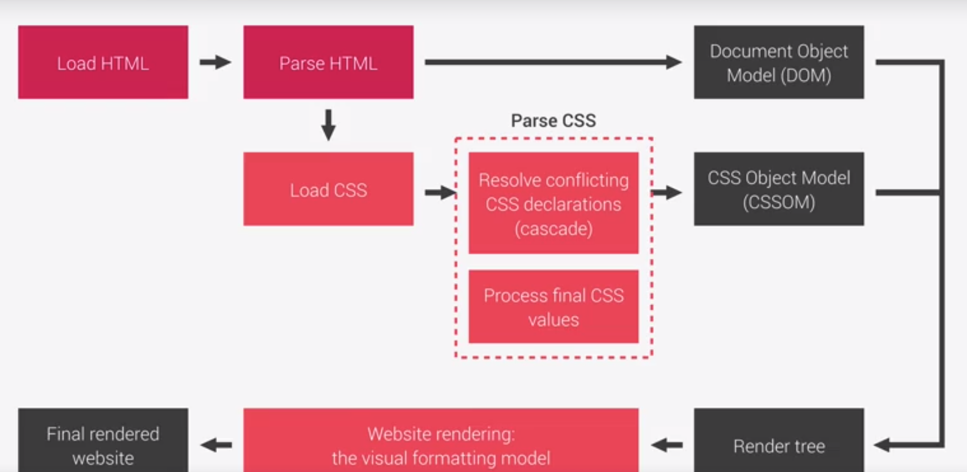

How is Parsed:

1. Cascade conflicting css rules through stylesheets
   1. Priority
      1. 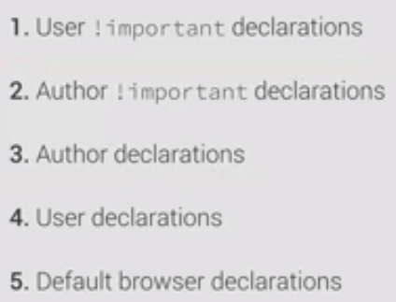
      2. Specificity order
         1. 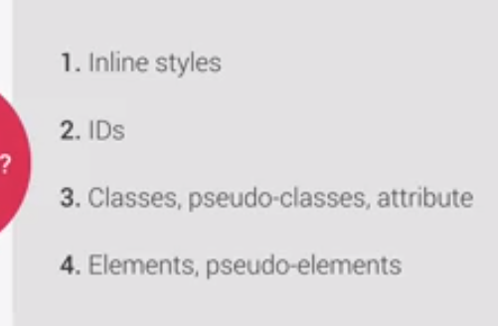

Measurement units

|  |  |
| --- | --- |
| % | values are calculated from the parent or element |
|  | (fonts) x% * parent computed font-size |
|  | (lengths) x% * parent computed width |
| rem | is calculated by multiplying by the current font size of the **root** font-size |
| em | is calculated by multiplying by the current font size |
|  | (fonts) x% * current **parent element** computed font-size |
|  | (lengths) x% * current **element computed** font-size |
| vh | x * 1% of the viewport height |
| vw | x * 1% of the viewport width |

Inheritance

* Properties related to **text** are inherited
  + Font-family, font-size, color
* What gets inherited is the **computed** value
* One can use the **inherit** keyboard to force inheritance on a certain property
* One can use the **initial** keyboard to force the value to reset to the default value

Visual formatting model

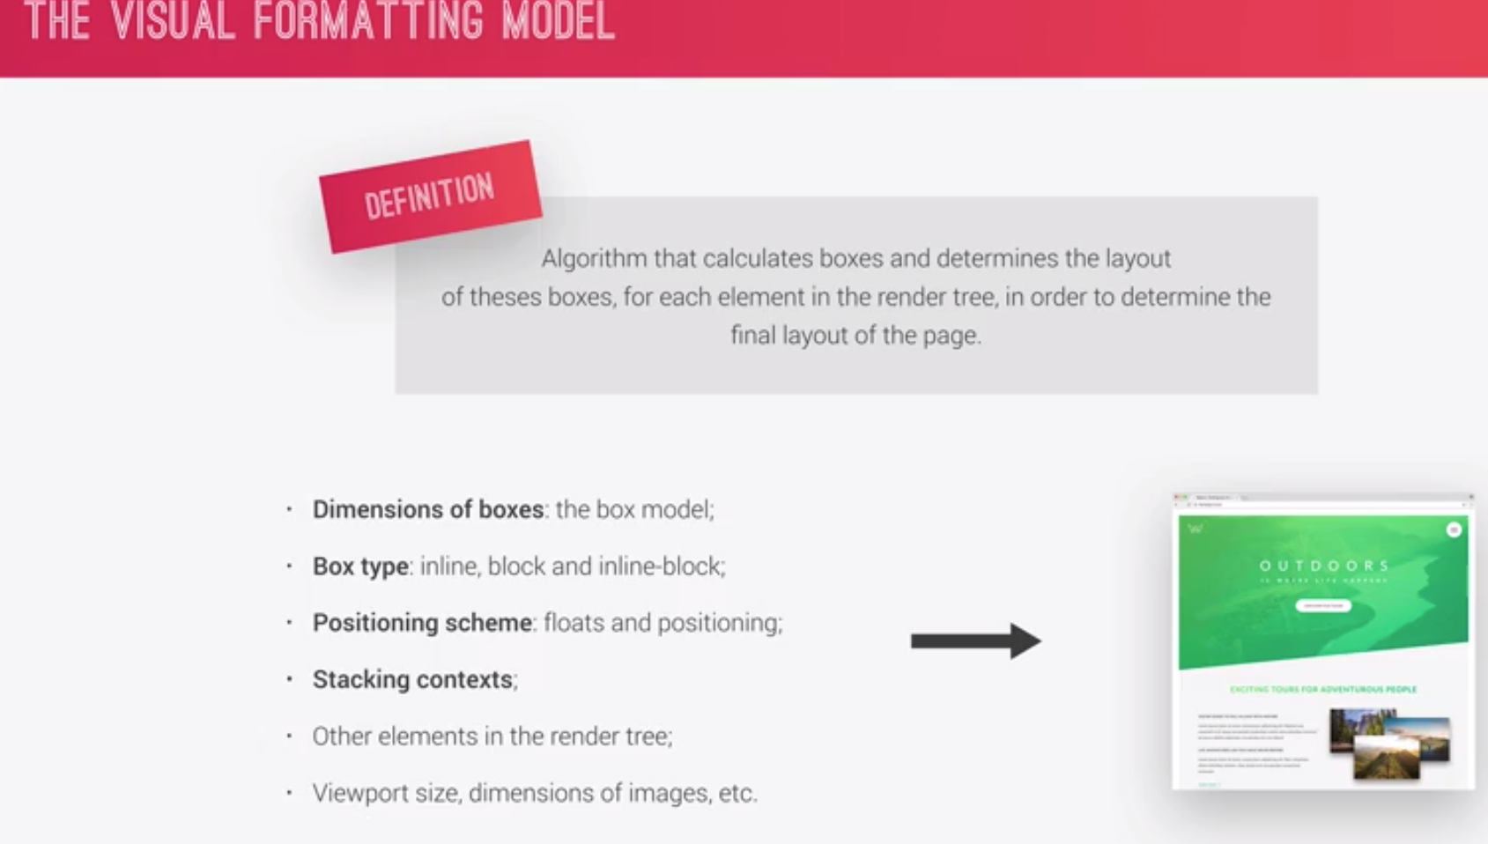

Box Model

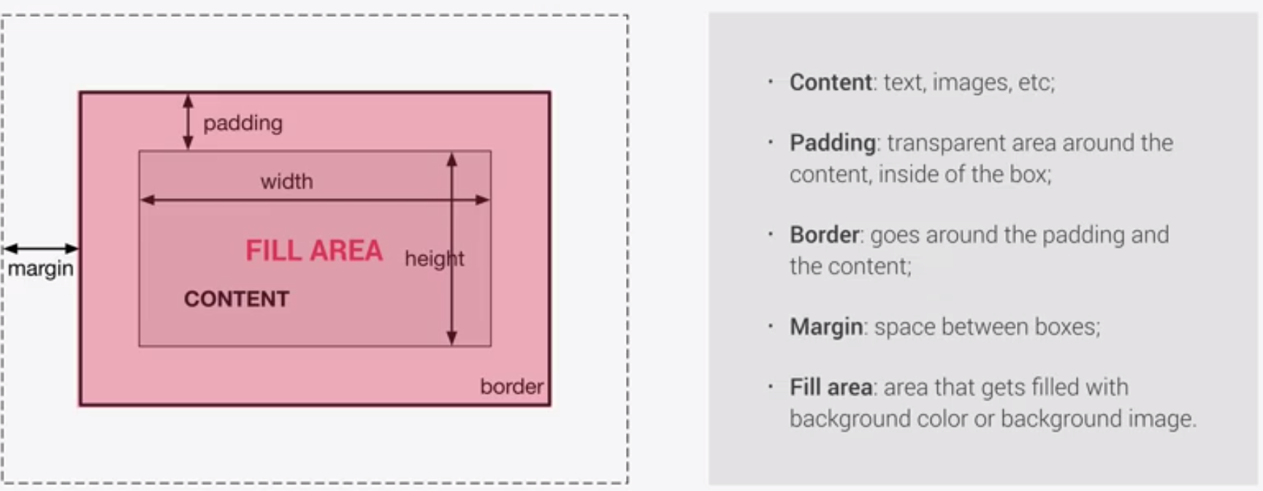

Box Types

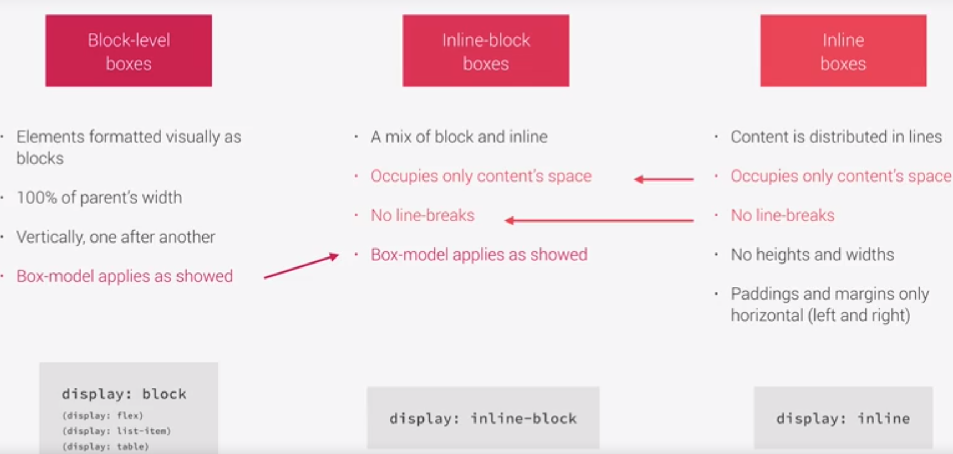

Positioning schemes

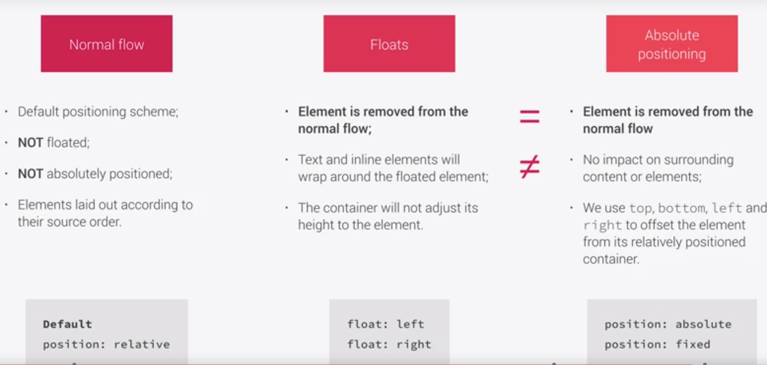

BEM

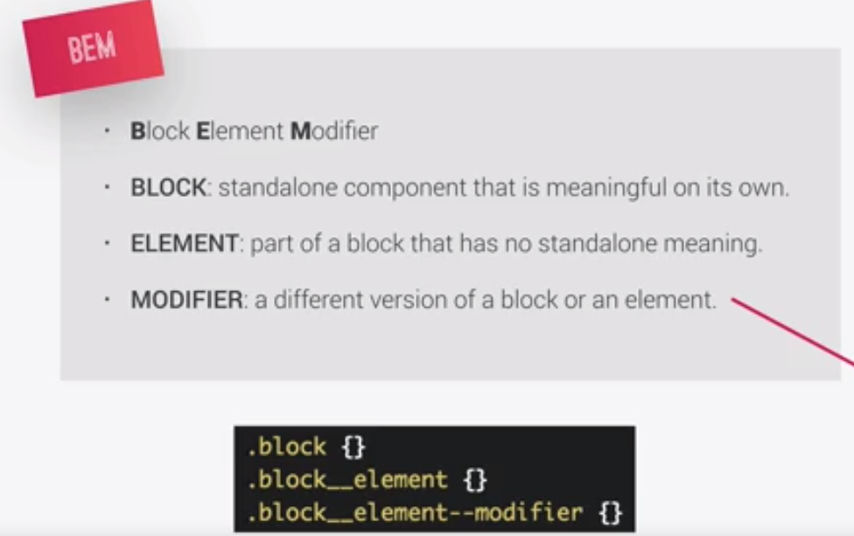

SASS Architecture

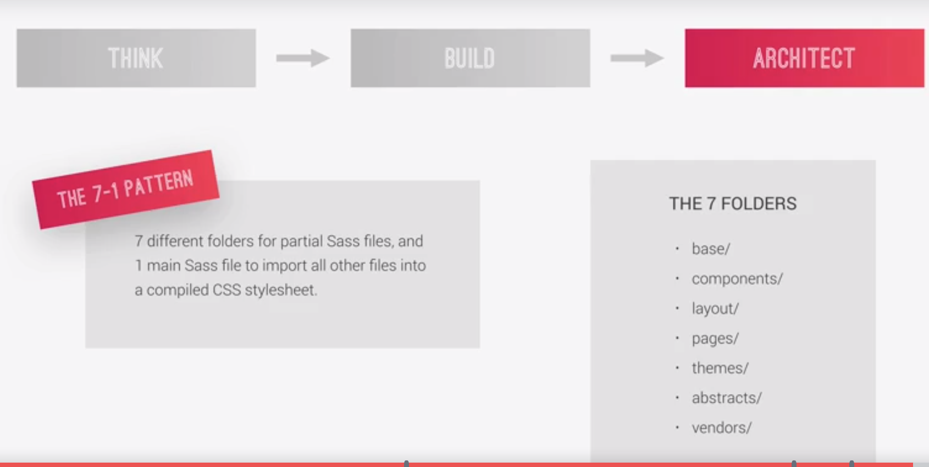

Features

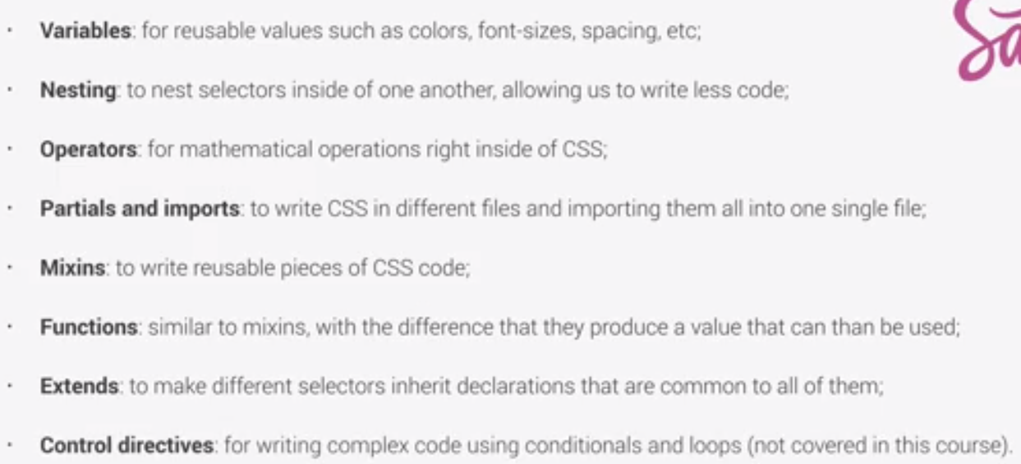html and scss example of variables and nesting and mixing