Jorge Diaz My partner: Enrique Gambra

May 2, 2019

SELECT * FROM CAR_INFO;

SELECT * FROM CARS_BEING_SOLD;

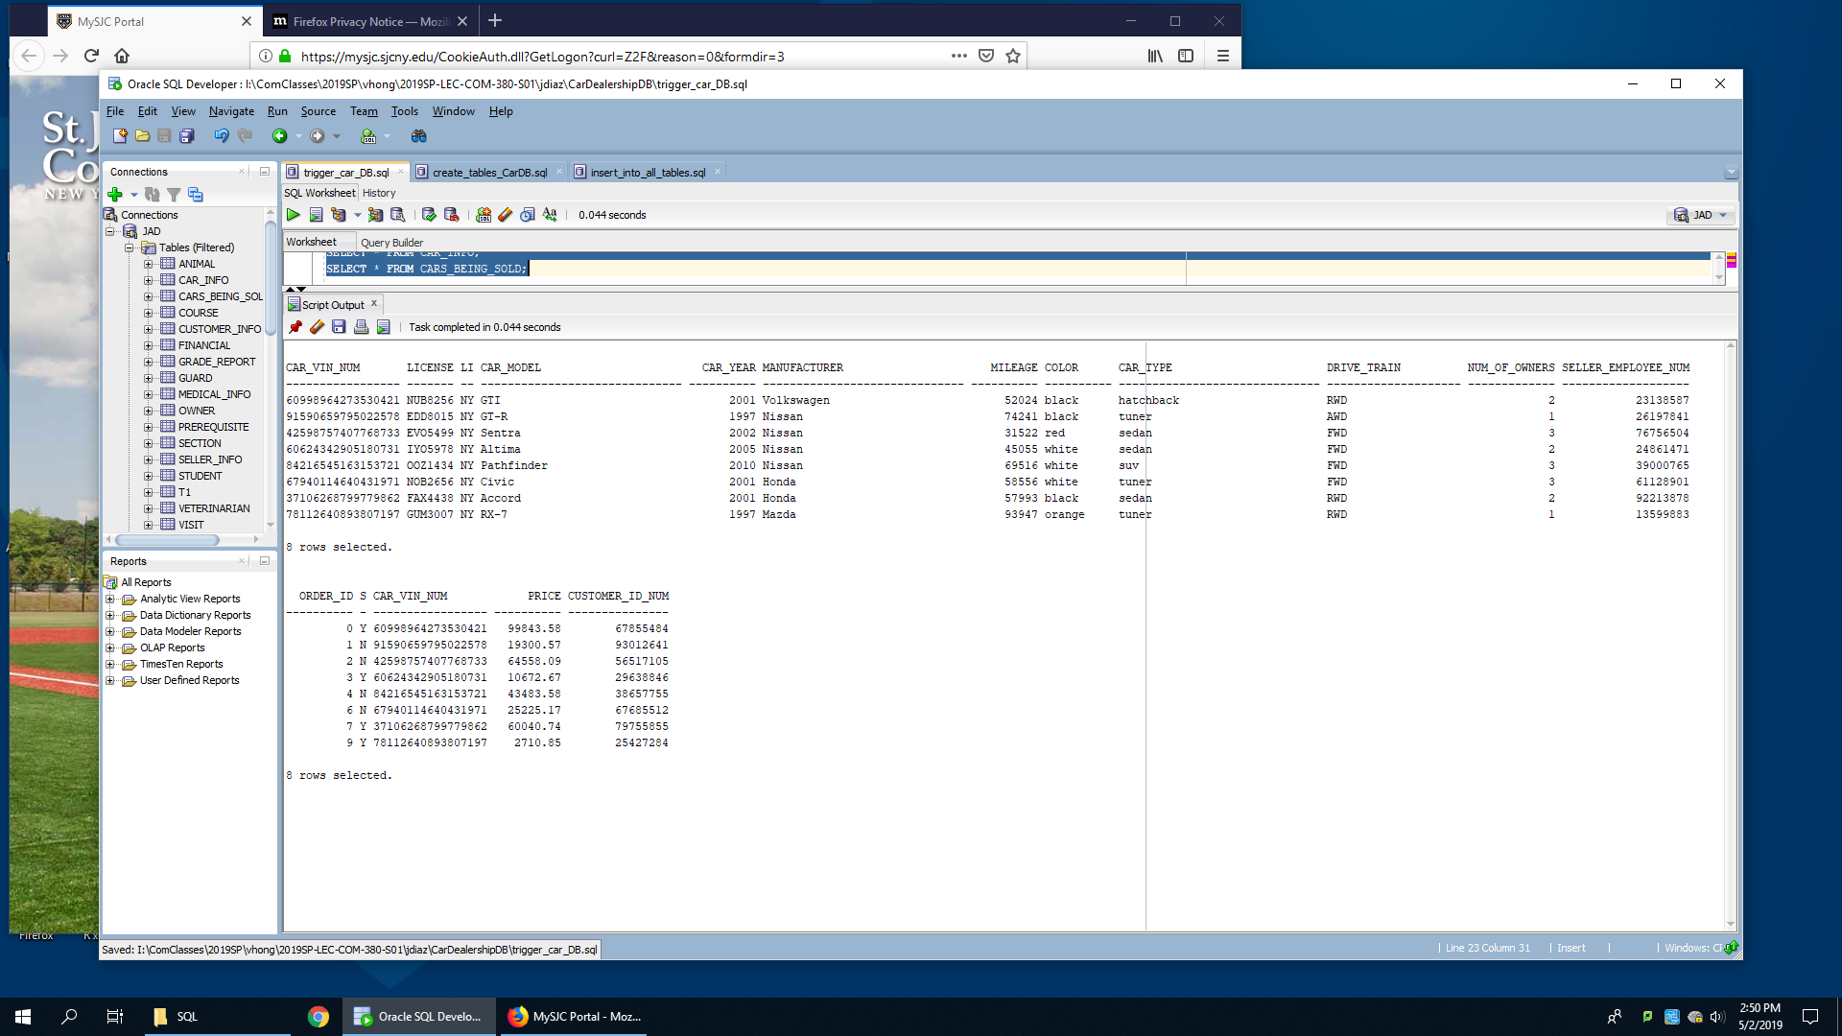

CREATE TRIGGER T_CARINFO

AFTER DELETE ON CAR_INFO

FOR EACH ROW

DELETE FROM CARS_BEING_SOLD

WHERE CAR_VIN_NUM = :OLD.CAR_VIN_NUM

/

DELETE FROM CAR_INFO WHERE MANUFACTURER = 'Toyota';

SELECT * FROM CAR_INFO;

SELECT * FROM CARS_BEING_SOLD;

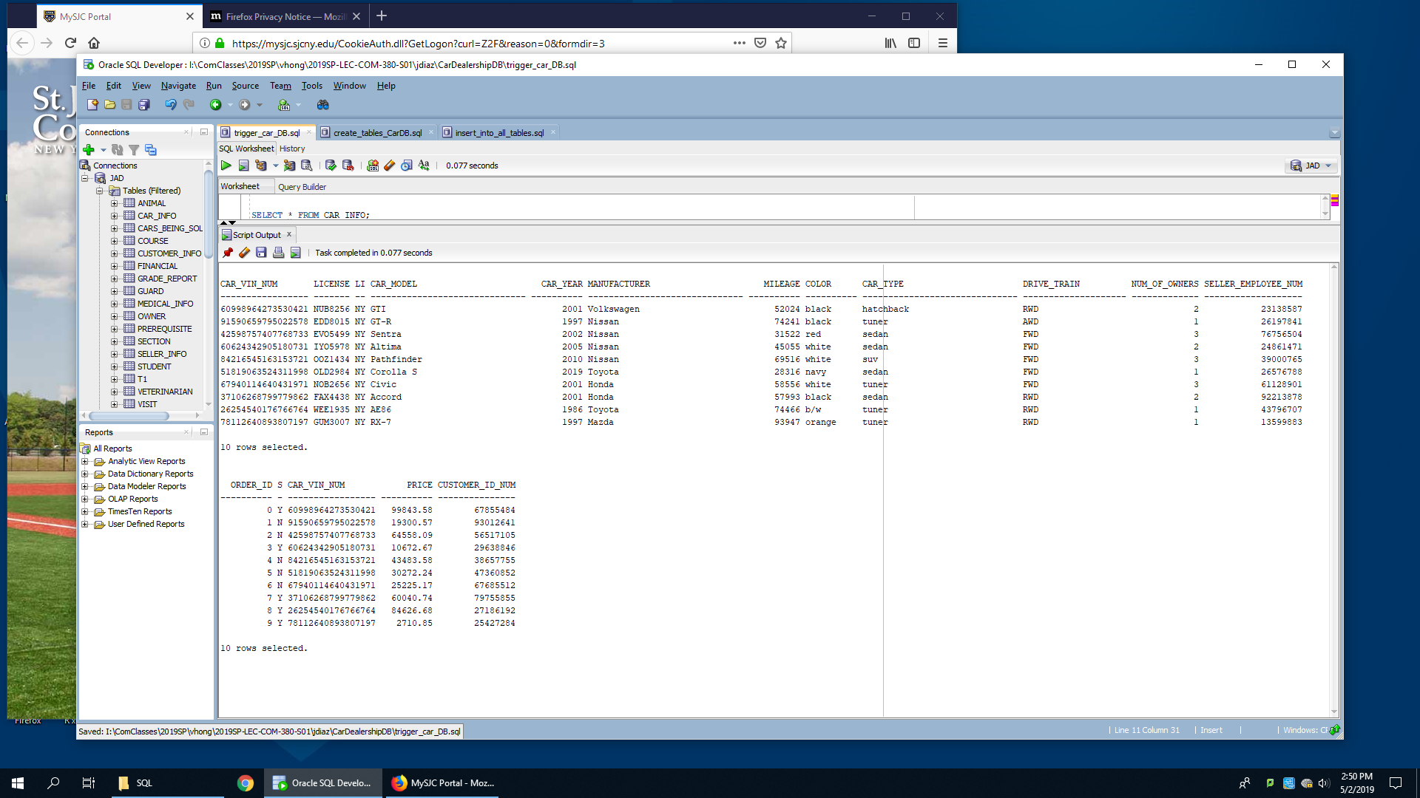

SELECT * FROM CUSTOMER_INFO;

SELECT * FROM CARS_BEING_SOLD;

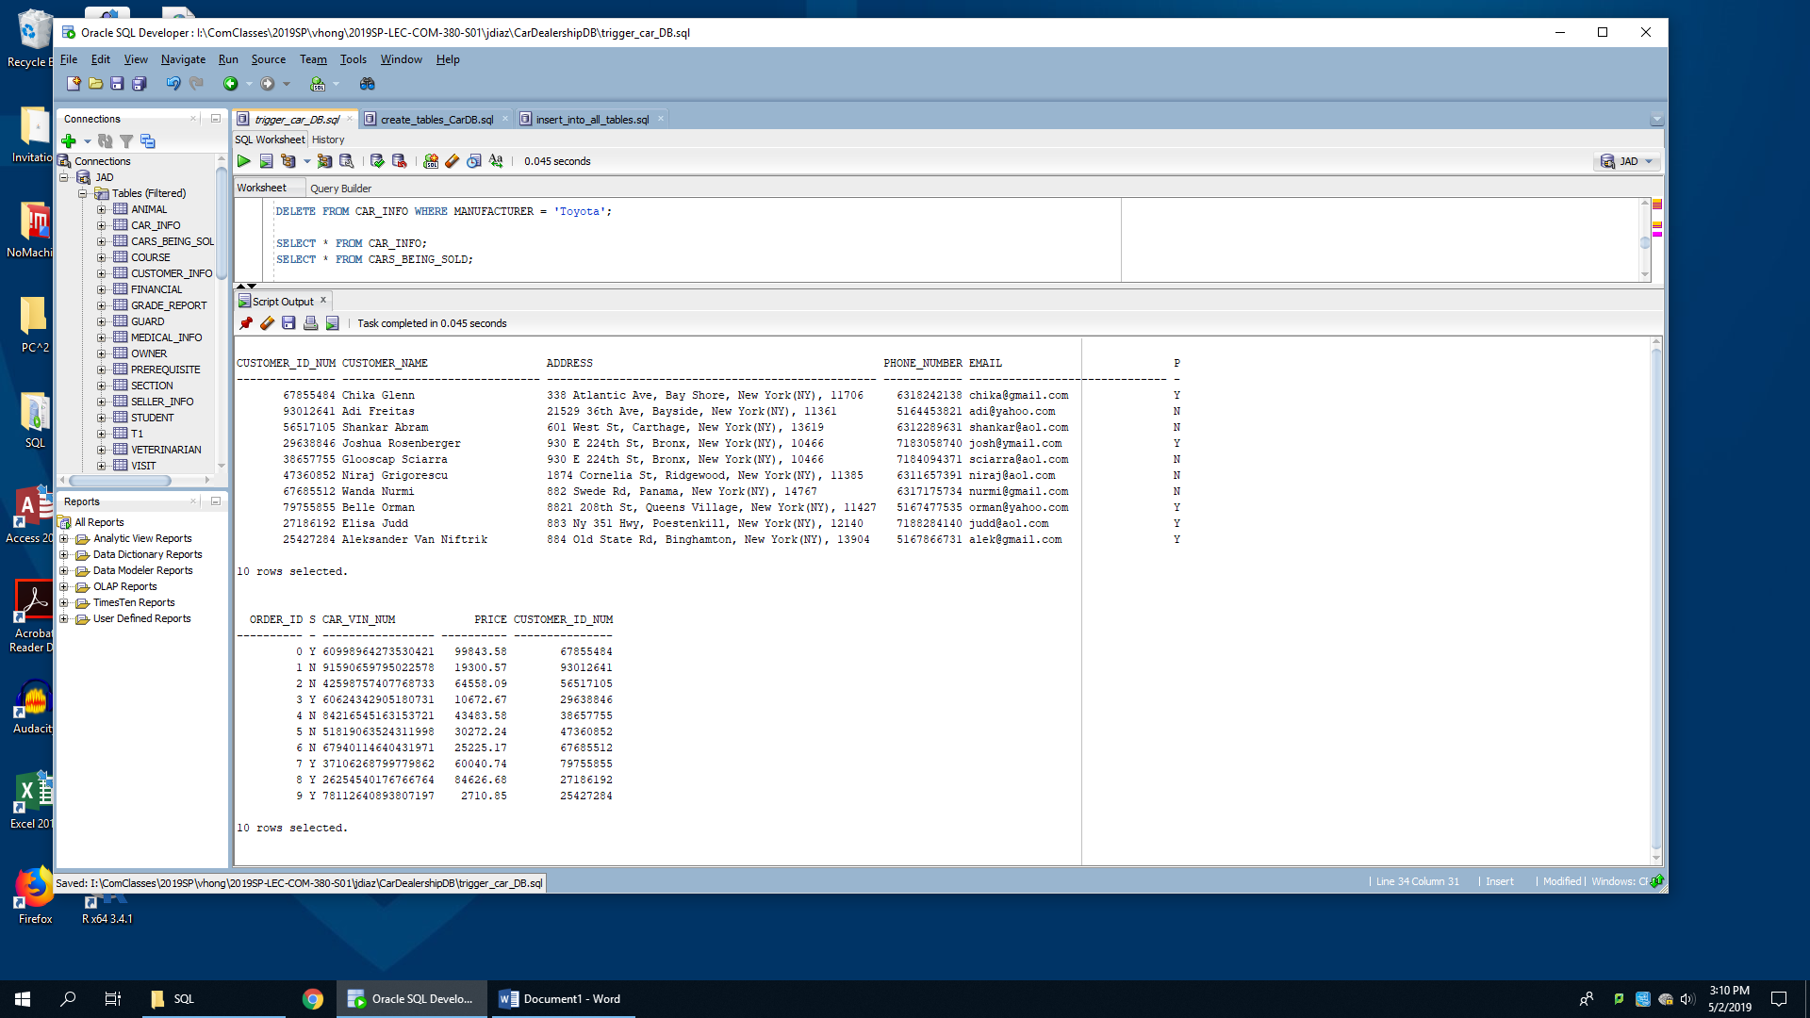

CREATE TRIGGER T_CUSTOMER

AFTER INSERT ON CUSTOMER_INFO

FOR EACH ROW

INSERT INTO CARS_BEING_SOLD

VALUES (999999, 'N', 99999999999999999, 9999.99, :NEW.CUSTOMER_ID_NUM)

/

INSERT INTO CUSTOMER_INFO

VALUES (91827364, 'laporte Quer', '124 5th Ave, Queens, New York(NY), 11706', 7186263839, 'laporte123@gmail.com', 'N');

SELECT * FROM CUSTOMER_INFO;

SELECT * FROM CARS_BEING_SOLD;

