Jorge Diaz – Designer/Programmer Veterinarian

Partner: Enrique Gambra

1) What are the names of the dogs Enrique Gambra owns?

SELECT NAME, ANIMAL_NAME

FROM OWNER O, ANIMAL A

WHERE o.name = 'Enrique Gambra'

and o.animal_id = a.animal_id;

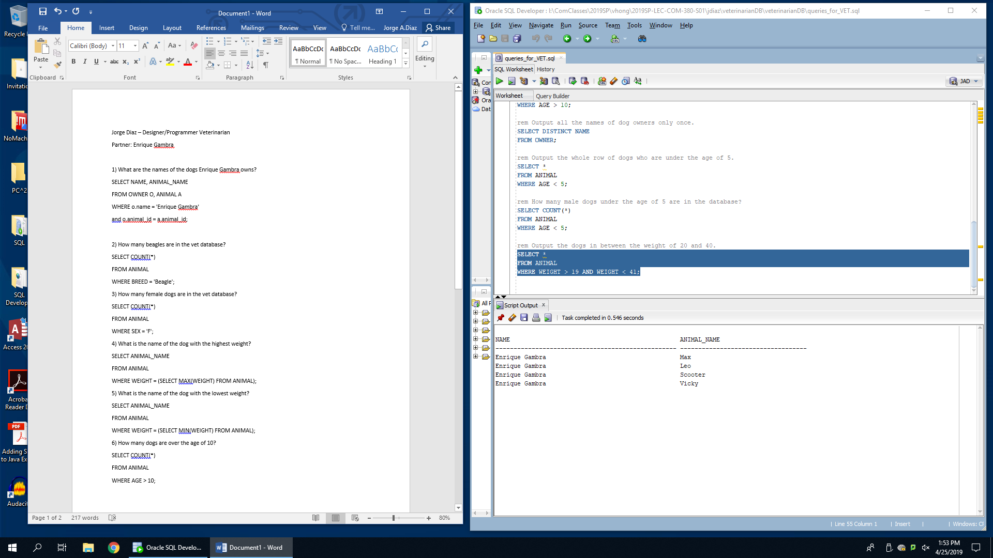

2) How many beagles are in the vet database?

SELECT COUNT(*)

FROM ANIMAL

WHERE BREED = 'Beagle';

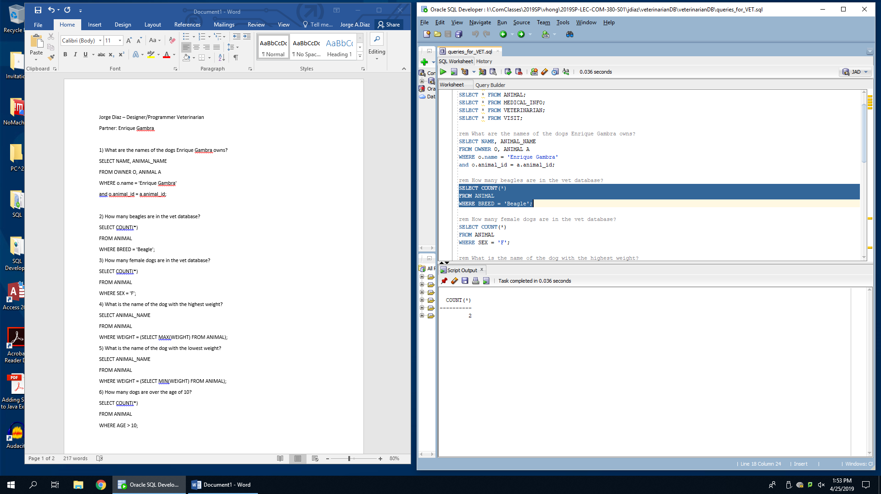

3) How many female dogs are in the vet database?

SELECT COUNT(*)

FROM ANIMAL

WHERE SEX = 'F';

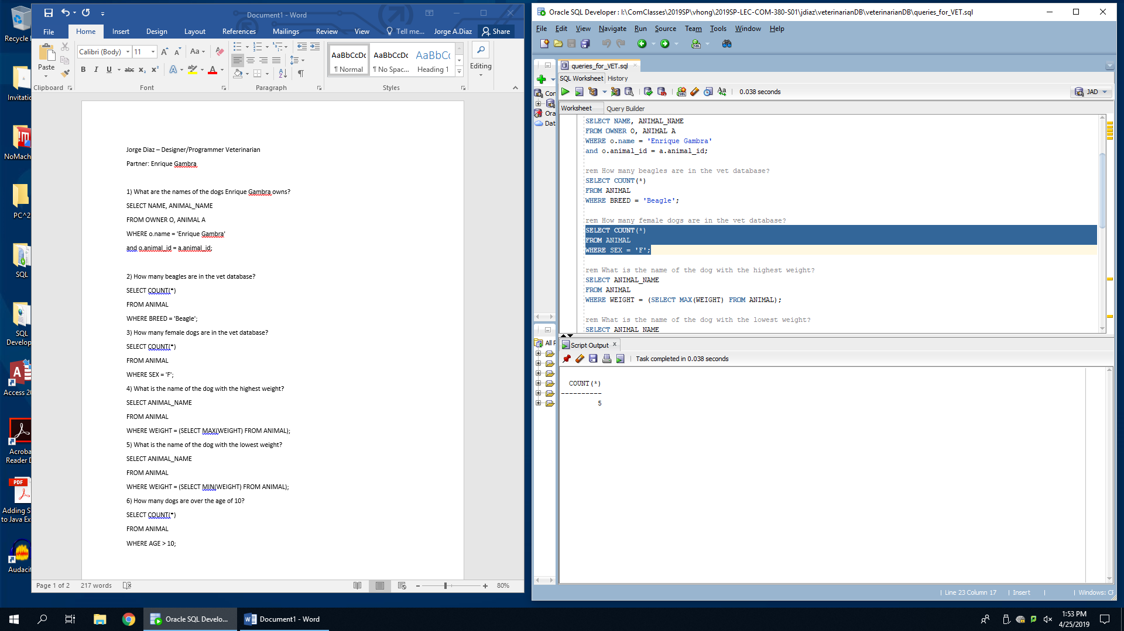

4) What is the name of the dog with the highest weight?

SELECT ANIMAL_NAME

FROM ANIMAL

WHERE WEIGHT = (SELECT MAX(WEIGHT) FROM ANIMAL);

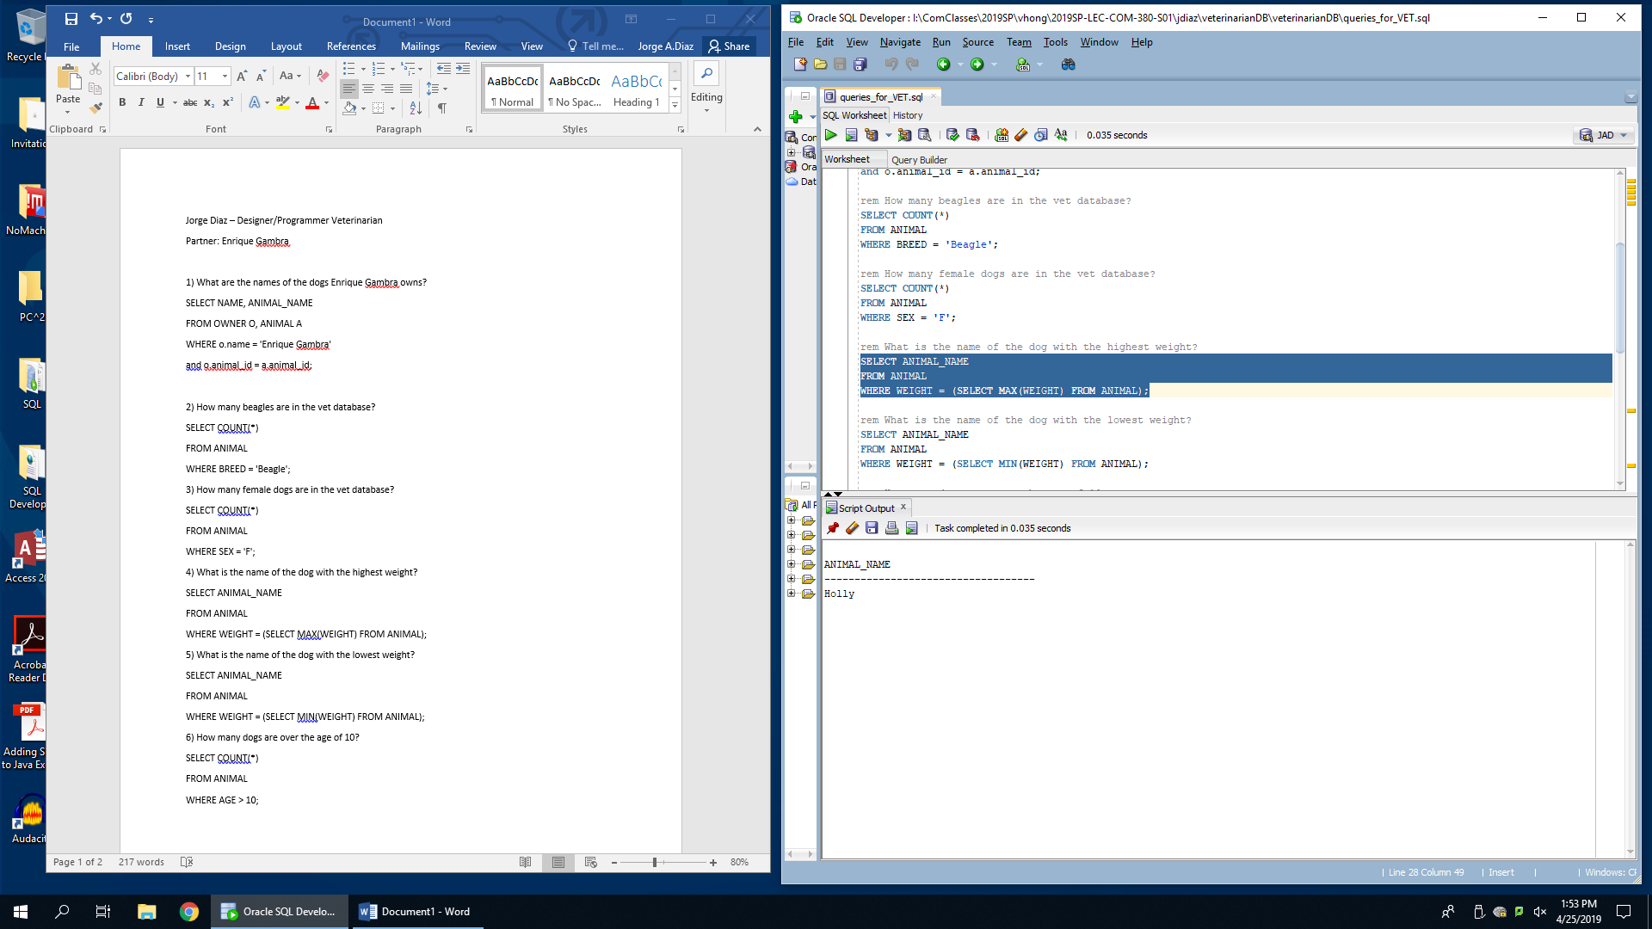

5) What is the name of the dog with the lowest weight?

SELECT ANIMAL_NAME

FROM ANIMAL

WHERE WEIGHT = (SELECT MIN(WEIGHT) FROM ANIMAL);

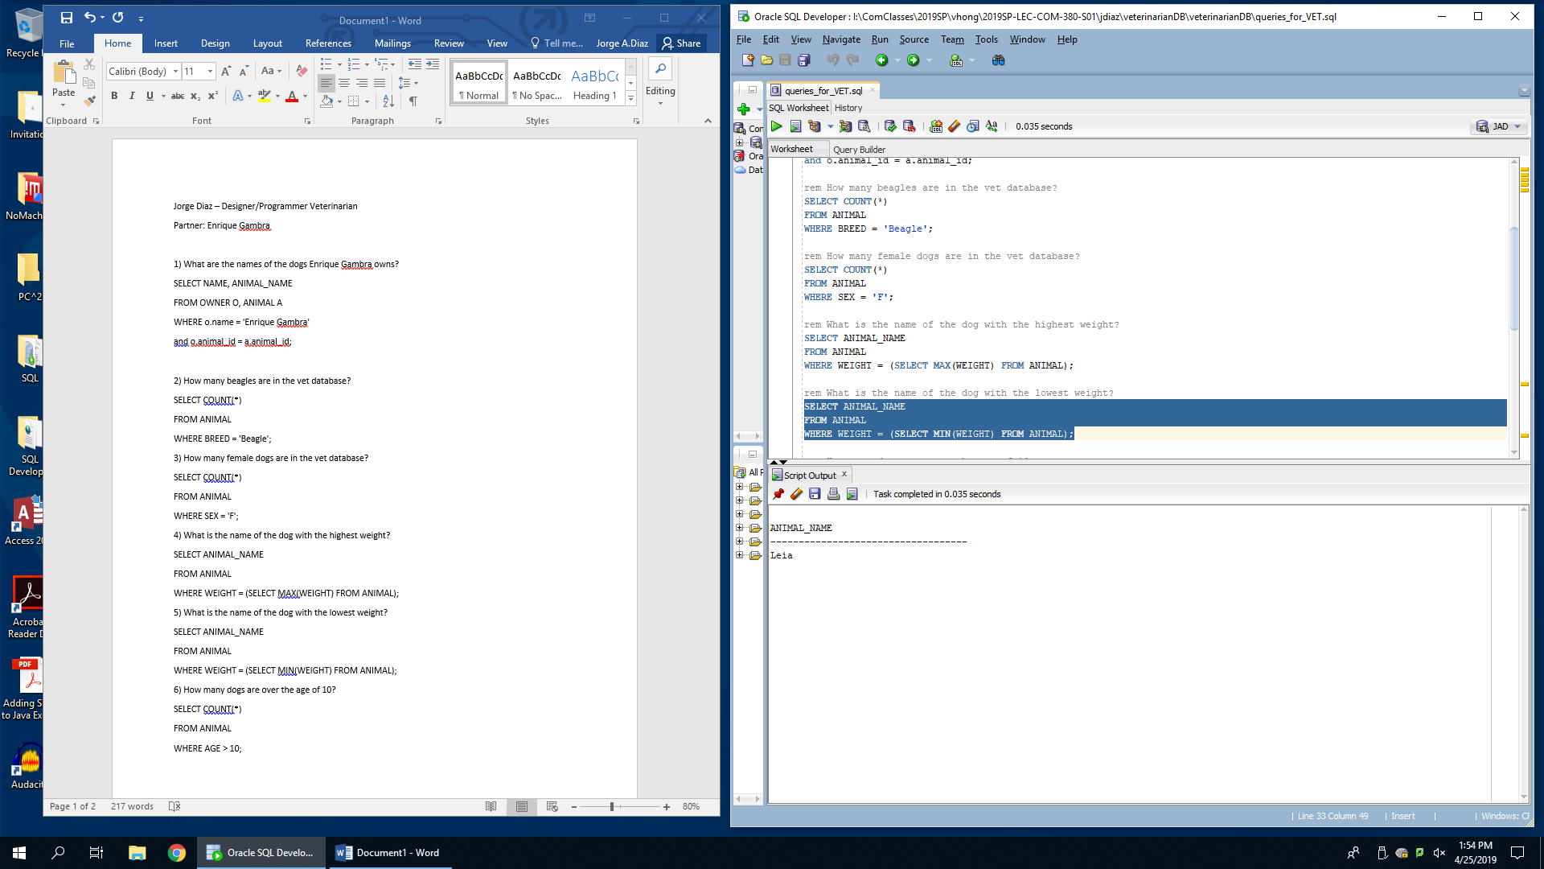

6) How many dogs are over the age of 10?

SELECT COUNT(*)

FROM ANIMAL

WHERE AGE > 10;

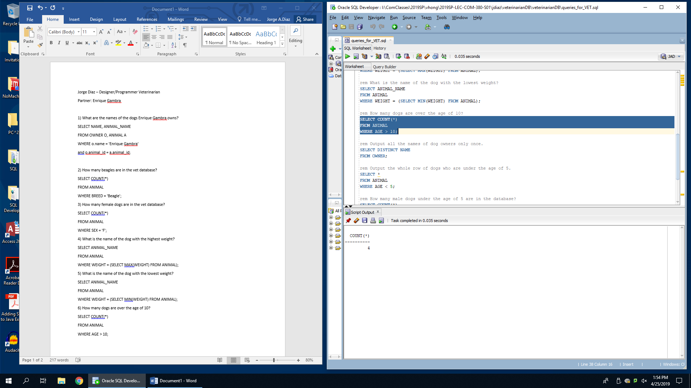

7) Output all the names of dog owners only once.

SELECT DISTINCT NAME

FROM OWNER;

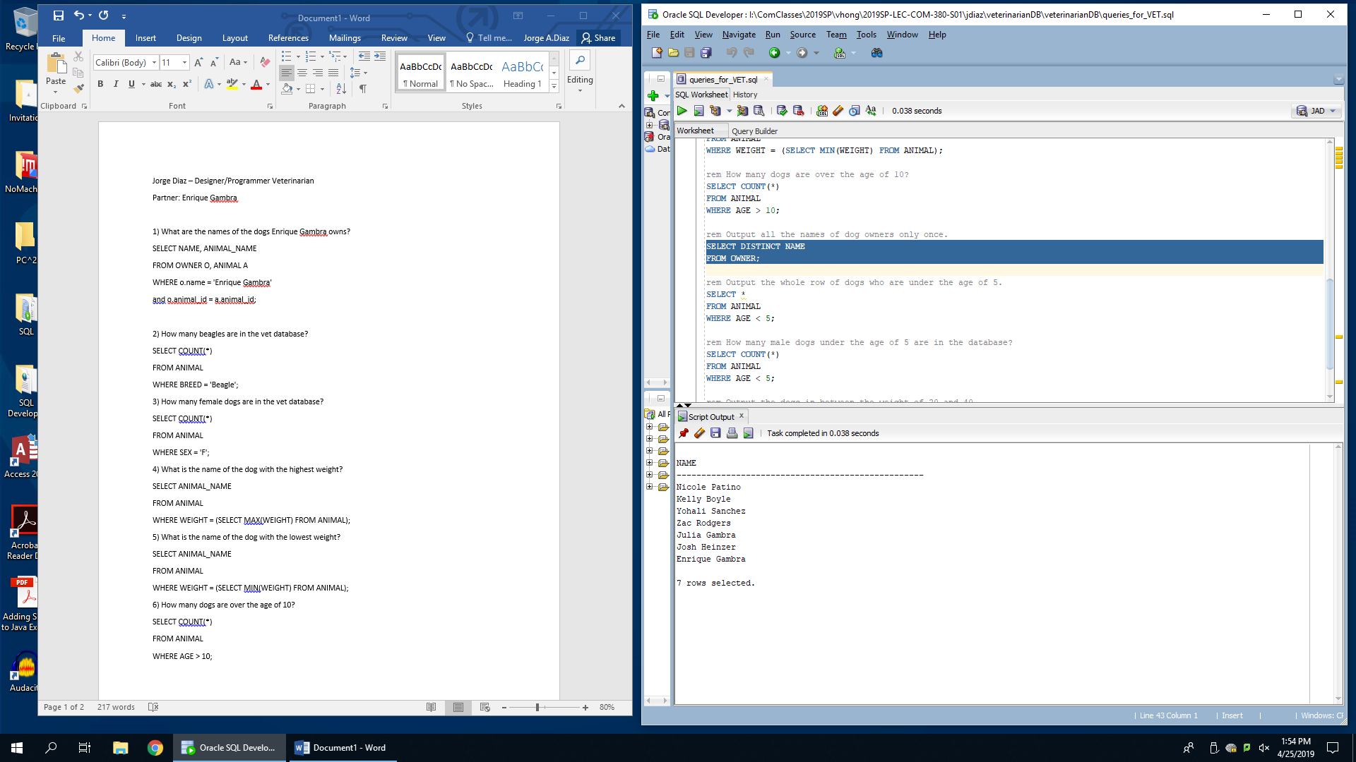

8) Output the whole row of dogs who are under the age of 5.

SELECT *

FROM ANIMAL

WHERE AGE < 5;

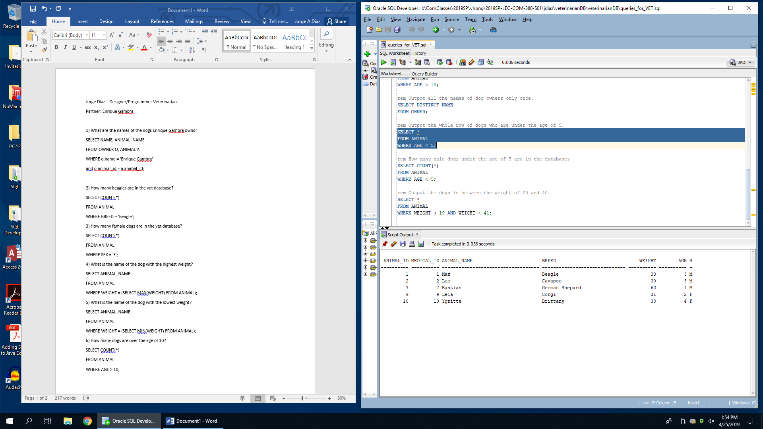

9) How many male dogs under the age of 5 are in the database?

SELECT COUNT(*)

FROM ANIMAL

WHERE AGE < 5;

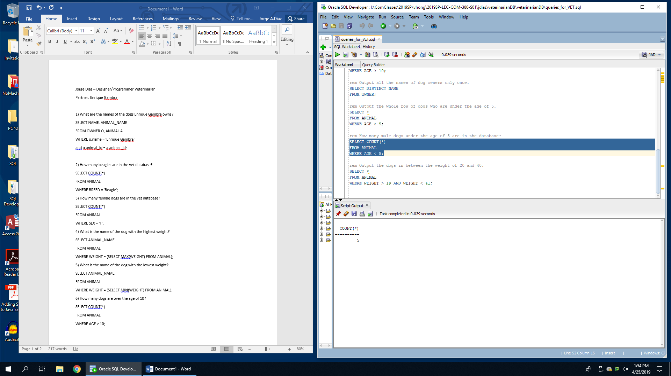

10) Output the dogs in between the weight of 20 and 40.

SELECT *

FROM ANIMAL

WHERE WEIGHT > 19 AND WEIGHT < 41;

