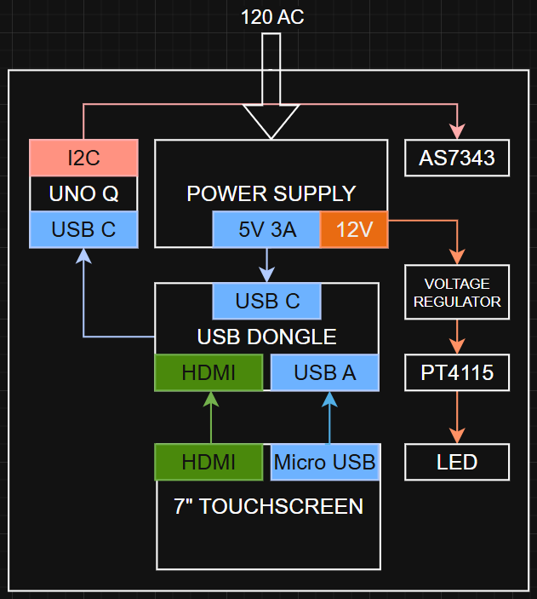
Description: Layout showing component positions and cable paths
Notes: I²C to sensor, power distribution, USB connections

