A20474413

Jorge Gonzalez Lopez **Assignment 4**

Question 1

S484 Spring 2021

March 27, 2021

# Answer

|  |  |  |  |
| --- | --- | --- | --- |
| Insurance | 0 | 1 | 2 |
| Frequency Count | 143691 | 426067 | 95491 |
| Class Probability | 0.215996 | 0.640462 | 0.143542 |

# Explanation

# To do so, the pandas’ function df[‘insurance’].value_counts() (with and without the option normalize) gives back the frequency counts and the Class Probabilities of the target variable (insurance).

# Answer

|  |  |  |  |
| --- | --- | --- | --- |
| Group_size | Insurance | | |
| 0 | 1 | 2 |
| 1 | 115460 | 329552 | 74293 |
| 2 | 25728 | 91065 | 19600 |
| 3 | 2282 | 5069 | 1505 |
| 4 | 221 | 381 | 93 |

# Explanation

# To do so, ther are two easy ways:

# df.groupby(['group_size','insurance']).size())

# pd.crosstab(df['group_size'], df['insurance']) (this way outputs the result in the same format as the table shown above).

# Answer

|  |  |  |  |
| --- | --- | --- | --- |
| Homeowner | Insurance | | |
| 0 | 1 | 2 |
| 0 | 78659 | 183130 | 46734 |
| 1 | 65032 | 242937 | 48757 |

# Explanation

To do so, the pandas’ function pd.crosstab(df['homeowner'], df['insurance']) is used.

# Answer

|  |  |  |  |
| --- | --- | --- | --- |
| Married_couple | insurance | | |
| 0 | 1 | 2 |
| 0 | 117110 | 333272 | 75310 |
| 1 | 26581 | 92795 | 20181 |

# Explanation

To do so, the pandas’ function pd.crosstab(df[‘married_couple’], df['insurance']) is used.

# Answer

|  |  |
| --- | --- |
| Feature | Cramer’s V |
| group_size | 0.0271020 |
| homeowner | 0.0970864 |
| married_couple | 0.0324216 |

# Explanation

The feature with the strongest association with the target value is the one with the highest Cramer’s V statistic. In this case, this feature is **homeowner.**

# Answer

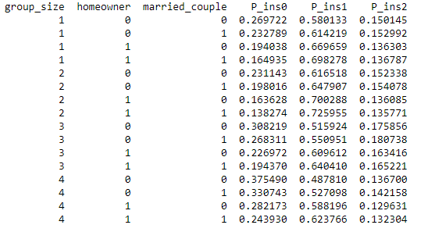

# Explanation

A Naïve Bayes model without any smoothing has been trained using all the observations. The Laplace/Lidstone alpha has been set to 1e-10 instead of zero as an alpha too small will result, in the sklearn library, in numeric errors.

# Answer

The maximum odds value of *Prob(insurance=1)/Prob(insurance=2)* = 5.3469126

The value combination that yields it is:

group_size = 2, homeowner = 1, married_couple = 1

# Explanation

It was calculated by dividing the column P_ins1 by P_ins2 of the dataframe computed in question f) and getting the line that has the maximum value of them all.

Question 2

# Answer

The equation is: 0.0033450 + 0.0533351x + 0.3286838y = 0

# Explanation

# The coefficients are given by coef_ and intercept_ of the SVM.SVC model.

# Answer

The misclassification rate is 0.5

# Explanation

# The model does not have a good accuracy as the values cannot be split with a linear hyperplane.

# Figure

# 

# Figure

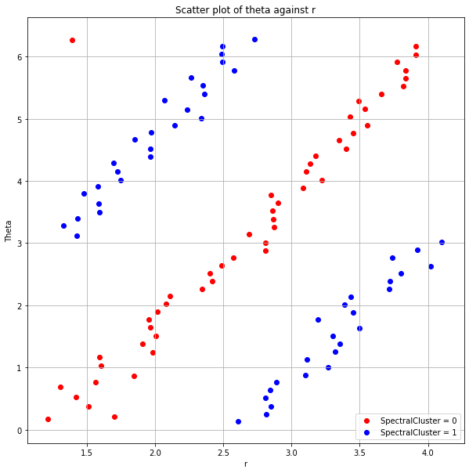

# Figure

# 

# Answer

SVM 0

The intercept w0 is: [1.46912508]

The coeficients are: [[ 0.93378415 -0.45380249]]

The equation is: 1.4691251 + 0.9337841 r + -0.4538025 theta = 0

SVM 1

The intercept w0 is: [0.88406321]

The coeficients are: [[-1.88674959 0.8914745 ]]

The equation is: 0.8840632 + -1.8867496 r + 0.8914745 theta = 0

SVM 2

The intercept w0 is: [-4.13284488]

The coeficients are: [[ 2.01258355 -0.83756164]]

The equation is: -4.1328449 + 2.0125835 r + -0.8375616 theta = 0

# Explanation:

# Split the data depending on the value of ‘Group’ and apply SVM three times as in (a).

# 

# Figure

# 

# Explanation:

# The hyperplane 1 is the one obtained from applying SVM to Group 0 and 1, hyperplane 2 to Group 1 and 2 and hyperplane 3 to Group 2 and 3.

# Figure

# 

# Answer

# The hyper curve that is not needed is hyper curve 1 because hyper curve 3 performs the same classification but avoiding some misclassifications.

# 