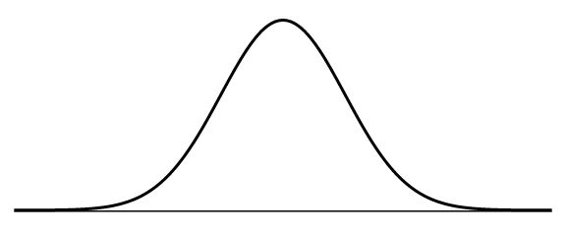Recall that the total area underneath the entire normal curve is ___________ or ________.

**1.** Shade the area requested.

|  |  |  |
| --- | --- | --- |
| a) Center 75%  Image result for normal curve | b) Middle 20%  Image result for normal curve | c) The bottom 5% and the top 5%  Image result for normal curve |

A z-score is the number of ________________________ from the mean a data point is on a normal distribution. On a standard normal distribution, the mean is ___________ and the standard deviation is __________.

We can work backwards so that if we know what probability/area we want under the curve, then we can find the $z-$ score.

**2**. Estimate the z-score by making a mark that separates the given area on the following standard normal distributions.

|  |  |  |
| --- | --- | --- |
| a) Lower 10% of $z$-scores | b) Lower 45% of $z$-scores | c) Lower 75% of $z$-scores |

**3**. Estimate the z-score by making a mark that separates the given area on the following standard normal distributions.

|  |  |  |
| --- | --- | --- |
| a) Top 10% of $z$-scores | b) Top 45% of $z$-scores | c) Top 75% of $z$-scores |

**4**. For the last two exercises, what do you notice about the estimated numerical values of your z-scores? Why do you think that is?

**5**. Is this the correct picture for a $z-$ score that separates the bottom 85% of the data from the top 15%. Why or why not?

$$z=?$$

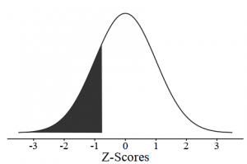

**6a.** Given the diagram below, circle which area to the right you think is shaded out of the options below:

z

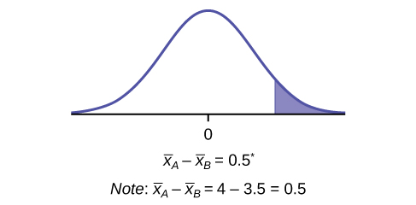

• 10% to the right of $z$• 5% to the right of $z$

• 90% to the right of $z$• 1% to the right of $z$

**6b.** Why did you choose this answer out of the four options? What does that mean the area to the left will be?

**6c.** Do you think the $z$-score we find will be negative, zero, or positive? Explain your reasoning.

The following [infographic](https://www.nytimes.com/2014/04/23/upshot/what-good-marathons-and-bad-investments-have-in-common.html) is a real world example of an approximately normal distribution, made up of around 9 million marathon (26.2 miles) finishing times (in hours and minutes).

**7a**. What marathon time has the highest frequency? Why do you think that is?

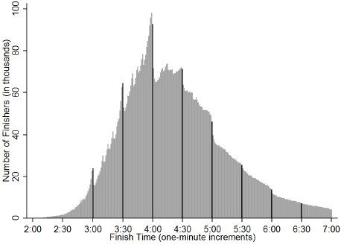

**Distribution of Marathon Finishing Times**

**7b.** What would you estimate the mean marathon time to be, and why?

**7c.** What marathon time would you estimate to separate the fastest 5% of finishers from the other 95%?

**7d.** What marathon time would you estimate to separate the slowest 20% of finishers from the other 80%?

The following [infographic](https://www.theatlantic.com/sexes/archive/2013/01/why-its-so-rare-for-a-wife-to-be-taller-than-her-husband/272585/) is a real world example of two approximately normal distributions, made up of a survey on the height distributions of 4,600 husbands and wives in the United States in 2009.

**8a**. Which distribution belongs to the husbands and which to the wives? Why do you believe that?

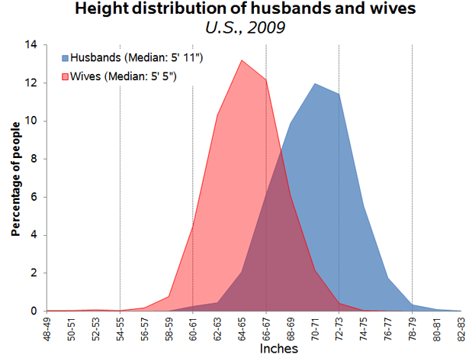

**8b.** What do you believe is the mean height for the wives?

**8c.** Which distribution has a smaller standard deviation?

**8d.** What height would you estimate to separate the shortest 30% of husbands from the taller 70%?

**8e.** What two heights would you estimate to contain the middle 50% of wives?