“Reflection is one of the most underused yet powerful tools for success.” — Richard Carlson

**I.** After watching the video(s), describe **grit** in your own words.

**II**. Go to <http://angeladuckworth.com/grit-scale/> and find out how “gritty” you are. For the most accurate score, when responding, think of how you compare to most people – not just the people you know well, but most people in the world. There are no right or wrong answers, so just answer **honestly!**

Write your Grit Score here: _______________

**III**. Think about someone you know who has worked hard towards a long-term goal. Remember (and this is important), this exercise is **not** about someone overcoming hardships in life and then doing well. This assignment is to ask all you can about **someone who set a difficult, far-off goal**, and was able to achieve it. What was the goal your gritty person was aiming for, what were the obstacles/struggles your person had to overcome and how were they able to manage those, and what is their life like now that they accomplished the big goal. Summarize that information here. (Write at least five sentences here)

**IV**. Camille A. Farrington, a former inner-city high-school teacher who now works at the University of Chicago Consortium on School Research, has found four key beliefs that, when embraced by students, seem to contribute most significantly to their tendency to persevere in the classroom. Indicate how much you agree with the following statements regarding this course. Circle your response for each.

**a)** I belong in this academic community.

Strongly disagree Disagree Neutral Agree Strongly Agree

**b)** My ability and competence grow with my effort.

Strongly disagree Disagree Neutral Agree Strongly Agree

**c)** I can succeed at this.

Strongly disagree Disagree Neutral Agree Strongly Agree

**d)** This work has value for me.

Strongly disagree Disagree Neutral Agree Strongly Agree

**V.** Read this list of values and think about each one. Circle 2 to 3 that are most important to you.

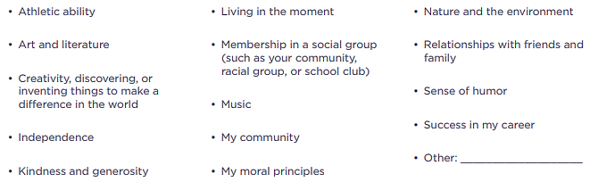

In a few sentences, describe why the selected values are important to you. Focus on your thoughts and feelings, and don’t worry about spelling, grammar, or how well-written it is.