Project Exam Week 2

**Target Audience**

My Target Audience are children who wants to become future astronauts. The micro site has a purpose to encourage children to get engaged in space program activities that will form a further basis for directing choices later.

**Storyboard**

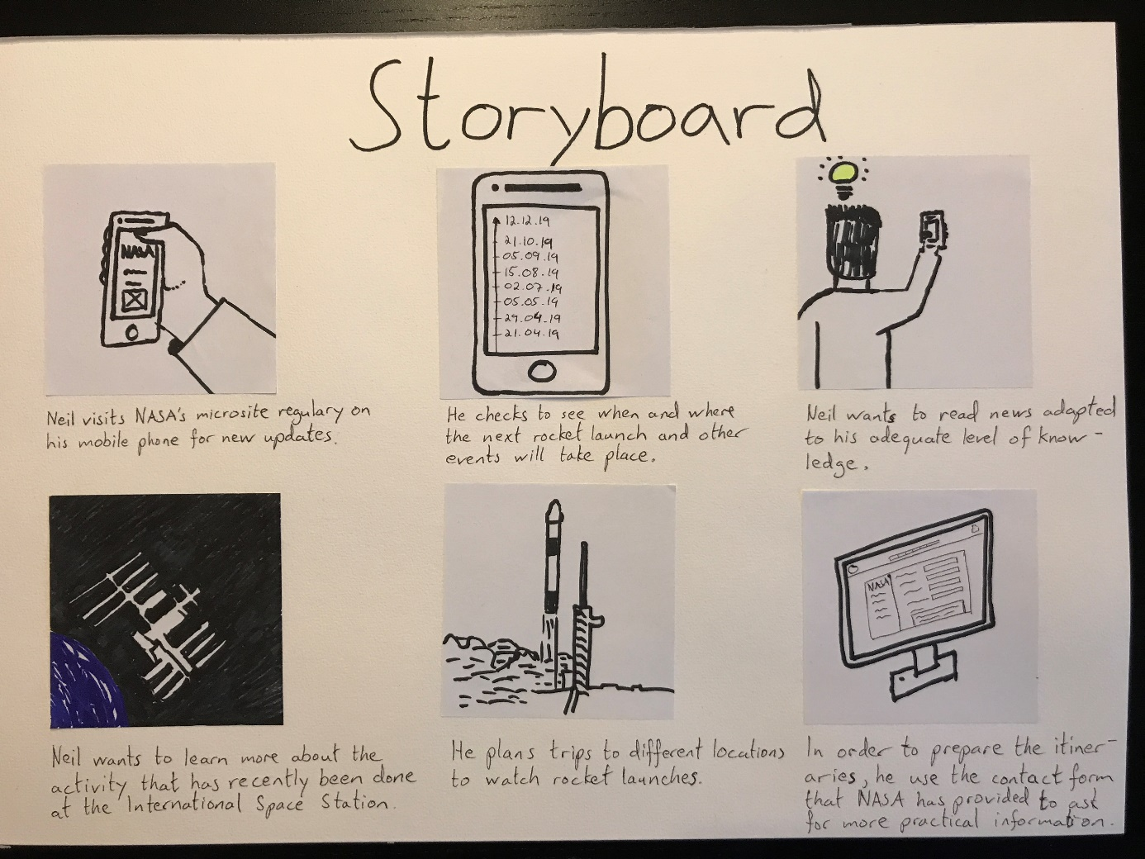

**Personas**

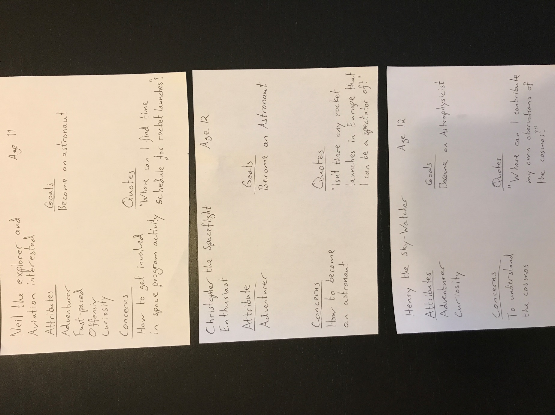

**Wireframes**

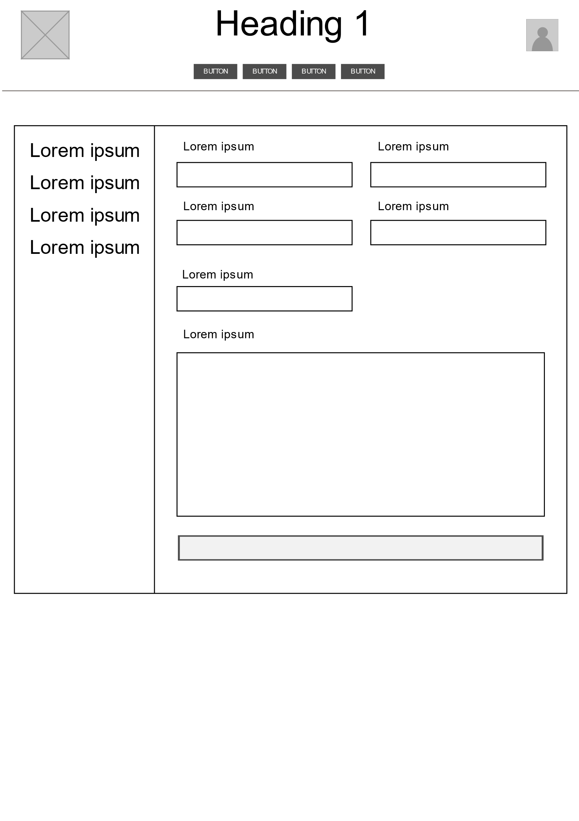

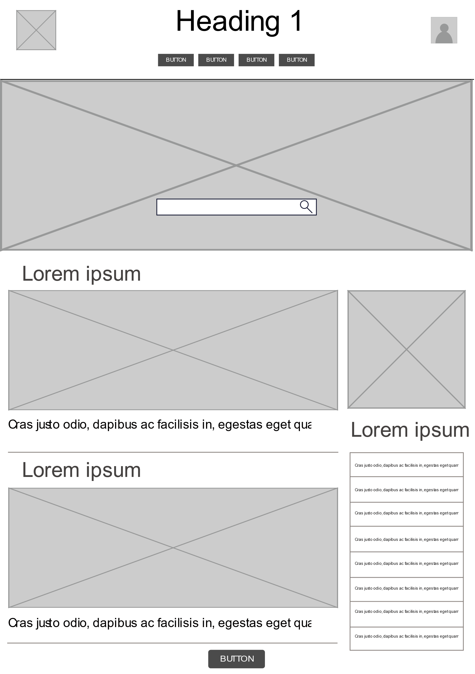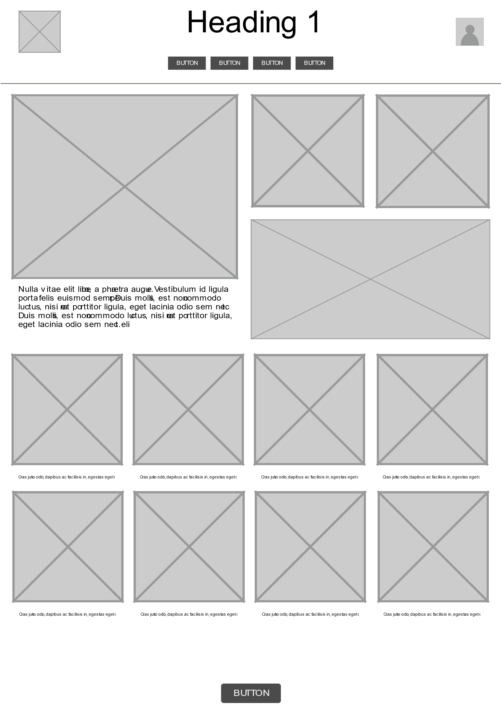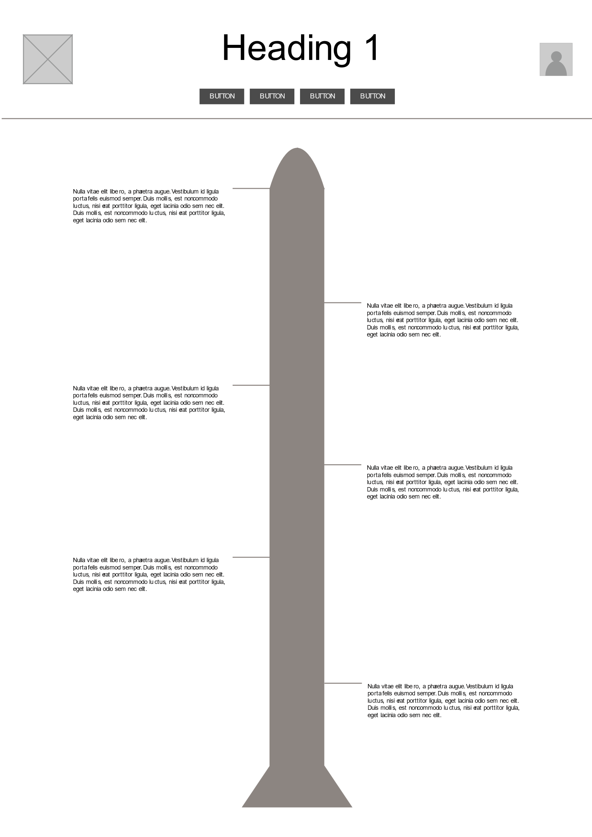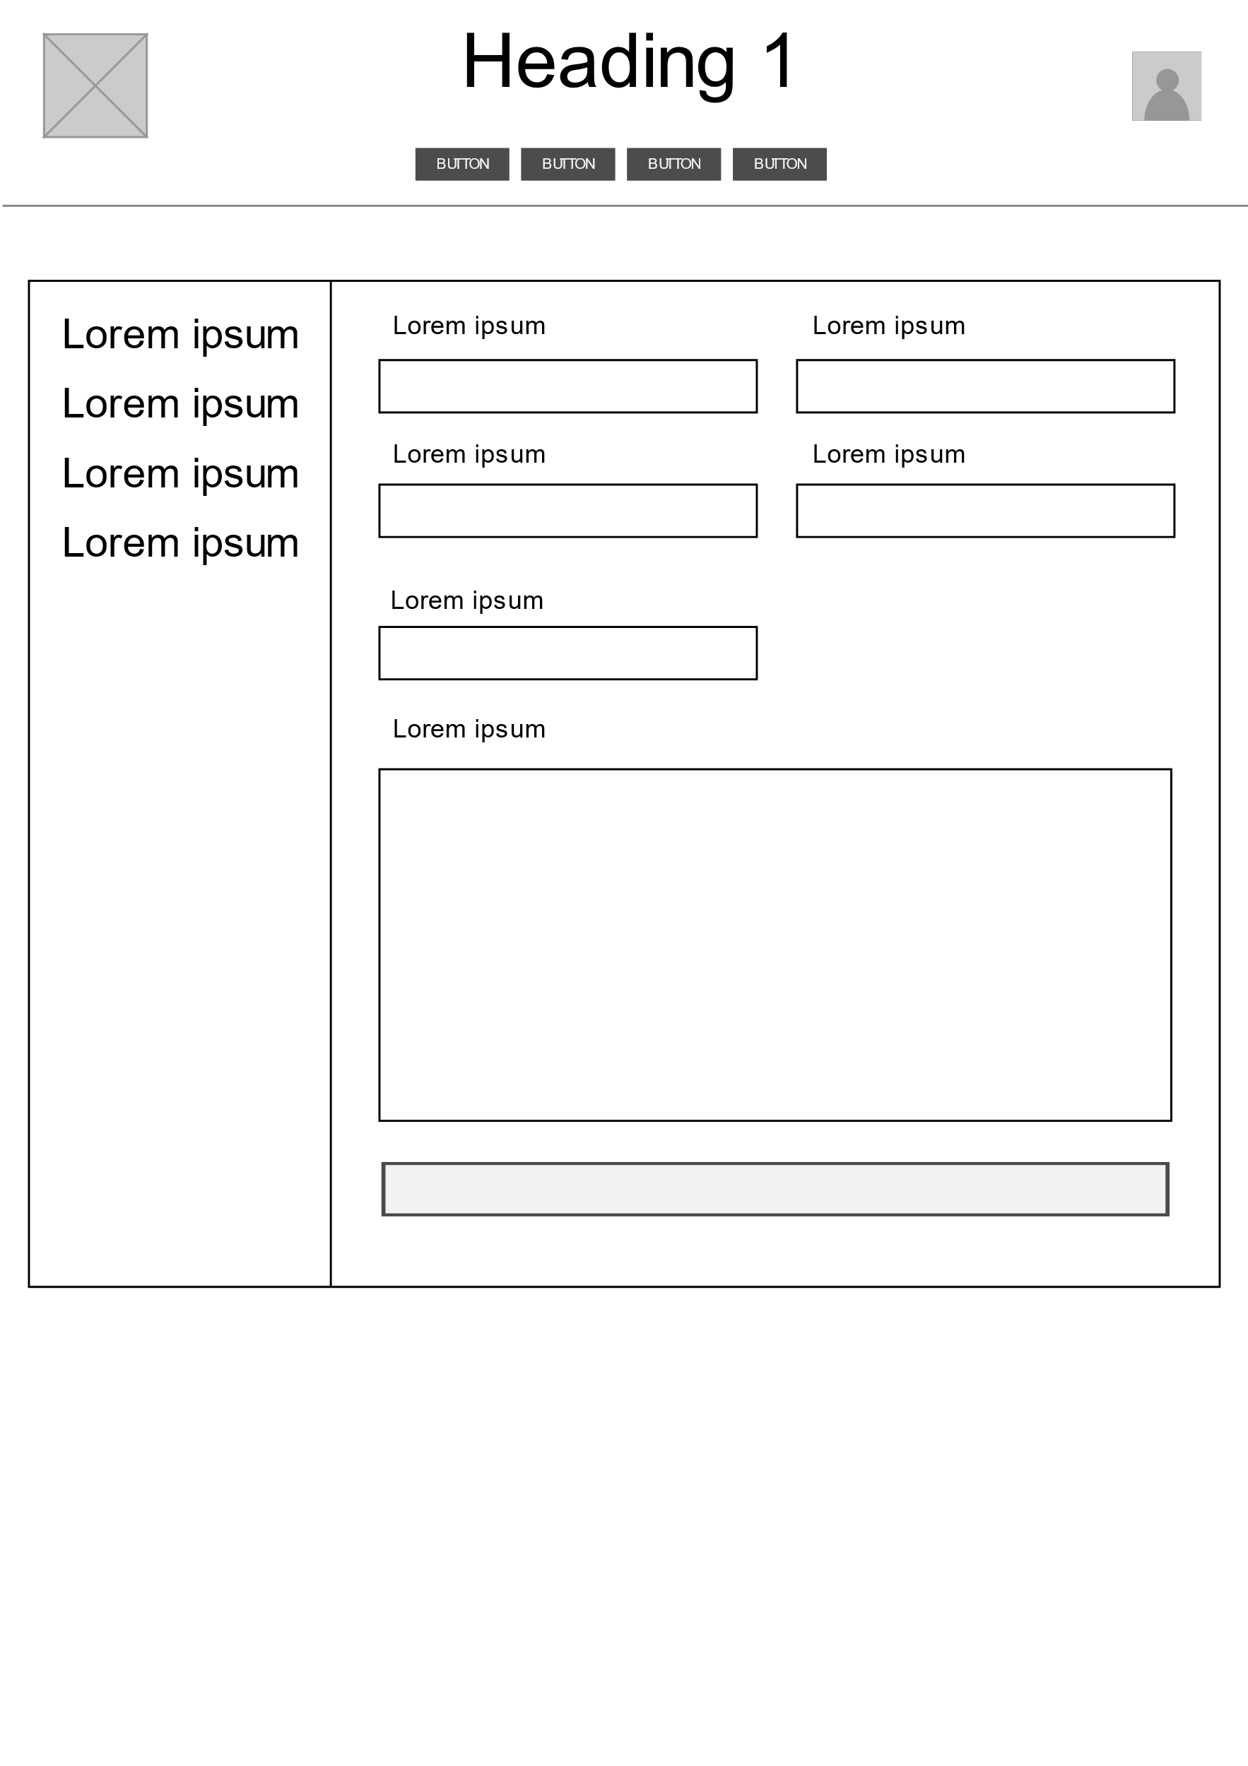

**Prototype**

<https://xd.adobe.com/view/1bf9fade-7017-4cb2-7a9c-5b7fd9fb3d75-6dc8/screen/532deac0-0cd4-40aa-9414-e8135c42239d/Web-1920-Space-Activities?fullscreen>