[https://en.wikipedia.org/wiki/A\_Game\_of\_Thrones\_(board\_game)#A\_Clash\_of\_Kings](https://en.wikipedia.org/wiki/A_Game_of_Thrones_(board_game)" \l "A_Clash_of_Kings)

**Icons**

Dice: Number between 1 - 6

Characters:

1. Eddard Stark - House Stark
2. Brynden Tully - House Tully
3. Tywin Lannister - House Lannister
4. Robert Baratheon - House Baratheon
5. Viserys Targaryen - House Targaryen
6. Balon Greyjoy - House Greyjoy
7. Loras Tyrell - House Tyrell
8. Robin (Robert) Arryn - House Arryn
9. Walder Frey - House Frey
10. Thoros of Myr - Brotherhood Without Banners

Units:

* + Footmen
  + Knights (Horses)
  + Ships
  + Siege Engines

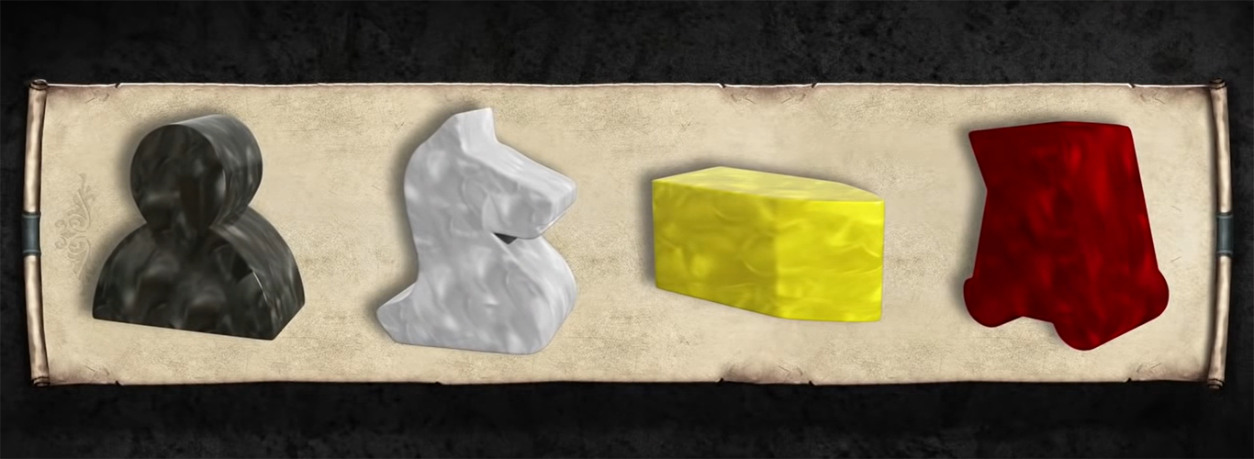

Tokens example:

* March orders
* Defend orders
* Support orders
* Raid orders
* Consolidate Power orders

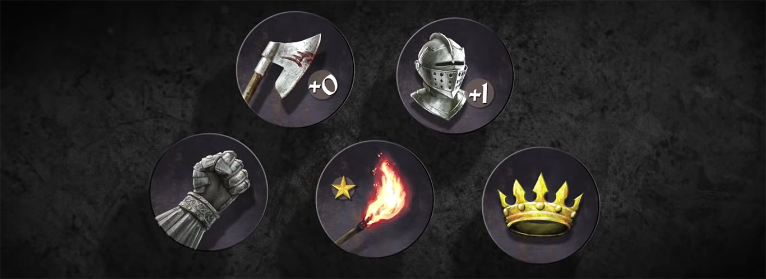

Board:

From the start to the end there should be **30 tiles** for the tokens to move on.

Create traps for some of the tiles.

Image sources:

<https://unsplash.com/photos/N1gFsYf9AI0>

The Dark Hedges

<https://pixabay.com/photos/trees-road-moonlight-avenue-3458478/>

Medieval-dark-gothic-witch

<https://pixabay.com/photos/fantasy-medieval-dark-gothic-witch-4422921/>

Castle

<https://unsplash.com/photos/ITsonWRfU6o>

Main heading

<https://www.fonts4free.net/game-of-thrones-font.html>

Game of thrones

<https://fontmeme.com/permalink/200224/c832edeaa63af12a9a95ae29baec1147.png>

<https://fontmeme.com/game-of-thrones-font/>

Subheading

Nanum Gothic Regular (Google fonts)

Body text

Roboto Regular (Google fonts)