[https://en.wikipedia.org/wiki/A\_Game\_of\_Thrones\_(board\_game)#A\_Clash\_of\_Kings](https://en.wikipedia.org/wiki/A_Game_of_Thrones_(board_game)" \l "A_Clash_of_Kings)

**Icons**

Logo:

Dice: Number between 1 - 6

Characters:

1. Eddard Stark - House Stark - Wolf
2. Brynden Tully - House Tully - Fish
3. Tywin Lannister - House Lannister - Lion
4. Robert Baratheon - House Baratheon - Stag Rampant
5. Viserys Targaryen - House Targaryen - Dragon
6. Balon Greyjoy - House Greyjoy - Kraken
7. Loras Tyrell - House Tyrell - Rose
8. Robin Arryn - House Arryn - Falcon
9. Walder Frey - House Frey - Tower
10. Doran Martell - House Martell - Sun

Units:

* + Footmen
  + Knights (Horses)
  + Ships
  + Siege Engines

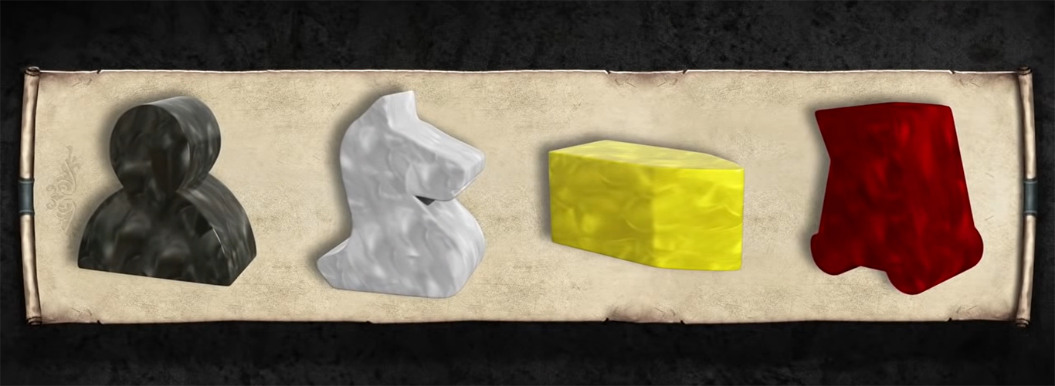

Tokens example:

* March orders
* Defend orders
* Support orders
* Raid orders
* Consolidate Power orders

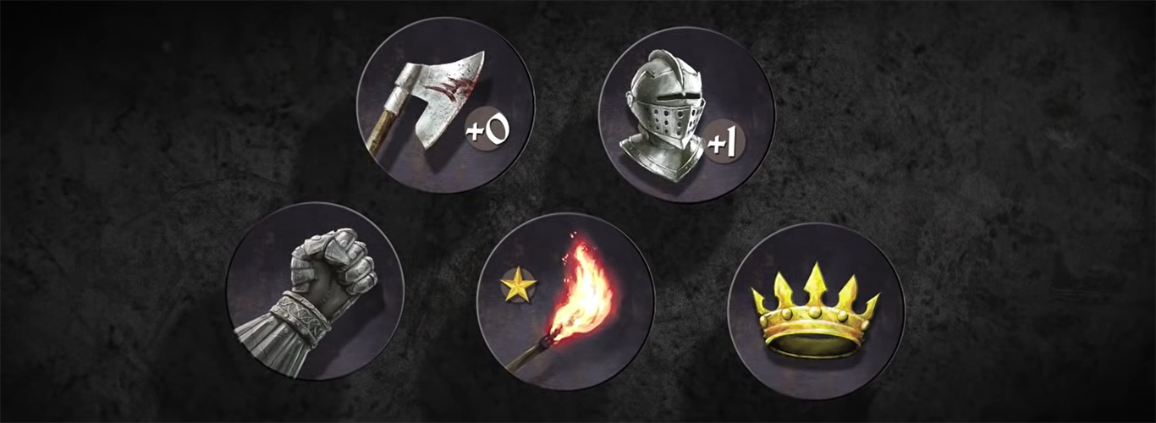

Image sources:

Map

<https://unsplash.com/photos/N1gFsYf9AI0>

The Dark Hedges

<https://pixabay.com/photos/trees-road-moonlight-avenue-3458478/>

Castle

<https://unsplash.com/photos/ITsonWRfU6o>

**Graphics**

Must attribute the author

By Source, Fair use, <https://en.wikipedia.org/w/index.php?curid=58462381>

By Source, <a href="//en.wikipedia.org/wiki/File:Reigns\_Game\_of\_Thrones\_logo.svg" title="Fair use of copyrighted material in the context of Reigns: Game of Thrones">Fair use</a>, <a href="https://en.wikipedia.org/w/index.php?curid=58462381">Link</a>

**Icons**

Source: <https://game-icons.net/tags/game-of-thrones.html>

**Main heading**

<https://www.fonts4free.net/game-of-thrones-font.html>

Game of thrones

<https://fontmeme.com/permalink/200224/c832edeaa63af12a9a95ae29baec1147.png>

<https://fontmeme.com/game-of-thrones-font/>

**Subheading**

Nanum Gothic Regular (Google fonts)

**Body text**

Roboto Regular (Google fonts)

**Board**

From the start to the end there should be **30 tiles** for the tokens to move on.

Create traps for some of the tiles.

**Game rules**

* Throw the dice
* Move the character icon according to the number they roll
* If landed on enemy trap one (tax penalty), go 1 step back
* If landed on enemy trap two (), go 2 steps back
* If landed on enemy trap three (Deanerys’s Dragons have blocked the road ahead), go 3 steps back
* If landed on enemy trap four (), go 4 steps back
* If landed on enemy trap five (), go 5 steps back

If the dice number is higher than the remaining steps to the final destination, stay on the current tile and wait until it’s your turn again. The character icon can only be moved to the final destination with an exact roll.

**JS notes**

JS Docs: To make my functions more understandable and easy to read I added some strong types with the JSDocs.

Source: <https://www.valentinog.com/blog/jsdoc/>

Source: <https://jsdoc.app/tags-param.html>

**CSS notes**

Properties to animate for best performance and too achieve 60fps: position, scale, rotation, opacity.