Data Management Plan

SFCW Radar

Document version: DMP V0.1

Data Description and Collection
The Stepped Frequency Continuous Wave (SFCW) radar has been implemented based on BladeRF Software Defined Radio (SDR) and GNU radio framework. The system architecture is shown in Figure 1.
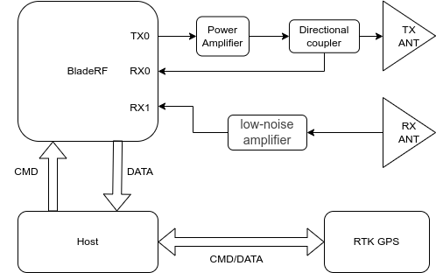
Figure 1. The system architecture of the SFCW radar
The host is a single-board computer that controls the radar, collect and process echo signals and extract location information from the RTK-GPS.
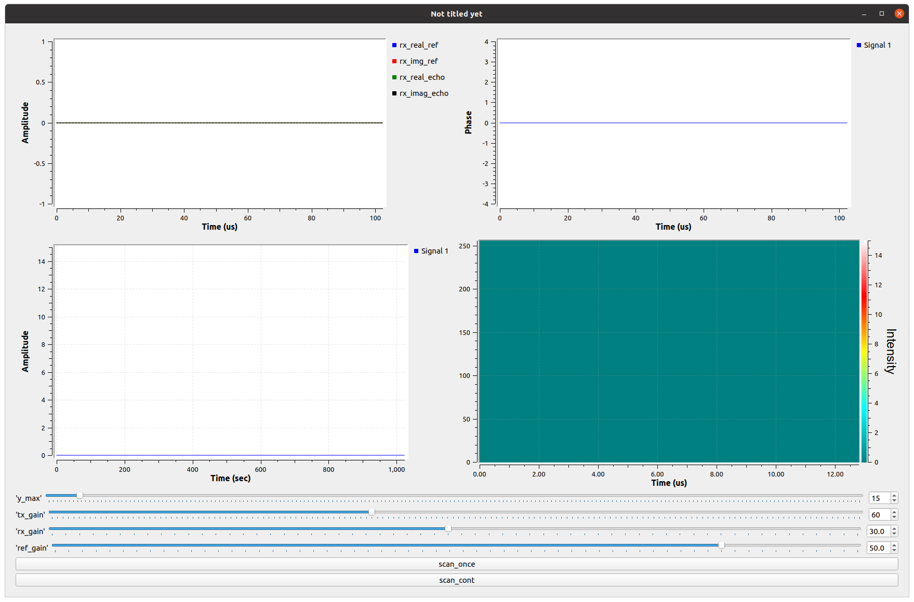
A graphic user interface as shown in Figure 2 can be used for collecting data.

Figure 2. SFCW radar GUI.
The main data produced within the project is the raw radar echo signals and the extracted range profiles. The I/Q samples will be stored in SigMF format as this format is widespread used in the research community. The range profile of each scan is stored in json format. Table 1 and 2 summaries the details of the collected data.
Table 1. Collection specification of raw I/Q samples
Type of Data | Raw I/Q samples in SigMF format
Hardware | The I/Q samples of radar echo signals are collected by BladeRF SDR
Data format | Raw I/Q samples. The data is stored in two files (i) a dataset file, a binary file of the recorded digital samples, and (ii) the SigMF metafile, which contains information that describes the dataset in plain-text JSON format.
Data collection locations | Indoor:  - SnT lab testbed  Outdoor:  - To be confirmed
Data organization | The data is organized in folders and each folder contains the data collected from one location. The filename convention of each I/Q samples should be as the following:  <location>_<collection datetime>.SigMF
Metadata format | The metadata of each I/Q sample records contains the following information  RF-related:  - Start frequency  - End frequency  - Step frequency  - Sample rate  - TX power  - RX power (set to -1 if AGC is enabled)  Collection environment:  - Location-code  - Soil type  - Soil VWC  - Soil compactness (low-medium-high)  - Temperature  - Air Humidity  - Tx_Rx_distance  - Distance to ground  - Has buried object (boolean)  Buried object information:  - Type  - Material  - Depth
Size | 10 Gb / location

Table 2. Collection specification of range profile
Type of Data | Range profile in Json format
Hardware | The range profiles collected by BladeRF SDR and stored in the Host
Data format | The range profiles are stored in Json format
Data collection locations | Indoor:  - SnT lab testbed  Outdoor:  - To be confirmed
Data organization | The data is organized in folders and each folder contains the data collected from one location. The filename convention each range profile should be as the following:  <location>_<scan_ID>.json
Metadata format | Each json records contains the following information  RF-related:  - Start frequency  - End frequency  - Step frequency  - Sample rate  - TX power  - RX power (set to -1 if AGC is enabled)  Collection environment:  - Location-code  - Soil type  - Soil VWC  - Soil compactness  - Temperature  - Humidity  - Tx_Rx_distance  - Distance to ground  - Has buried object (boolean)  Range profile:  - I components  - Q components  - GPS locations
Size | 100 MB / location

Documentation and Data Quality
The I/Q samples should be stored in SigMF format accompanied with extendable metadata files. The information recorded in the metadata file is outlined in Table 1. The range profiles should be stored in json format (e.g., Table 2). The collected data will be organized in folders such that each folder contains the data collected from one location. A readme file should be provided under each folder to describe collection setup, environment, weather conditions and soil conditions.
The following measures are applies to ensure the integrity and quality of the collected data:
- The data collection tools should be calibrated before collecting data.
- The PI ensures that all data collection activities follow the predefined methodology and the laboratory protocols.
- The collected data and results based on the data should be discussed and reviewed in the team meetings.
- Checksums are used if data need to be transferred.

Storage and Backup
The collected data will be initially stored on the local workstations and then regularly backed up using the network drives provided by the University of Luxembourg. To guarantee the quality of the data, the backup should be performed after each weekly team meeting, during which the collected data is discussed and reviewed by the PI. The data processing is carried out on local workstations or on servers managed by the SEDAN group at SnT.
The PI of the project will be responsible for managing and controlling access to the data. The access will be granted to all members who are involved in the project. All workstations, network drives, and servers will be password protected to ensure the safety and security of the data. Access to the university network drive will only be granted to the project members. These measures are deemed sufficient as the project does not involve the generation of sensitive data.

Data Management Responsibilities and Resources
The PI of the project holds the responsibility for managing the project data. To ensure data safety and security, Dr. Hui HUANG will be responsible for data storage and backup. He will update the data management plan as and when required during the project's progress.

