Sesion 3 - Practica 6

[estadisticalemon@delarivagroup.com](mailto:estadisticalemon@delarivagroup.com)

## Creacion de reportes - R Markdown

En este reporte exploraremos la base de datos “mtcars”

Resumen de datos tabla mtcars

|  |  |  |  |  |  |  |  |  |  |  |  |
| --- | --- | --- | --- | --- | --- | --- | --- | --- | --- | --- | --- |
|  | mpg | cyl | disp | hp | drat | wt | qsec | vs | am | gear | carb |
| Mazda RX4 | 21.0 | 6 | 160 | 110 | 3.90 | 2.620 | 16.46 | 0 | 1 | 4 | 4 |
| Mazda RX4 Wag | 21.0 | 6 | 160 | 110 | 3.90 | 2.875 | 17.02 | 0 | 1 | 4 | 4 |
| Datsun 710 | 22.8 | 4 | 108 | 93 | 3.85 | 2.320 | 18.61 | 1 | 1 | 4 | 1 |
| Hornet 4 Drive | 21.4 | 6 | 258 | 110 | 3.08 | 3.215 | 19.44 | 1 | 0 | 3 | 1 |
| Hornet Sportabout | 18.7 | 8 | 360 | 175 | 3.15 | 3.440 | 17.02 | 0 | 0 | 3 | 2 |
| Valiant | 18.1 | 6 | 225 | 105 | 2.76 | 3.460 | 20.22 | 1 | 0 | 3 | 1 |

## Vizualizacion de la informacion

A continuacion generaremos un grafico de dispersion para visualizar el comportamiento de las variables de las base de datos mtcars

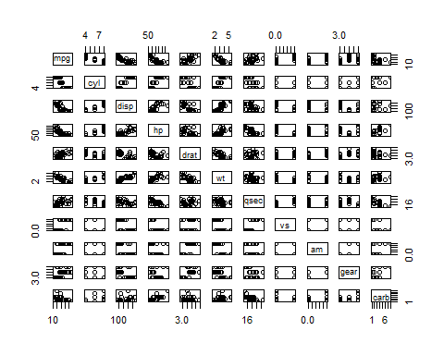

Adicional al grafico imprimiremos una tabla con el coeficiente de correlacion de cada variable de la base de datos mtcars

cor(mtcars) %>%  
 knitr::kable(digits = 3, caption = 'Coeficiente de Correlacion "mtcars"')

Coeficiente de Correlacion “mtcars”

|  |  |  |  |  |  |  |  |  |  |  |  |
| --- | --- | --- | --- | --- | --- | --- | --- | --- | --- | --- | --- |
|  | mpg | cyl | disp | hp | drat | wt | qsec | vs | am | gear | carb |
| mpg | 1.000 | -0.852 | -0.848 | -0.776 | 0.681 | -0.868 | 0.419 | 0.664 | 0.600 | 0.480 | -0.551 |
| cyl | -0.852 | 1.000 | 0.902 | 0.832 | -0.700 | 0.782 | -0.591 | -0.811 | -0.523 | -0.493 | 0.527 |
| disp | -0.848 | 0.902 | 1.000 | 0.791 | -0.710 | 0.888 | -0.434 | -0.710 | -0.591 | -0.556 | 0.395 |
| hp | -0.776 | 0.832 | 0.791 | 1.000 | -0.449 | 0.659 | -0.708 | -0.723 | -0.243 | -0.126 | 0.750 |
| drat | 0.681 | -0.700 | -0.710 | -0.449 | 1.000 | -0.712 | 0.091 | 0.440 | 0.713 | 0.700 | -0.091 |
| wt | -0.868 | 0.782 | 0.888 | 0.659 | -0.712 | 1.000 | -0.175 | -0.555 | -0.692 | -0.583 | 0.428 |
| qsec | 0.419 | -0.591 | -0.434 | -0.708 | 0.091 | -0.175 | 1.000 | 0.745 | -0.230 | -0.213 | -0.656 |
| vs | 0.664 | -0.811 | -0.710 | -0.723 | 0.440 | -0.555 | 0.745 | 1.000 | 0.168 | 0.206 | -0.570 |
| am | 0.600 | -0.523 | -0.591 | -0.243 | 0.713 | -0.692 | -0.230 | 0.168 | 1.000 | 0.794 | 0.058 |
| gear | 0.480 | -0.493 | -0.556 | -0.126 | 0.700 | -0.583 | -0.213 | 0.206 | 0.794 | 1.000 | 0.274 |
| carb | -0.551 | 0.527 | 0.395 | 0.750 | -0.091 | 0.428 | -0.656 | -0.570 | 0.058 | 0.274 | 1.000 |

#### Principales salidas de reportes que se pueden crear en RMarkdown

* beamer_presentation
* github_document
* html_document
* ioslides_presentation
* latex_document
* md_document
* odt_document
* pdf_document
* powerpoint_presentation
* rtf_document
* slidy_presentation
* word_document