# Investigación variables cualitativas y cuantitativas

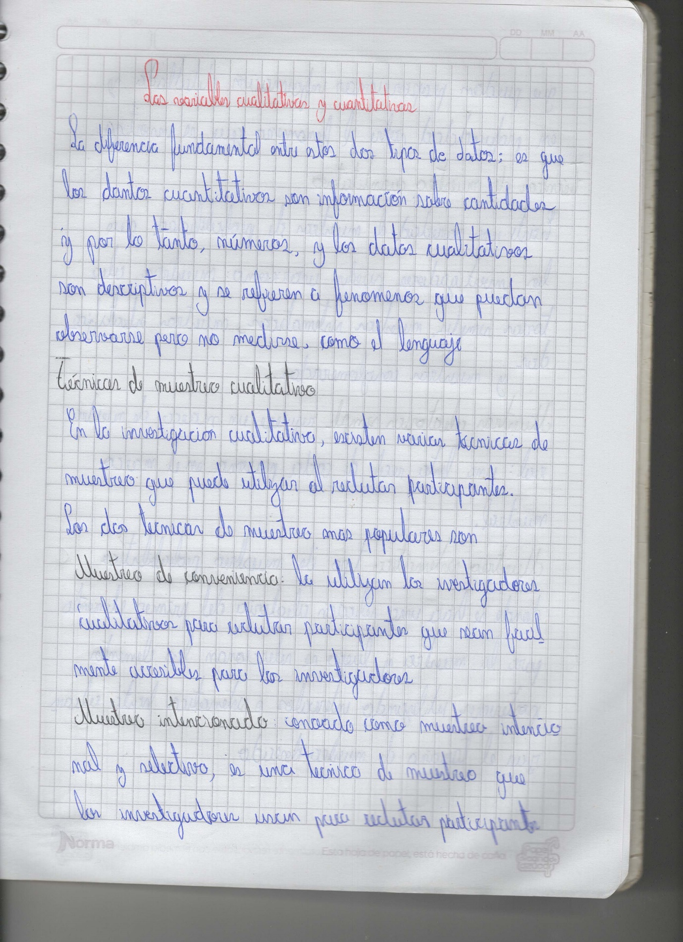 •Nombre: Ortega Jorge •Curso: 3ro FGI A   
 •Fecha: 2021/10/07 •Materia: Emprendimiento

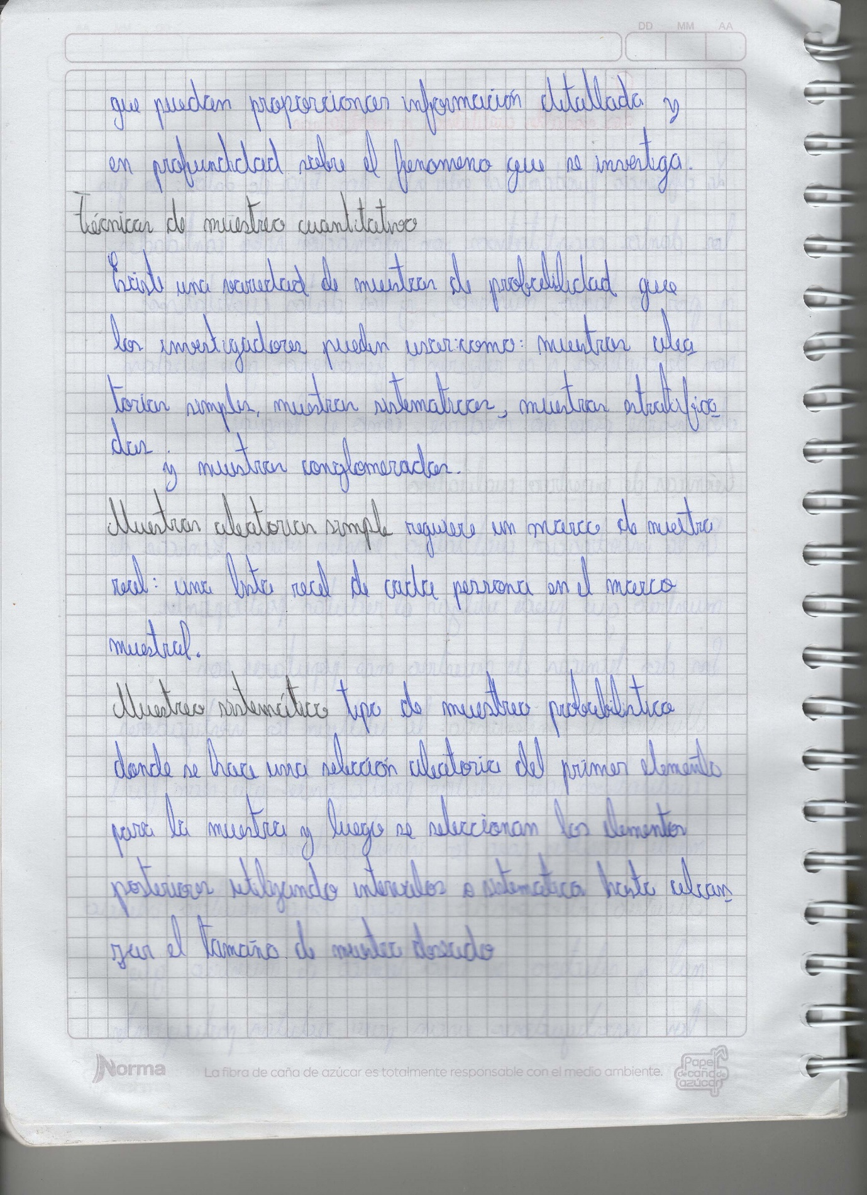

Fuentes:

1. Figure 10.2 copied from Blackstone, A. (2012) Principles of sociological inquiry: Qualitative and quantitative methods. Saylor Foundation. Retrieved from: https://saylordotorg.github.io/text_principles-of-sociological-inquiry-qualitative-and-quantitative-methods/ Shared under CC-BY-NC-SA 3.0 License (https://creativecommons.org/licenses/by-nc-sa/3.0/) [↵](https://scientificinquiryinsocialwork.pressbooks.com/chapter/10-3-sampling-in-quantitative-research/#return-footnote-352-1)
2. Holt, J. L., & Gillespie, W. (2008). Intergenerational transmission of violence, threatened egoism, and reciprocity: A test of multiple psychosocial factors affecting intimate partner violence. American Journal of Criminal Justice, 33, 252–266. [↵](https://scientificinquiryinsocialwork.pressbooks.com/chapter/10-3-sampling-in-quantitative-research/#return-footnote-352-2)