Butcher’s Broom Tea Remedy
(CB705 for 1 Matrix Point in http://StartOver.xyz) (revised 5 December 2018 by Clinton Callahan)

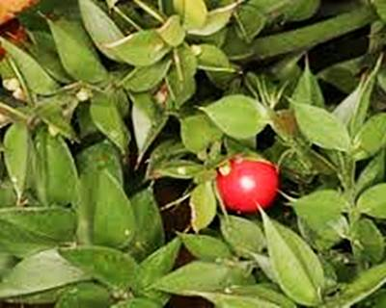
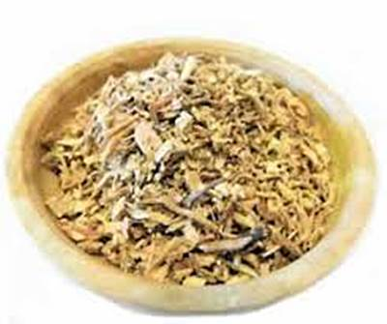

Dried Chopped Roots Fresh Living Plant

SYMPTOMS
Butcher's broom is used to heal hemorrhoids, gallstones, ‘hardening of the arteries’ (atherosclerosis), and for symptoms of poor blood circulation such as pain, heaviness, leg cramps, leg swelling, varicose veins, itching, and swelling. Butcher's broom is also used as a laxative, as a diuretic to increase urine output, to reduce swelling, and to speed the healing of fractures.

INGREDIENTS
In this remedy there is only one ingredient: the dried roots of (rusci aculeate), commonly known as Butcher’s Broom. Also known as: Balai du Boucher, Box Holly, Fragon, Fragon Épineux, Fragon Faux Houx, Fragon Piquant, Houx Frelon, Jew's Myrtle, Kneeholm, Knee Holly, Petit Houx, Pettigree, Sweet Broom, Rusci Aculeati, Rusci Aculeati Rhizoma, Rusco, Ruscus aculeatus.

INSTRUCTIONS
Make Butcher’s Broom tea. Place 1 teaspoon of dried chopped Butcher’s Broom roots in a coffee mug. Fill the cup with freshly boiled water. Let it steep for 10-15 minutes. Leave the roots in the bottom and drink the tea.
For acute symptoms drink one mug of this tea 1 or 2 times per day.
For maintenance, drinking one or two mugs per week will keep things in balance.
Drink this alone or in combination with taking Vitamin C and Hesperidin.

PURCHASE
You can order dried Butcher’s Broom root (rusci aculeate) from your local pharmacy.

FURTHER INFORMATION
http://www.webmd.com/vitamins-supplements/ingredientmono-320-BUTCHER%27S+BROOM.aspx?activeIngredientId=320&activeIngredientName=BUTCHER%27S+BROOM&source=0

