Project Summaries

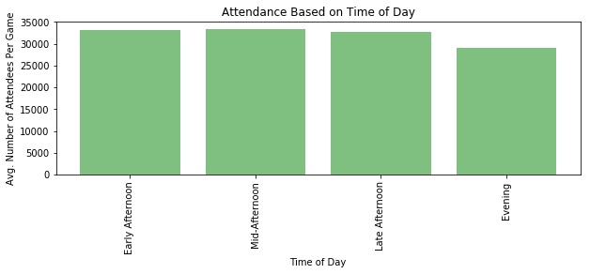

* Upon first look, it seemed that time of day had little influence on average number of attendees per game (first) graph
* 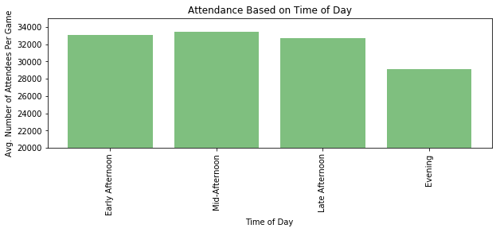After zooming in on just the top portions of the bar graphs, time of day seemed to have more relevance in terms of game attendance
* Based on further look, the attendance numbers seem to suggest a preference for games in the early and mid afternoon

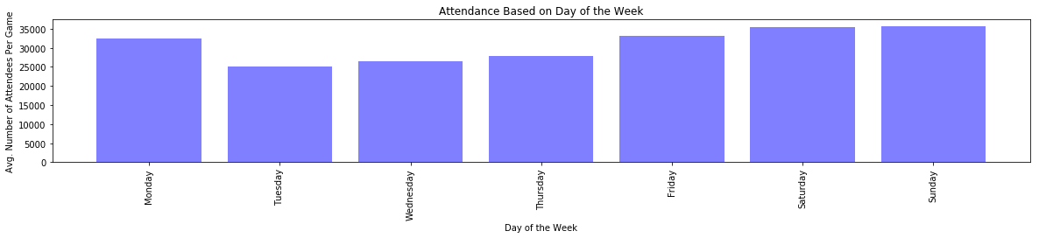

* With first look at the average attendance based on day of the week, there seems to be a strong preference for games toward the end of the week
* The exception to that trend is Monday, which suggests the preference is likely for games closer to the weekend
* On Tuesdays, when people realize how far off Friday is they don’t seem to have the heart to go to a baseball game

(LAST GRAPH ON NEXT PAGE)

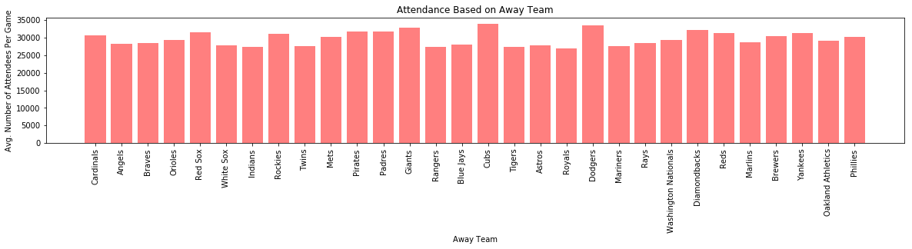

* We wanted to see whether the visiting (away) team would affect average attendance for games because some teams have rivalries with others as well as other potential hype
* The teams that drove up the attendance numbers the most are the Dodgers, the Giants, and the Cubs while the teams with the lowest attendance are the Indians, the Rangers, and the Royals
* Given a difference in average attendance of over 5000 attendees between teams like the Cubs and the Rangers, the data implies that the visiting team affects average attendance