This webpage has been made for an international package company

in order to make the clients able to send packages and request

budgets online.

**Link:**

<http://informatica.iesquevedo.es/dam1/DAM-JorgeMartinLlorente/>

Transporteur

HTML Validations: 2

CSS Validations: 4

# HTML Validations:

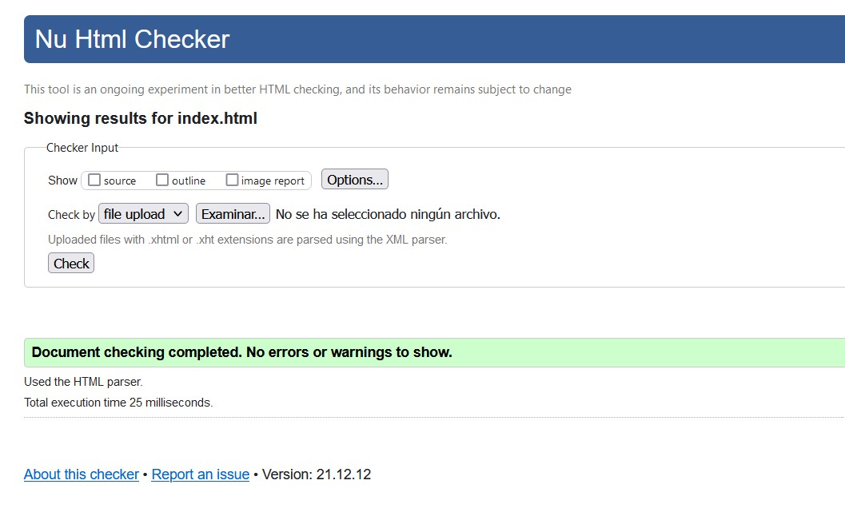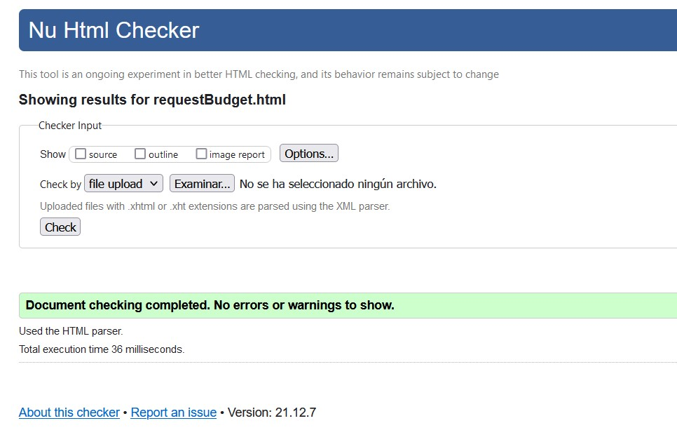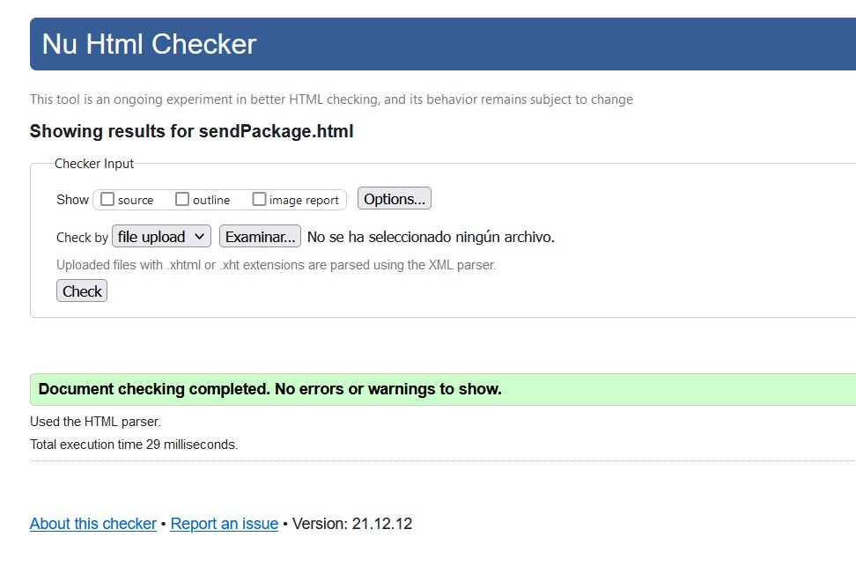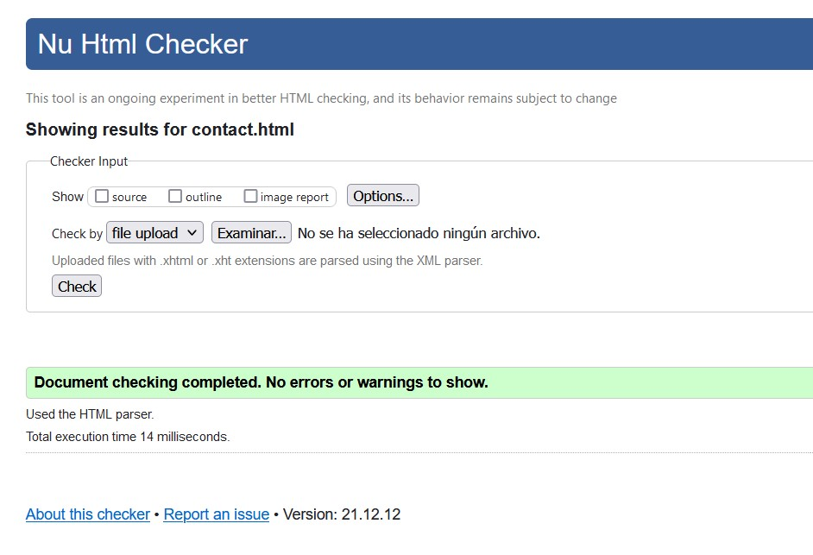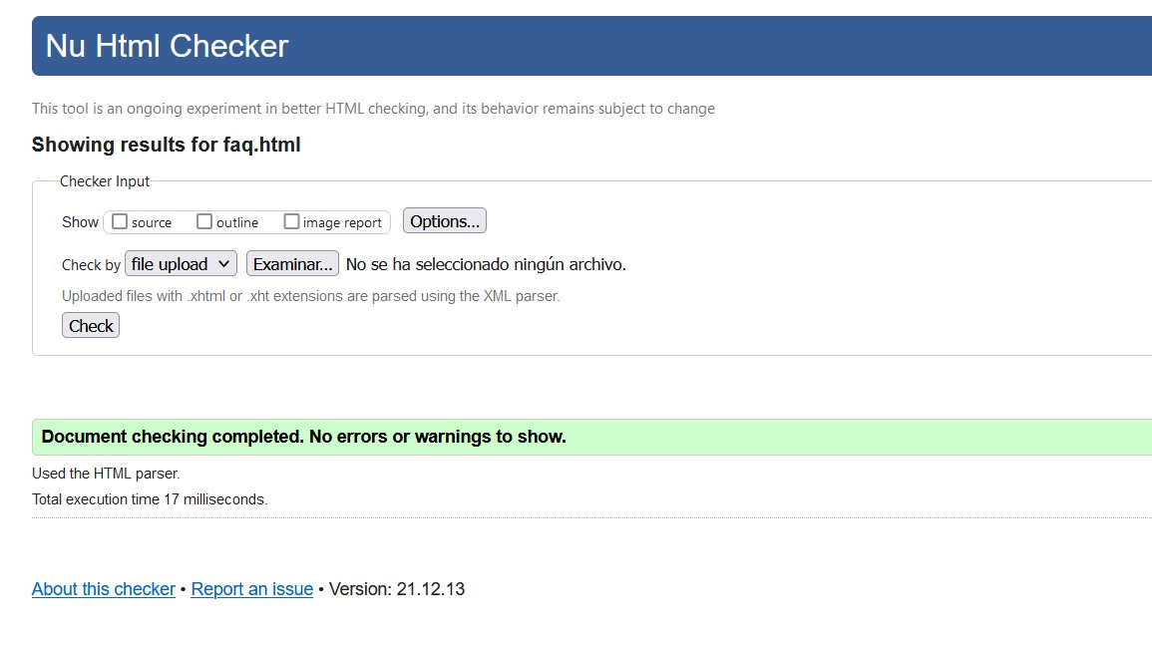

# CSS Validations:

