

# Interview Homework Project (Android)

## Overview

Below you will find a simple set of requirements to construct a basic Android app that consumes a JSON feed from Amazon S3. The JSON file is a list of bar venues used by our NFL12 application.

We have also provided some sketch wireframes to guide you in the design of this application.

We want you (in no more than a few days) to write an Android app that displays this data to the user on both handsets and tablets.

**Source Code Repository**

Please upload your code to GitHub, and share that repository link with us.

### 3rd Party Libraries

You can use whatever code or 3rd party libraries that you desire. Here are some possible libraries you might want to use:

* ActionBar backwards compatibility
  + Google AppCompat
* Image loading
  + Picasso (<http://square.github.io/picasso/>)
  + AQuery (<https://code.google.com/p/android-query/>)
* JSON parsing
  + Jackson JSON Processor (<http://wiki.fasterxml.com/JacksonDownload>)
  + GSON (<https://code.google.com/p/google-gson/>)
* Network requests
  + Retrofit (<http://square.github.io/retrofit/>)
  + Volley (<https://developers.google.com/events/io/sessions/325304728>)

### Evaluation

We will be evaluating your app against a few criteria:

* Organization
* Android fundamentals
* Android design
* Code quality / style

It is up to you whether you use Android Studio or Eclipse to complete this exercise, although at the moment Eclipse is preferred. Once you have completed this to the best of your ability you can either send us a ZIP of your workspace (via email) or upload your submission to a public git repository (GitHub/Bitbucket) (bonus points for this option).

**Please make sure that your submission is easily compilable in the form that you submit it.**

Don’t be afraid if you get stuck on a particular area, or think that it will take you too long to complete. When you have something you are comfortable with send it along! Just let us know which parts of the assignment have been omitted - you will not be evaluated on features that are left out in this manner.

### Helpful Reading

* [Android Training](http://developer.android.com/training/index.html)
  + [Communicating with Other Fragments](http://developer.android.com/training/basics/fragments/communicating.html)
  + [Building a Flexible UI](http://developer.android.com/training/basics/fragments/fragment-ui.html)
  + [Adding an Easy Share Action](http://developer.android.com/training/sharing/shareaction.html)
  + [Performing Network Operations](http://developer.android.com/training/basics/network-ops/index.html)
* [API Guides: Action Bar](http://developer.android.com/guide/topics/ui/actionbar.html)
* [Android Design Guidelines](http://developer.android.com/design/index.html)
* [Android Components: Loaders](http://developer.android.com/guide/components/loaders.html)

### Style Guidelines

Please try to adhere to a few style guidelines that we use at Phunware. This will help us better evaluate your code by not getting hung up on code-style.

#### Write Short Methods

To the extent that it is feasible, methods should be kept small and focused. It is, however, recognized that long methods are sometimes appropriate, so no hard limit is placed on method length. If a method exceeds 40 lines or so, think about whether it can be broken up without harming the structure of the program.

#### Define Fields in Standard Places

Fields should be defined either at the top of the file, or immediately before the methods that use them.

#### Follow Field Naming Conventions

* Non-public, non-static field names start with m.   
   (ex: private TextField mTextFieldColor;)
* Other fields start with a lowercase letter.
* Public static final fields (constants) are ALL_CAPS_WITH_UNDERSCORES.

#### Use Standard Brace Style

Braces do not go on their own line; they go on the same line as the code before them.

#### Logging

System.out.print() should NEVER be used unless contributing to a library that is not Android specific. Log sparingly.

## *Unused methods*

Please avoid empty/commented/unused methods in your code. If you are overriding a parent class’ method to disable its behavior please leave a comment behind indicating. If your method only calls the superclass method, it should be left out.

## 

## Requirements

* Consume the following JSON feed: <https://s3.amazonaws.com/jon-hancock-phunware/nflapi-static.json>
  + You should do this by performing any necessary network calls in the app. Do not store this file locally in the app.
  + Here you will find model java classes for the objects in the json file: <https://gist.github.com/jonfhancock/79db01538a3e4e40164b>
  + You may use this model to save yourself some time.
* App should be a master/detail type app
  + ListView that shows all the venues, and then show the details of a venue when tapped.
* Can use whatever 3rd party libraries you want.
* Should run on both handset devices and larger Android devices such as 7” or 10” tablets. Please do so “**responsively**” to the best of your ability. (See <http://developer.android.com/guide/practices/screens_support.html>). Please avoid restricting devices to being “handsets” or “tablets”.
* Should work on Android 2.3+
* Each Venue may or may not have an image associated with it.
  + For the ones that do, you should load the image appropriately and display it to the user according to the wireframes. (These images are available online with full links in the JSON feed.)
* Each Venue may or may not have schedule information associated with it.
* All schedule times are in GMT, and should be represented in the user’s timezone.
* When the share button is pressed, the share text should be composed of the current venue’s name and address.

## Sample Venue Data

{

"zip": "70130",

"phone": "(504) 582-3000",

"ticket_link": "http://www.nfl.com/superbowl/47/events/nfl-experience",

"state": "LA ",

"pcode": 10,

"city": "New Orleans",

"id": 16150,

"tollfreephone": "(555) 555-5555",

"schedule": [

{

"end_date": "2013-01-30 20:00:00 -0800",

"start_date": "2013-01-30 13:00:00 -0800"

},

{

"end_date": "2013-01-31 20:00:00 -0800",

"start_date": "2013-01-31 08:00:00 -0800"

}

],

"address": "900 Convention Center Blvd",

"image_url": "http://lorempixel.com/900/500/city/",

"description": "",

"name": "Verizon Training Ground @ NFL Experience",

"longitude": -90.064287,

"latitude": 29.941511

}

## 

## 

## Wireframes

Handset Home Screen

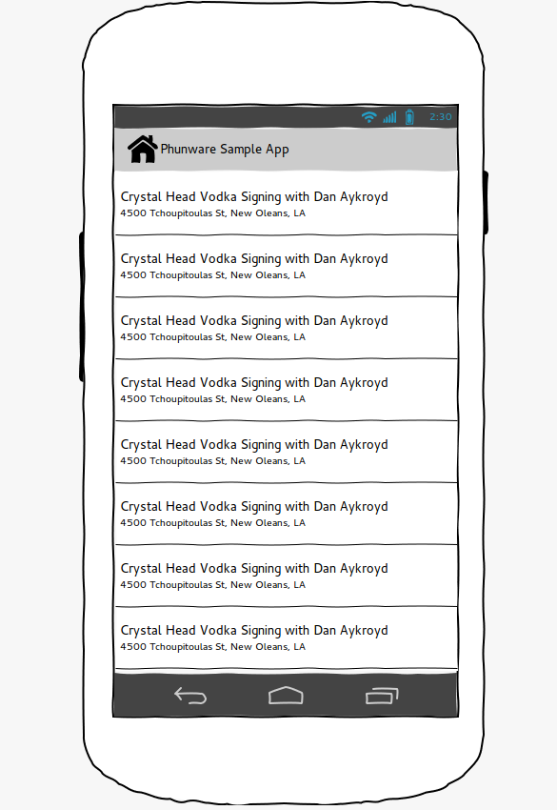

Handset Detail Screen

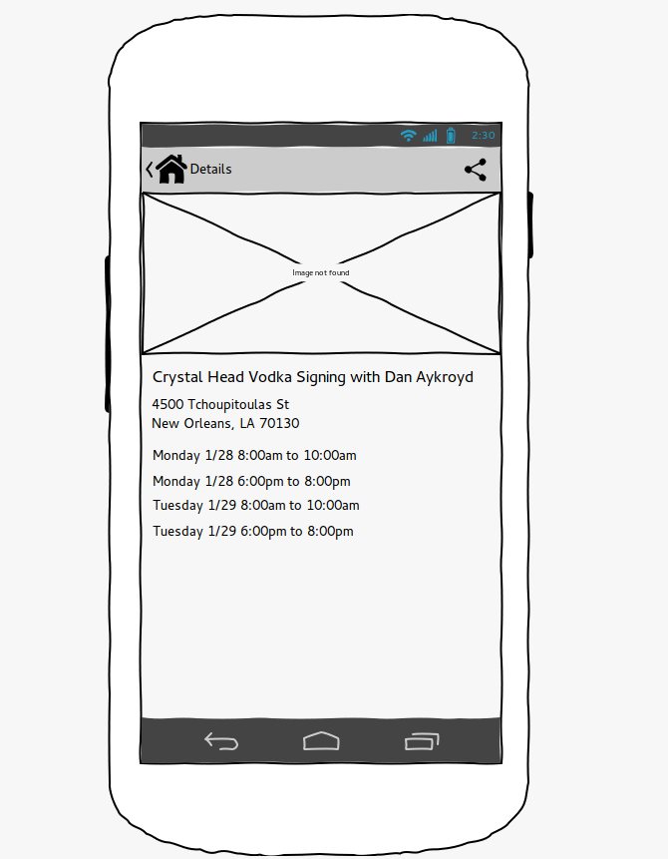

Tablet Screen

