Blender-aid release October 2010
User manual

this document is part of a GPLv3 license.
Table of Contents
Introduction 3
What is Blender-aid? 3
What can you do with it? 3
How does it work? 3
When do you use it? 3
Features 4
Visibility 4
Refactoring 4
Installation 5
Configuration of settings 5
Technical dependencies 5
De-installation 6
Functionality – web base 7
First configuration 7
Production-view 10
Production-view Files 10
Production-view Scenes 12
Production-view Missing links 13
File-view 15
File-view Local link 16
File-view Rename file 17
File-view Move file 19
File-view Basic tab 20
File-view Elements tab 21
File-view References tab 23
File-view Dependancy viewer tab 24
SVN bindings 28

Introduction
Blender is a 3d content creation suite. It enables user to model, animate, shade and do post productions (composing) on 3d content. With Blender it is possible to create 3d games, 2.5d animations and 3d animations.

What is Blender-aid?
Blender-aid is a tool that helps you manage Blender productions. Blender focuses on the creation of content. Blender-aid focuses on managing the content of a production.
Big Buck Bunny consists of a lot of 3d content. This content is located in many files. Using Blender to manage content across files is difficult, especially when the content is not part of a single scene (= technical representation of a movie script).

What can you do with it?
The 2 main features of blender-aid are visibility and refactoring.
Visibility presents technical data of a production in different ways, like the links between files or the output settings of files. Presenting the data in a useful way lets you see where and why a file is used. With this information it is possible to answer questions like: "What scenes needs to be re-rendered when you modify a file or a part of a file?".
During the creation of a production changes happen. Blender-aid can perform complex refactoring tasks like renaming a file or moving a file to another folder location. Blender-aid will assure that the structure of the production stays intact.

How does it work?
Using Blender-aid is very simple. Just configure where your production is located on your computer. Blender-aid will inspect the files in the given location. With your web browser you can navigate through your production and perform refactoring tasks.

When do you use it?
Blender-aid has been designed for small teams working on blender animations or series. But feel free to use it and see what it can do for you. By using modern web and data warehousing techniques it enables you to quickly inspect and control your production.

Features
This section explains the main (functional) features of the tool.

Visibility
Blender-aid shows different aspects of the technical data of your production. Details are described below:
- View render settings of all production files
- View all production files used by a production file
- View all production files that uses a production file
- View all direct neighbours (users and used) production files
- View missing links in a production
- View list of elements from a blend file
- View filtered references and dependencies (table and graphic)

Refactoring
Refactoring is the ability to change the structure of a production.
- Rename production file
- Rename element of blend file
- Move production file

Installation
- Download blender-aid package what can be found at http://code.google.com/p/blender-aid/downloads/
- Unzip the downloaded file into a directory
- Optional: Configure the settings (see configuration). This is only necessary when
  - using windows or
  - if one would like to use different settings.
- Run the application in command line by typing: python server.pyc or ./server.pyc
Make sure the user has read & write privileges to the database location (default "/var/tmp"). The default location for windows is the installation directory.

Configuration of settings
Currently only the web server listening port and the database location can be configured. The web server listens default to port 8080 on localhost. The default database location is /var/tmp/sql.bin. Windows users should change the default location of the database.
- Open the file settings.py
- Change whatever you like
- Save the settings
- Restart the server.pyc

Technical dependencies
Blender-aid depends on the following software:
- Optional PIL (Python Imaging Library) for thumbnail generation
- Python 2.6 or Python 3.1
- Pysvn (tested with version 1.7.2) can be downloaded from http://pysvn.tigris.org
- A subversion implementation (1.6 or 1.5) can be downloaded from http://subversion.apache.org/packages.html

It is advisable to install the dependencies using the packaging system of your OS. Installation of pysvn can be hard task as building the sources depends on many other libraries and OS specific settings like the location of the site-packages directory.

During installation (via sources) of this library on Ubuntu 10.10 and Python 3.1 the next additional packages also needed to be installed (only during compilation).
- libneon27-dev
- python3-cxx
The site-packages directory is different as mentioned in the INSTALL.html of pysvn. The location we used is /usr/lib/python3.1

De-installation
To remove Blender-aid just delete the directory where it is installed. The only created file is /var/tmp/sql.bin (or otherwise when changed in settings.py)

Functionality – web base
! Please note that the screenshots inside the document can be from other versions than what you are using !

First configuration
When the server is started. You can start a browser and browse to “http://localhost:8080”. This can be different when configured otherwise.
When first started the next screen will be displayed
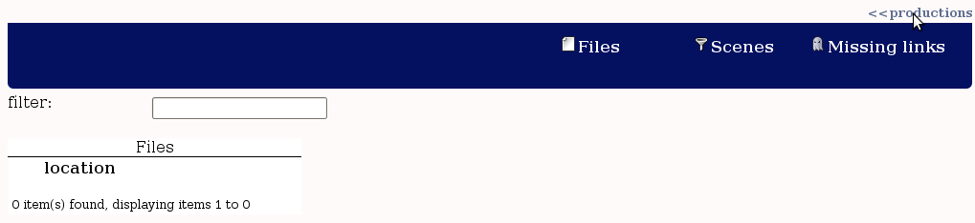
The first thing what has to be done is to add some productions to the tool. Press “<< productions” in the upper right to open the production selection popup.
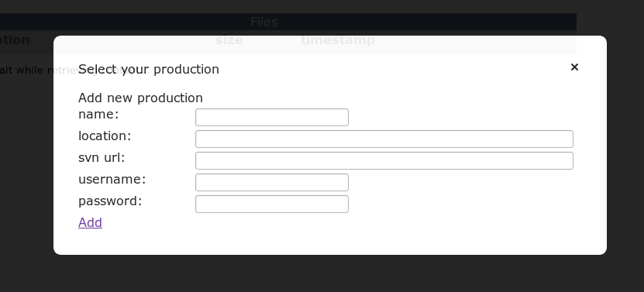
First we need to add out production location to the tool. For the next example I've downloaded Yo Frankie! And unzipped it to /var/productions/yf
Enter the next values
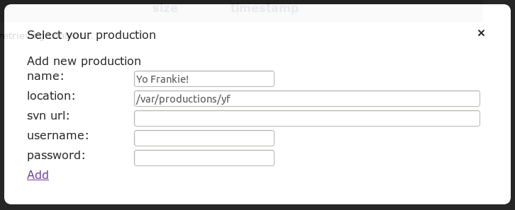

After clicking on the link “Add”. The production location is defined.
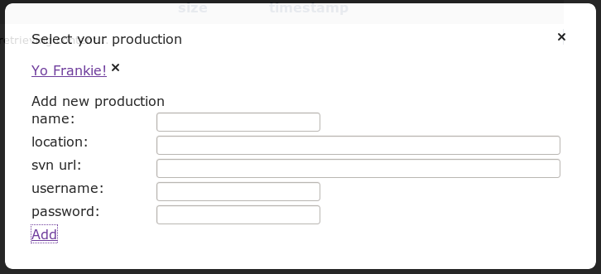

What has happened:
The location of the production “Yo Frankie!” on the location “/var/productions/yf” is not known by Blender-aid. Blender-aid will extract the technical data from this location and be able to display it to you.
Now click on your newly added production (“Yo Frankie!”) and the popup will close.
We have to wait for halve a minute or so, depending on the speed of your computer. Blender-aid inspects all production files and will store this information in a database. This process is called indexing. Indexing normally takes up to a few seconds, but when a lot of changes happen, it can take longer.
When indexing is done the screen will look like this:
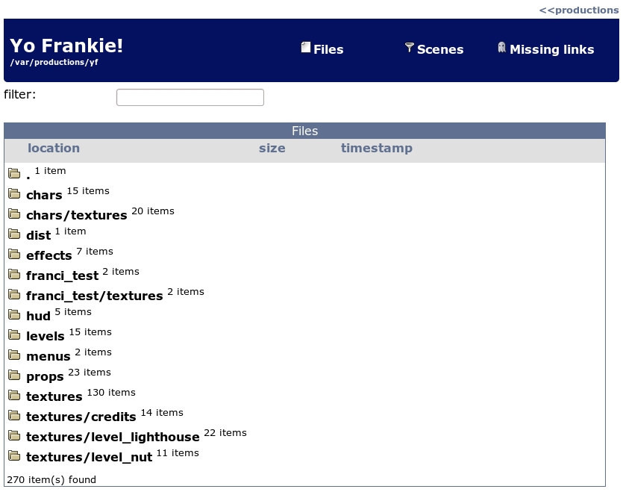
Now you are ready to use the tool.

Production-view
The production view is the screen as displayed above. It contains information of the selected production. The view contains 3 choices in the header.
- Files – displays a list of production files. It has a filter for quick finding of a specific production file.
- Scenes – display a list of all scenes in the production. It can be used to find and align render settings.
- Missing links – display a list of all missing links between files.
- SVN state – is only visible when svn bindings are present. It displays the state of SVN and has basic functionalities to revert and commit the changes to SVN.
When pressing on a link in a tab you will be show detailed information of the file. This will be described in the File-view section

Production-view Files
The files tab displays files from the selected production.
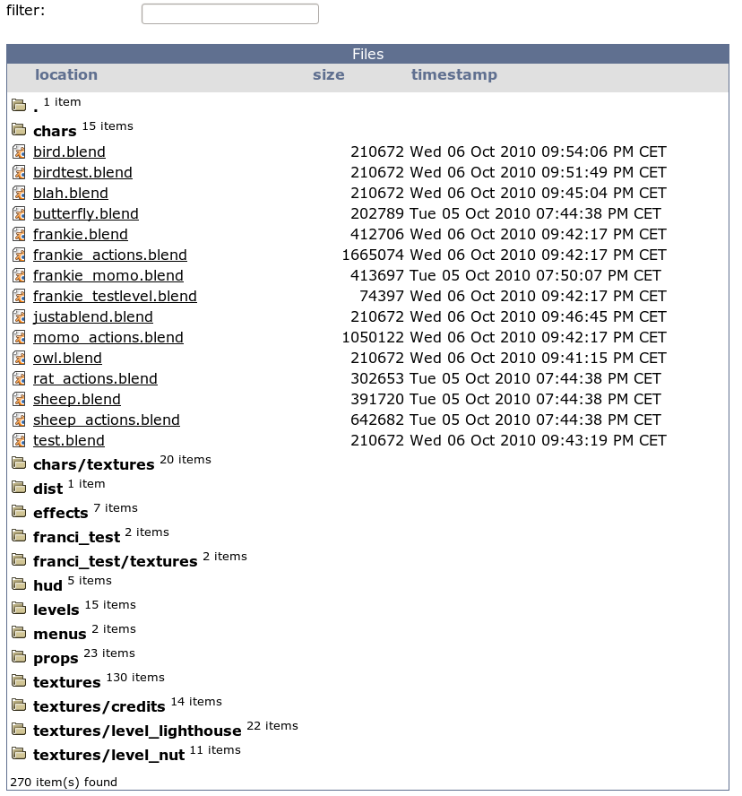
The filter can be used to search for a specific files.
When clicking on a folder the files inside the folder will be displayed.
When clicking on the column-headers the files will be sorted. The folder structure will not be sorted.

Production-view Scenes

The scenes tab has a advanced filter. You can match every files to criteria.
In the section Columns you'll be able to view additional information of the scene.
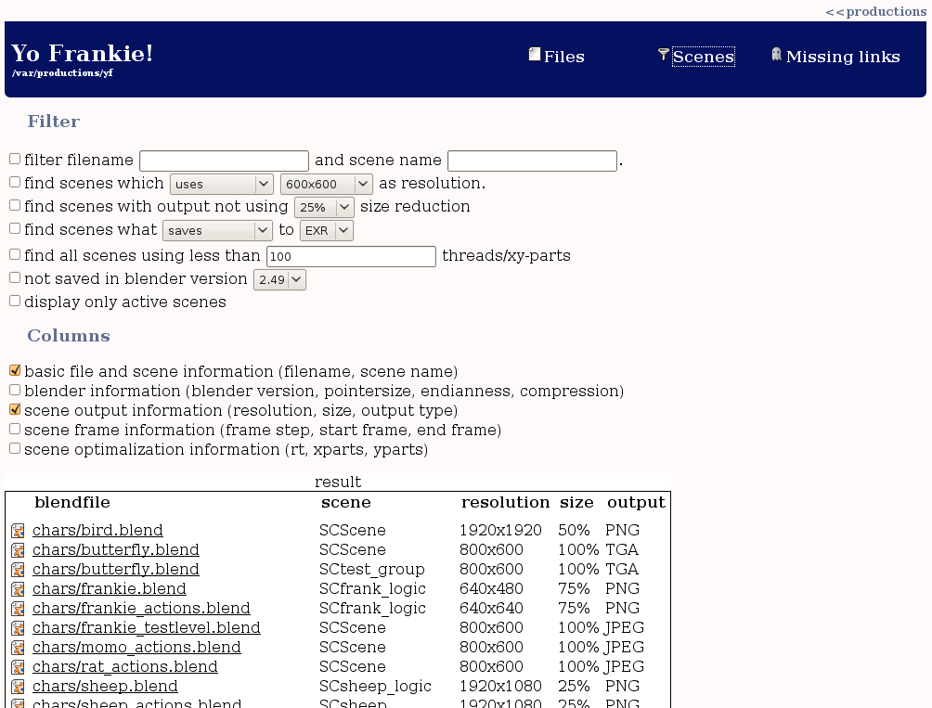

Production-view Missing links

When viewing the missing links you'll be shown a table with all missing links in the production. At the moment these links are only missing file links. In the future this can be enhanced with missing elements.
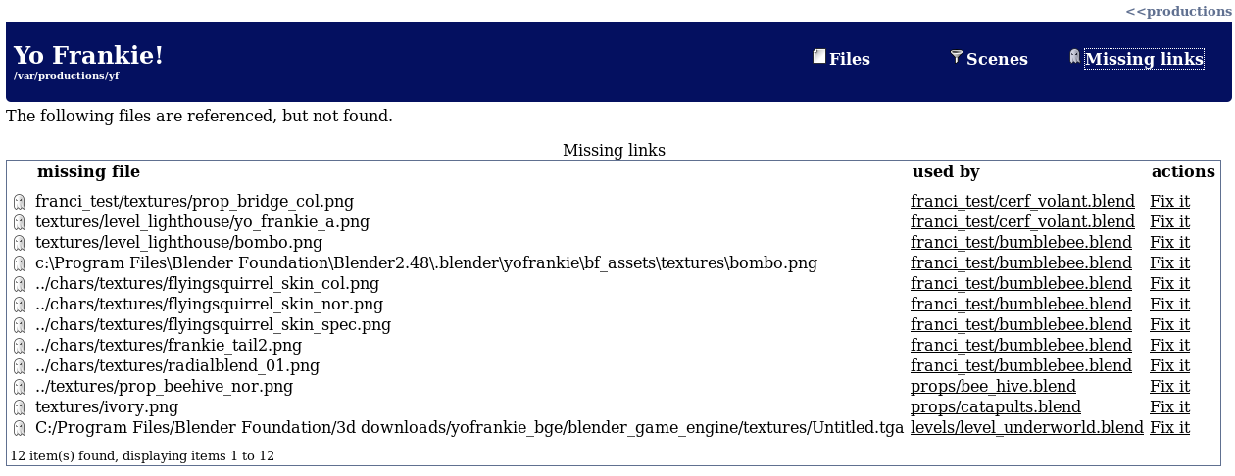When clicking on “Fix it” a popup will appear with possible links what can be made. These options are sorted by relevance
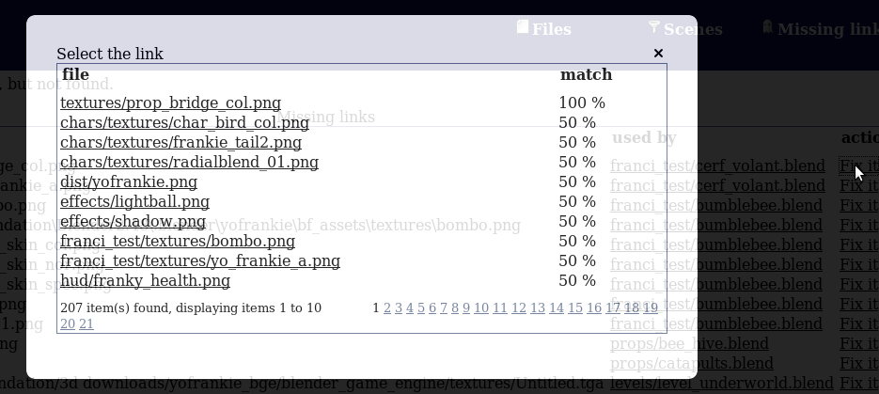
The relevance is determined by the name of the file (missing texture link) or by the usage of the file (missing blend link)
After selecting an option the next screen will appear to fix the link
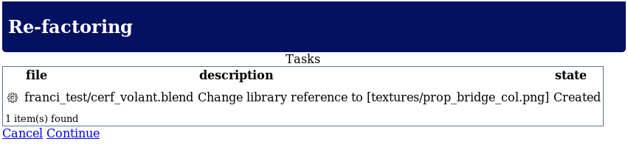
Press continue to perform these tasks or press cancel to return to the production-view
After continue the tasks will be performed and you will be asked to rollback or commit the changes. Before you continue, please test the result. After a commit or rollback you will be show the production-view

File-view
When clicking on a file in the production view you will get information about the file. This section describes this.
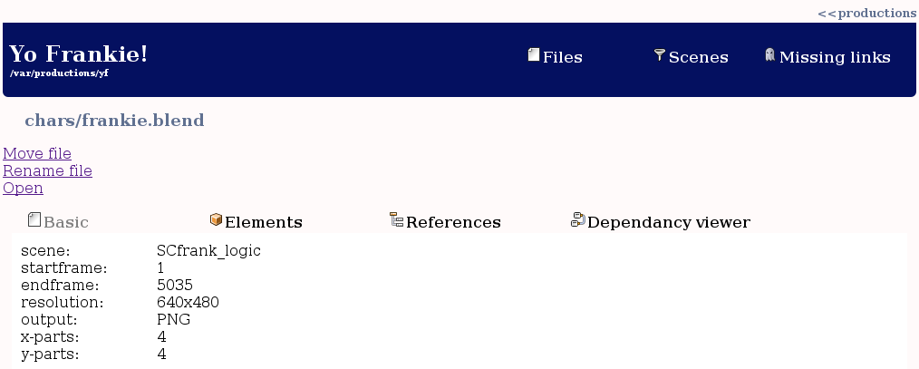
A file is show together with
- Local link – location to the file on the local file system for quick opening of the file
- Rename – Rename the file.
- Move – Move a file to another location in the production

Next to this information 4 tabs are displayed:
- Basic – some basic information about the file.
- Elements – the elements inside a blender file
- References – references between files
- Dependancy viewer – advanced production reference viewer

File-view Local link
With local link it is possible to quickly open the file on your system. Due to security reasons this has to be done using the following steps.
1. Press other mouse button on the link and choose Copy Link Location.
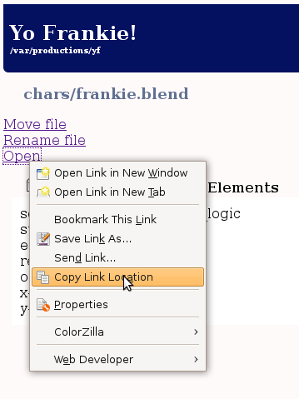
2. Depending on your OS start the run command (Alt-f2 on Ubuntu)
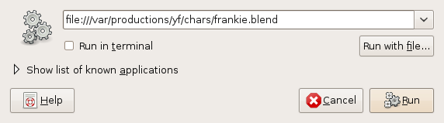
3. Press Paste
4. Press Run
blender will be started with the file depending on the configuration of your machine.
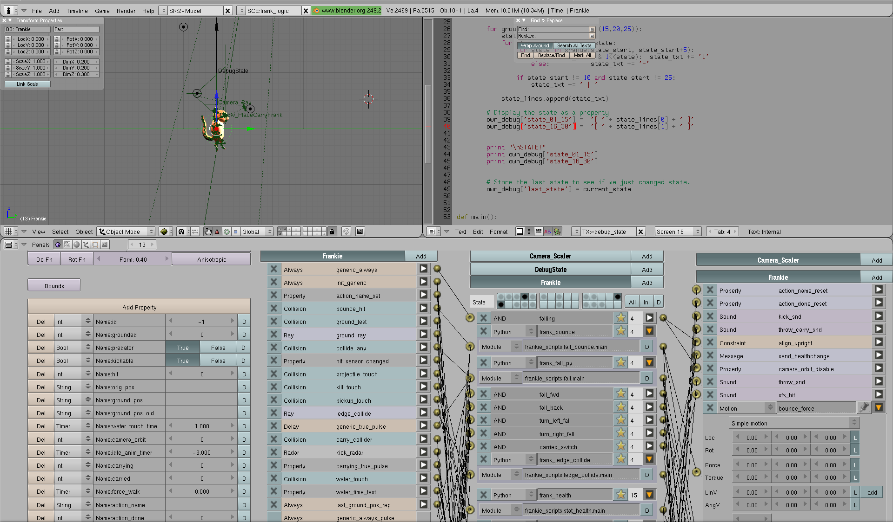

File-view Rename file
When pressing on rename file a popup will be shown asking you to enter the new filename
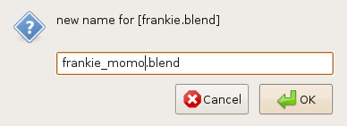
Enter new name and press OK. A screen will be displayed showing you what will be done
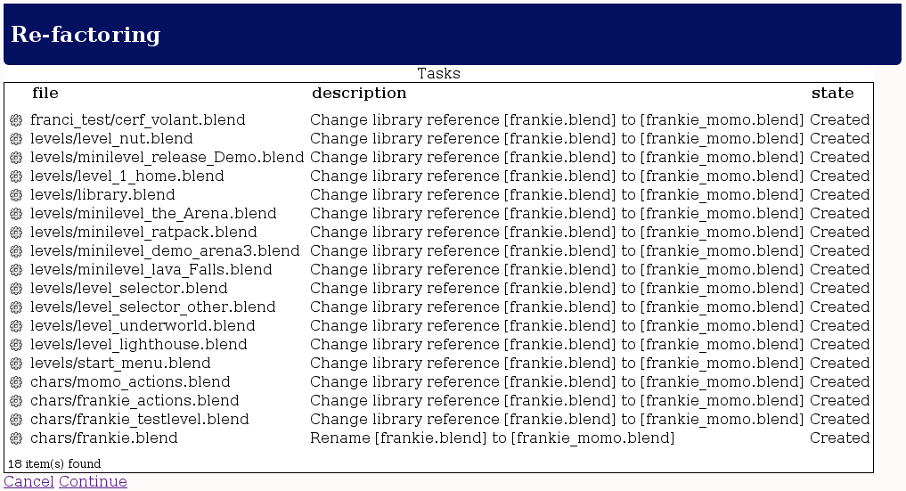Press continue to perform these tasks or press cancel to return to the file-view
After continue the tasks will be performed and you will be asked to rollback or commit the changes. Before you continue, please test the result of the rename. After a commit or rollback you will be show the production-view

File-view Move file
When pressing on move file a popup will be shown asking you to enter the new location
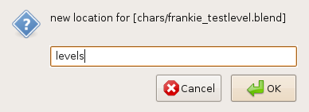
Enter new location and press OK. A screen will be displayed showing you what will be done
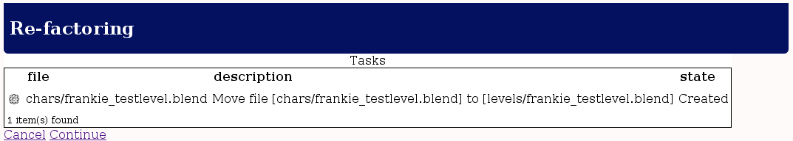
Press continue to perform these tasks or press cancel to return to the file-view
After continue the tasks will be performed and you will be asked to rollback or commit the changes. Before you continue, please test the result of the rename. After a commit or rollback you will be show the production-view

File-view Basic tab
The basic tab will display some basic information of the file. When the file is a texture a thumbnail will be displayed. For a blend file render information of the active scene will be shown.
When clicking on the image, the image will be downloaded or opened in your browser depending your browser-settings.
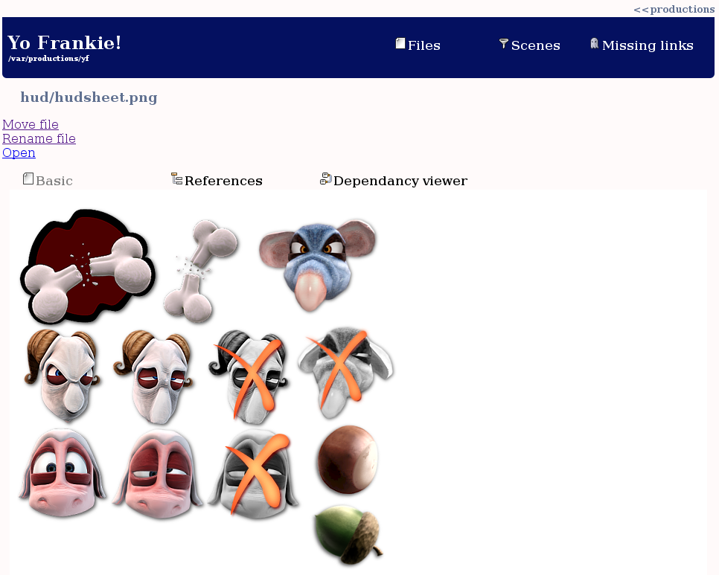

File-view Elements tab
The elements tab is only visible for blend files. It shows blender elements inside the file
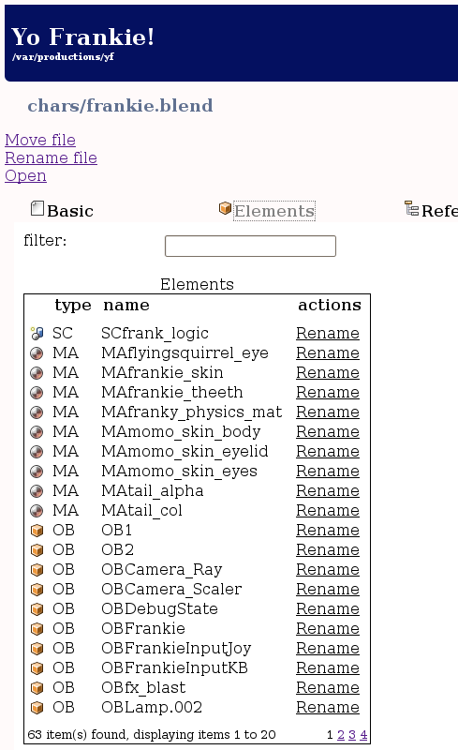
It has a filter to quickly find a specific element in the file. And the possibility to rename an element
When rename is clicked a popup will appear asking for a new name
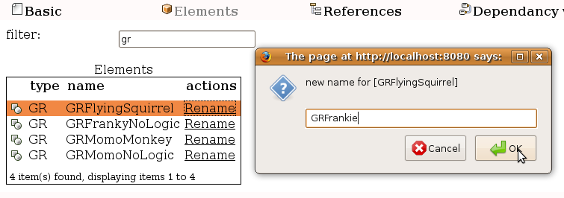
Enter new location and press OK. A screen will be displayed showing you what will be done

Press continue to perform these tasks or press cancel to return to the file-view
After continue the tasks will be performed and you will be asked to rollback or commit the changes. Before you continue, please test the result of the rename. After a commit or rollback you will be show the production-view
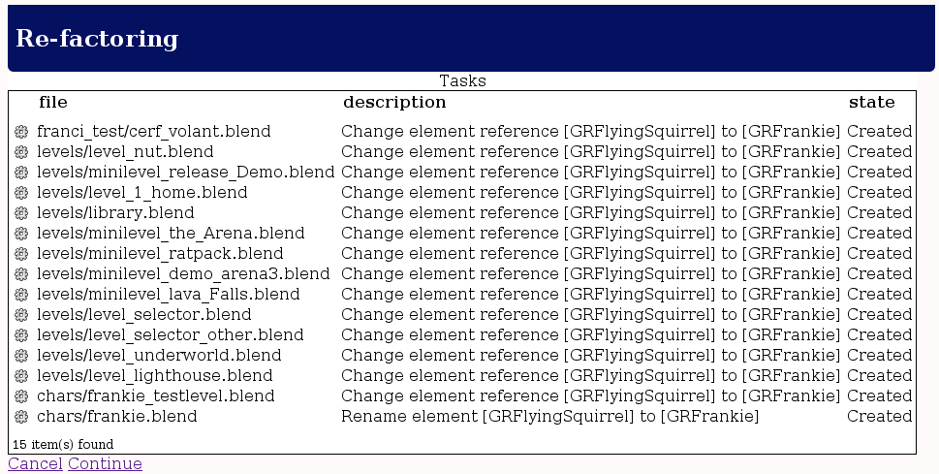

File-view References tab
The reference tab shows all links to other files and all links that other files have to the current selected file
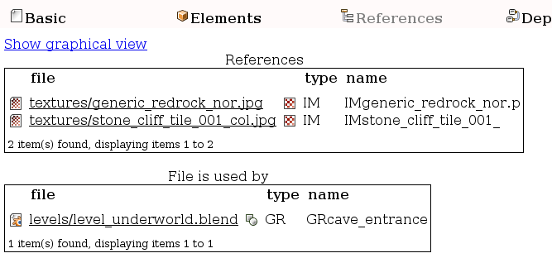
It also has the ability to show a graphical display of the file in with their direct neighbour files.
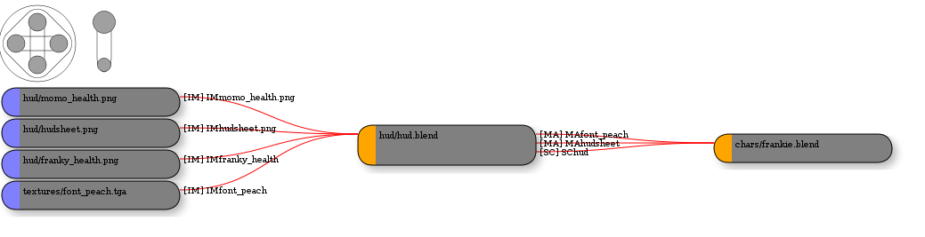
The buttons on the top-left enable you to move and to zoom the graphical display.
TODO: how to read the graphical display.

File-view Dependancy viewer tab
The dependancy viewer tab is an advanced version of the references tab.
It has filter options of certain blender elements (show only groups, or groups and materials) and it has the ability to look broader than only direct linked files. It also has a function to view all references in the total production.
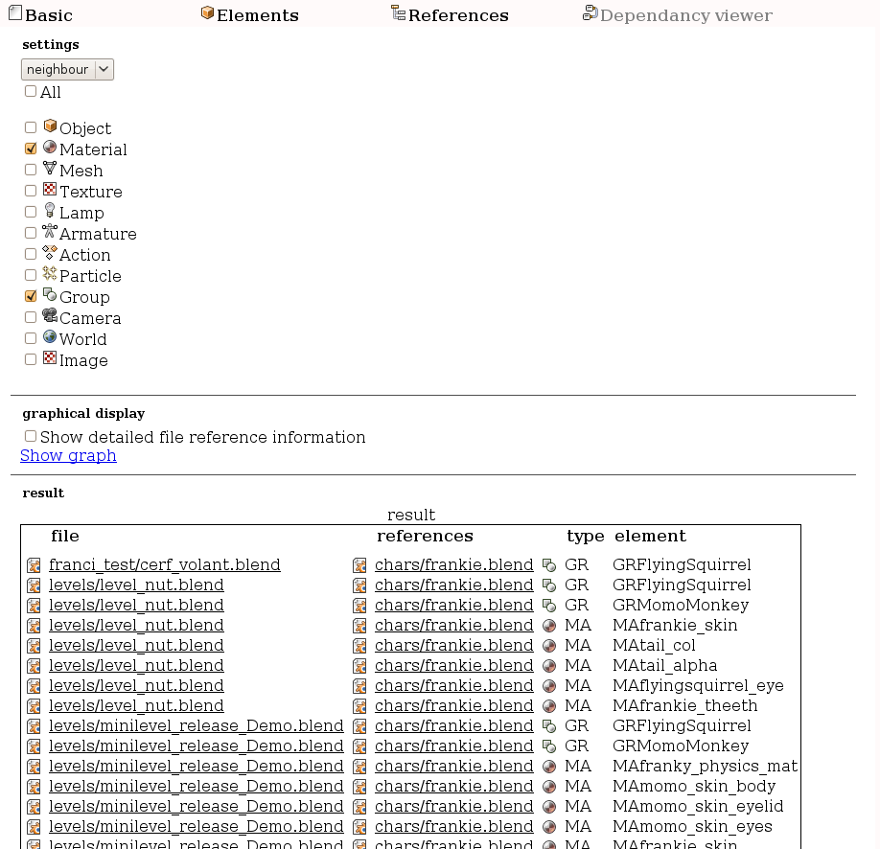
the dropdown list has 4 options. (neighbour, uses, used, production)
Neighbour | Shows only direct relations to and from the selected file. (example: texture, character, scene, when character is selected)
Uses | Will show all relations (and files) the selected file depends on. (example: texture, character, when character is selected)
Used | Will show all relations (and files) what depends on the selected file (example: character, scene, when character is selected)
Production | Show all relations between all files from the production.

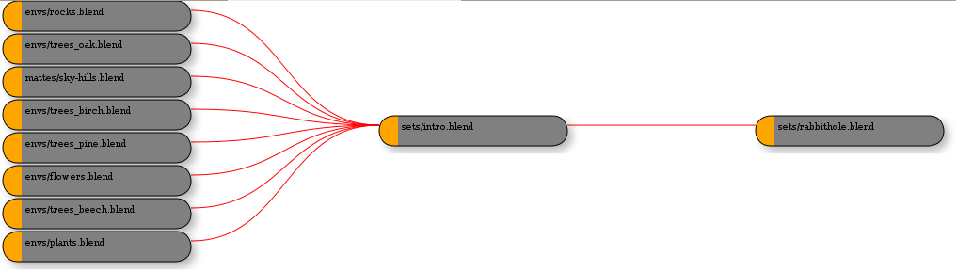Neighbours of “sets/intro.blend”

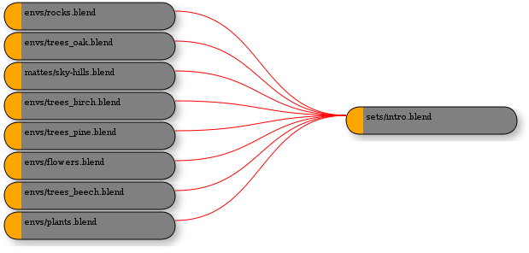
All uses of “sets/intro.blend”

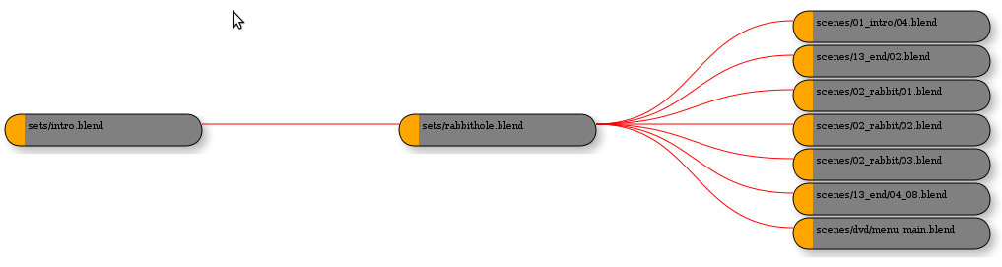
All used of “sets/intro.blend”

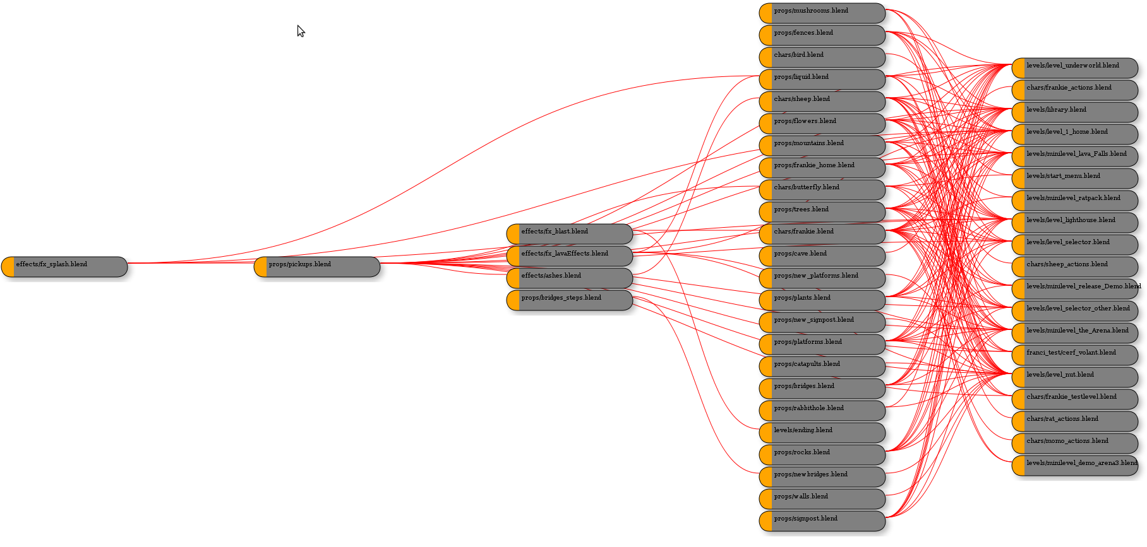
View complete production

Beneath the dropdown list it is possible to filter the relations (not show unselected relations)
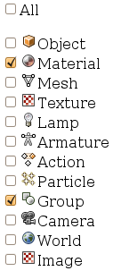
When “All” is selected the other selections are not shown.

SVN bindings
When the production has been checked-out with SVN information blender-aid provides basic SVN functionalities.
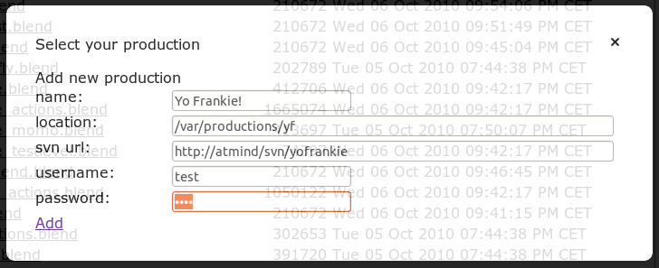
- Blender-aid will update the svn working folder during all refactoring actions. During renaming of a file, svn rename will be executed to update the bindings.
- Blender-aid can display the state of the working folder.
- Blender-aid can do basic SVN tasks like adding or reverting files.
When adding the production the Blender-aid and the location does not exist the production will be checked out from the SVN repository. For large productions this can take a while. During this time the mouse will be turned in a waiting cursor (hourglass or waiting wheel pending on your computer).
After selecting the production with SVN bindings a new menu item will be displayed (SVN state). This is highlighted in the next screenshot.
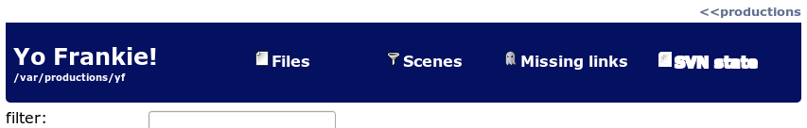

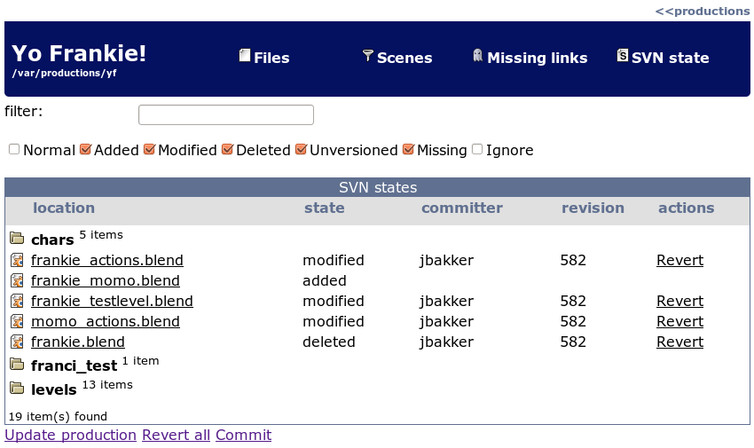
After usage the SVN state menu will display the SVN status of the working folder. Using the filter a file can be searched. Using the check-boxes the different states can be filtered.
Update production will perform a SVN update.
Revert all will revert all files
Commit will commit the changes to the SVN repository.

