Impact on screen:
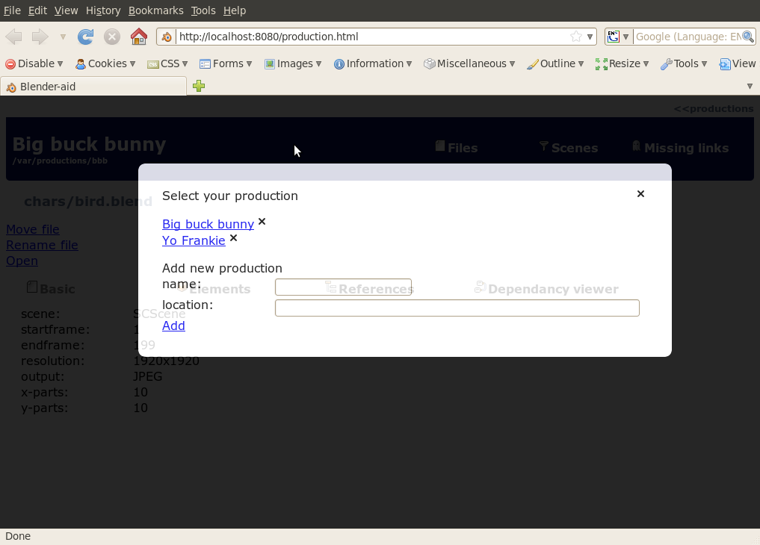
Add fields:
svn-url, svn-user and svn-password to screen
validations:
production.svn-url is empty ==> production.location must exist
production.svn-url is not empty & production.location exists & production.location(.svn) does not exist ==> do already connected warning
production.svn-url is not empty & production.location does not exist ==> do svnCheckout
production.location(.svn) exists ==> OK. Svn bindings found

Needs to be checked if we can reused existing repository settings (url, uid, pwd)

