🧼 Cleanser
• CeraVe Hydrating Cleanser
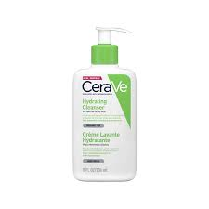
• La Roche-Posay Effaclar Gel
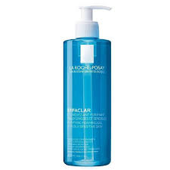
• The Ordinary Squalane Cleanser
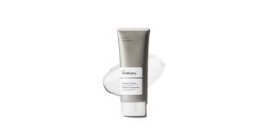
• Cetaphil Gentle Skin Cleanser
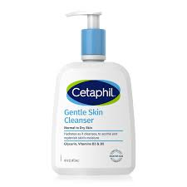

💧 Moisturiser
• CeraVe Moisturising Cream
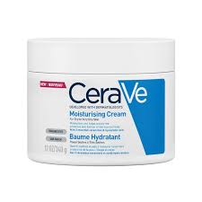
• La Roche-Posay Toleriane Sensitive
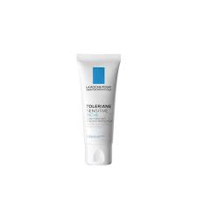
• Neutrogena Hydro Boost
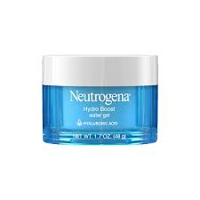
• The Ordinary Natural Moisturizing Factors + HA
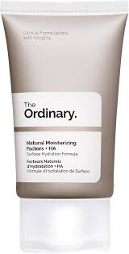

☀️ SPF (Sunscreen)
• La Roche-Posay Anthelios SPF 50+
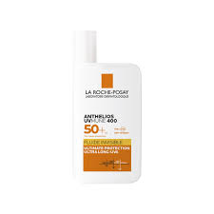
• Eucerin Oil Control SPF 50+
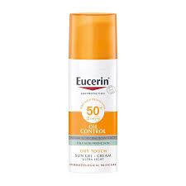
• Bioderma Photoderm SPF 50+
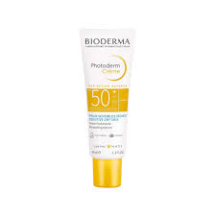
• Nivea Sun UV Face SPF 50
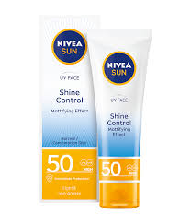

🌿 Toner
• Paula’s Choice Skin Perfecting 2% BHA
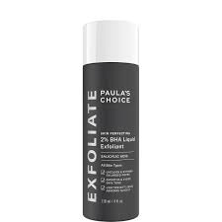
• The Ordinary Glycolic Acid 7% Toner
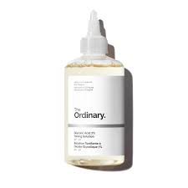
• Pixi Glow Tonic
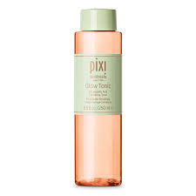
• Klairs Supple Preparation Toner

