Example test_space_truss_mm:

Go to File->Open->select the file test_space_truss_mm.geo

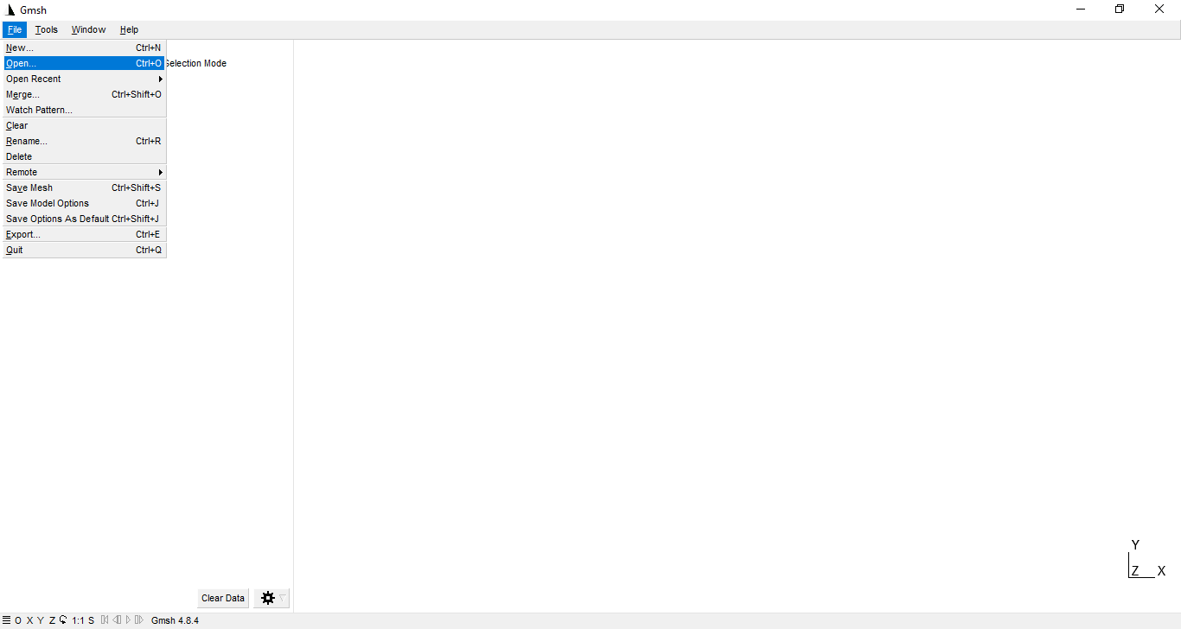

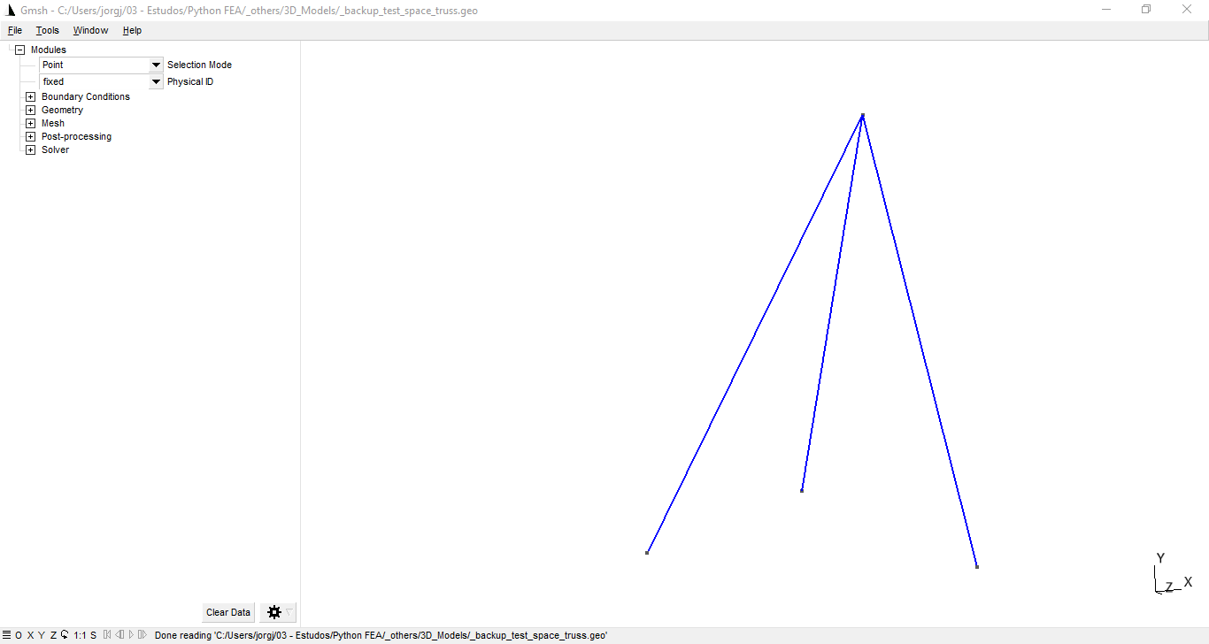

In the Upper Left of the program we have the drop-down menu of Selection Mode, and the Physical ID. The Physical IDs that are shown in the menu are the Physical Groups created using the GMSH build-in functions. In this example these groups were already created, so we just need to set the conditions of the analysis.

The units used are:

* [mm] for displacements and length of the trusses;
* [kN] for the force vectors;
* [GPa] for the stresses and young’s modulus (when using mm and kN for the anlysis the stresses will always be in GPa).

With the model loaded, we can now set the Boundary Conditions and the Material properties. After checking and changing the values according to the images, it is needed to click on the Set Boundary Conditions and the Set Material Properties button:

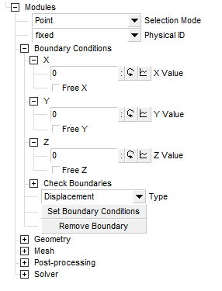 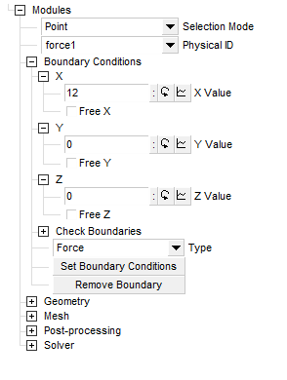

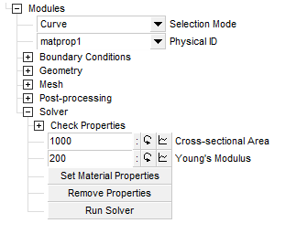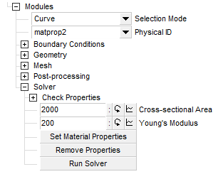

After setting both the boundary conditions and the material properties, we can now run the solver, by clicking on the Run Solver button. When the solver ends the simulation, the “Analysis finished” message will appear, and we can go to the Post-Processing submenu and check the results. Four additional files are created by the end of the analysis, they will appear on the root folder of the program. The .pdf file have the graphics of the displacement and stresses for every element modeled. The other files can be loaded direct on the program, to show only the results of the analysis.

