Lab 2
Jorge Mendez
2026-01-31

Probelm 1
We derive the following identities used in simple linear regression.
By definition,
$$S_{XY}=\sum_{i=1}^{n}{\left(x_{i}−\overset{‾}{x}\right)}\left(y_{i}−\overset{‾}{y}\right).$$
Expand the product:
$$\left(x_{i}−\overset{‾}{x}\right)\left(y_{i}−\overset{‾}{y}\right)=x_{i}y_{i}−\overset{‾}{x}y_{i}−\overset{‾}{y}x_{i}+\overset{‾}{x}\overset{‾}{y}.$$
Summing over $i$ gives
$$S_{XY}=∑x_{i}y_{i}−\overset{‾}{x}∑y_{i}−\overset{‾}{y}∑x_{i}+∑\overset{‾}{x}\overset{‾}{y}.$$
Since $\overset{‾}{x}$ and $\overset{‾}{y}$ are constants,
$$∑\overset{‾}{x}\overset{‾}{y}=n\overset{‾}{x}\overset{‾}{y}, ∑x_{i}=n\overset{‾}{x}, ∑y_{i}=n\overset{‾}{y}.$$
Substituting,
$$S_{XY}=∑x_{i}y_{i}−n\overset{‾}{x}\overset{‾}{y}.$$
Using
$$\overset{‾}{x}=\frac{∑x_{i}}{n}, \overset{‾}{y}=\frac{∑y_{i}}{n},$$
we obtain
$$S_{XY}=∑x_{i}y_{i}−\frac{\left(∑x_{i}\right)\left(∑y_{i}\right)}{n}.$$
By definition,
$$S_{XX}=\sum_{i=1}^{n}{{\left(x_{i}−\overset{‾}{x}\right)}^{2}}.$$
Expand the square:
$${\left(x_{i}−\overset{‾}{x}\right)}^{2}=x_{i}^{2}−2\overset{‾}{x}x_{i}+{\overset{‾}{x}}^{2}.$$
Summing over $i$,
$$S_{XX}=∑x_{i}^{2}−2\overset{‾}{x}∑x_{i}+∑{\overset{‾}{x}}^{2}.$$
Since $∑x_{i}=n\overset{‾}{x}$ and $∑{\overset{‾}{x}}^{2}=n{\overset{‾}{x}}^{2}$,
$$S_{XX}=∑x_{i}^{2}−n{\overset{‾}{x}}^{2}.$$
Using $\overset{‾}{x}=\frac{∑x_{i}}{n}$,
$$S_{XX}=∑x_{i}^{2}−\frac{{\left(∑x_{i}\right)}^{2}}{n}.$$
Similarly,
$$S_{YY}=\sum_{i=1}^{n}{{\left(y_{i}−\overset{‾}{y}\right)}^{2}}.$$
Expanding and summing,
$$S_{YY}=∑y_{i}^{2}−2\overset{‾}{y}∑y_{i}+n{\overset{‾}{y}}^{2}.$$
Since $∑y_{i}=n\overset{‾}{y}$,
$$S_{YY}=∑y_{i}^{2}−n{\overset{‾}{y}}^{2}.$$
Using $\overset{‾}{y}=\frac{∑y_{i}}{n}$,
$$S_{YY}=∑y_{i}^{2}−\frac{{\left(∑y_{i}\right)}^{2}}{n}.$$

Problem 2

(2a) Correlation Matrix
## midterm final hw total
## midterm 1.00 0.55 0.27 0.84
## final 0.55 1.00 0.09 0.78
## hw 0.27 0.09 1.00 0.56
## total 0.84 0.78 0.56 1.00

(2b)
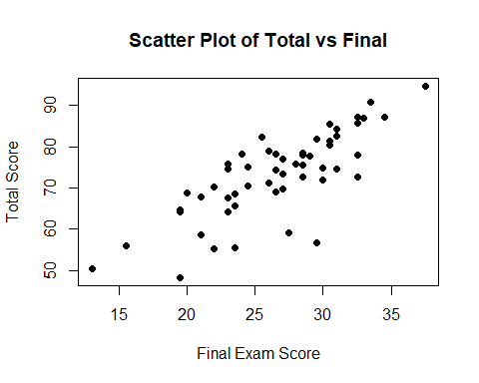

(2c)
##
## Call:
## lm(formula = total ~ final, data = stat500)
##
## Residuals:
## Min 1Q Median 3Q Max
## -21.062 -3.369 1.233 4.046 10.831
##
## Coefficients:
## Estimate Std. Error t value Pr(>|t|)
## (Intercept) 30.7126 4.7631 6.448 3.48e-08 ***
## final 1.5983 0.1768 9.041 2.53e-12 ***
## ---
## Signif. codes: 0 '***' 0.001 '**' 0.01 '*' 0.05 '.' 0.1 ' ' 1
##
## Residual standard error: 6.436 on 53 degrees of freedom
## Multiple R-squared: 0.6066, Adjusted R-squared: 0.5992
## F-statistic: 81.73 on 1 and 53 DF, p-value: 2.533e-12
A simple linear regression model was fit with total score as the response variable and final exam score as the predictor. The estimated regression equation is
$\hat{\text{total}}=30.71+1.60\left(\text{final}\right)$
The slope estimate indicates that for each one-point increase in final exam score, the total score increases by approximately 1.60 points on average. The slope is statistically significant (t = 9.04, p-value = 2.53 × 10⁻¹²).

(2d) Residual analysis

Residuals vs fitted values
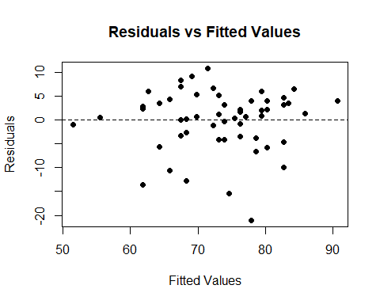

Normal Q–Q plot
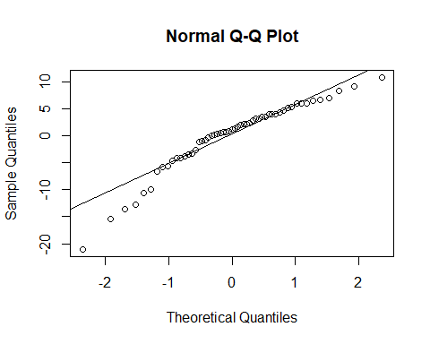

Cook’s distance (outliers / influence)
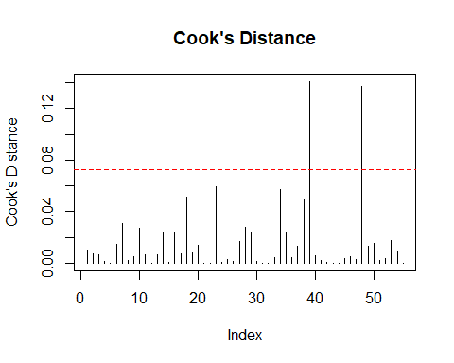 The residuals versus fitted values plot shows no clear pattern, suggesting that the assumptions of linearity and constant variance are reasonable. The normal Q–Q plot indicates that the residuals are approximately normally distributed. Cook’s distance does not reveal any highly influential observations.

(2e) Prediction with prediction intervals
## fit lwr upr
## 1 142.5929 122.4015 162.7843
## 2 158.5758 135.5609 181.5906
## 3 174.5587 148.5429 200.5744
Using the fitted regression model, prediction intervals were constructed for total scores at selected final exam scores. For example, when the final exam score is 80, the predicted total score is 158.58, with a 95% prediction interval of (135.56, 181.59). This interval represents the range in which an individual student’s total score is expected to fall.

Problem 3

(3a) Fit the simple linear regression
##
## Call:
## lm(formula = y ~ x8, data = table.b1)
##
## Residuals:
## Min 1Q Median 3Q Max
## -3.804 -1.591 -0.647 2.032 4.580
##
## Coefficients:
## Estimate Std. Error t value Pr(>|t|)
## (Intercept) 21.788251 2.696233 8.081 1.46e-08 ***
## x8 -0.007025 0.001260 -5.577 7.38e-06 ***
## ---
## Signif. codes: 0 '***' 0.001 '**' 0.01 '*' 0.05 '.' 0.1 ' ' 1
##
## Residual standard error: 2.393 on 26 degrees of freedom
## Multiple R-squared: 0.5447, Adjusted R-squared: 0.5272
## F-statistic: 31.1 on 1 and 26 DF, p-value: 7.381e-06
A simple linear regression model was fit relating the number of games won
$$\hat{y}=21.79−0.00703 x_{8}$$
The slope is negative, indicating that as opponents’ rushing yards increase, the number of games won tends to decrease. The slope is statistically significant (t = −5.58, p-value = 7.38 × 10⁻⁶), suggesting that opponents’ rushing yards have a significant effect on games won.

(3b) ANOVA table and test for significance of regression
## Analysis of Variance Table
##
## Response: y
## Df Sum Sq Mean Sq F value Pr(>F)
## x8 1 178.09 178.092 31.103 7.381e-06 ***
## Residuals 26 148.87 5.726
## ---
## Signif. codes: 0 '***' 0.001 '**' 0.01 '*' 0.05 '.' 0.1 ' ' 1
Hypotheses
$$H_{0}:β_{1}=0 \text{vs.} H_{a}:β_{1}≠0$$
$$F=31.10, p\text{-value}=7.38×{10}^{−6}$$
The ANOVA F-test gives
$F=31.10$ with a p-value of $7.38×{10}^{−6}$.
Since the p-value is much smaller than 0.05, we reject the null hypothesis. There is strong evidence that opponents’ rushing yards are significantly related to the number of games won.

(3c) 95% confidence interval for the slope B1
## 2.5 % 97.5 %
## (Intercept) 16.246064040 27.330437725
## x8 -0.009614347 -0.004435854
A 95% confidence interval for the slope parameter $β_{1}$ (the coefficient of $x_{8}$) is
$$\left(−0.00961, −0.00444\right).$$
Equivalently,
$$−0.00961≤β_{1}≤−0.00444.$$
Since this interval does not contain $0$, we conclude that the slope is statistically different from zero at the $α=0.05$ level. Because the entire interval is negative, this indicates that larger values of opponents’ rushing yards ($x_{8}$) are associated with fewer games won ($y$).

(3d) Percent of variability
From the fitted regression model, the coefficient of determination is
$$R^{2}=0.5447.$$
Therefore, the percentage of variability in $y$ (games won) explained by the linear relationship with $x_{8}$ (opponents’ rushing yards) is
$$0.5447×100\%=54.47\%.$$
Thus, approximately $54.47\%$ of the variability in games won is explained by opponents’ rushing yards.

(3e) 95% confidence interval for the mean response
## fit lwr upr
## 1 7.73805 6.765753 8.710348
A 95% confidence interval for the mean number of games won when opponents’ rushing yards are $x_{8}=2000$ is $\left(6.77, 8.71\right)$. This interval represents plausible values for the average number of games won for teams whose opponents allow approximately 2000 rushing yards.

Problem 4

(4a) Hypotheses
We wish to test whether the population mean repair time exceeds 225 hours. The hypotheses are
$$H_{0}: μ=225 \text{vs.} H_{a}: μ>225.$$
##
## One Sample t-test
##
## data: hours
## t = 0.66852, df = 15, p-value = 0.257
## alternative hypothesis: true mean is greater than 225
## 95 percent confidence interval:
## 198.2321 Inf
## sample estimates:
## mean of x
## 241.5

(4b)
Using a one-sample $t$-test at the $α=0.05$ significance level, the test statistic is
$$t=0.669 \text{with }df=15.$$
The p-value is $0.257$. Since $0.257>0.05$, we fail to reject $H_{0}$. Therefore, there is insufficient evidence to conclude that the mean repair time exceeds 225 hours.

(4c)
The p-value is $0.257$.

(4d)
A 95% confidence interval for the population mean repair time is
$$\left(198.23, ∞\right).$$

