Lab1
Jorge Mendez
2026-01-18

Problems

Problem 1: Check Normality Dsitribution of data (QQ PLOT)
sample <- c(26.4,23.5,25.4,22.9,25.2,39.2,25.5,31.9,26.0,44.6,35.5,38.6,
30.1,31.0,30.8,32.8,47.7,39.1,55.3,50.7,73.8,71.1,68.4,77.1,
19.4,19.3,18.7,19.0,23.2,21.3,23.2,19.9,18.9,19.8,19.6,21.9)
hist(sample)
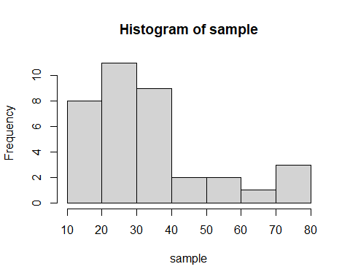
sample.s <- sort(sample) #sort data increasing
sample.s
## [1] 18.7 18.9 19.0 19.3 19.4 19.6 19.8 19.9 21.3 21.9 22.9 23.2 23.2 23.5 25.2
## [16] 25.4 25.5 26.0 26.4 30.1 30.8 31.0 31.9 32.8 35.5 38.6 39.1 39.2 44.6 47.7
## [31] 50.7 55.3 68.4 71.1 73.8 77.1
rank <- rank(sample.s) #rank data from 1 to 36
rank
## [1] 1.0 2.0 3.0 4.0 5.0 6.0 7.0 8.0 9.0 10.0 11.0 12.5 12.5 14.0 15.0
## [16] 16.0 17.0 18.0 19.0 20.0 21.0 22.0 23.0 24.0 25.0 26.0 27.0 28.0 29.0 30.0
## [31] 31.0 32.0 33.0 34.0 35.0 36.0
size <- length(sample.s) # tells me the size of the data
size
## [1] 36
p <- (rank-.5)/size
p
## [1] 0.01388889 0.04166667 0.06944444 0.09722222 0.12500000 0.15277778
## [7] 0.18055556 0.20833333 0.23611111 0.26388889 0.29166667 0.33333333
## [13] 0.33333333 0.37500000 0.40277778 0.43055556 0.45833333 0.48611111
## [19] 0.51388889 0.54166667 0.56944444 0.59722222 0.62500000 0.65277778
## [25] 0.68055556 0.70833333 0.73611111 0.76388889 0.79166667 0.81944444
## [31] 0.84722222 0.87500000 0.90277778 0.93055556 0.95833333 0.98611111
z.quantile <- qnorm(p) #Standard Normal Quantiles with such Probability
z.quantile
## [1] -2.20041058 -1.73166440 -1.47994139 -1.29754293 -1.15034938 -1.02459239
## [7] -0.91324993 -0.81221780 -0.71886805 -0.63140189 -0.54852228 -0.43072730
## [13] -0.43072730 -0.31863936 -0.24616365 -0.17495994 -0.10463346 -0.03482132
## [19] 0.03482132 0.10463346 0.17495994 0.24616365 0.31863936 0.39283081
## [25] 0.46925288 0.54852228 0.63140189 0.71886805 0.81221780 0.91324993
## [31] 1.02459239 1.15034938 1.29754293 1.47994139 1.73166440 2.20041058
plot(x= z.quantile, y=sample.s, pch=16, main= 'QQ Plot') #scatterplot of x=Z quantiles, y - data sorted
abline(lm(sample.s ~ z.quantile))
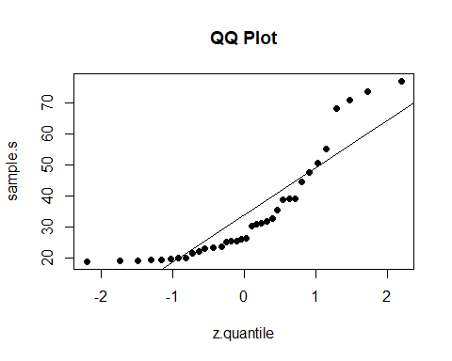 Question: Observe the patter of the points.
Observation : If the data were normal, deviations from the line would be small and random; here they are large, especially in the tails, indicating that the data is not approximately normal.
qqnorm(sample.s)
qqline(sample.s)
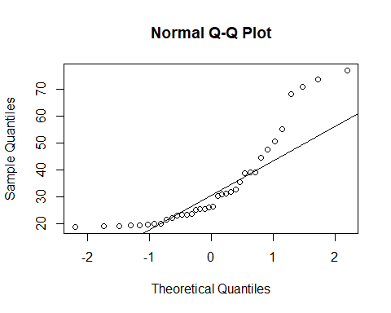

Problem 2
sample <- c

