Gingeras Lab RNA-Seq Library Production Document
ENCODE Transcriptome
Sample Description: [Cell Line] Whole Cell Poly-A+ RNA Biorep #
RNA ID:
Library ID:
Protocol ID:
Cold Spring Harbor Laboratory
Genome Center
500 Sunnyside Blvd
Woodbury, NY 11797

Lab members
Wet lab: Kim Bell, Meagan Fastuca, Carrie A. Davis, Jorg Drenkow, Lei Hoon See, Huaien Wang.
Computational Lab: Alex Dobin, Sonali Jha, Wei Lin, Felix Schlesinger, Chris Zaleski.

PI: Tom Gingeras

CELL CULTURE: Cells are grown according to the ENCODE growth protocol and standards. Each bioreplicate grown and isolated independently.

RNA ISOLATION:

Kits: miRNeasy Mini kit (QIAGEN cat#:217004)
RNeasy MinElute cleanup kit (QIAGEN cat#:74204)

1. Regular harvest and count cells and centrifuge for 10 min at 1900 rpm 4°C.
2. Completely aspirate supernatant.
3. Resuspend all pellets in 10-30 mL of cold PBS by pipetting up and down.
4. Centrifuge for 5 min at 2000 rpm 4°C.
5. Carefully aspirate the supernatant.
6. Add QIAzol Lysis Reagent to the pellet and vortex to mix.
7. If number of cells is ≤ 3x10⁶ then vortex for 1 min to homogenize the cells.
If number of cells is >3x10⁶ homogenize by placing 700 µL of sample into a QIAshredder homogenizer and centrifuge for 2.5 min at maximum speed.
8. Place the tube(s) containing the homogenate on the benchtop at room temperature (15-25°C) for 5 min.
9. Add 20% volumes of chloroform to the homogenate and cap it securely. Shake the tube vigorously for 15 s.
10. Place the tube containing the homogenate on the benchtop at room temperature for 2-3 minutes.
11. Centrifuge the homogenate for 15 min at 12,000 x g at 4°C.
12. Transfer the upper, colorless, aqueous phase containing the RNA to a new collection tube.
13. Add and equal volume of 70% ethanol and mix thoroughly by vortexing. Do not centrifuge.
14. Pipet 700 µL of the sample including any precipitate that may have formed into an RNeasy Mini spin column placed in a 2 mL collection tube. Close the lid gently and centrifuge at ≥8000 x g (≥10,000 rpm) for 30 s at room temperature. Repeat this step until the whole sample has been pipetted into the spin column and discard the flow-through each time.
15. Pipet the flow-through (which contains miRNA) into a 2 mL RNase free tube. The spin column contains the large RNA.

Large RNA Purification

L1. Pipet 700 µL Buffer RWT into the RNeasy Mini spin column from step 15. Close the lid gently and centrifuge for 30 at ≥8000 x g (≥10,000 rpm) to wash the spin column membrane. Discard the flow through.
L2. Add 500 µL Buffer RPE to the RNeasy Mini spin column. Close the lid gently and centrifuge for 30 s at ≥8000 x g (≥10,000 rpm) to wash the spin column membrane. Discard the flow through.
L3. Add another 500 µL Buffer RPE to the RNeasy Mini spin column. Close the lid gently and centrifuge for 30 s at ≥8000 x g (≥10,000 rpm) to wash the spin column membrane. Discard the flow through and the collection tube.
L4. Place the RNeasy Mini spin column in a new 2 mL collection tube. Open the lid and centrifuge at full speed for 1 min.
L5. Transfer the RNeasy Mini spin column to a new 1.5 ml collection tube. Pipet 30-50 µL RNase-free water directly onto the RNeasy Mini spin column membrane. Close the lid gently. Wait one minute and then centrifuge for 1 min at ≥8000 x g (≥10,000 rpm) to elute the total RNA (containing large RNA).
L6. If the expected RNA yield is >30 µg, repeat step L5 with an additional volume of 30-50 µL RNase-free water. Elute into the same collection tube.
L7. Proceed to ethanol precipitation.

Ethanol Precipitation

1. Add 2.5 volumes of 100% ethanol and 1/10 volumes of NaOAc PH 5.5 to the eluted RNA.
2. Freeze in -80°C for at least 30 min.
3. Centrifuge for 35 min at max speed at 4°C.
4. Pipette and discard the supernatant making sure not to touch the pellet of RNA.
5. Wash with 1 mL of 70% ethanol and centrifuge at max speed for 5 min.
6. Pipette and discard the supernatant.
7. Open the cap and speed vacuum at low heat for 3-5 min making sure that the pellet is dry.
8. Resuspend the pellet with RNase-free water.

DNase Digest (same for Small and Large RNA)

Reagents | 100 µL Sample (100 µg RNA max) | 50 µL Sample  (50 µg RNA max)
Total RNA (100 µg max) | 78 µL | 39 µL
10X One-phor-all Buffer | 10 µL | 5 µL
10 U/µL DNase/RNase Free | 8 µL | 4 µL
20 U/µL RNasin/anti-RNase | 4 µL | 2 µL
Total Volume | 100 µL | 50 µL

1. Add all reagents to resuspended RNA and pipette to mix well.
2. Place in a 37°C waterbath for 30 min.
3. Proceed to RNA Cleanup, which is different for Small and Large RNA.

Large RNA Cleanup

1. Add 350 µL Buffer RLT to the 100 µL (100 µg) sample of RNA. Vortex to mix well.
2. Add 250 µL of 100% ethanol to the reaction and mix by inverting.
3. Transfer the 700 µL of sample to an RNeasy mini spin column placed in a 2 mL collection tube. Close the lid gently and centrifuge for 30 s at 8000 x g (≥10,000 rpm). Discard the flow through.
4. Add 700 µL Buffer RW1 to the RNeasy mini spin column. Close the lid gently and centrifuge for 30 s at 8000 x g (≥10,000 rpm). Discard the flow through.
5. Repeat Step 4.
6. Add 500 µL Buffer RPE to the RNeasy mini spin column. Close the lid gently and centrifuge for 30 s at 8000 x g (≥10,000 rpm). Discard the flow through.
7. Repeat Step 6.
8. Transfer the RNeasy spin column to a new collection tube. Centrifuge for 2 min at 10,000 x g to dry the RNeasy membrane.
9. Place the RNeasy spin column into a new 1.5 mL collection tube and discard the old tube. Add 30-50 µL of RNase-free water directly on the spin column membrane. Close the lid gently and let stand for 1 min. Centrifuge for 1 min at 10,000 x g to elute the RNA.
10. Add another 30-50 µL of RNase-free water onto the membrane using the same centrifuge tube. Wait 1 min and then centrifuge for 1 min at 10,000 x g to elute the RNA.
11. Proceed to ethanol precipitation.

Ethanol Precipitation

1. Add 2.5 volumes of 100% ethanol and 1/10 volumes of NaOAc PH 5.5 to the eluted RNA.
2. Freeze in -80°C for at least 30 min.
3. Centrifuge for 30 min at max speed at 4°C.
4. Pipette and discard the supernatant making sure not to touch the pellet of RNA.
5. Wash with 1 mL of 70% ethanol and centrifuge at max speed for 5 min.
6. Pipette and discard the supernatant.
7. Open the cap and speed vacuum at low heat for 5 min making sure that the pellet is dry.
8. Resuspend the pellet with RNase-free water.

POLY-A+ SELECTION:

Qiagen mRNA Isolation Protocol (using Oligotex mini kit)

The batch protocol has been used for the recent library production, but from other experience the spin column protocol (listed in the handbook prior to the batch protocol) gives the same results (as far as bioanalyzer image goes)

Important notes before starting
• This protocol may be necessary if you are using impure total RNA or if you are unsure about the purity of your total RNA. Many isolation procedures do not remove contaminants such as protein that can clog Oligotex spin columns. Better results are generally obtained with purer starting material.

• Heat Oligotex Suspension to 37°C in a water bath or heating block. Mix by vortexing, and then place at room temperature.
• Heat a water bath or heating block to 70°C, and heat Buffer OEB.
• Review the introductory material on pages 12–19 before starting.
• If working with RNA for the first time, please read Appendix A (page 76).
• Determine the amount of total RNA in the RNA sample (see “Quantification of starting
RNA”, page 18).

• Buffer OBB may (and almost always does) form a precipitate upon storage. If necessary, redissolve by warming at 37°C for approximately 10 minutes, and then place at room temperature. You can wrap the OBB bottle in parafilm and carefully, partially, submerge it in the water bath, or aliquot the needed amount in 1.5ml tubes and use the heat block

• Unless otherwise indicated, all protocol steps, including centrifugation, should be performed at 20 to 30°C (room temp).
• All centrifugation steps should be performed in a microcentrifuge at maximum speed (14,000–18,000 x g).

Procedure

1. Determine the amount of starting RNA. Do not use more than 3 mg total RNA. Pipet total RNA into an RNase-free 1.5 ml microcentrifuge tube, and adjust the volume with RNase-free water (if necessary) to the volume indicated in Table 5.

Note: The initial volume of the RNA solution is not important so long as the volume can be brought up to the indicated amount with RNase-free water. If starting with precipitated RNA, dissolve the RNA pellet in the appropriate amount of RNase-free water by heating the tube for 3 min at 60°C followed by vortexing for 5 s and sharply flicking the tube. Repeat at least twice.

2. Add the appropriate volume of Buffer OBB and Oligotex Suspension (see Table 5). Mix the contents thoroughly by pipetting or flicking the tube.

Table 5. Buffer amounts for Oligotex mRNA Batch Protocol

Total RNA | Add RNAse free water to: | Buffer OBB (ul) | Oligotex Suspension (ul) | Prep size
≤0.25 mg | 250 ul | 250 | 15 | Mini
0.25–0.50 mg | 500ul | 500 | 30 | Midi
0.50–0.75 mg | 500ul | 500 | 45 | Midi
0.75–1.00 mg | 500ul | 500 | 55 | Midi
1.0–1.5 mg | 650ul | 650 | 85 | Maxi
1.5–2.0 mg | 650ul | 650 | 115 | Maxi
2.0–2.5 mg | 650ul | 650 | 135 | Maxi
2.5–3.0 mg | 650ul | 650 | 175 | Maxi

*We generally use slightly more than the recommended amount of beads (~5ul)

3. Incubate the sample for 3 min at 70°C in a water bath or heating block.
This step disrupts secondary structure of the RNA.
4. Remove sample from the water bath/heating block, and place at 20 to 30°C for
12 min (manual says 10, we say 12).
This step allows hybridization between the oligo dT30 of the Oligotex particle and the poly-A tail of the mRNA.
5. Pellet the Oligotex:mRNA complex by centrifugation for 2 min at maximum speed (14,000–18,000 x g), and carefully remove the supernatant by pipetting.
Loss of the Oligotex resin can be avoided if approximately 50 μl of the supernatant is left in the microcentrifuge tube. The remaining solution will not affect the procedure. Note: Save the supernatant until certain that satisfactory binding and elution of poly A+ mRNA has occurred. We save the supernatant always, as to save the A- fraction.

6. Resuspend the Oligotex:mRNA pellet in 1 ml Buffer OW2 by vortexing or pipetting (pipetting works better, be sure to resuspend well) Pellet the Oligotex:mRNA complex by centrifugation for 2 min at maximum speed, and carefully remove the supernatant by pipetting.
Loss of the Oligotex resin can be avoided if approximately 50 μl of the supernatantis left in the microcentrifuge tube. The remaining solution will not affect the procedure.
7. Repeat step 6 once.
8. Add 20–100 μl hot (70°C) Buffer OEB. Pipet up and down 10-15 times to resuspend the resin, and centrifuge for 2 min at maximum speed. Carefully transfer the supernatant, containing the eluted poly A+ mRNA, to a small spin column, close column and set aside.
*We always use 100ul, it gives better yields.
Note: The volume of Buffer OEB used depends on the expected or desired concentration of poly A+ mRNA. Ensure that Buffer OEB does not cool significantly during handling. Remember that small volumes cool down quickly. With multiple samples, it may be necessary to place the entire microcentrifuge tube (with Oligotex and sample) into a 70°C heating block to maintain the temperature while preparing the next samples.
9. To ensure maximal yield, add another 20–100 μl hot (70°C) Buffer OEB to the
Oligotex pellet. Pipet up and down 10-15 times to resuspend the resin, and centrifuge for 2 min at maximum speed. Carefully transfer the supernatant, containing the eluted poly A+ mRNA, into the spin filter with the previous 100ul of eluate.
10. Spin filter column for 2 min at 18000xg to remove any remaining Oligotex suspension from the A+ RNA.
11. EtOH precipitate.

RIBOMINUS TREATMENT:

Hybridization Step
Instructions are provided below to perform hybridization for 1–10 ug of your total RNA sample with the RiboMinus™ Eukaryote Probe. To process >10 ug total RNA sample, divide your sample into two samples, each containing <10 ug total RNA.
1. Set a water bath or heat block to 70–75°C.
2. To a sterile, RNase-free 1.5 mL microcentrifuge tube, add the following:
Total RNA (1–10 ug): <10 uL
RiboMinus™ Probe (15 pmol/L): 10 uL
Hybridization Buffer: 100 uL
3. Incubate the tube at 70–75°C for 5 minutes to denature RNA.
4. Allow the sample to cool to 37°C slowly over a period of 30 minutes by placing the tube in a 37°C water bath (a heat block works as well). To promote sequence-specific hybridization, it is important to allow slow cooling. Do not cool samples quickly by placing tubes in cold water.
5. While the sample is cooling down, proceed to Preparing Beads.

*An earlier version of this protocol says to use RNA in less than 20ul, add 10ul of probe and 300ul hybridization buffer, this larger volume means you need to precipitate the ribominused RNA in a 2ml tube at the end. Either way works. It doesn’t change anything else expect the supernatant volumes and the precipitation tube size.

Preparing Beads
1. Resuspend RiboMinus™ Magnetic Beads in its bottle by thorough vortexing.
2. Pipet 750 uL of the bead suspension into a sterile, RNase-free, 1.5 mL microcentrifuge tube.
3. Place the tube with the bead suspension on a magnetic separator for 1 minute. The beads settle to the tube side that faces the magnet. Gently aspirate and discard the supernatant.
4. Add 750 uL sterile, DEPC Water to the beads and resuspend beads by pipetting
5. Place tube on a magnetic separator for 1 minute. Aspirate and discard the supernatant.
6. Repeat Steps 4–5 once.
7. Resuspend beads in 750 uL Hybridization Buffer and transfer 250 μL beads to a new tube and maintain the tube at 37ºC for use at a later step.
8. Place the tube with 500 uL beads on a magnetic separator for 1 minute. Aspirate and discard the supernatant.
9. Resuspend beads in 200 uL Hybridization Buffer and keep the beads at 37°C until use.

Removing rRNA
1. After the incubation at 37°C for 30 minutes of the hybridized sample (above), briefly centrifuge the tube to collect the sample to the bottom of the tube.
2. Transfer the sample (~120 uL- this will be ~330ul with the older protocol) to the prepared RiboMinus™ Magnetic beads from Step 9 (Preparing Beads, above). Mix well by pipetting up and down
3. Incubate the tube at 37°C for 15 minutes. During incubation, gently mix the contents occasionally. Briefly centrifuge the tube to collect the sample to the bottom of the tube.
4. Place the tube on a magnetic separator for 1 minute to pellet the rRNA-probe complex. Do not discard the supernatant. The supernatant contains RiboMinus™ RNA.
5. Place the tube with 250 μL beads from Step 7 (Preparing Beads, above) on a magnetic separator for 1 minute. Aspirate and discard the supernatant.
6. To this tube of beads, add ~320 μL (~500ul with older protocol) supernatant containing RiboMinus™ RNA from Step 4, above. Mix well by pipetting up and down or low speed vortexing.
7. Incubate the tube at 37°C for 15 minutes. During incubation, gently mix the contents occasionally. Briefly centrifuge the tube to collect the sample to the bottom of the tube.
8. Place the tube on a magnetic separator for 1 minute to pellet the rRNA-probe complex. Do not discard the supernatant as the supernatant contains RiboMinus™ RNA.
9. Transfer the supernatant (~ 320 uL- ~500ul with older protocol) containing RiboMinus™ RNA to a small filter column and spin at max speed for 2 minutes to remove any remaining magnetic particles.
10. Transfer flow through (ribominus RNA) to a new tube (1.5ml for small volume, 2ml for large volume)
11. EtOH precipitate with glycoblue

SPIKE-INS: NIST Spike-Ins beta set: Pool 14. 2 ng added to 100 ng of RNA. Use “corrected fasta” to map against.

LIBRARY PROTOCOL: Adapted from… Transcriptome analysis by strand-specific sequencing of complementary DNA Dmitri Parkhomchuk, Tatiana Borodina, Vyacheslav Amstislavskiy, Mariya Banaru, Linda Hallen, Sylvia Krobitsch, Hans Lehrach & Alexey Soldatov.

Use 100 ng of ribominused RNA (add spike ins, pool14 NIST beta) in 4.75ul or less of RNase free H20 for cDNA synthesis

cDNA- 1st strand: Mix

4.75 ul sample r- RNA
2ul 50ng/ul random primers
2.5 50uM oligo-DT primer
2ul NIST spike-ins
1.25ul RNAse inhibitor
Up to 12.5ul with RNAse free H20 if needed

98° 2 min
70° 5 min
.1°/s ramp to 15°
15° 30 min
.1°/s ramp to 25°
25° 10 min
.1°/s ramp to 42°
42° 45 min
.1°/s ramp to 50°
50° 15 min
75° 15 min
4° hold

As soon as 15 degrees is reached (after ~15min), pause program and add:

5ul 5X First Strand Buffer
1.25ul .1M MgCl2
1.25ul 10mM dNTPs
2.5ul .1M DTT
___________________
22.5ul (total at this point)

After 30 minutes at 15 degrees, pause program and add (before temp. ramp!):

1.25ul Actinomycin-D (we have a 1mg/ml stock, dilute to 120ng/ul in 10mM Tris-Cp pH 7.6 before use)
1.25ul Superscript III
_____________________
25ul final volume for 1st strand reaction

Rest of reaction takes about 1 hour 40 minutes
Then, 4 degree hold

Bring reaction volume to 100ul (add 75ul Rnase free H20)
Add 5 volume PB (500ul) mix and apply to Minelute spin column
Follow Qiagen Minelute cleanup protocol
Elute 2 x 15ul EB

2nd Strand Synthesis

Prepare 2nd strand mix:
(22.5ul per sample)

1ul 5X 1st Strand Buffer
15ul 5X 2nd Strand Buffer
.5ul MgCl2
1ul DTT
2ul dUNTPs
.5ul E. coli DNA ligase
2ul E. coli DNA polymerase I
.5ul RNAse H
______________
22.5ul

Mix:
30ul first strand reaction
22.5ul second strand mix
22.5ul RNase free H20
______________
75ul final reaction volume

2 hours 16 degrees, 4 degrees hold in PCR machine
Bringing volume to 100ul with H20, then add 500ul PB, follow minelute cleanup protocol
Elute 2 x 26ul (fragmentation takes place in 50ul).
Bioanalyzer- high sensitivity DNA chip (to see if cDNA is full length, peak should be around 1000bp- if it is not, you need to lessen fragmentation time)

Fragment cDNA: Covaris
If machine is not on:
Fill appropriate chambers with autoclaved DI water
Run degas program (~30 minutes)

Transfer your 50ul cDNA sample to the sonicator tube (using pipette)
Place on machine (snaps in) and run program degas60snapcap100ul (60s sonication)
Run Bioanalyzer- high sensitivity DNA chip to check fragment size (peak should be 200-300)

End-Repair cDNA

48ul sample
27ul H20
10ul T4 DNA ligase buffer with 10mM ATP (“10X ER”)
4ul dNTP mix 10mM
5ul T4 DNA polymerase 3U/ul (NEB)
1ul Klenow DNA polymerase 5U/ul (NEB)
5ul T4 PNK 10U/ul (NEB)
_____________________
100ul final volume

Room temp. 30min.
Add 500ul PB, follow Minelute cleanup, elute 2 x 16ul

Addition of single <A> Base

32ul eluted cDNA
5ul NEBuffer2
10ul dATP (1mM)
3ul Klenow fragment 3’ to 5’ exo- 5U/ul
_________________________
50ul final volume

37 degrees, 30 min.

Bring volume to 100ul (add 50ul H20), then add 500ul PB
Follow minelute cleanup, elute 1 x 19ul

Adapter Ligation

19ul eluted cDNA
25ul DNA ligase buffer
1ul adapter oligo mix
5ul DNA ligase 1U/ul (Enzymatics)
______________________
50ul final volume

Room temp, 15 min.
Bring volume to 100ul with H20 (add 50ul), then add 500ul PB
Minelute cleanup, elute 1 x 15ul

UNG Treatment

15ul eluted cDNA
1.7ul 500 mM KCl
1ul UNG

37 degrees, 15 min
95 degrees, 10 min
Hold on ice

Add 10ul loading buffer

Run on 2% Ultra-pure agarose gel for 2 hours, 70V (use 100bp ladder)
Cut out 200bp band, and another band just slightly larger (freeze larger slice, -20)

If you do not see anything on the gel at this point, do not be alarmed, cut bands anyway

Use Qiaquick gel extraction kit, elute 2 x 15ul

PCR Amplification: Mix

15ul eluted cDNA from gel-extraction (freeze remaining cDNA)- If you suspect you need more or less for good amplification, use more or less
1ul PE primer 1
1ul PE primer 2
50ul HF Phusion Mix
33ul H20 (adjust this volume according to how much cDNA was used)
____________
100ul final PCR volume

98° 1 min

18 cycles of:
98° 10s
60° 30s
72° 30s

72° 5 min
4° hold

Add 500ul PB, Min-elute clean up, elute 1 x 15ul

Add 10ul loading dye, run on 2% gel at 70V for 2 hours

Cut distinct band (should be ~100bp larger than cDNA band)
You may have more than 1 band at this point, cut whichever band is ~100bp larger than your cDNA cut was

Gel purify as before
Elute 2 x 15ul
Precipitate
Resuspend 25ul H20

Measure library with Nanodrop (1ul) –very inaccurate.
Run High sensitivity DNA chip (1ul)
Measure concentration also with Tecan (pico green) (1ul per dilution)
KAPA Biosystems qPCR (1ul) per dilution

Dilute to 10nM (do not have to use whole library)

Prior to cluster generation we add PhiX at 1%.

BioAnalyzer: Total RNA | BioAnalyzer: After oligo-dT | BioAnalyzer: After Ribominus
 | 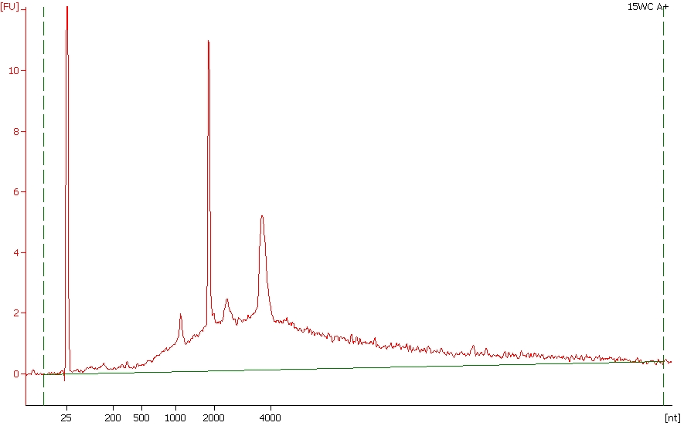 | 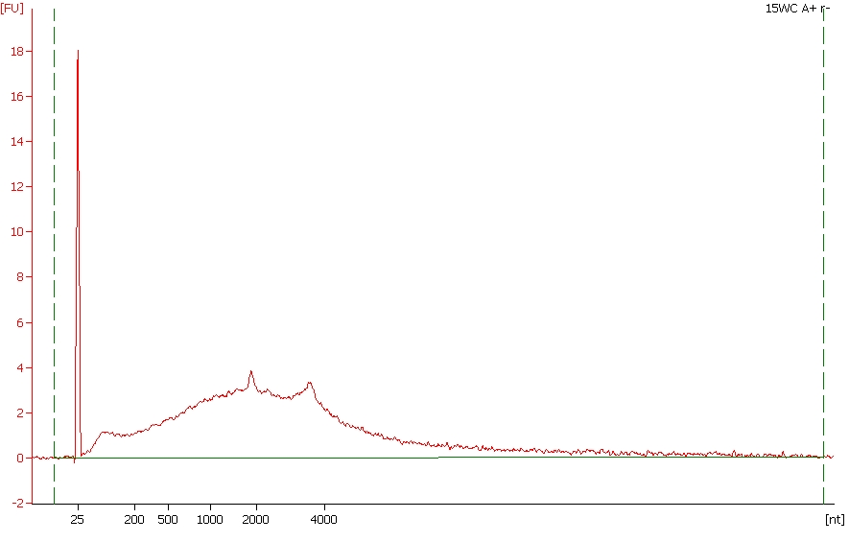
  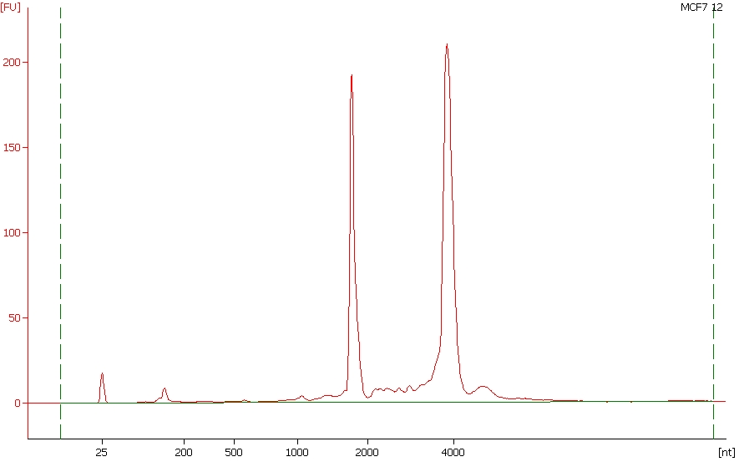

BioAnalyzer: cDNA | BioAnalyzer: Post-Fragmentation | Gel Size Selection
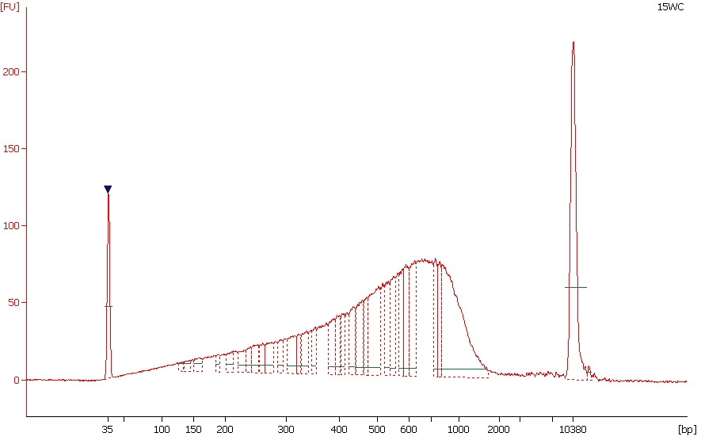 | 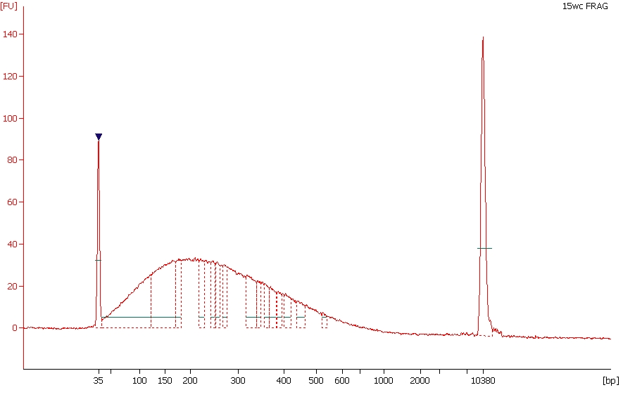 | 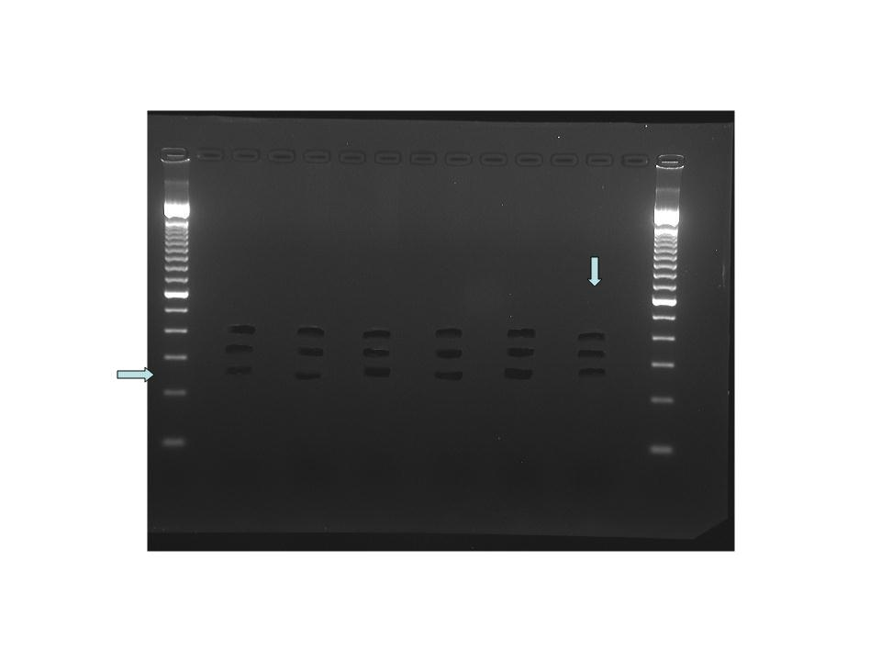

Final Gel Purification | BioAnalyzer: Final Library*
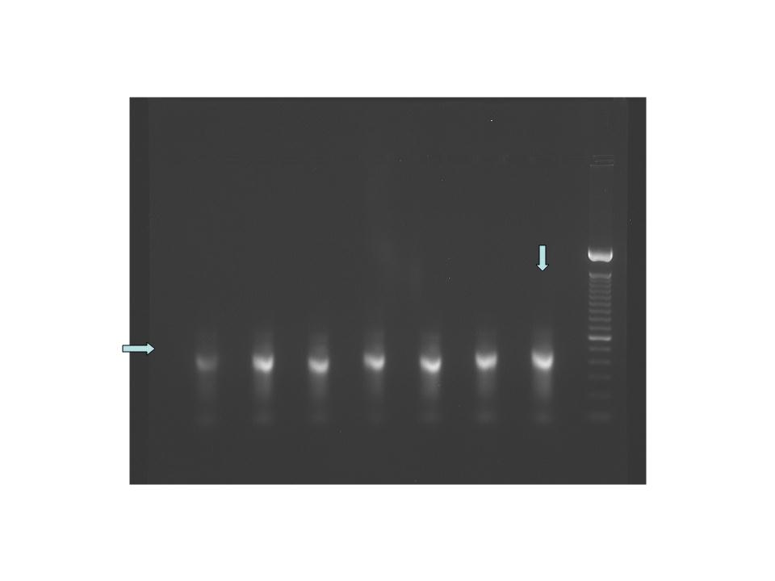 | 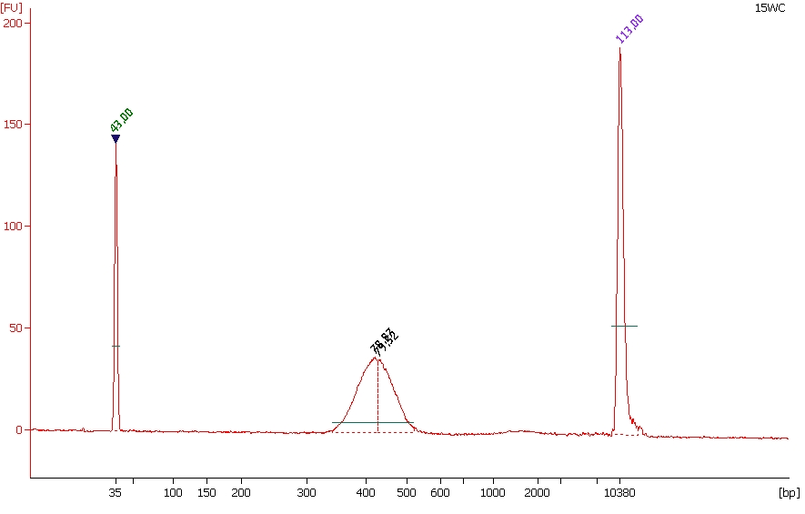
* Sometimes we see a doublet in the BioAnalyzer image of the final library. We take the height of the first peak to represent the library insert size when determining molarity. These doublets are not visible on gels, the libraries sequence fine and show inserts surrounding the first peak size.

