Materials Property Open Database (MPOD)

Daniel Chateigner, Giancarlo Pepponi, Saulius Grazulis

General
Variable names for the properties: see Chateigner (2010) "Combined Analysis", ISTE-Wiley.

All tensor components are listed except those forced to 0 by point group or groupoids symmetry. If a ? is given for a component, the corresponding paper did not give the corresponding component. For diagonally symmetric tensors, only the diagonal and above components are given.

In all data, when given by the authors, the error is indicated in parenthesis for the last digit(s).

New tags and associated units:

_SYMMETRY_POINT_GROUP_NAME_H-M pg
pg = 1, -1, 2, m, 2/m, 222, mm2, mmm, 4, -4, 4/m, 422, 4mm, -42m, 4/mmm, 3, -3, 32, 3m, -3m, 6, -6, 6/m, 622, 6mm, -6m2, 6/mmm, 23, m3, 432, -43m, m3m, ... Quasicrystal groupoids: 5mm, 8mm, 10mm, 12mm ...

_structure_refined 'no'

If there has been structural refinement of the same crystal which served the property measurements, then the answer is 'yes', and the cod_database_code refers to it. If 'no', the cod_database_code points to an example of cif file for the structure. If the authors only refined the cell parameters (not the atomic positions etc), 'no' is indicated, but the cell parameters indicated are the ones refined in the actual paper.

_phase_generic 'compound generic name'

Compound generic name = PIN-PMN-PT for instance in ferroelectrics

_phase_density number

Material's density in kg/m³

_phase_density_temperature number
The temperature to which the density is given (in K)

_phase_transition_temperature_rhomb_tetra number

rhombohedral-tetragonal phase transition temperature (in K)

_phase_transition_temperature_rhomb_ortho number

orthorhombic-tetragonal phase transition temperature (in K)

_phase_transition_temperature_ortho_tetra number

orthorhombic-tetragonal phase transition temperature (in K)

_phase_transition_temperature_curie

TC = Curie temperature (in K)

_phase_transition_temperature_melting

Tm = Melting temperature (in K)

_phase_debye_temperature

TD = Debye temperature (in K)

_phase_cell_temperature

Tcell = temperature (in K) for which has been determined the cell parameters

1 Dielectric Properties

_prop_dielectric_permittivity_relative_epsrij

D_{i} = ε₀E^{j} + P^{j} = ε₀(1+χ_{ij})E^{j} = ε₀ε_{r,ij}E^{j}

ij = 11 – 33 Units: 1

_prop_dielectric_permittivity_relative_epsrijT

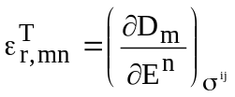

_prop_dielectric_permittivity_relative_epsrijS

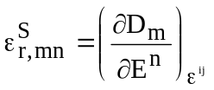

_prop_dielectric_stiffness_relative_betrijT

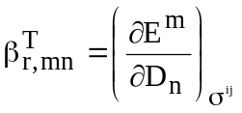

mn = 11 – 33 Units: 10⁻⁴

_prop_dielectric_stiffness_relative_betrijS

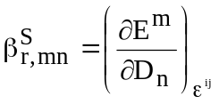

mn = 11 – 33 Units: 10⁻⁴

2 Mechanical Properties

21 Elastic Properties

_prop_elastic_stiffness_cij

σ^{ij} = C_{ijk}ε_{k}
ij = 11 – 66 Units: GPa =10⁹ N/m²

_prop_elastic_stiffness_cijE

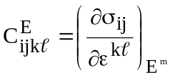

With the correspondance: ijk --> ij:

11 → 1; 22 → 2; 33 → 3; 23 → 4; 13 → 5; 12 → 6

and c_{ij} = C_{ijk}

_prop_elastic_stiffness_cijD

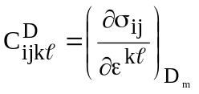

_prop_elastic_stiffness_cijS (isentropic or adiabatic)

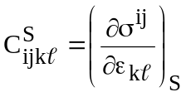

_prop_elastic_compliance_sij

ε_{ij} = S_{ijk}σ^{k}

ij = 11 – 66 Units: 10⁻¹² m²/N (= 1 TPa⁻¹)

s_{ij} = 2^{p} S_{ijk}, in which p is the number of indices larger than 3 in s_{ij}.

_prop_elastic_compliance_sijE

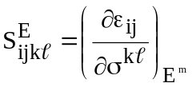

_prop_elastic_compliance_sijD

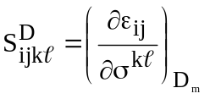

_prop_elastic_compliance_sijS 'sijS'

22 Internal friction

_PROP_INTERNAL_FRICTION_Q11-1 2.7

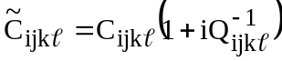

ij = 11 – 66 Units: 10⁻⁴

23 Third-Order Elastic Constants (TOEC)

σ^{ij} = C_{ijk}ε_{k} + C_{ijkmn}ε_{k}ε_{mn}

Similarly as for C_{ijk}, a matrix notation can be developped using the Voigt convention. The six indices of the TOEC are then condensed to only 3, c_{αβγ}, giving rise to 56 independent constants in triclinic crystal systems [Brugger 1965].

_prop_TOEC_stiffness 'cijk'

α: 1 - 6
βγ: 11 – 66, β and γ ≤ α Units: GPa

Triclinic
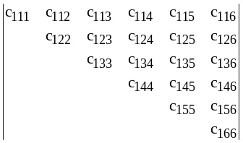 | 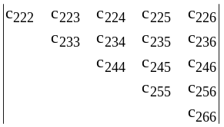 | 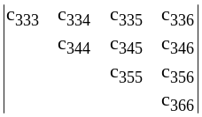 | 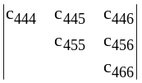 | 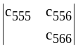  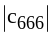

24 Pressure dependence of elastic constants (hydrostatic pressure)

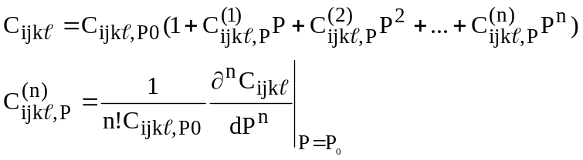

P₀ = reference pressure

_prop_elasticstiffness_hydrostaticpressure_1storder_cij1P 'cij1P'
ij = 11 – 66 Units: GPa⁻¹

_prop_elasticstiffness_hydrostaticpressure_2ndorder_cij2P 'cij2P'
ij = 11 – 66 Units: GPa⁻¹

_prop_elasticstiffness_hydrostaticpressure_3rdorder_cij3P 'cij3P'
ij = 11 – 66 Units: GPa⁻¹

_prop_elasticcompliance_hydrostaticpressure_1storder_sij1P 'sij1P'
ij = 11 – 66 Units: GPa⁻¹

_prop_elasticcompliance_hydrostaticpressure_2ndorder_sij2P 'sij2P'
ij = 11 – 66 Units: GPa⁻¹

_prop_elasticcompliance_hydrostaticpressure_3rdorder_sij3P 'sij3P'
ij = 11 – 66 Units: GPa⁻¹

_prop_reference_hydrostatic_pressure

Reference pressure P₀ taken for the non linear fit of elastic compliances and stiffnesses (in GPa)

_prop_hydrostatic_pressure_range_begin
_prop_hydrostatic_pressure_range_end

In GPa

3 Thermal Properties

31 Thermal conductivity

_prop_thermal_conductivity_kappaij

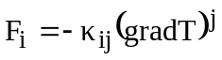

ij = 11 – 33 Units: WK⁻¹m⁻¹

ij=ji

1 WK⁻¹cm⁻¹ = 10² WK⁻¹m⁻¹

32 Thermal diffusivity

_prop_thermal_diffusivity_kappadij

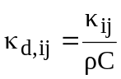

ij = 11 – 33 Units: m²s⁻¹

4 Thermo-elastic properties

41 Linear

_prop_thermal_expansion_alphaij

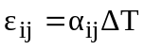
ij = 11 – 33 Units: 10⁻⁶K⁻¹

_prop_thermal_expansion_temperature_range_begin
_prop_thermal_expansion_temperature_range_end

This is the temperature range for which the alphaij are given. Temperature units are K

_prop_thermal_expansion_temperature_cycle

The thermal expansion measurements can be repeated several times, in order to check for hysteresis

_prop_thermal_expansion_Tij

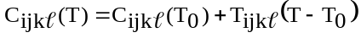

ij = 11 – 66 Units: MPa K⁻¹

42 Non-Linear

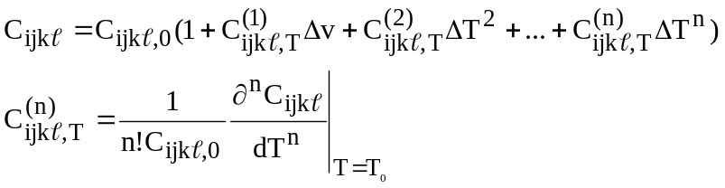

ΔT = T - T₀

_prop_thermoelasticstiffness_1storder_cij1T 'cij1T'
ij = 11 – 66 Units: 10⁻⁶K⁻¹

_prop_thermoelasticstiffness_2ndorder_cij2T 'cij2T'
ij = 11 – 66 Units: 10⁻⁹K⁻¹

_prop_thermoelasticstiffness_3rdorder_cij3T 'cij3T'
ij = 11 – 66 Units: 10⁻¹²K⁻¹

_prop_thermoelasticcompliance_1storder_sij1T 'sij1T'
ij = 11 – 66 Units: 10⁻⁶K⁻¹

_prop_thermoelasticcompliance_2ndorder_sij2T 'sij2T'
ij = 11 – 66 Units: 10⁻⁹K⁻¹

_prop_thermoelasticcompliance_3rdorder_sij3T 'sij3T'
ij = 11 – 66 Units: 10⁻¹²K⁻¹

prop_conditions_reference_temperature_thermoelastic_non_linear_fit

Reference temperature T₀ taken for the non linear fit of elastic compliances and stiffnesses (in K)

5 Electro-Mechanic properties

51 Piezoelectricity

_prop_piezoelectric_gij

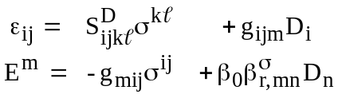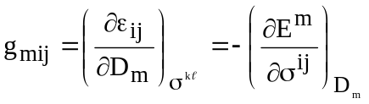

ij = 11 – 36 Units: 10⁻² Vm/N
with g_{iα} = g_{ijk} (α ≤ 3) or g_{iα} = 2g_{ijk} (α > 3)

_prop_piezoelectric_eij

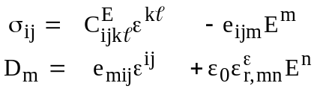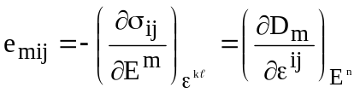

ij = 11 – 36 Units: C/m²
e_{iα} = e_{ijk} whatever α

_prop_piezoelectric_hij

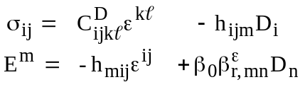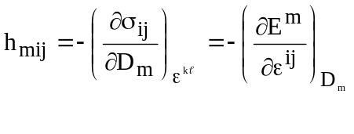

ij = 11 – 36 Units: 10⁸ V/m
h_{iα} = h_{ijk} whatever α

_prop_piezoelectric_dij

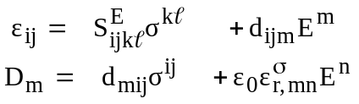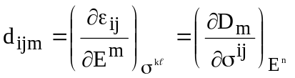

ij = 11 – 36 Units: 10⁻¹² C/N or 10⁻¹² m/V
with d_{iα} = d_{ijk} (α ≤ 3) or d_{iα} = 2d_{ijk} (α > 3)

data_prop_electromechanical_coupling_kij

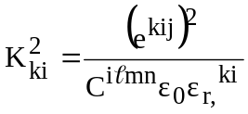

ij = 11 – 36 Units: 1

52 Electrostriction

_prop_electrostriction_Dij

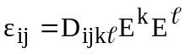
ij = 11 – 66 Units: 10⁻²⁰ m²V⁻²

_prop_electrostriction_Dprimeij

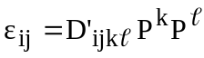
ij = 11 – 66 Units: m⁴C⁻²

6 Mechano-Optic properties

_prop_photoelastic_pij

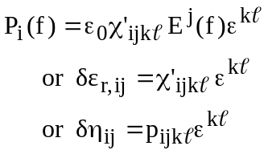

ij = 11 – 66 Units: 1
with p_{iα} = p_{ijk}

_prop_photoelastic_pijE

ij = 11 – 66 Units: 1
with p_{iα} = p_{ijk}

_prop_piezooptic_piij

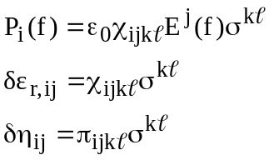

ij = 11 – 66 Units: 10⁻³ GPa⁻¹

7 Superconducting properties

_prop_superconducting_critical_temperature
_prop_superconducting_critical_temperature_onset

Onset of the superconducting critical temperature in the resistivity or magnetic susceptibility curve. Units: K

_prop_superconducting_critical_temperature_onset_90% 13.3
_prop_superconducting_critical_temperature_mid_50% 12.2
_prop_superconducting_critical_temperature_offset_10% 11.4
The three previous tags correspond to the ρ(T) or χ(T) transition at a given percentage of the normal-state resistivity

_prop_superconducting_critical_temperature_thermodynamic 16.8

_prop_superconducting_critical_current_density_Jci
Critical current density along direction i
i = 1, 2 or 3 Units: A m⁻²

_prop_superconducting_critical_field1_Hc1i
Upper critical field along direction i
i = 1, 2 or 3 Units: T

_prop_superconducting_critical_field2_Hc2i
Upper critical field along direction i
i = 1, 2 or 3 Units: T

_prop_superconducting_irreversibility_field_Hirri 'Hirri'
Irreversibility field along direction i, defined by the field below which there is an observable difference of the magnetization for increasing and decreasing magnetic field
i = 1, 2 or 3 Units: T

_prop_superconducting_coherence_length_ksii 'ksii'
Coherence lengths along direction i
i = 1, 2 or 3 Units: nm

_prop_superconducting_penetration_depth_lambdai 'lambdai'
Penetration Depth along direction i
i = 1, 2 or 3 Units: nm

_prop_superconducting_zero_resistivity_temperature

_prop_superconducting_resistivity_transition_width 1.1

_prop_RRR
Residual Resistivity Ratio between the resistivity at 300K and extrapolated residual resistivity at 0K

8 Heat Capacity

_prop_heat_capacity_C 'C'
scalar Units: Jg⁻¹K⁻¹

9 Optical Properties

91 Linear birefringence

_prop_optical_index_ordinary_no 'no'
_prop_optical_index_extraordinary_ne 'ne'
_prop_optical_index_ni 'ni'
Vector i = 1, 2 or 3 Units: 1
_prop_optical_index_principal_Ni 'Ni'
Vector i = 1, 2 or 3 Units: 1

10 Electrical Properties
10.1 Resistivity-Conductivity
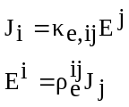
_prop_electric_resistivity 'rhoeij'
ij = 11 – 33 Units: μΩ cm
10.2 Ferroelectricity

_phase_transition_temperature_curie_ferroelectric

Tfc = Curie temperature (in K)

_prop_electric_remnent_polarisation 'Pri'

i = 1 – 3 Units: μΩ cm⁻²
_prop_electric_coercive_field 'Eci'
i = 1 – 3 Units: kV cm⁻¹
10.3 Carrier Concentration

_prop_electric_carrier_concentration_n 5.7

Scalar, n = Carrier concentration (in 10¹⁹ cm⁻³)

11 Thermo-electric properties
11.1 Seebeck coefficient
Se_{ji}
_prop_thermoelectric_Seebeck_Seij 'Seij'
ij = 11 – 33 Units: μV K⁻¹

12 Magnetic properties

_prop_magnetic_paramagnetic_critical_temperature_Neel 'TN'
_prop_magnetic_paramagnetic_critical_temperature_Neel_transitionwidth 'DeltaTN'
_prop_magnetic_antiferromagnetic_ordering_temperature_Neel 'TN_AFM'

_phase_transition_temperature_curie_ferromagnetic

Tmc = Curie temperature (in K)

13 Electro-optic properties

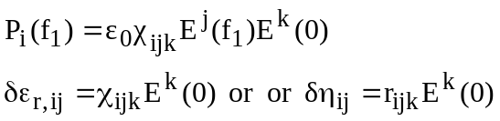

_prop_electrooptic_rijk 'rijk'
_prop_electrooptic_rijkS 'rijkS' (strain free)
_prop_electrooptic_rijkT 'rijkT' (stress free)

ijk = 111 – 333 Units: 10⁻¹² m V⁻¹

The matrix form of the tensor, using the conventional notation 11 → 1; 22 → 2; 33 → 3; 23 → 4; 13 → 5; 12 → 6, results in χ_{αk} 3x6 matrices (Error: Reference source not found), with χ_{αk} = χ_{ijk} (α ≤ 3) or χ_{αk} = 2χ_{ijk} (α > 3). The electrooptic components are in m.V⁻¹ units.

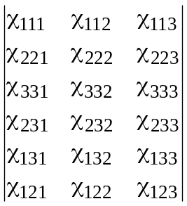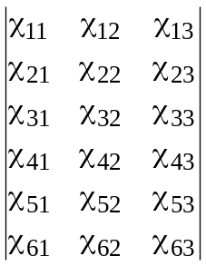
.

Conditions of measurements

_prop_conditions_temperature
Not everytime the physico-chemistry conditions are given when a property is measured. When indicated the condition is given. Sometimes only "room temperature" is mentionned in the corresponding literature.
Units: Temperature K

_prop_conditions_pressure
Units: 10⁵ Pa (= 1 bar)

_prop_conditions_frequency 1000
In capacitance measurements for instance to determine epsrij, the frequency used in the measurements is given in kHz.

_prop_conditions_magnetic_field
Units: T

_prop_conditions_magnetic_field_Bi
i = 1, 2 or 3 Units: T

_prop_measurement_poling '[hkl]'
In piezoelectric measurements, the poling direction is of importance. We refer to it by the [hkl] direction of poling.

_PROP_SYMMETRY_POINT_GROUP_NAME_H-M 'm m 2'
The property point group can differ from the crystal point group. For instance, poling in piezoelectrics can modify the symmetry of dipoles depending on the poling direction.

_prop_frame '1=[0-11]c 2=[100]c 3=[011]c'
Indicates the axes numbers used in tensor description of the property, in the crystal reference frame.

_prop_conditions_wavelength
Units: wavelength μm

_prop_conditions_temperature_range_begin
_prop_conditions_temperature_range_end
_prop_conditions_temperature_cycle

_prop_measurement_method 'method'
Method used to determine the considered properties
epsrij CAP Capacitance measurements
LCR LCR meter
alphaij PND Powder Neutron Diffraction
PXD Powder X-ray Diffraction
SCXD Single-Crystal X-ray Diffraction
DIL Single-Crystal dilatometry
TMA Thermal Mechanical Analysis
cij RT Resonance Technique
TRT Thickness Resonance Technique
PEM Pulse-Echo Measurements
RUS Resonance Ultrasound Spectroscopy
RUS-Laser-Doppler RUS assisted by Laser-Doppler interferometry
EMAR ElectroMagnetic Acoustic Resonance
mB micro-Brillouin scattering
ISS impulsive stimulated scattering
CPO Composite Piezoelectric Oscillator
ST Static Torsion
IXRS Inelastic X-Ray Scattering
BS Brillouin Scattering
PI Pulsed Interferometry
PSM Pulse-Superposition Method
AWP Acoustic Wave Propagation (Wedge Method)
COM Composite Oscillator Method
Static Statical Method
Wedge Wedge Method
PND Powder Neutron Diffraction
TRM Torsional Resonance Measurements
BS-PEM Combined BS and PEM technique
USV Ultrasonic Sound Velocity
cijk SWC Shock Wave Compression
Qij-1 EMAR
dij BTM Berlincourt-Type Meter
XRD X-Ray Diffraction
IntF Interferometric Measurements
kij SAW Surface Acoustic Waves
RT Resonance Technique
Kappaij SST Steady-State technique with thermocouples
kappadij LPM Laser Pulse Method
C DSC Differential Scanning Calorimetry
no, ne MDT Minimum Deviation Technique
FT-IRRef Fourier Transformed InfRared Reflectivity
ni BA Brewster Angle method
Tc RFS LCR Resonance Frequency Shift
MI Mutual Inductance
RC Resistivity Curve
SQUID-ZFC Zero-Field Cooled SQUID magnetometry
AC_S AC Susceptibility
MS Magnetic Susceptibility
Hc2i MagTorque Magnetic Torque Measurements
lambdai MagTorque Magnetic Torque Measurements
raueij FP Four Point probe
TN muSR muon Spin Resonance
DeltaTN muSR muon Spin Resonance
TN_AFM DC-MS DC Magnetic Susceptibility
Piij Birefringence
pijE LDU Light Diffraction by gratings under Ultrasonic waves (Dixon et Cohen [1966] method)
n Hall Hall mobility
Jci SQUID SQUID magnetometry

_journal_article_reference 053511
often now the articles are given a number, like in Phys. Rev. B or J. Appl. Phys.

_journal_pages_number 7
then the total number of pages of this article

Some historical landmarks

June 2013: poster presentation of MPOD at the Association Française de Cristallographie conference, Bordeaux, France
Mai 2013: poster presentation of MPOD at the JNCO conference, Cherbourg, France
October 2012: presentation of MPOD at the software fayre of EPDIC 13, Grenoble, France
September 2012: 1st MPOD paper in NIMB
December 2011:
3rd MPOD poster at ICOTOM 16, Mumbai, India
Luis Fuentes and his team want to join
1st June 2011: MPOD reaches 250 files
May 2011: 2nd MPOD poster presented at EMRS, Nice, France
February 2011: 1st MPOD poster presented at AXAA, Sydney, Australia
November 2010: MPOD site launched, Saulius Grazulis in the Advisory Board
31st August 2010: Giancarlo Pepponi joined
1st August 2010: creation of MPOD

references

Bolef D.I., de Klerk J. (1963). Anomalies in the Elastic Constants and Thermal Expansion of Chromium Single Crystals. Physical Review 129(3) 1063-1067
Bridgman P.W. (1924). Some properties of single metal crystals. Proceedings of the National Academy of Science of the United States of America 10 411-415
Bu G., Ciplys D., Shur M., Schowalter L.J., Schulman S., Gaska R. (2004). Electromechanical coupling coefficient for surface acoustic waves in single-crystal bulk aluminum nitride. Applied Physics Letters 84(23) 4611-4613
Dixon R.W., Cohen M.G. (1966). Applied Physics Letters 8 205-?
Fisher E.S., Renken C.J. (1961). Adiabatic elastic moduli of single crystal alpha zirconium. Journal of Nuclear Materials 4(3) 311-315
Gao Z.L., Sun Y.X., Yin X., Wang S.P., Jiang M.H., Tao X.T. (2010). Growth and electric-elastic properties of KTiAsO4 single crystal. Journal of Applied Physics 108(2) 024103(1-4)
Goens E. (1933). Elastic constants of aluminum single crystals. Annalen der Physik 17 233
Goens E., Weerts J. (1936). Elastic constants of single crystals of copper, gold, and lead. Physikalische Zeitschrift 37 321
Greiner J.D., McMasters O.D., Smith J.F. (1980). Single-crystal elastic-constants of gamma-cerium. Scripta Metallurgica 14(9) 989-991
Hildmann Bernd, Ledbetter Hassel, Kim Sudook, Schneider Hartmut (2001). Structural control of elastic constants of mullite in comparison to sillimanite. Journal of the American Ceramic Society 84(10) 2409-2414
Kimura R. (1933). Elastic constants of single crystals of copper. Tohoku University Science Reports 22 553
Kimura R. (1939). Elastic moduli of ferromagnetic materials, I: iron crystals. Proceedings of the Physical and Mathematical Society of Japan 21 686
Kimura R., Ohno K. (1934). Elastic constants of single crystals of iron. Tohoku University Science Reports 23 359
Kriven W.M., Palko J.W., Sinogeikin S., Bass J.D., Sayir A., Brunauer G., Boysen H., Frey F., Schneider J. (1999). High temperature single crystal properties of mullite. Journal of the European Ceramic Society 19 2529-2541
Kurtz S.K. (1968). New nonlinear optical materials. IEEE Journal of Quantum Electronics 4(10) 578-584
Leamy H.J., Warlimon H. (1970). Elastic behaviour of Ni-Co alloys. Physica Status Solidi 37(2) 523-
Ledbetter H., Kim S. (2000). Monocrystal elastic constants and derived properties of the cubic and the hexagonal elements. In 'Handbook of Elastic Properties of Solids, Liquids, and Gases", Vol. 2 (Academic Press), Levy M., Bass H., Stern R. (Eds.)
Ledbetter H., Ogi H., Kai S., Kim S., Hirao M. (2004). Elastic constants of body-centered-cubic titanium monocrystals. Journal of Applied Physics 95(9) 4642-4644
Lee Bumsung, Khim Seunghyun, Kim Jung Soo, Stewart G.R., Kim Kee Hoon (2010). Single-crystal growth and superconducting properties of LiFeAs. European Physics Journal 91 67002 (1-6)
Liu X., Zhang S., Luo J., Shrout T.R., Cao W. (2010). A complete set of material properties of single domain 0.26Pb(In1/2Nb1/2)O3-0.46Pb(Mg1/3Nb2/3)O3-0.28PbTiO3 single crystals. Applied Physics Letters 96(1) 012907(1-3)
Liu X., Zhang S., Luo J., Shrout T.R., Cao W. (2010). Erratum: "A complete set of material properties of single domain 0.26Pb(In1/2Nb1/2)O3-0.46Pb(Mg1/3Nb2/3)O3-0.28PbTiO3 single crystals" [Appl. Phys. Lett. 96, 012907 (2010)]. Applied Physics Letters 97(1) 019901(1-2)
Masima M., Sachs G. (1928). Mechanische eigenschaften von messingkristallen. Zeitschrift für Physik 50(3-4) 161-186
Masumoto H., Saito H., Kikuchi M. (1967). Thermal expansion and temperature dependence of Youngs modulus of single crystal of hexagonal cobalt. Science Reports of the Research Institutes Tohoku University Series A-Physics Chemistry and Metallurgy 19(3) 172-
Matsui M., Shimizu T., Adachi K. (1983). Invar anomalies of Fe-Pd alloys. Physica B & C 119(1-2) 84-89
McSkimin H.J., Andreatch Jr. P. (1964). Elastic Moduli of Silicon vs Hydrostatic Pressure at 25.0°C and − 195.8°C. Journal of Applied Physics 35(7) 2161-2165.
Mytsyk Bogdan G., Andrushchak Anatoliy S., Demyanyshyn Nataliya M., Kost Yaroslav P., Kityk Andriy V., Mandracci Pietro, Schranz Wilfried (2009). Piezo-optic coefficients of MgO-doped LiNbO₃ crystals. Applied Optics 48(10) 1904-1911
Nakamura N., Ogi H., Hirao M. (2004). Elastic constants of chemical-vapor-deposition diamond thin films: resonance ultrasound spectroscopy with laser-Doppler interferometry. Acta Materialia 52(3) 765-771
Ogi H, Fukunaga M, Hirao M, Ledbetter H. (2004). Elastic constants, internal friction, and piezoelectric coefficient of alpha-TeO₂. Physical Review B 69(2) 024104()
Ogi H., Kai S., Ledbetter H., Tarumi M., Hirao M., Takashima K. (2004). Titanium high-temperature elastic constants through the hcp-bcc phase transformation. Acta Materialia 52(7) 2075-2080
Ogi H, Kawasaki Y, Hirao M, Ledbetter H. (2002). Acoustic spectroscopy of lithium niobate: Elastic and piezoelectric coefficients. Journal of Applied Physics 92(5) 2451-2456
Ogi H, Ledbetter H, Kim S, Hirao M. '1999). Contactless mode-selective resonance ultrasound spectroscopy: Electromagnetic acoustic resonance. Journal of the Acoustical Society of America 106(2) 660-665
Ogi H, Nakamura N, Sato K, Hirao M., Uda S. (2003). Elastic, anelastic, and piezoelectric coefficients of langasite: Resonance ultrasound spectroscopy with laser-doppler interferometry. IEEE Transactions on Ultrasonics Ferroelectrics and Frequency Control 50(5) 553-560
Ogi H., Ohmori T., Nakamura N., Hirao M. (2006). Elastic, anelastic, and piezoelectric coefficients of alpha-quartz determined by resonance ultrasound spectroscopy. Journal of Applied Physics 100(5) 053511
Quimby S.L., Sigiel Sidney (1938). The variation of the elastic constants of crystalline sodium with temperature between 80°K and 210°K. Physical Review 54 293-299
Rölh H. (1933). Elastic constants of gold-silver single crystals. Annalen der Physik 16 887-906
Seitz Frederick, Read T.A. (1941). Theory of the plastic properties of solids. I. Journal of Applied Physics 12(2) 100-118
Shanthi M., Lim L.C., Rajan K.K., Jin J. (2008). Complete sets of elastic, dielectric, and piezoelectric properties of flux-grown [011]-poled Pb(Mg_{1/3}Nb_{2/3})O₃-(28-32)% PbTiO₃ single crystals. Applied Physics Letters 92(14) 142906(1-3)
Siegel Sidney (1940). The variation of the principal elastic moduli of Cu₃Au with temperature. Physical Review 57 537-545
Sisodia P., Verma M.P. (1989). Shear moduli of polycrystalline cubic elements. Journal of Physics and Chemistry of Solids 50(2) 223-224
Stevens Lewis L., Hooks Daniel E., Migliori Albert (2010). A comparative evaluation of elasticity in pentaerythritol tetranitrate using Brillouin scattering and resonant ultrasound spectroscopy. Journal of Applied Physics 108(5) 053512(1-4)
Sun Enwei, Zhang Shujun, Luo Jun, Shrout Thomas R., Cao Wenwu (2010). Elastic, dielectric, and piezoelectric constants of Pb(In_{1/2}Nb_{1/2})O₃-Pb(Mg_{1/3}Nb_{2/3})O₃-PbTiO₃ single crystal poled along [011]c. Applied Physics Letters 97(3) 032902(1-3)
Sun Y., Cao W.W., Pan W.Y., Chang Z.P., Cross L.E. (1988). Complete determination of electrostriction tensor components of KMnF₃ single crystals at room temperature. Journal of Materials Science Letters 7 327-330
Sun Y., Cao W.W., Cross L.E. (1986). Electrostriction effect in glass. Materials Letters 4(8-9) 329-336
Swift Irvin H., Tyndall E.P.T. (1942). Elasticity and creep of Pb single crystals. Physical Review 61(5-6) 359-364
Tarumi R., Ledbetter H., Shiomi S., Ogi H., Hirao M., Tsai A.P. (2010). Elastic constants and anisotropic internal frictions of decagonal Al₇₂Ni₁₈Co₈ single quasicrystal at low temperature. Journal of Applied Physics 108(1) 013514 (1-5)
Wright S.J. (1930). Elasticity of Pintsch crystals of tungsten. Proceedings of the Royal Society of London A 126(803) 613-629

Some units transfer:

10¹² gm/cm-sec² = 100 GPa
1 Pa = 1 N/m² = 10⁵ dynes/m² = 10 dynes/cm²
1 GPa = 10¹⁰ dynes/cm²
10⁻¹² m²/N = 10⁻⁸ cm²/N = 10⁻¹³ cm²/dyne

