Hidden Markov Model assignment

For this assignment I’ll build a Hidden Markov Model trained on Hemoglobin beta.

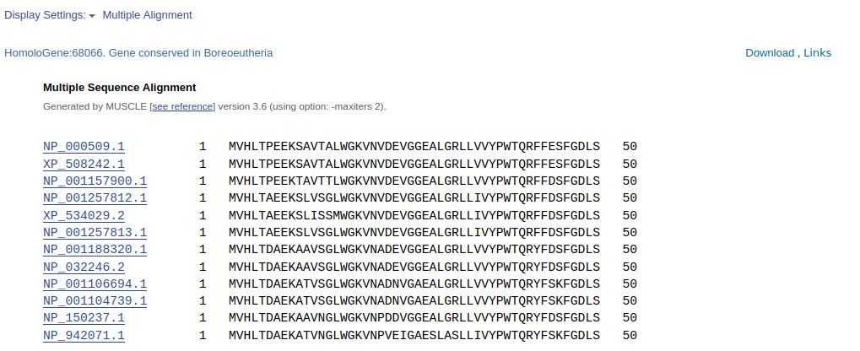
To begin I downloaded this MSA (Multiple Sequence Alignment) file from the homologene database of NCBI (National Center for Biotechnology Information).

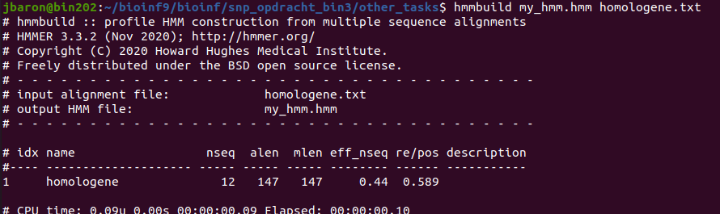
Then using the hmmbuild command-line tool a hmm file was created.

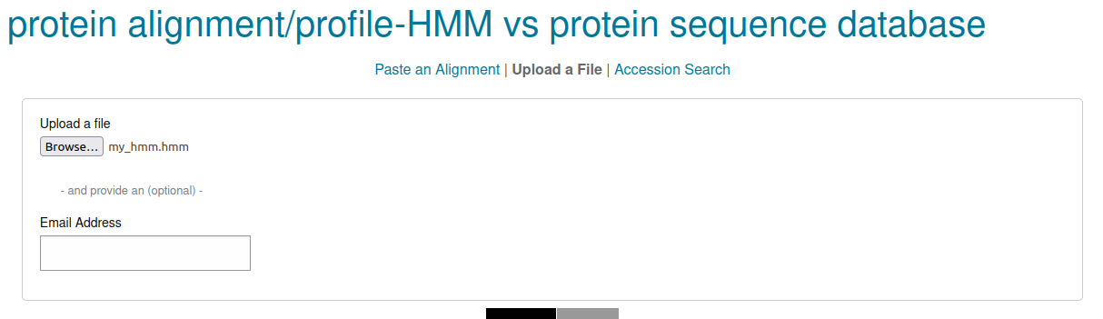

Searching in the uniprotrefprot database of EBI (European Bio-informatics Institute) using my built hmm,

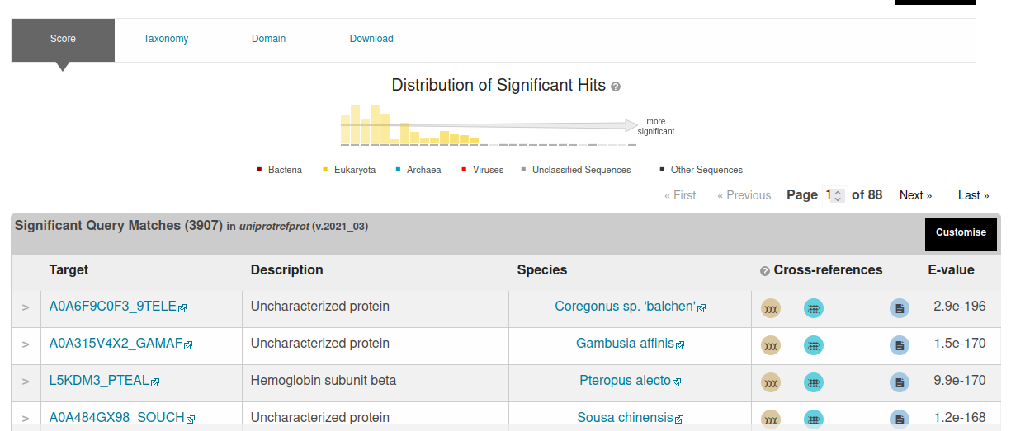
yielded these results.
The top 3 results where globins just like the source MSA, these where taken and put into a new MSA.

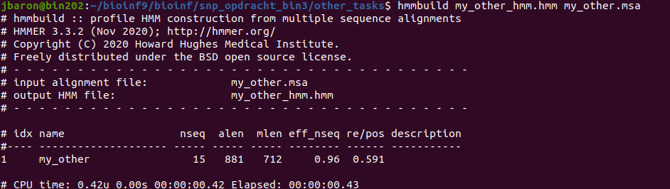
This was used to rebuild a hmm.
??????????????

