# How to add a Hello World extension to Microsoft Edge

## Introduction

This sample demonstrates how to add a Hello World extension to Microsoft Edge.

Now development of the extension platform is ongoing, not all the APIs are supported. You can check the detail list [here](https://developer.microsoft.com/en-us/microsoft-edge/platform/documentation/extensions/api-support/supported-APIs/).

## Running the sample

* Open Microsoft Edge browser and type ‘about:flags’ into the address bar.
* Select the **Enable extension developer features** checkbox.

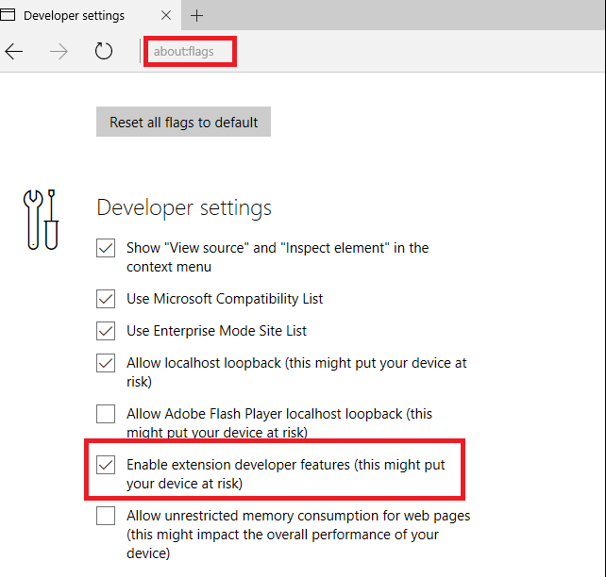

* Select **More (…)** to open the menu.
* Select **Extensions** from the menu.
* Select the **Load extension** button.
* Navigate to your extension’s folder and select the **Select folder** button.

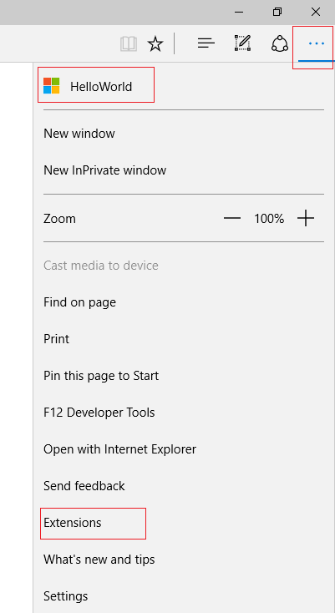

* Click on the extension button.
* Toggle Show button **next to address bar** to on.

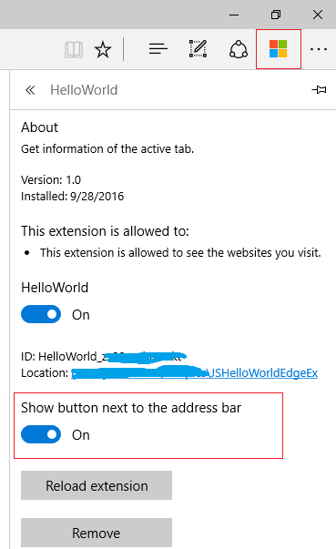

* Type ‘microsoft.com/en-sg’ into the address bar
* Click the extension icon

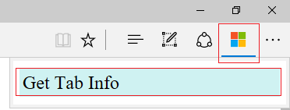

* Click ‘Get Tab Info’ to get the tab’s information

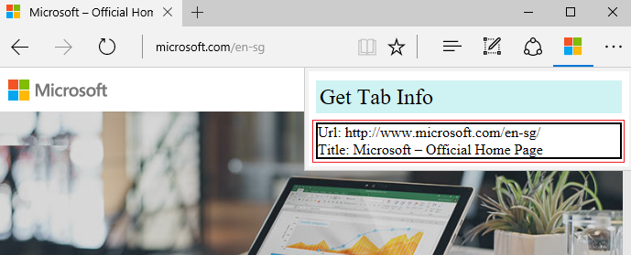

**Using the code**

**manifest.json (Required)**

Required keys: author (not supported in Chrome), name, version.

{

"author": "Microsoft OCOS Team",

"description": "Get information of the active tab.",

"icons":

{

"48": "icons/microsoft.png",

"96": "icons/microsoft-96.png"

},

"manifest_version": 2,

"name": "HelloWorld",

"version": "1.0",

"permissions": [

"tabs"

],

"browser_action": {

"default_icon": {

"30": "icons/microsoft-30.png"

},

"default_title": "HelloWorld",

"default_popup": "GetTabInfo.html"

}

}

**GetTabInfo.js**

document.addEventListener("click", function(e) {

if (!e.target.classList.contains("tabInfo")) {

return;

}

var root = document.getElementById("info");

root.innerHTML = "";

browser.tabs.query({ active: true, currentWindow: true }, function (tabs) {

browser.tabs.get(tabs[0].id, function (tab) {

var node = document.createElement("div");

var textnode = document.createTextNode("Url: " + tab.url);

node.appendChild(textnode);

root.appendChild(node);

var node2 = document.createElement("div");

var textnode2 = document.createTextNode("Title: " + tab.title);

node2.appendChild(textnode2);

root.appendChild(node2);

});

root.style.display = "block";

});

});

**GetTabInfo.html**

<!DOCTYPE html>

<html>

<head>

<meta charset="utf-8">

<link rel="stylesheet" href="GetTabInfo.css" />

</head>

<body>

<div class="tabInfo">Get Tab Info</div>

<div id="info" style="display:none"></div>

<script src="GetTabInfo.js" ></script>

</body>

</html>

## More information

[Supported manifest keys](https://developer.microsoft.com/en-us/microsoft-edge/platform/documentation/extensions/api-support/supported-manifest-keys/)

[Supported APIs](https://developer.microsoft.com/en-us/microsoft-edge/platform/documentation/extensions/api-support/supported-APIs/)

[Debugging extensions](https://developer.microsoft.com/en-us/microsoft-edge/platform/documentation/extensions/guides/debugging-extensions/)