HOME MADE STACKABLE Z80 COMPUTER DOCUMMENTATION

Description:

Block Diagram:
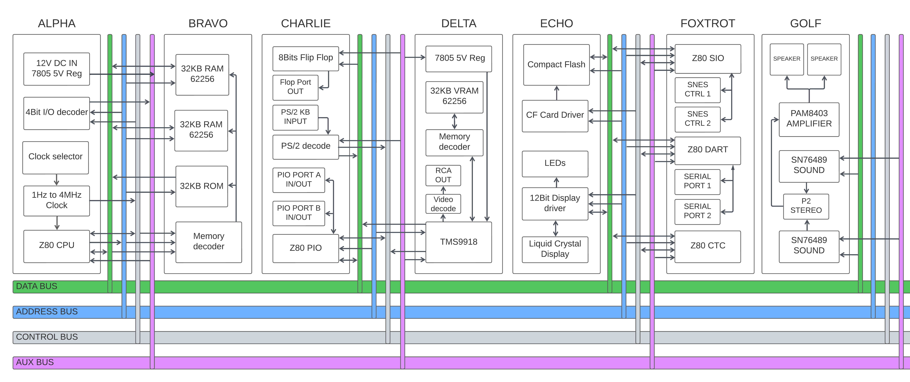
Memory Map:
