SMA2 Plug v2 User Manual

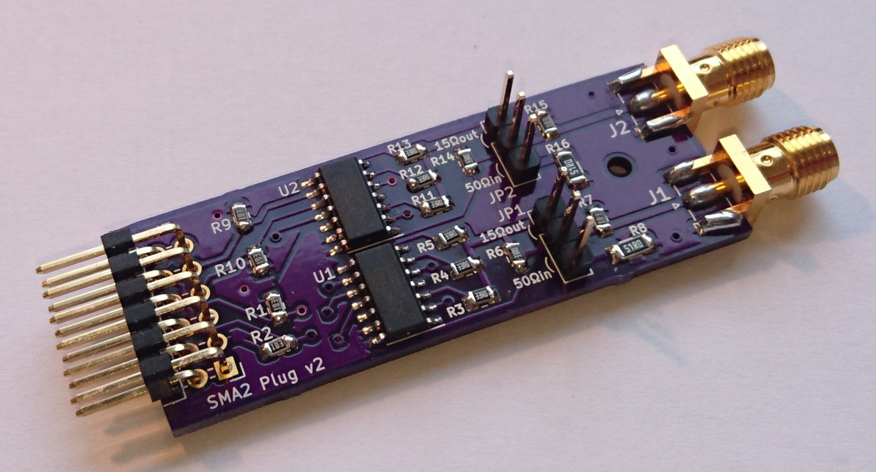

Overview
The SMA2 Plug provides an easy way to connect digital TTL signals to an FPGA board via coaxial cables.

One side of the module has two SMA connectors which can each be used either as digital input or as digital output. The other side of the module has a 2x6 pin header which can be plugged into an FPGA board.

The module converts the TTL input level of each SMA connector into a matching IN signal for the FPGA. The module also expects two output signals from the FPGA for each SMA connector: OE (output enable) to enable or disable the output function, and OUT to determines whether the output (if enabled) produces a logic high or logic low level.

Features:
- Two SMA connectors for external digital signals, separately configurable as input or output.
- Useful for connecting TTL control signals or trigger signals to external equipment.
- Signal rate up to 100 Mbit/s.
- Input impedance 10 kOhm or 50 Ohm, configurable via jumper.
- Output 3.3 Volt with 50 Ohm output impedance into high impedance load,
or 2.5 Volt with low output impedance into 50 Ohm load, configurable via jumper.
- Compatible with Digilent Pmod specification.

See https://github.com/jorisvr/hw-sma-plug for schematics and design files.

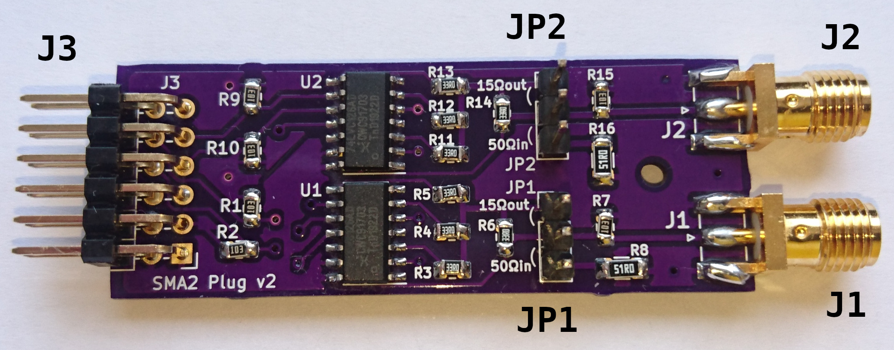
Connectors
Label | Type | Description
J1 | SMA | Digital input/output channel 1
J2 | SMA | Digital input/output channel 2
J3 | 2x6 pin header | Connection to FPGA board
Table 1: Connectors
Connector J3 is compatible with the Digilent Pmod specification v1.2.0
(see https://reference.digilentinc.com/reference/pmod/start). This means the module will work when plugged into a dual-row Pmod connector as present on many Digilent FPGA boards.
Figure 1: Pin numbers of Pmod connector on host FPGA board and SMA Plug module

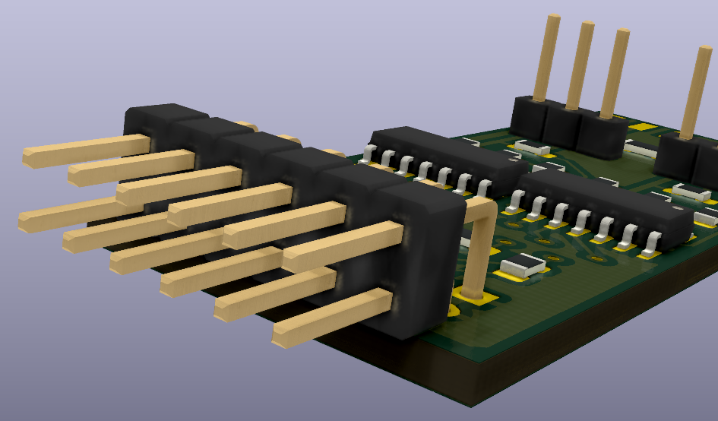
1
2
3
4
5
6
7
8
9
10
11
12
host Pmod socket
1
6
5
4
3
2
7
12
11
10
9
8
host board edge
The pin functions of connector J3 match Pmod interface type 1A (GPIO).
The pin assignments are as follows:

Pin nr | Name | In/out | Function
1 | IN2 | FPGA input | Input signal from J2.
2 | OUT2 | FPGA output | Output signal for J2.
3 | OE2 | FPGA output | High to enable output via J2;  low to disable output via J2.
4 |  |  | not connected
5 | GND |  | 0 V ground
6 | 3V3 |  | +3.3 V power supply from FPGA board
7 | IN1 | FPGA input | Input signal from J1.
8 | OUT1 | FPGA output | Output signal for J1.
9 | OE1 | FPGA output | High to enable output via J1;  low to disable output via J1.
10 |  |  | not connected
11 | GND |  | 0 V ground
12 | 3V3 |  | +3.3 V power supply from FPGA board
Table 2: Connector J3 pin assignments
Note: These pin number assignments are based on the Digilent Pmod specification. The schematic of the SMA2 Plug v2 uses different pin numbers internally.

Jumpers
Each of the two SMA ports has a 3-pin jumper which is used to choose between 3 modes of operation for that port. The jumper settings are as follows:

Jumper not connected

1
2
3
15Ω out
50Ω in
This is the best setting to use in most cases.
The input function receives a TTL signal from an external device. The SMA Plug input has 10 kΩ termination. The external device is expected to provide 50 Ω source termination to avoid reflections in the cable.

The output function drives a 3.3 V TTL signal to an external device with high input impedance. The output has 50 Ω series termination to avoid reflections in the coax cable. The external device must have high input impedance (at least 500 Ω) to ensure that the output meets the TTL threshold.

Input function: 10 kΩ input impedance.
Input threshold: logic low level max 0.8 V, logic high level min 2.0 V.
Output function: 50 Ω output resistance.
Output levels: 0.0 V to 3.2 V into high-impedance load.

Jumper connected from pin 1 to pin 2

1
2
3
15Ω out
50Ω in
This mode is suitable for driving a 2.5 V TTL output signal to an external device with 50 Ω input impedance.

The jumper reduces the output resistance of the SMA Plug to 15 Ω to make it strong enough to drive a 50 Ω load. This only works well if the coax cable ends in 50 Ω termination at the external device, otherwise reflections may occur.

Input function: 10 kΩ input impedance.
Input threshold: logic low level max 0.8 V, logic high level min 2.0 V.
Output function: 15 Ω output resistance.
Output levels: 0.0 V to 2.5 V into 50 Ω load.

Jumper connected from pin 2 to pin 3

1
2
3
15Ω out
50Ω in
This mode is suitable for TTL input from an external device which is designed to drive a 50 Ω load. The jumper connects a 50 Ω load resistor between the SMA port and ground to terminate the coax cable.

In this mode the input voltage must stay below 3.6 V to prevent overheating of the load resistor.

Input function: 50 Ohm input impedance.
Input threshold: logic low level max 0.8 V, logic high level min 2.0 V.
Output function: not usable (keep OEn = '0').

Specifications
Physical specifications
Board dimensions: | 54.4 x 20.4 mm

Damage limits
Input voltage limits: | minimum | −0.5 V
Input voltage limits: | maximum (10 kΩ input impedance) | +5.5 V
Input voltage limits: | maximum (50 Ω input impedance) | +3.6 V
Output load: | minimum load resistance | 30 Ω

Exceeding these limits may damage the SMA Plug.
Short-circuiting the SMA connector with output enabled may damage the SMA Plug.

Voltage levels
Input thresholds: | logic low level, maximum input voltage | 0.8 V
Input thresholds: | logic high level, minimum input voltage | 2.0 V
Output levels:  (typical) | logic low output level | 0.0 V
Output levels:  (typical) | logic high output level  (50 Ω output resistance, > 1 kΩ load) | 3.2 V
Output levels:  (typical) | logic high output level  (15 Ω output resistance, 50 Ω load) | 2.5 V

Power consumption
Supply current:  (typical) | both outputs disabled | 1 mA
Supply current:  (typical) | both outputs enabled, logic high output,  15 Ω output resistance, 50 Ω load | 100 mA

Copyright 2020 Joris van Rantwijk

This manual describes Open Hardware and is licensed under the CERN-OHL-S v2.

You may redistribute and modify this documentation and make products using it under the terms of the CERN-OHL-S v2 (https://cern.ch/cern-ohl).
This documentation is distributed WITHOUT ANY EXPRESS OR IMPLIED WARRANTY, INCLUDING OF MERCHANTABILITY, SATISFACTORY QUALITY AND FITNESS FOR A PARTICULAR PURPOSE. Please see the CERN-OHL-S v2 for applicable conditions.

Source location: https://github.com/jorisvr/hw-sma-plug

