**Outcome by Parent Category**

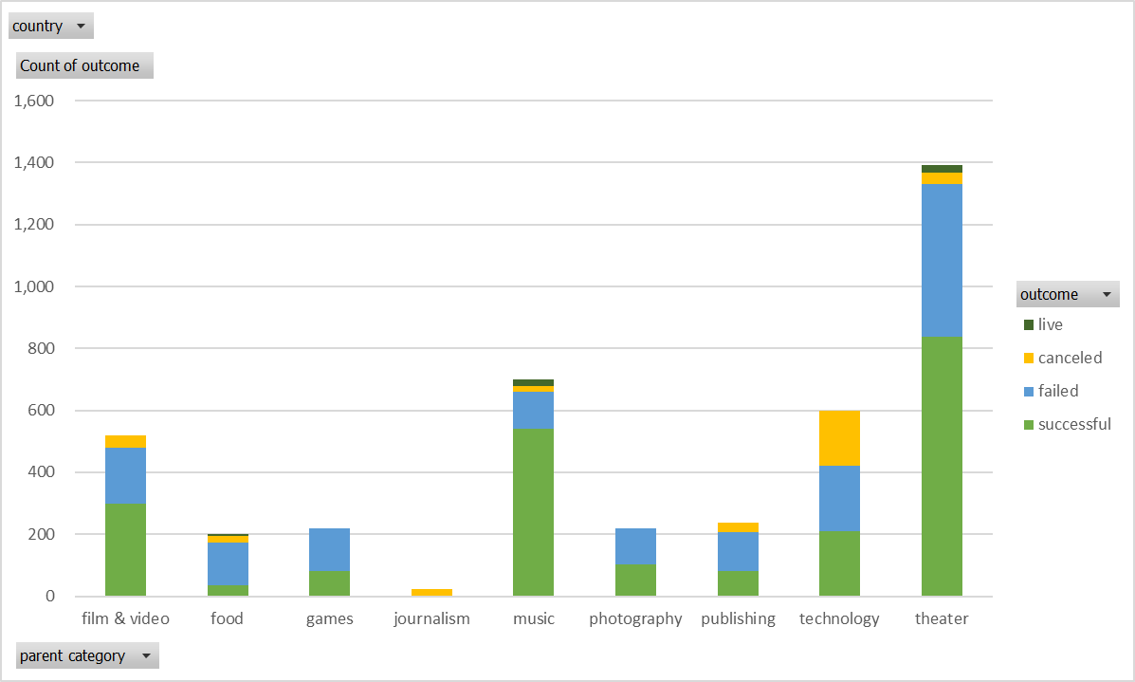

**Outcome by Sub-Category**

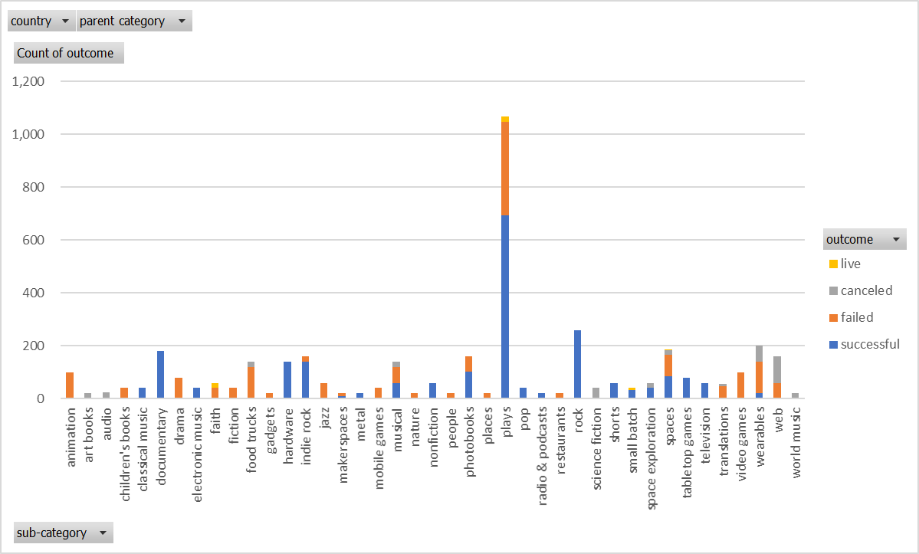

**Outcomes based on Created Date**

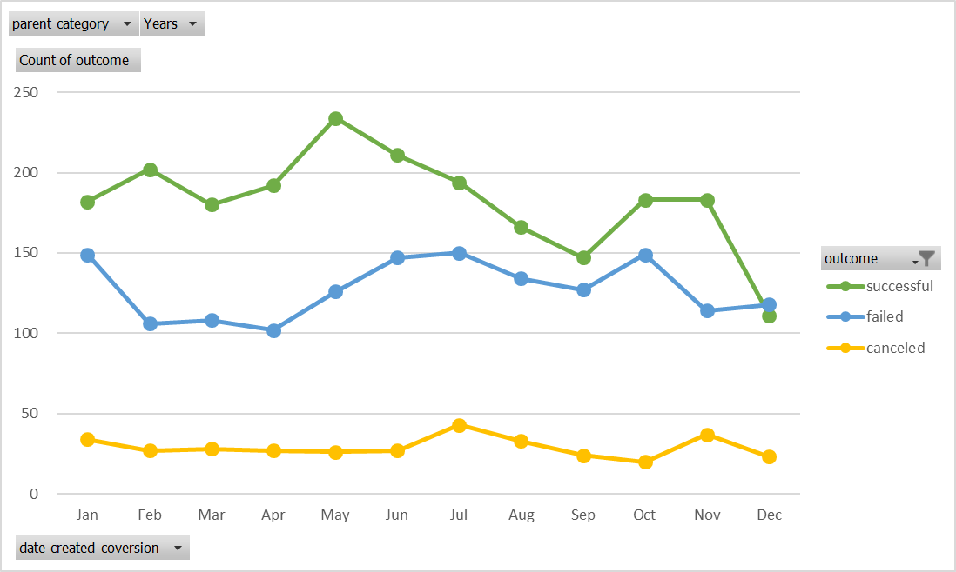

**Questions**

*What are three conclusions we can make about Kickstarter campaigns given the provided data?*

There are several high-level, initial conclusions you could make based on the visualizations created for the homework on the Kickstarter data provided. As a caveat, all would need further analysis into the dataset as well as additional data to substantiate the conclusion as there are definite limitations on drawing any strong conclusions from just the provided data (addressed in answer to question #2).

* The most straight forward conclusion that can be drawn is related to the types of projects that have attempted to crowdfund through the Kickstarter platform. It has been most utilized for projects related to the arts (theater, film & video, music, etc) vs projects related to science and technologies. Strictly related to crowdfunding done through Kickstarter, it is also possible to take this conclusion one step further and say that projects related to the arts have had a greater relative degree of success vs science and technology related projects on Kickstarter. The fact that the only live projects are also art related, speaks somewhat to this conclusion.
* It can be said that there is some slightly visible seasonality in terms of the date a project is started on Kickstarter and its chances of success or failure. Just looking at the trend of successful outcomes over the months of a given year, the seasonality can be explained conceptually by a few possibilities. As an example, the successful projects spike with start dates in May. This could be attributed to tax season completely in the middle of April and extra discretionary cash being available from refunds. This would also correspond to the slight upward trend again around when people that file extensions finish their taxes in October. Another example of a possible explanation for the peak in upward trend through May could be related to bonus seasons for many industries where employees have more disposable income. As a final example, the dip towards year end is probably related to discretionary spending going towards holiday shopping. Again, to validate this conclusion would take more digging into the dataset provided as well as additional data.
* Another fairly straight forward conclusion is based on the chart shown on the last page of this report created for the homework bonus question. There is a positive relationship between the stated goal for a project and the failure rate and a negative relationship between the stated goal for a project and the success rate. In other words, as a project’s goal grows on Kickstarter, its chance of failure increases (or chances of success decrease).

*What are some of the limitations of this dataset?*

There are several limitations that hinder drawing any substantial or truly useful conclusions from the data. It is a good base of data, but hard to verify any real relationships without additional data and/or additional manipulation of given data. One of the biggest limitations I see in the data I qualify in all my conclusions stated in question #1. The data is strictly related to the Kickstarter platform. There are many different platforms for crowdfunding, so limited in conclusions that can be drawn in using crowdfunding as way to fund a project.

However, even conclusions drawn strictly on the use of Kickstarter have their limitations with provided data. This can be exemplified by reviewing the first conclusion given for question #1. As far as category and/or subcategory of project and the associated expected outcomes by using Kickstarter, it is difficult to verify any relationship between the two based on given data because there are no comparables. As an example, a category/subcategory of a project could actually be more successful (or less successful) on Kickstarter than implied by historicals in the sample as the dataset grows. By using comparables in the crowdfunding space as well different types of funding for similar categories/subcategories of projects, it is possible to make a more substantiated conclusion on whether a relationship and its associated performance was really related to the Kickstarter platform or more systematic.

While the limitation I just went through touches on a related sample vs population issue, it is also probably pertinent to point out that in terms of the population of existing Kickstarter outcomes, the dataset of sample Kickstarter outcomes doesn’t appear at a high level to represent the population. This is evidenced by the fact the success rate of the sample size is way larger than the population success rate provided in the instructions. Along these lines, no way to verify sample dataset is representative of category/subcategory, goal size, etc, of Kickstarter population with given dataset.

A few other limitations such as missing variables that would need to be considered (eg health of economy, social trends, etc) to truly verify any conclusions on using Kickstarter and its expected outcomes, but think I covered the main ones without continuing to go down this rabbit hole.

*What are some other possible tables/graphs that we could create?*

While the dataset has limitations, there is value in the dataset by determining a starting place of which relationships potentially warrant further investigation and whatever that might entail. Some additional tables/graphs to establish other potential keys to success using Kickstarter based on given dataset are listed below.

* line chart of count of cumulative outcome against length of time Kickstarter was used for project (could also do as stacked bar chart and break tenor into distinct invtervals) to see if any relationship to success related to tenor
* instead of outcome, could also look at backers_count in a bar chart by category/subcategory to know volume of interest in type of project
* looking at average donation either by category in bar chart or over time in pivot line chart with category/subcategory as filter to determine trends in interest and willingness to spend (along these lines might also want to check a scatter plot with backers as independent variable versus average donation to see if average donation is mostly explained by a strong negative relationship to number of backers for particular category)
* number of other different stacked bar charts for outcomes by other categories provided in data (country, currency, spotlight)

**Outcomes based on Goals**

