# Exercise 3

## Chapter 5

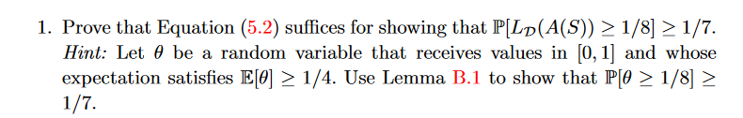

## Chapter 6

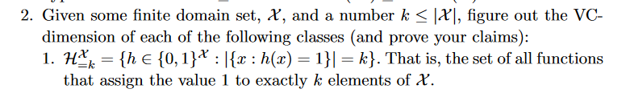



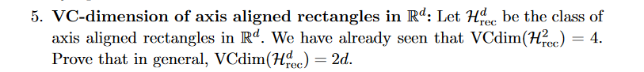

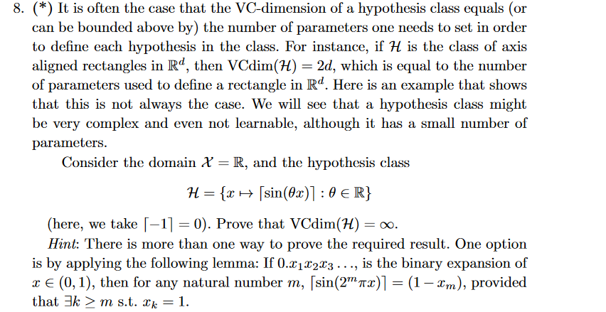

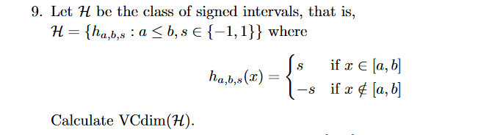

## Chapter 7

