# Exercise 1

## Chapter 3

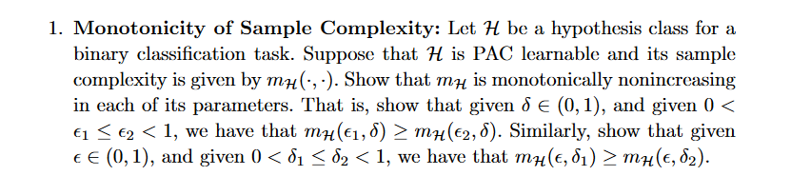

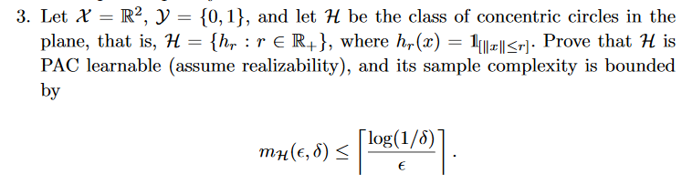

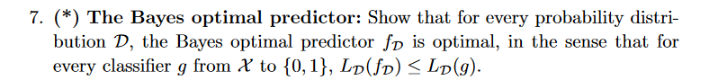

## Chapter 4

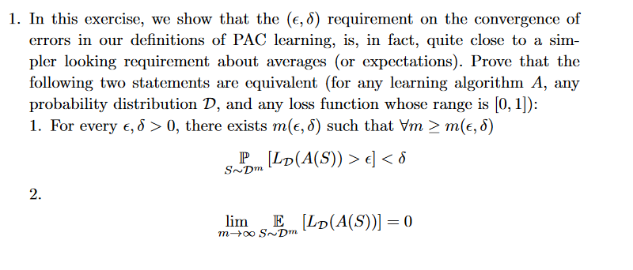

## 

## Chapter 5

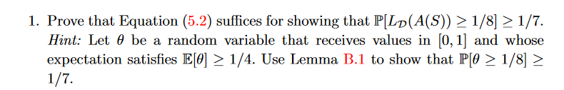

## Chapter 6

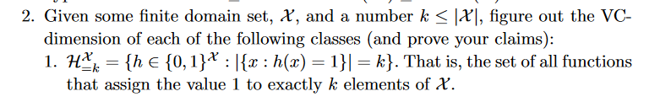



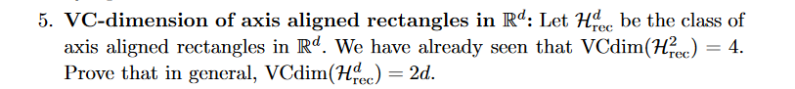

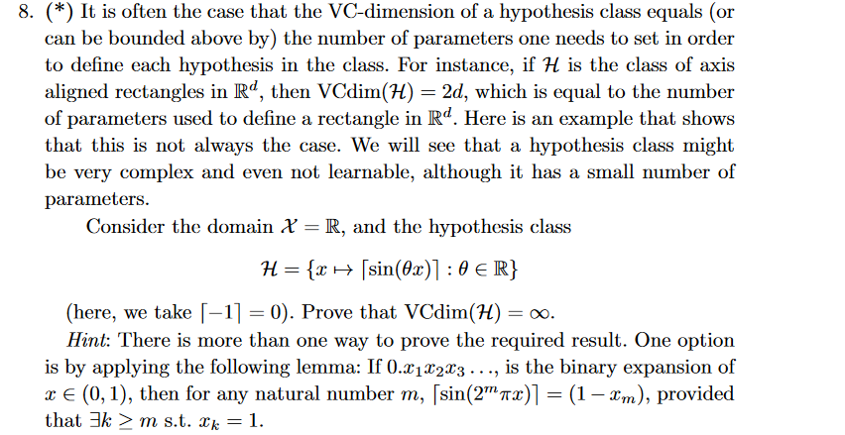

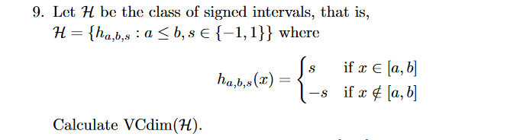

## Chapter 7

