# Exercise 1

## Chapter 3

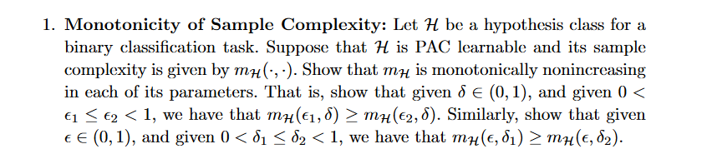

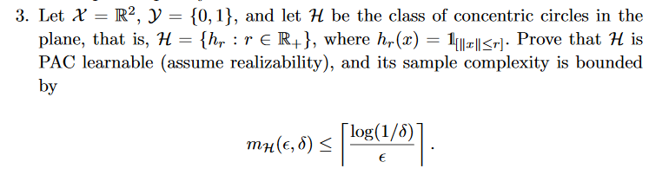

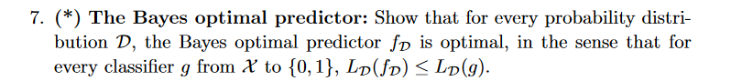

## Chapter 4



 