Testing and Evaluation

For the testing of our app, since it was done in an Agile development style, we decided to prioritize our testing methods to focus on quick and concise responses from the relevant shareholders on the said product being worked on. Different technologies were utilized to ensure that our feedback data matched that description.

Our first tool used was to get early feedback from our prototype UI. We used a survey style form of data collection as this was what met our needs. With a bit of discussion between the UX developers and the other lead staff team, we decided to use Google Forms as it was both free and accessible to us and the end users.

https://docs.google.com/forms/d/e/1FAIpQLSduj1-eeilpneA2XkY-ZQu45aiZ5dJsEM1HUwbaGAGWzksyQw/viewform?usp=publish-editor

Linked above is a link to a Google Form asking for some general feedback on a prototype design done in Figma.

Aside from data collection, we also used a myriad of other more technical tools to aid in the tests of any given step of implementation. One example would be Git. Instead of everyone pushing updates to 1 main repository, we had the repository branched into multiple other sub branches that were used for testing updates before they were finalized by the right group of people. Finalized changes are carefully reviewed before being pushed to the main branch.

Manually inspecting the flow of the finalized diagrams in the main user repository was done to ensure the backbone of the program has basic logic.

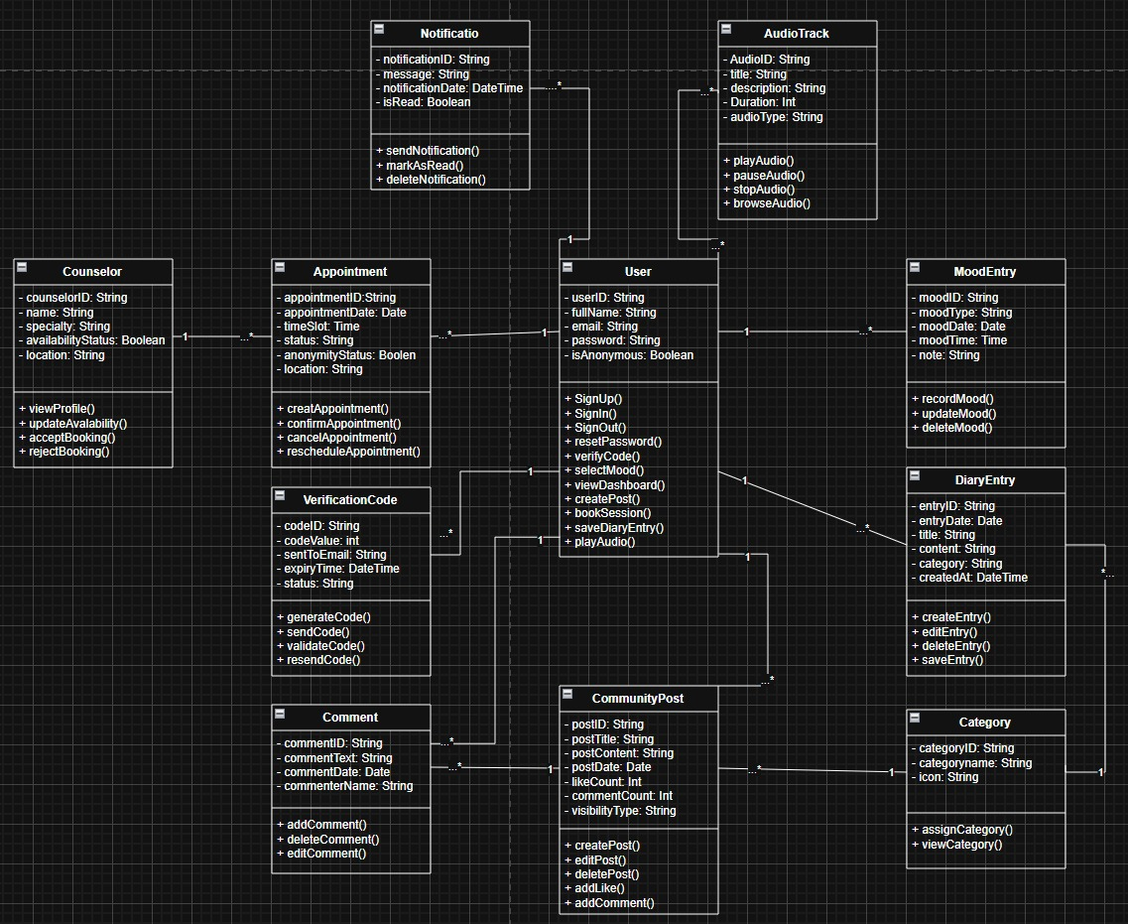

Example : Scenario A where Student signs up.

SignUp() -> generateCode() -> sendCode() -> verifyCode

In this flow, logically, the flow makes sense and the quantitative relationship of the object does too. Only one student can sign up or verify their login code at any given time but they can login multiple times.

We repeated this for every other basic functionality, like for example, a scenario where a student makes a post or wants to save a diary entry.

