Barcode Identification Terminal System

- I.Introduction

- Background
The use of barcode technology has been growing dramatically over the last 15 years and bar codes have become an everyday experience for many people. Bar codes are fast, easy and accurate data entry method. It is not surprising that as more and more things get automated, the use of barcode technology is also increasing.

Currently, the gate entry and exit to and from the college compounds in the University of the Philippines Manila (UPM) is not automated. Whenever a student or personnel enters the gate of a college, that person simply presents an identification card (ID) to the guard on duty.

The IDs of the students have, on them, stickers that correspond to the current year and semester. This sticker is issued by the university registrar after the registration and is meant as a proof that the student that is bearing the ID is registered for the said semester. This sticker is checked by the guard to make sure that every student entering the college premises are registered UP Manila students. This is a good security measure since any person who picks lost IDs wouldn’t be able to get a new sticker because that person is not a registered student, thus making the ID devoid of value and unusable for people who have no business in entering into college territory.

Whenever a student or personnel enters the college, it is expected from that person to once in a while look at bulletin boards for announcements that may concern that person. Bulletin boards are the university’s major medium of making announcements that concerns only a minor group of individuals. There are an abundance of bulletin boards scattered around the university. Different departments such as DPSM, Office of the College Secretary, etc, have bulletin boards of their own.

- Statement of the problem

The problem that arises is mainly because of human error. It is very possible for humans to create mistakes and this does not exempt the guards in duty. A person may sneak pass the guards by presenting fake IDs, or by taking advantage of the guards when they are not checking IDs. Also, students who had left their IDs have a tendency to borrow from their friends where the latter will hand the ID to the former through a window or a non guarded fence on the perimeter of the college.

Due to the nature of their work, the guards may sometimes feel lazy in checking the IDs. Often they will neglect the checking of the ID stickers but sometimes, they do not check the IDs at all as long as you show them something that may look like a legitimate ID. This type of neglect on the part of the guards is a security threat for the college.

With regards to the bulletin boards, sadly, looking at them every now and then is not the case for many, if not most, of the students. There are people that just walk by these boards without even looking at what is posted on them. But it is important for people to look at bulletin boards for the message in them may be so important like matters concerning about a person’s enlisted subjects or registration.

- Objectives

The system proposed provides a way of automating personnel and student identification by using information stored at the back of our current IDs. It will consist of several terminal clients which connects to an application server. These terminals will be situated at the gates or entry / exit points of different colleges and buildings.

When entering / leaving a facility though the terminal, the user (student or personnel) allows the system to scan the barcode at the back side of his / her identification card. The system then contacts the application's server in another location which logs the entry / exit of the user into a database. If there are any notifications posted for the user, it will be displayed on the screen. These notifications act like bulletin board notifications we see in the college halls or outside of different college offices. In this manner, the notifications are posted on a centralized location; and the target audience (the student or personnel) have a better chance of being informed.

Aside from the client-server architecture, the system will be managed through a web interface. This interface allows registered users, or admins, to do the following tasks:

- Manage the list of students and personnels.
- Post a notification targeted to a student or personnel.
- Modify any notification already posted but not yet viewed by the target user.
- Modify own admin account. (change information, password, etc)
- Allow some selected admins to create, modify, and delete other admin accounts.
- Create a report of all entry/exit transactions for a location for a given span of time.

- Significance

The system will reduce the amount of people who have no official business from entering the college premises. It will also help track if more that one person is using the same ID number; this may be the case for fraud IDs or IDs that are passed around or borrowed from friends.

Because the identification of students and personnel will be automated, it will be easier for gate guards. The identification process will also be more reliable; guards will just have to make sure that everyone gets their IDs scanned in the terminal.

The notification feature will reduce the chances that a bulletin board message will be missed by the student. It is, however, not meant as a complete replacement of the current bulletin boards as some bulletin messages are simply too long or complex, or targeted at too many students.

- Scope and Limitations

The system's scope covers only identification of people, bulletin messages from admins, and generating reports. It is not an alternative to the personnels' time clock.

The system would be limited to people passing through the terminal on foot. It will be difficult to use if people can enter through the entrance in a vehicle. The College of Arts and Science compound is one such location where, aside from a normal entrance, people can enter in a vehicle through another entrance. It would be a hassle if everyone inside that vehicle would need to get off and have their IDs scanned; and this process will also slow down vehicle traffic. Also, other people riding the vehicle, like drivers and parents, might not even have a UP ID and this creates a problem of whether we should allow the vehicle entry or not.

One workaround to the preceding limitation is to place the terminals in the actual college entrances (the main doors) rather than the gate. This solution would, however, mean that the parking area, and other tambayans would be considered as 'outside' college.

Another possible workaround to the problem is too allow only the drivers to enter the college within the vehicle; other passengers would need to get of before the vehicle enters and enter normally like other people. The driver would then need to present his / her driver's license to the gate guards and will be given a special 'pass'.

The notification feature of the system is also not meant to be a replacement for the current system of using bulletin boards. This is because some messages can be very long and complicated and it may be more efficient to use the notification system to just tell the user to "check the bulletin board". Sometimes, a bulletin message may also apply to a lot of students and/or specifying each student will be so much trouble, if not impossible. These are the “To all those interested” or “To all B.S. Biology students” type of bulletin messages.

- Assumptions

With the various limitations of the proposed system, it is assumed that:

- Students and personnels who have lost their IDs and are currently applying for a new one must be given a temporary ID card signed by the University Registrar.
- The student and personnel database is kept current including upcoming freshmen.

- II.Review of Related Literature

- A. Library Solutions

Libraries were one of the first to adopt barcodes. It is no surprise as it is obvious that libraries need a way to easily identify and keep track of books in their possession, which grows as time passes.

The University of the Philippines Manila University Library also uses barcode technology. They use a solution called Library.Solution, product of The Library Company. It is an integrated automation system that was first introduced to the library market in 1997 and since had served almost 600 libraries. It runs on a Windows operating system, Intel compatible hardware, and Oracle database and internet linkage.

For the borrower's identification, they use the barcodes that are located at the back of the students' and personnels' IDs. This eliminates the need for a borrower's card; and whenever a person wants to borrow a book, the system will even show if that person has any pending books borrowed. The books also have barcoded stickers which the system uses to identify them.

B. Computerized Registration System (CRS)

The Computerized Registration System of the University of the Philippines is being used primarily used for student registration with features for preregistration, registration, and printing the students' Form5a and Form5. It has since gained various features like storing student grades, allowing professors to submit the students' grades online, and can generate different reports from it like printable true copy of grades (TCG), list of scholars, class cards, list of classes, etc. It has a list of students of the university campus and it is that list where BITS is expected to take data from.

- C.Asset Management

Another example of the use of barcodes for identification is an application from University of New York (NYU), called Asset Management, where they used it in tagging and inventory of their equipments. The purpose is to record and tag new capital equipments acquired by the university, satisfy their government's requirements for reporting assets, and to provide accurate capital equipment inventory reporting for all departments. It is notified for every capital equipment acquisitions and the staff then locates and affixes an inventory barcode tag to each piece of equipment, recording the physical location, and providing detailed description of each item. They also prepare equipment acquisition records for all items tagged and the inventory database is updated accordingly.

- III. Theoretical Framework

- A.Barcodes

A barcode is a series of varying width vertical lines, called bars, and spaces. The different combinations of these bars and spaces represent different characters.[6 bar 1] They were first used in the 1960s to track freight cars, but the idea can be traced back to the year 1932 when Wallace Flint led a small group of students at the Harvard University Graduate School of Business Administration. The project was Flint's masters thesis. The project proposed that customers select desired merchandise from a catalog by removing corresponding punched cards from the catalog. These punched cards were then handed to a checker who placed the cards into a reader. The system then pulled the merchandise automatically from the storeroom and delivered it to the checkout counter. A complete customer bill was produced and inventory were updated.

In 1948, a graduate student named Bernard Silver overheard a conversation between the president of a food chain and one of the deans about a study on capturing product information automatically on checkout. He mentioned this to his friend, then a twenty seven year old graduate student a teacher, Norman Joseph Woodland who became facinated about the problem. Woodland came up with the linear barcode that is based from Morse code. He then went on and came up with circular codes that can be scanned in any direction, which became popularly known as the "bull's eye code". Woodland and Silver filled a patent on October 20, 1949 entitled "Classifying Apparatus and Method".

There are different kinds of barcodes. Some barcodes are numeric only like the UPC and EAN, which are used in groceries. Some barcodes are fixed length, like UPC with 12 digits and EAN with 13. Some barcodes can have alphanumeric information, like code 39(3 of 9) and code 128, and allows the encoding of all 128 characters.

There are also two dimensional barcodes that can encode a large amount of data into a relativeley small space like the PDF417. As conventional linear barcodes get wider as more data is encoded, 2D barcodse makes use of the vertical dimension to pack in more data. But even if more information can be put into a 2D barcode, it is advantageous only for those data that contains 15 or more characters; for a vast majority of barcode users, 15 characters or digits are more than enough for their needs. Linear barcodes also contains a high degree of redundancy; even with considerable degredation, a linear barcode will scan as long as the scanner can find a single horizontal line that is undamaged. Increasing the linear barcode's height does not increase its content but only its redundancy which makes it more reliable.
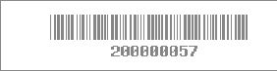
conventional linear barcode
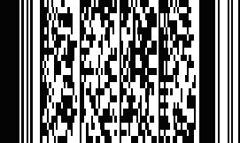
two dimensional barcode
- B.Keyboard Wedge

A keyboard wedge is a system that allows data to be entered into a computer in a way that may or may not be anticipated by the programmer of the application that receives the data. This is based on the idea that all applications are programmed to allow data to be entered by the user via the keyboard. Wedge systems are used to enter small packets of machine collected data into applications written to accept keyed data. The application will then treat the data as keyboard input unknowingly that it came from another input device. Without a wedge system, the user has to rely on the application itself or the operating system to handle the data.

This technique is currently firmly established and is widely used in many situations but particularly for the collection of barcode data. There are different wedge solutions that are available to the users but most barcode scanners now include a built-in keyboard wedge circuit. This is currently the most popular way of connecting barcode scanners to PCs.

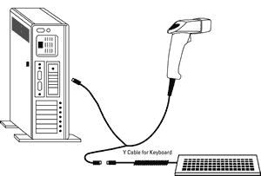
A typical keyoard wedge setup

- C.Ruby

Ruby is an interpreted programming language created in the mid 90's by Yukihiro "Matz" Matsumoto. It supports multiple programming paradigms, including functional, object oriented, imperative and reflection. The author said that it's a blend of his favorite languages: Perl, Smalltalk, Eiffel, Ada, and Lisp.

- D.Ruby on Rails

"Ruby on Rails is an open-source web framework that's optimized for programmer happiness and sustainable productivity. It lets you write beautiful code by favoring convention over configuration"

Rails is a framework using the Ruby programming language that makes it easier to develop, deploy and maintain web applications. It is extracted from an application by its creator: David Heinemeier Hansson. "Convention over configuration" is crucial, it means Rails has sensible defaults in every aspect of knitting together and application. If a developer follows conventions, he can write a Rails application with less code.

IV. Design and Implementation

- A.Entity Relationship Diagram (ERD)

As seen in the next diagram, the system will have 6 entities namely: students, personnels, admins, alerts, inside, and logbook. Both the students and the personnels can enter inside the gates. At any given time, only one instance of the student or the personnel can be inside any campus. Also, students and personnels can both have alerts for them. Each student can have none or many alerts at once. The admins have the ability to post bulletin messages (alerts). An admin can post as many alerts as he or she wishes.

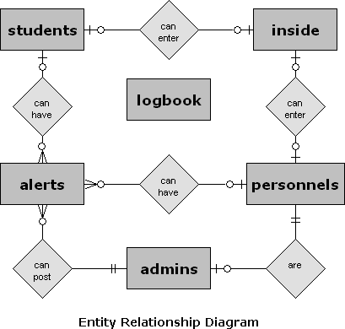

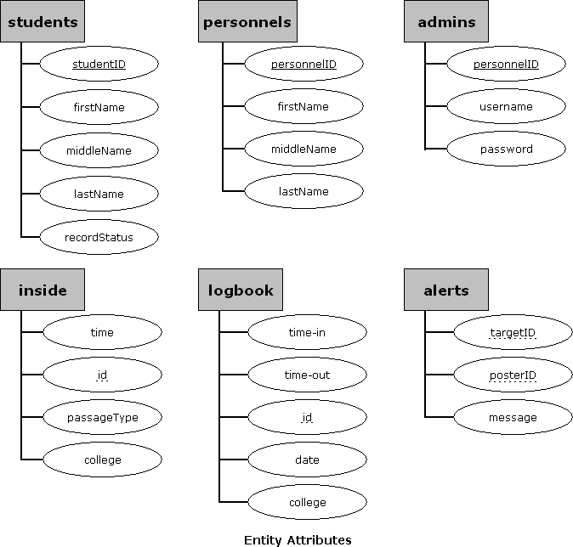
- B.Data Dictionary

students - table that contains information about the students of UP Manila. It is ideal that the entries of this table would come from the students table of the CRS or the Computerized Registration System. This is this table is a simplified version of CRS’s students.

data field | data type | description
student_id | integer | the student number (PK)
first_name | varchar(30) | first name of the student
middle_name | varchar(30) | middle name of the student
last_name | varchar(30) | family name of the student
record_status | char | U – unconfirmed freshman  F – confirmed freshman  E – enrolled regular student  C – cross registrant  L – L.O.A.  W – A.W.O.L.  A – alumni

personnels - table that contains information about the personnels working in UP Manila

data field | data type | description
personnel_id | integer | the personnel number (PK)
first_name | varchar(30) | first name of the personnel
middle_name | varchar(30) | the middle name
last_name | varchar(30) | the family name

admins - table that contains the list of admins. Admins can post bulletin messages for any student or personnel.

data field | data type | description
id | integer | (PK)
personnel_id | integer | personnel id
username | varchar(30) | username for logging in
crypted_password | varchar(30) | crypted password for loggin in
salt | varchar(30) | salt for the encrypted password
superadmin | boolean | true if super admin

terminal - table of client terminals

data field | data type | description
id | integer | (PK)
college | varchar(10) | college initial
name | varchar(30) | brief name of the terminal
description | varchar(255) | description of the terminal
ip_address | varchar(15) | ip address of the terminal

alerts - table of bulletin alerts

data field | data type | description
id | integer | (PK)
target_id | integer | id of the target of this message
target_type | varchar(10) | Student or Personnel
admin_id | integer | admin who posted this
message | varchar(255) | the message
created_at | datetime | datetime the message is created

inside - table that contains who are inside all the colleges of the campus.

data field | data type | description
id | integer | (PK)
time | datetime | datetime of entry or exit
passage_type | char | N - entry  X - exit
college | varchar(10) | college initial  (e.g. CAS, CAMP, CM)
person_id | integer | student or personnel id
person_type | varchar(10) | Student or Personnel

logbook - table that contains all entry/exit transactions.

date field | data type | description
id | integer | (PK)
time_in | datetime | datetime of entry
time_out | datetime | datetime of exit
date | date | date of the event
college | varchar(10) | college initial
person_id | integer | student or personnel id
person_type | varchar(10) | Student or Personnel

- C.Context Diagram

The next figure shows the context diagram of the proposed system. The two main type of users encountered by the system are labeled here as the USERS and the ADMINS.

The USERS are the students or personnel that are passing through the terminal. The user presents his or her ID to be scanned by the system and is given a go signal on success. Any bulletin alerts will also be shown to the user.

ADMINS are system admins. They can post bulletin alerts or manage other admins if they have the power to. They access the system not through the terminal but through a web interface component of the application by using a username and a password.

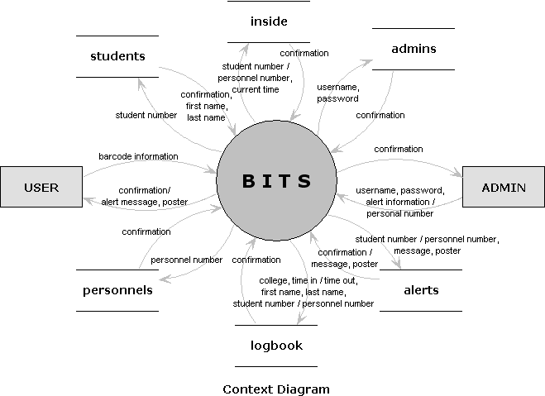

- D.Data Flow Diagram

The system can be divided into three separate applications and into two parts; these are the terminal client and terminal server, and the administration web interface. The level 0 data flow diagram has been divided also to reflect that.

The different functionalities available to the users using the terminal is shown in the next figure. Here we see that the user have only two functionalities and that is to enter and exit the gates. The student number or personnel number of the user is obtained through scanning the ID barcode. The system contacts the terminal server for a response to give to the user.
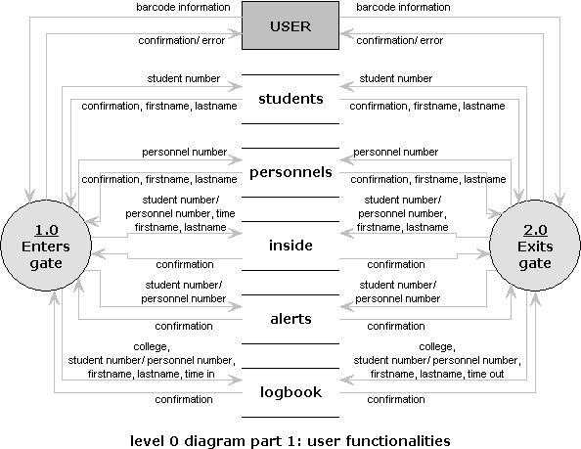

The administration part, on the other hand, is accessed through a web interface. The admins can add bulletin alerts. Some admins can also add, edit and delete other admins. Admins authenticate themselves by giving a username and a password to the system.
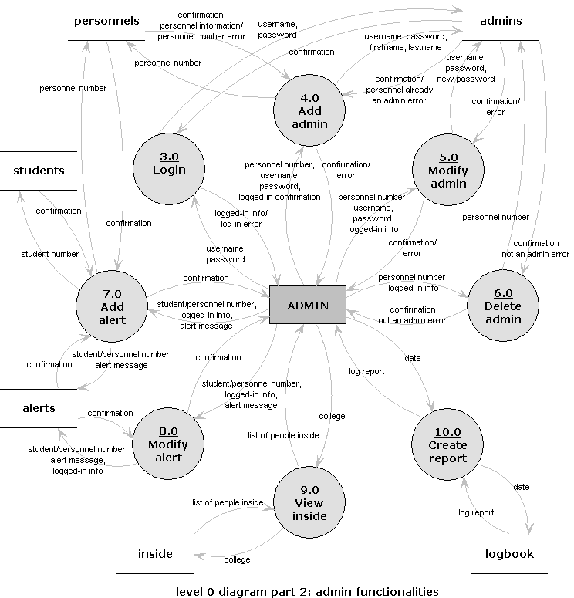

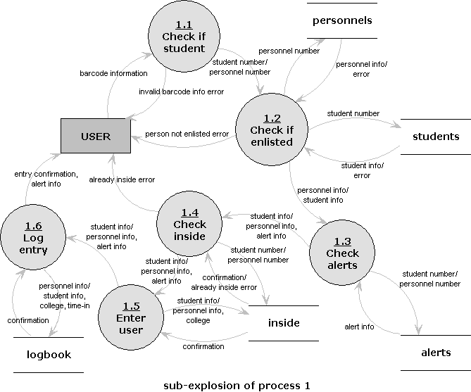

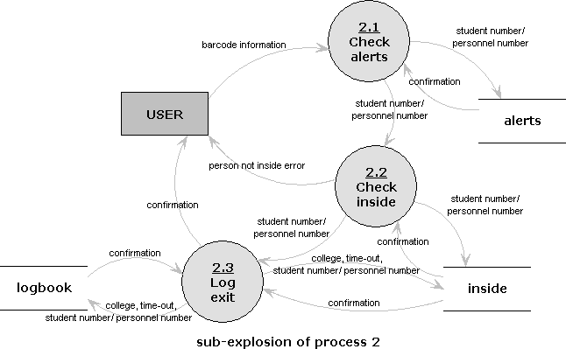

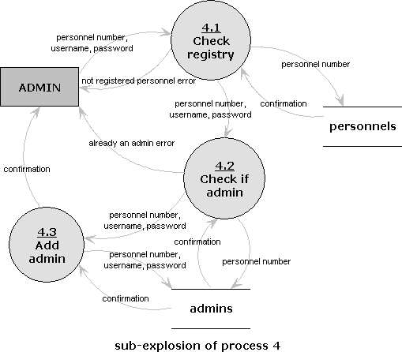

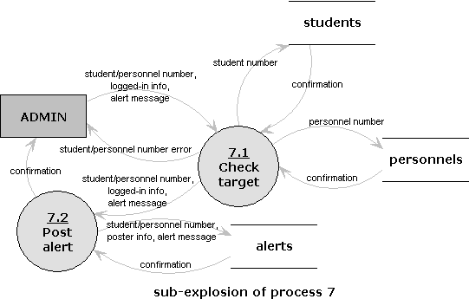

E. Technical Architecture

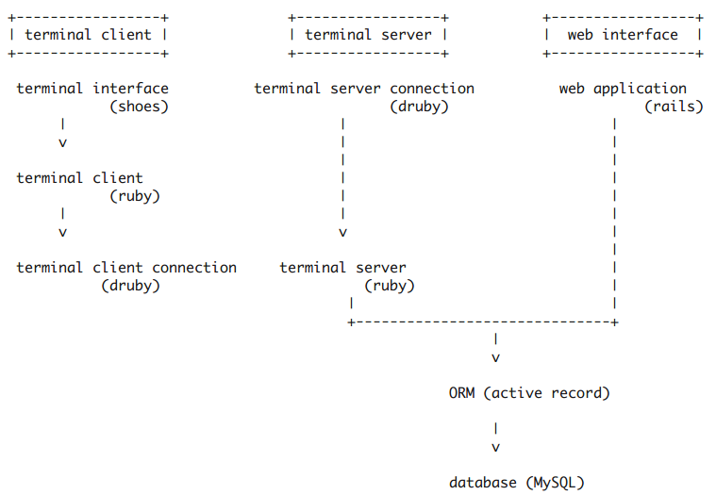
The system can be divided into 3 applications: the terminal client, the terminal server, and the web interface. The terminal client and terminal server work together for the actual entry/exit of people. The web interface is for the posting of bulletin messages and other administrative tasks.

The terminal client application is written using the ruby programming language and its interface implemented using the shoes GUI library. It connects to the terminal server using its terminal client connection component which by default uses druby.

System requirements for the terminal:
- Barcode scanner
- Shoes runtime application
- Linux (GTK), Windows or OSX (cocoa)

The terminal server application is written using the ruby programming language. It accepts incoming requests from terminals using its terminal server component component which is by default is a druby accessible object. The server restricts/identifies terminal clients via their IP; it checks if the terminal is granted access by checking a table of terminals.

System requirements for the terminal server:
- Ruby 1.8
- MySQL
- libmysql-ruby or equivalent

The web interface application of the system is a web application using the ruby on rails web framework.

System requirements for the web interface:
- Ruby 1.8
- Rails 2.1
- MySQL
- libmysql-ruby
- apache, litespeed, lighttpd, or nginx web server

- V.Expected Output

The terminal part of the system allows students and personnel entry/exit of colleges by having the barcode information of their IDs scanned.

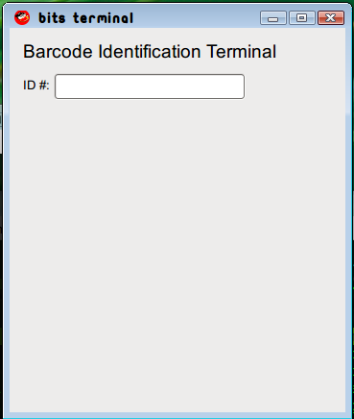
terminal starting interface

Once the person has his or her ID scanned, the terminal client contacts the terminal server and the response is given back to the user.

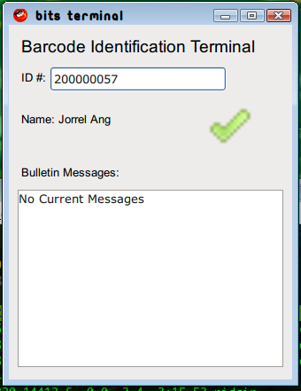
entry granted

If any bulletin alerts is assigned to the person who is about to pass, it is displayed as well on the screen.
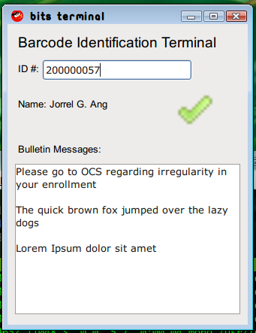
entry granted with bulletin alerts

For any invalid access, such as invalid ID or probable duplicate ID (a user is trying to enter a college but it is registered that he or she is already inside), the user will be notified with the appropriate message.
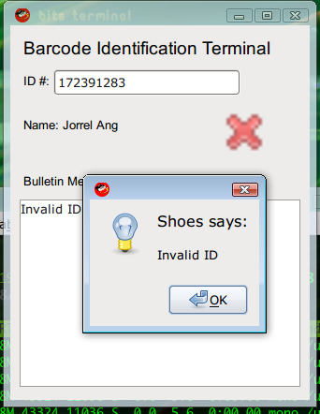
invalid ID

For the web interface application, admins need to provide their login and password in order to gain access.

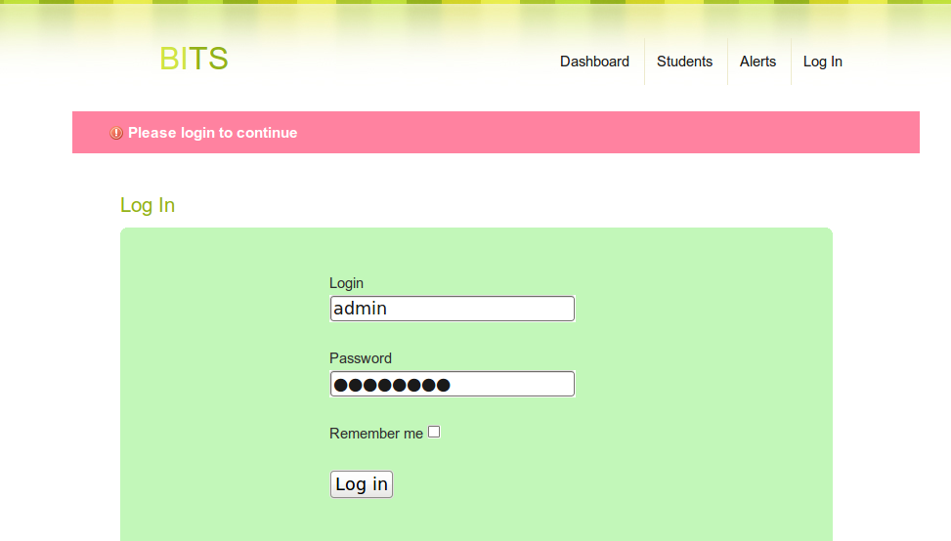
admins provide their username and password

Once the admin is authenticated, he or she can post bulletin alerts to any student by selecting from a list.

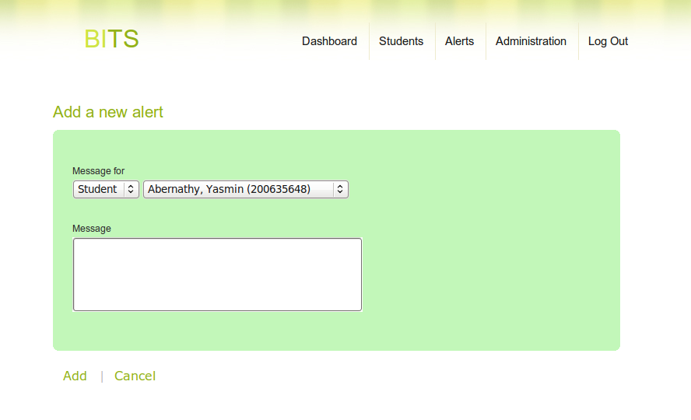

Some admins, called superadmins, will have the ability to add, modify or delete other admins. They can also manage the list of terminals that have access to the terminal server.

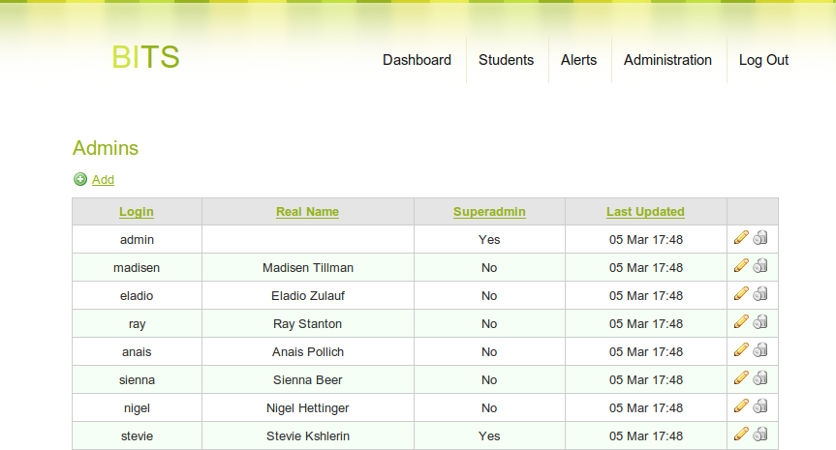

Superadmins are also allowed to manage the list of terminals. Machines not listed here will not be recognized by the server.

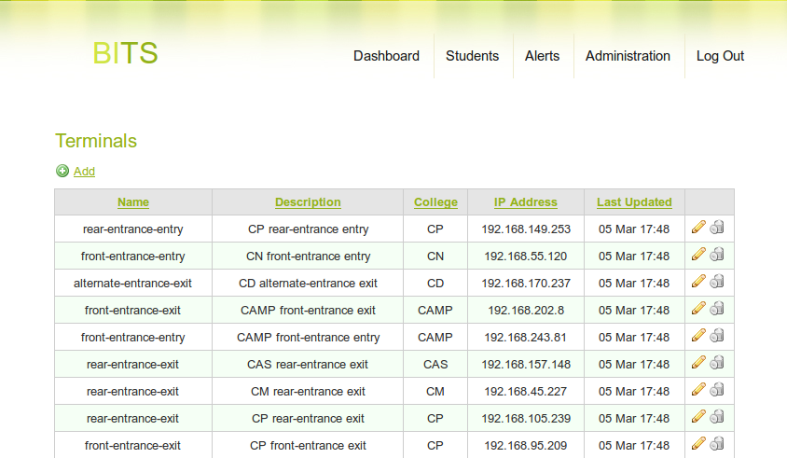

VII. Bibliography

“A Bar Code Primer”. Worth Data Company. http://www.barcodehq.com/primer.html
"Bar-coding". Biblio Tech Revie^{w} http://www.biblio-tech.com/html/barcoding.htm^{l}
"The Library Corporation finds a better read". Raxco Software, Inc .http://www.raxco.com/new/pressreleases/PD2K_TLC_Release.pdf
"Library Corporation announces Library.Solution Version 3.2". Library Technology Guides. http://www.librarytechnology.org/fulldisplay.pl?SID=20040909365753173&UID=&auth=&RC=10845&Row=19&code=BIB
“Library.Solution: TLC's integrated automation system now contracted by 60 libraries”. Library Technology Guides http://www.librarytechnology.org/lwc-displayarticle.pl?SID=20040909365753173&UID=&auth=&code=BIB&RC=7987
University of New York. http://www.nyu.edu/
Slotnick, et.al. “Computers and Applications”. Lexington, Massachusetts: D.C. Health and Company. 1986
Adams, Russ. “Barcode History Page”. BarCode 1. http://www.adams1.com/pub/russadam/history.html
Seideman, Tony. “The History of Barcodes”. BASICS (Barcoded(Assets Sales & Inventory) Control Systems). http://www.basics.ie/History.htm
“2D Barcodes Explained”. Altek Instruments Ltd. http://www.barcodeman.com/faq/2d.php
“Keyboard Wedge Techniques”. Altek Instruments Ltd. http://www.barcodeman.com/altek/mule/wedge.php
http://www.real-star.com/Point%20of%20Sale/Barcode%20Scanners/barcode%20general%20info_files/li50withcable.gif
http://www.ruby-lang.org/en/about/
David Thomas and Andrew Hunt. "Programming Ruby - The Pragmatic Programmer's Guide". Addison Wesley Longman Inc. 2001
Ruby on Rails. http://rubyonrails.org
Sam Ruby, Dave Thomas and David Heinemeier Hansson, "Agile Web Development with Rails". The Pragmatic Programmers. 2008

