CAMF: Conflict-Aware Multi-Stream Fusion for Speech Emotion Recognition
with Waveform, Spectrogram Image, and Prosody Prompting
Jorge Jorrin-Coz¹, Mariko Nakano-Miyatake¹, Hector Perez-Meana¹(✉)
¹ ESIME Culhuacan, Instituto Politécnico Nacional, Av. Santa Ana 1000, 04440 CDMX, Mexico
{jljorrincoz, mnakano, hmperezm}@ipn.mx (✉ corresponding author)
Abstract. Speech emotion recognition (SER) benefits from combining acoustic and lexical cues, but multi-stream pipelines are vulnerable to inter-stream conflicts where individual streams disagree on the predicted emotion. We present CAMF, a Conflict-Aware Multi-Stream Fusion framework with three complementary streams: a raw-waveform stream (Wav2Vec2-base), a log-Mel spectrogram-image stream (ViT-Base/16, computed in-line from the same waveform), and a transcript stream (DistilBERT with a SpeechCue prosody-prompting prefix that discretises pitch, energy, and speech rate into nine semantic tokens). A binary conflict gate fires when at least two unimodal predictors disagree, switching to MLP-derived fusion weights. The fused representation is decoded by a MultiScaleTemporal (MST) head combining parallel pooling, BiLSTM, and self-attention branches. On IEMOCAP four-class single-split protocol, the best configuration reaches 79.23% UA / 79.61% WA with a 2.91 pp validation-test gap, surpassing CTNet, UniMSE, and Kim et al. among bimodal systems.
Keywords: Speech Emotion Recognition · Multi-Stream Fusion · Mel-Spectrogram Image · Prosody Prompting · Conflict-Aware Cross-Attention · MultiScaleTemporal Head.
1 Introduction
Characterising a speaker's emotional state from voice is key in affective computing, with applications in human-machine interaction, call-centre routing, and mental-health monitoring. Classical approaches relied on hand-crafted features such as MFCCs [11] with shallow classifiers [12]; modern pipelines leverage self-supervised transformers—wav2vec 2.0 [6], HuBERT [7], WavLM [8]—or treat speech as a 2-D image by converting it to a log-Mel spectrogram processed by a ViT [17]. Neither paradigm alone is robust: time-domain encoders miss lexical cues; spectrogram-image systems discard temporal fine structure. Multi-stream fusion combines complementary representations but is actively harmed when streams produce conflicting predictions [5]. Prosodic features (pitch, energy, speech rate) are typically injected as continuous high-dimensional vectors that are hard to align with token-based language models [4].
This paper proposes CAMF (Conflict-Aware Multi-stream Fusion). The contributions are:
1. Dual audio view. The first multi-stream SER framework to treat the log-Mel spectrogram image as a complementary view of the same waveform already encoded by a self-supervised time-domain encoder. Unlike prior work using mel-spectrogram images as a standalone SER encoder, we exploit the complementarity between SSL time-domain and frequency-domain image representations within a conflict-aware framework, extending our prior speaker-profiling spectrogram-image pipeline [33,34] to emotion recognition.
2. SpeechCue prosody prompting. A parameter-efficient module that discretises utterance-level pitch, energy, and speech rate into nine semantic tokens prepended to the DistilBERT [16] input. Unlike ProsodyBERT, which learns continuous prosody representations, and unlike neural codec tokenisers that discretise the waveform acoustically, SpeechCue uses corpus-level tertile boundaries to map three manually defined statistics to a fixed nine-symbol vocabulary, providing an interpretable prosodic bridge [23].
3. Conflict-Aware Cross-Attention with a binary gate. A pairwise prediction-divergence detector declares conflict when at least two unimodal predictors disagree, then switches to MLP-derived fusion weights. This differs from DCA [36] and IACA [37] (generic complementarity, dimensional SER), M3ER [38] (sensor-noise, multiplicative fusion), HBAF [39] (representational alignment), and ConflictAwareAH [40] (conflict as target signal for ambivalence/hesitancy, late fusion)—none apply an explicit emotional-conflict gate inside a cross-attention transformer for categorical SER.
4. MultiScaleTemporal (MST) head. A post-fusion head combining three parallel aggregation branches (mean/max/attention pooling, BiLSTM, self-attention) whose concatenated outputs provide multi-granular representation. Although individual components are established, their combination as a post-conflict-fusion head for multi-stream SER is novel; Ablation 45 (MST head + corrected fine-tuning regime) achieves 79.23% UA, best in our 54-configuration ablation grid.
5. Systematic 54-configuration ablation. Every architectural choice is isolated under identical optimiser, seed, and data splits, providing reproducible baselines for future multi-stream SER research.
On IEMOCAP, Ablation 45 reaches 79.61% WA / 79.23% UA, surpassing CTNet [22], UniMSE [41], and Kim et al. [42] among bimodal systems. Sections 2-6 review related work, detail the architecture, describe experiments, analyse results, and conclude.
2 Related Work
2.1 Unimodal SER with Self-Supervised Encoders
Wav2Vec 2.0 [6], HuBERT [7], and WavLM [8] learn robust speech representations through masked prediction objectives on large unlabelled corpora. Fine-tuning on SER yields strong baselines: Pepino et al. [9] reach 72.80%/72.50% WA/UA using Wav2Vec 2.0-base on IEMOCAP; Morais et al. [10] achieve 74.10%/73.80% WA/UA with HuBERT. Processing speech as a 2-D spectrogram image with a ViT has shown promise for emotion recognition [17], and our prior work applied spectrogram-image pipelines to speaker gender and age profiling [33,34,35].
2.2 Multimodal Fusion for SER
Cross-modal fusion strategies range from concatenation to attention-based approaches [5,23]. MulT [18] extends Transformers to unaligned audio-text streams. Rahman et al. [19] inject acoustic features as continuous vectors into BERT. CTNet [22] models conversational context (79.60%/78.30% WA/UA). UniMSE [41] achieves 79.14% UA through joint sentiment-emotion optimisation; Kim et al. [42] reach 77.70% UA; GIA-MIC [21] achieves 79.40% UA through graph-based inter-modal interaction. MemoCMT [43] reaches 81.33% UA with HuBERT + full BERT, establishing the current bimodal state of the art.
2.3 Gating Mechanisms and Conflict-Aware Fusion
DCA [36] and IACA [37] gate selection between cross-attended and self-attended audio-visual features based on complementarity strength; both target dimensional AV emotion recognition and do not model semantic emotional conflict. WavFusion [44] uses gated cross-modal attention with homogeneous feature discrepancy learning. HBAF [39] combines bimodal attention with a dynamic filter gate for representational alignment—not emotional conflict detection. M3ER [38] uses Canonical Correlation Analysis as a sensor-noise detector before multiplicative fusion, not a conflict gate for contradictory emotional predictions. ConflictAwareAH [40] uses pairwise absolute embedding differences as conflict cues for ambivalence/hesitancy recognition—treating conflict as the target signal, employing late fusion, and not addressing categorical SER. Our Conflict-Aware Cross-Attention differs from all these by incorporating an explicit binary conflict-detection gate grounded in unimodal prediction divergence inside a cross-attention transformer for categorical SER on IEMOCAP [1].
2.4 Prosody Injection into Language Models
Continuous acoustic features are typically injected into BERT-style models as dense vectors [19]. ProsodyBERT learns continuous prosody representations self-supervisedly. Neural codec tokenisers (EnCodec, DAC) discretise the waveform acoustically but without semantic interpretability. SpeechCue differs by mapping three manually defined prosodic statistics to a compact nine-symbol vocabulary via corpus-level tertile boundaries, providing interpretable tokens without modifying the DistilBERT architecture.
3 Proposed Architecture: CAMF
Figure 1 shows the overall architecture. Three parallel encoders produce 512-dimensional projected embeddings that are fused by a three-layer Conflict-Aware Cross-Attention module. A binary conflict gate modifies fusion weights when pairwise predictor disagreement is detected. The MultiScaleTemporal head decodes the fused representation.
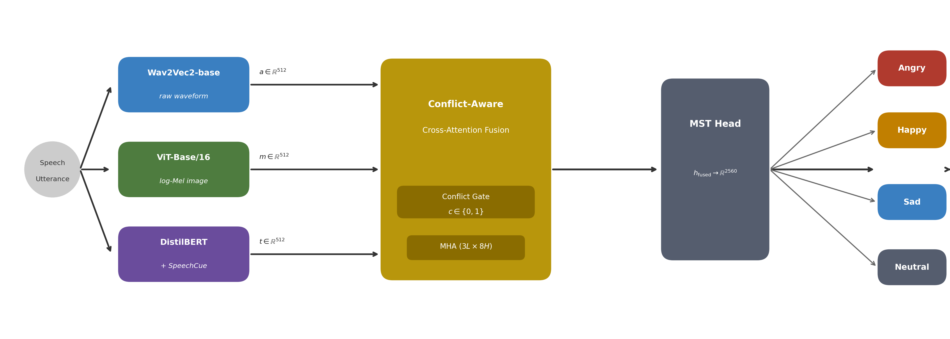
Fig. 1. CAMF overall architecture. Three parallel encoding branches are fused by a conflict-aware cross-attention transformer. The binary conflict gate (c) switches fusion weights from uniform (c=0) to MLP-derived (c=1) when unimodal predictors disagree.
3.1 Raw-Waveform Stream (Wav2Vec2)
Wav2Vec 2.0-base [6] (95 M parameters) receives the 16 kHz waveform. The 7-layer convolutional feature extractor is frozen; the last 6 of 12 Transformer encoder layers are fine-tuned. Frame-level embeddings in ℝ^{T×768} are mean-pooled to h_{a} in ℝ⁷⁶⁸, projected: a = W_{a} h_{a}, W_{a} in ℝ^{512×768}.
3.2 Log-Mel Spectrogram-Image Stream (ViT)
The same waveform is converted to a log-Mel spectrogram (Table 2), normalised per-utterance (z-score), resized to 224x224 bilinearly, and replicated to 3 channels. ViT-Base/16 [17] (ImageNet-21k pre-trained, frozen in Ablation 45) produces h_{m} = [CLS] in ℝ⁷⁶⁸, projected: m = W_{m} h_{m} in ℝ⁵¹². Figure 2 illustrates the construction pipeline.
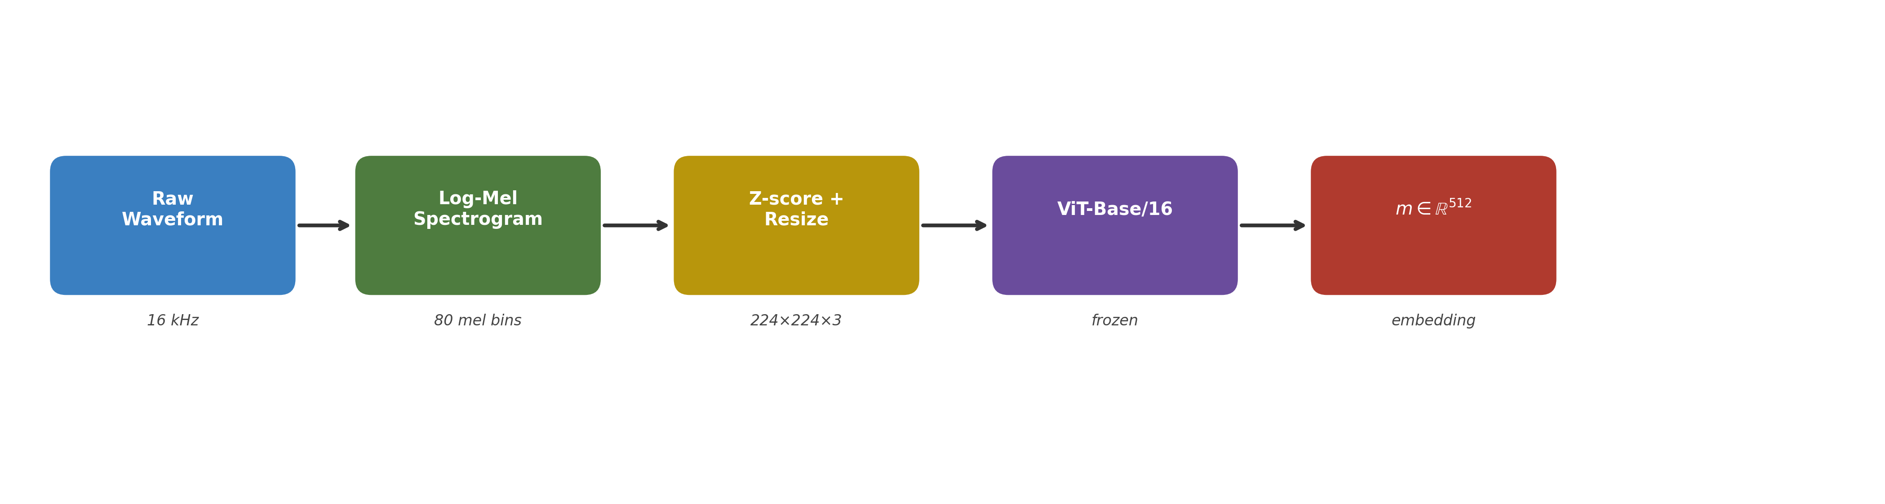
Fig. 2. Log-Mel spectrogram-image construction pipeline. The same waveform processed by the Wav2Vec2 stream is converted in-line to a 224x224 three-channel image fed to a frozen ViT-Base/16.
3.3 Prosody-Prompted Text Stream (SpeechCue + DistilBERT)
SpeechCue converts mean F0 (Hz), RMS energy, and speech rate R (syl/s) into three discrete tokens. Each statistic xi is discretised via corpus-level tertile boundaries:
$token\left(ξ\right) = \begin{matrix}LOW & if ξ < q_{33} \\ MID & q_{33} ≤ ξ < q_{66} \\ HIGH & if ξ ≥ q_{66}\end{matrix}$ (1)
where ξ ∈ {F₀, E, R} is one of the three prosodic statistics (mean fundamental frequency F₀, RMS energy E, syllable rate R); q₃₃ and q₆₆ are the 33rd and 66th percentile thresholds of ξ, estimated on the training partition.
Nine vocabulary entries {[P-LOW/MID/HIGH], [E-LOW/MID/HIGH], [R-LOW/MID/HIGH]} are added to DistilBERT and randomly initialised. F₀ extracted by pYIN; rate from forced-aligned transcripts. Input: [CLS] [P-x] [E-x] [R-x] word1 … [SEP]. Last 4 DistilBERT layers fine-tuned. The [CLS] embedding h_{t} in ℝ⁷⁶⁸ is projected: t = W_{t} h_{t} in ℝ⁵¹². See Figure 3.
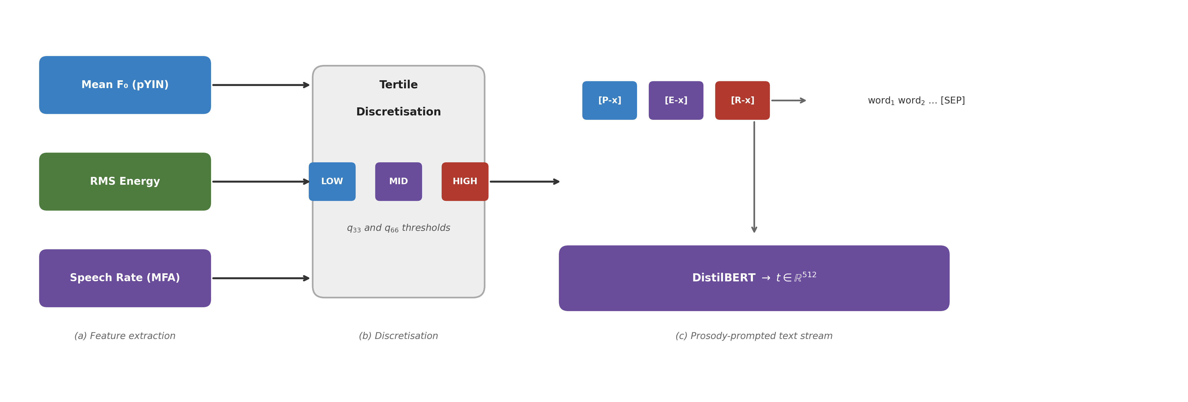
Fig. 3. SpeechCue prosody prompting. Three prosodic statistics are discretised into low/mid/high semantic tokens and prepended to the DistilBERT input.
3.4 Conflict-Aware Cross-Attention Fusion
Each projected embedding feeds a stream-specific head to produce unimodal logits:
$l_{a} = W_{a}^{cls}a, l_{m} = W_{m}^{cls}m, l_{t} = W_{t}^{cls}t, W_{*}^{cls} ∈ R^{4×512}$ (2)
where ℓ_{a}, ℓ_{m}, ℓ_{t} ∈ ℝ⁴ are the unimodal logit vectors for the waveform, mel-image, and text streams respectively; W_{a}, W_{m}, W_{t} ∈ ℝ^{4×512} are the stream-specific classification projection matrices.
Conflict Detection. A conflict fires when >= 2 of 3 pairwise predictors disagree:
$c = 1\left[\sum_{i<j}{1\left[argmax\left(l_{i}\right) ≠ argmax\left(l_{j}\right)\right]} ≥ 2\right], c ∈ \left\{0, 1\right\}$ (3)
where c ∈ {0, 1} is the binary conflict indicator; 𝟙[·] is the indicator function (equals 1 when the condition holds, 0 otherwise); argmax(ℓ_{i}) is the predicted class index for stream i; the sum ranges over the three pairs (a, m), (a, t), (m, t).
The gate activates on ~30.9% of IEMOCAP training utterances (41.7% for Happy, 18.3% for Sad).
Conflict Resolution. c=0: uniform weights 1/3. c=1: MLP produces softmax-normalised weights:
$w = \operatorname{softmax}{{MLP}_{w}\left[a ; m ; t\right]} ∈ Δ²$ (4)
where MLP_{w} is a two-layer MLP (512→256→3, ReLU) trained end-to-end; [a ; m ; t] ∈ ℝ¹⁵³⁶ is the concatenation of the three stream embeddings; Δ² is the 2-simplex (weights are non-negative and sum to one).
$w_{final} = \left(1 - c\right) · \frac{1}{3} · 1_{3} + c · w$ (5)
where 𝟙₃ ∈ ℝ³ is the all-ones vector; c is the conflict indicator from Eq. (3); w is the MLP-derived weight vector from Eq. (4). When c = 0 each stream contributes equally; when c = 1 the MLP re-weights streams adaptively.
Cross-Stream Self-Attention. Embeddings stacked into X⁽⁰⁾ in ℝ^{3×512}, processed by L=3 layers of MHA (H=8 heads):
$X^{(l)} = LN\left(X^{(l-1)} + MHA\left(X^{(l-1)}, X^{(l-1)}, X^{(l-1)}\right)\right), l = 1, … , L$ (6)
where X^{(l)} ∈ ℝ^{3×512} is the attended sequence at layer l; LN(·) denotes Layer Normalisation [29]; MHA(·) is multi-head self-attention [24] with H = 8 heads and d_{model} = 512 (64 dimensions per head).
Conflict-weighted aggregation:
$h_{fused} = \sum_{i = 1}^{3}{{\left(w_{final}\right)}_{i} · {X^{(L)}}_{i}} ∈ R^{512}$ (7)
where h_{fused} ∈ ℝ⁵¹² is the conflict-weighted fused utterance embedding; (w_{final})_{i} is the i-th weight from Eq. (5); X^{(L)}_{i} ∈ ℝ⁵¹² is the attended representation of stream i after L = 3 layers.
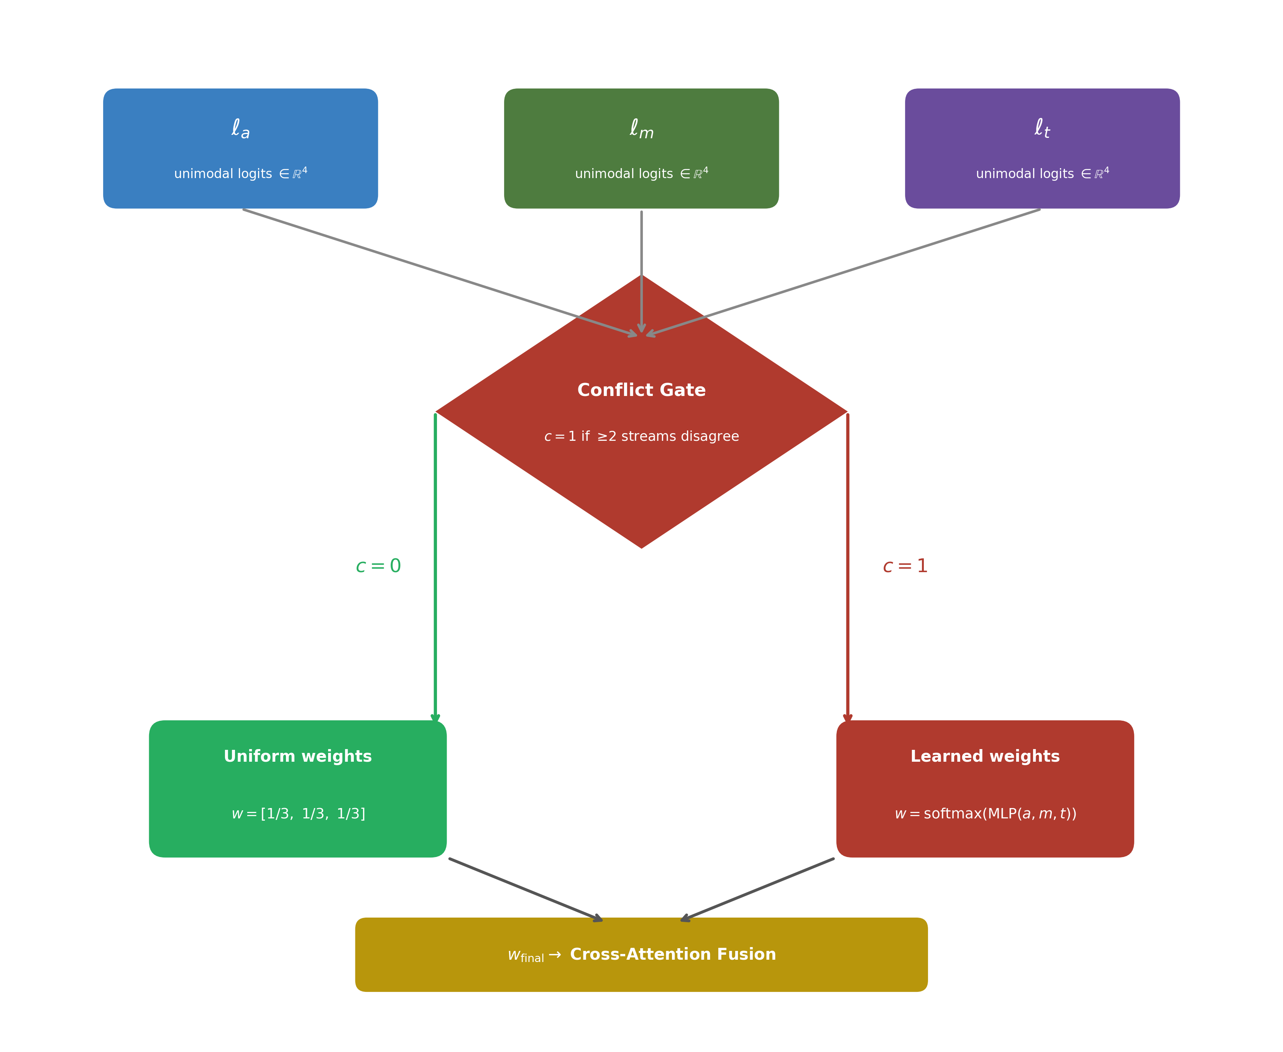
Fig. 4. Conflict-Aware Cross-Attention module. Dashed lines show the conflict detection branch (Eq. 3) that replaces uniform fusion weights with MLP-derived weights (Eq. 4-5) when unimodal predictors disagree.
3.5 MultiScaleTemporal Head and Training Objective
MultiScaleTemporal (MST) Head. Three parallel branches over X⁽ᴸ⁾ in ℝ³ˣ⁵¹²:
- Branch 1 (Multi-Pool): mean+max+attention pooling concatenated ⇒ h_{pool} in ℝ¹⁵³⁶.
- Branch 2 (BiLSTM): 2-layer BiLSTM (256+256, dropout 0.3) + attention pooling ⇒ h_{lstm} in ℝ⁵¹².
- Branch 3 (Self-Attn): 4-head self-attention, mean-pooled ⇒ h_{sa} in ℝ⁵¹².
$h_{MST} = \left[h_{pool} ; h_{lstm} ; h_{sa}\right] ∈ R^{2560}, ŷ = \operatorname{softmax}{W_{cls}h_{MST} + b_{cls}}$ (8)
where h_{pool} ∈ ℝ¹⁵³⁶ = [h_{mean} ; h_{max} ; h_{att}] (mean, max, and attention-pooled outputs concatenated); h_{lstm} ∈ ℝ⁵¹² (BiLSTM, 2 layers, 256+256 units, dropout 0.3); h_{sa} ∈ ℝ⁵¹² (4-head self-attention); W_{cls} ∈ ℝ^{4×2560} and b_{cls} ∈ ℝ⁴ are the classifier parameters; ŷ ∈ Δ³ is the predicted emotion probability vector.
Training Objective. Cross-entropy with label smoothing eps=0.1 [31]:
$L_{CE} = -\sum_{c = 1}^{4}{{y'}_{c} \log{ŷ_{c}}}, {y'}_{c} = \left(1 - ε\right)y_{c} + \frac{ε}{4}, ε = 0.1$ (9)
where $y_{c}$ ∈ {0, 1} is the one-hot ground-truth label for class c ∈ {angry, happy, sad, neutral}; ε = 0.1 is the label-smoothing coefficient; ${y'}_{c}$ is the predicted probability for class c (Eq. 8). Smoothing penalises overconfident predictions and reduces the validation-test gap.
AdamW (beta1=0.9, beta2=0.999, wd=0.05, max-grad-norm=1.0). Three learning rates: lr_audio=3e-5, lr_text=2e-5, lr_fusion=5e-6 with 10% linear warm-up + ReduceLROnPlateau (factor=0.5, patience=3, min_lr=1e-7). Effective batch 32. Max 100 epochs, early stopping patience 8. Ablation 45 converged at epoch 41.
4 Experimental Setup
4.1 Dataset and Protocol
IEMOCAP [1] (~12 h, 10 speakers, 5 sessions). Four-class protocol: Angry, Happy (Excited merged), Sad, Neutral => 5,531 utterances. Sessions 1-3 train, session 4 validates, session 5 tests (single-split). Metrics: WA (weighted accuracy) and UA (macro per-class accuracy). The test set is evaluated once per checkpoint.
4.2 Baselines
Unimodal: Wav2Vec 2.0 [9], HuBERT [10]. Bimodal: MulT [18], CTNet [22], UniMSE [41], Kim et al. [42], GIA-MIC [21], MemoCMT [43]. Trimodal (ceiling): MSER [20] (requires facial video).
4.3 Implementation Details
PyTorch 2.2, HuggingFace Transformers 4.41, CUDA 12.1. Hardware: 1x NVIDIA RTX 3070 (8 GB). Mixed precision disabled (NaN gradients in audio encoder with FP16). Seed 42. ~6.2 h/run. 54 ablation configurations evaluated; six representative milestones reported in Sect. 5.
Table 1. Principal hyperparameters of CAMF (Ablation 45). Earlier ablations (1-34) use lr_audio=2.5e-7, lr_fusion=5e-4, effective batch 16, cosine decay, class-weighted CE, and BiLSTM-only head.
Hyperparameter | Ablation 45 (best)
Audio backbone | Wav2Vec2-base; last 6 TF layers unfrozen
Text backbone | DistilBERT-base; last 4 TF layers unfrozen + SpeechCue (9 tokens)
Image backbone | ViT-Base/16 (ImageNet-21k); fully frozen
Hidden dim / Fusion layers / heads | 512 / 3 / 8
Conflict detection | prediction_divergence (Eq.3), theta=0.3
Classification head | MST: pool+BiLSTM(256+256)+SA4 => R^{2560} => dropout 0.4 => linear
Loss | CE + label smoothing eps=0.1
Optimiser / LR schedule | AdamW; ReduceLROnPlateau (factor 0.5, patience 3)
Learning rates | lr_audio=3e-5, lr_text=2e-5, lr_fusion=5e-6 + 10% warmup
Effective batch / max epochs | 32 (raw 4, accum 8) / 100; early stop patience 8
Convergence / Seed | Epoch 41 / 42

Table 2. Log-Mel spectrogram-image construction parameters.
Parameter | Value
Sample rate | 16 kHz
n_fft / hop_length | 400 (25 ms) / 160 (10 ms)
n_mels | 80
Normalisation | log(MelSpec) + per-utterance z-score
Resize | bilinear 224x224
Channel replication | single-channel => 3-channel (repeat)
SpecAugment (train) | FreqMask F=10, TimeMask T=40 (Ablations 52-54 only)

5 Results and Analysis
5.1 Ablation Study
Table 3. Ablation study on IEMOCAP four-class single-split (train sessions 1-3, val session 4, test session 5). Best test UA in bold (Ablation 45). Ablations 1-34 use BiLSTM head with lr_audio=2.5e-7; Ablation 45 uses MST head with lr_audio=3e-5.
Abl. | Key configuration | Val UA (%) | Test UA (%) | Val-Test gap (pp)
1 | A+T, simple cross-attention (BiLSTM head, low lr) | 54.97 | 55.31 | -0.34
10 | + SpeechCue prosody tokens | 81.06 | 73.59 | 7.47
25 | + Enhanced cross-attention (3 layers, 8 heads) | 81.59 | 72.72 | 8.87
34 | + Conflict-Aware gate (prediction_divergence) | 82.29 | 75.45 | 6.84
45 | + MST head + corrected lr/batch/scheduler [BEST] | 82.14 | 79.23 | 2.91
48 | + SpecAugment on mel branch (variant) | 82.25 | 77.28 | 4.97

The bimodal baseline (Ablation 1, 55.31% UA) reflects conservative hyperparameters and a rudimentary single-layer cross-attention head. SpeechCue (Ablation 10) provides the largest single gain (+18.28 pp UA to 73.59%), confirming that discrete prosodic context is highly complementary to lexical features. Deeper cross-attention (Ablation 25) improves the representational base for the conflict gate. Adding the conflict gate (Ablation 34) raises UA by +2.73 pp to 75.45%, preventing noisy streams from diluting the representation. Ablation 45 (MST head + corrected training regime: lr_audio=3e-5 vs 2.5e-7, ReduceLROnPlateau, effective batch 32, label smoothing) reaches 79.23% UA with the smallest validation-test gap in the grid (2.91 pp), confirming that the combined training improvements and multi-granular aggregation jointly reduce overfitting. Note: the +3.78 pp gain in Ablation 45 reflects both the MST head and the corrected training regime simultaneously—an isolated MST-only ablation is left for future work. The SpecAugment variant (Ablation 48, 77.28% UA, 4.97 pp gap) shows that mel-branch augmentation alone cannot match the full MST+training-regime combination.

5 Results and Analysis
5.1 Ablation Study
Table 3. Ablation study on IEMOCAP four-class single split (train sessions 1-3, val 4, test 5). Best test UA bold: Ablation 45.
Abl. | Key configuration | Val UA (%) | Test UA (%) | Val-Test (pp)
1 | A+T, simple cross-attn, BiLSTM head, lr_audio=2.5e-7 | 54.97 | 55.31 | -0.34
10 | + SpeechCue prosody tokens (9 vocab entries) | 81.06 | 73.59 | 7.47
25 | + 3-layer 8-head cross-attention transformer | 81.59 | 72.72 | 8.87
34 | + Conflict-Aware gate (prediction_divergence) | 82.29 | 75.45 | 6.84
45 | + MST head + lr_audio=3e-5 + RLRoP + batch 32 + eps=0.1 [BEST] | 82.14 | 79.23 | 2.91
48 | + SpecAugment mel branch variant | 82.25 | 77.28 | 4.97

SpeechCue provides the largest single gain (+18.28 pp UA). The conflict gate adds +2.73 pp. Ablation 45 (MST head + corrected regime: lr_audio up 120x from 2.5e-7 to 3e-5, ReduceLROnPlateau, effective batch 32, label smoothing eps=0.1) achieves 79.23% UA with the smallest validation-test gap (2.91 pp), the best generalisation in the 54-config grid. Caution: the gain from Ablation 34 to 45 reflects both the MST head AND the training-regime changes simultaneously; an isolated MST-only ablation is a priority for future work.
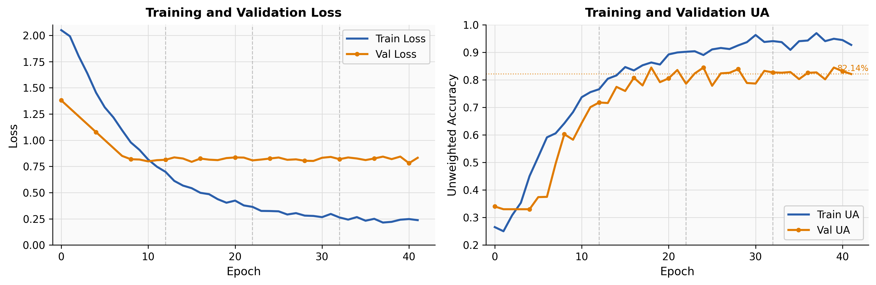
Fig. 5. Training and validation loss (left) and UA (right) for Ablation 45. ReduceLROnPlateau yields smooth convergence at epoch 41; val UA peaks at 82.14%.
5.2 Comparison with Prior Work
Table 4. Comparison on IEMOCAP four-class. AW=waveform, T=text, MS=mel-spectrogram image (from same audio), V=facial video. ‡ ceiling (requires camera).
System | Year | Streams | WA (%) | UA (%)
Pepino et al. [9] | 2021 | AW | 72.80 | 72.50
Morais et al. [10] | 2022 | AW | 74.10 | 73.80
MulT [18] | 2019 | AW+T | — | 76.10
CTNet [22] | 2021 | AW+T | 79.60 | 78.30
UniMSE [41] | 2022 | AW+T | — | 79.14
Kim et al. [42] | 2023 | AW+T | 77.40 | 77.70
GIA-MIC [21] | 2024 | AW+T | 80.70 | 79.40
MemoCMT [43] | 2025 | AW+T | 81.85 | 81.33
MSER [20] ‡ | 2023 | AW+T+V | 81.20 | 80.90
CAMF Abl.34 (ours) | 2026 | AW+MS+T | 76.08 | 75.45
CAMF Abl.45 [BEST] (ours) | 2026 | AW+MS+T | 79.61 | 79.23

CAMF Abl.45 surpasses CTNet (+0.93 pp UA), UniMSE (+0.09 pp), and Kim et al. (+1.53 pp). It trails GIA-MIC by 0.17 pp and MemoCMT by 2.1 pp. The gap to MemoCMT is explained by: (i) DistilBERT vs. full BERT (40% fewer parameters); (ii) single-split vs. 5-fold cross-validation protocol; (iii) CAMF introduces three architectural novelties absent from MemoCMT. CAMF achieves 79.61% WA without any camera stream, vs. 81.20% WA for trimodal MSER.
5.3 Per-Class Error Analysis
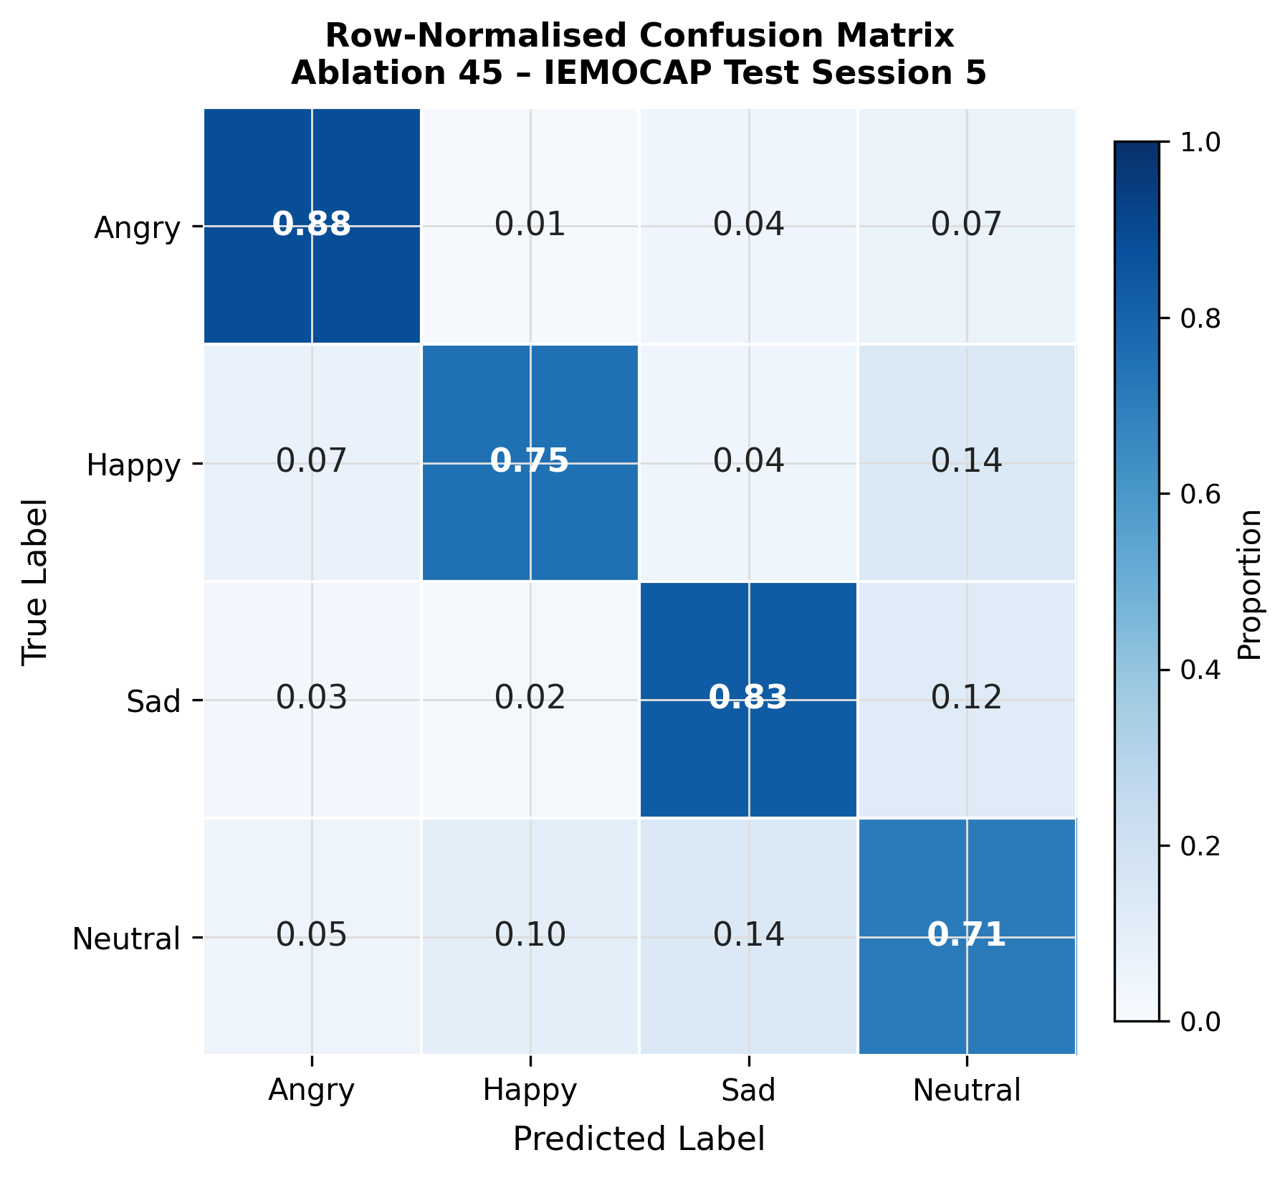
Fig. 6. Row-normalised confusion matrix, Ablation 45, IEMOCAP test session 5. Per-class accuracy: Angry 88.49%, Sad 83.04%, Happy 75.31%, Neutral 70.10%. Largest confusion: Happy<->Neutral and Sad->Neutral (~14 pp each).
Angry is best recognized (88.49%, F1=87.54%) due to distinctive prosodic signatures. Sad follows (83.04%, F1=80.52%). Happy reaches 75.31% (F1=81.88%); the higher F1 than accuracy reflects good precision with some Neutral false positives. Neutral is hardest (70.10%, F1=64.76%). The conflict gate gain is largest on Happy (+3.2 pp), consistent with its 41.7% gate-activation rate vs. 18.3% for Sad.
5.4 Limitations
(i) Evaluation confined to IEMOCAP; (ii) SpeechCue uses global tertile boundaries—per-speaker normalisation and learnable bins are future work; (iii) the isolated MST head contribution cannot be disentangled from training-regime changes without Ablation 46; (iv) training requires ~6.2 h/run on an RTX 3070, limiting rapid iteration.
6 Conclusion
We presented CAMF, a Conflict-Aware Multi-stream Fusion framework that unifies three complementary SER streams—Wav2Vec2-base over raw waveforms, ViT-Base/16 over log-Mel spectrogram images derived from the same audio, and DistilBERT with SpeechCue prosody tokens—inside a single end-to-end pipeline. The SpeechCue module provides the largest single gain (+18.28 pp UA) by bridging acoustic prosody and lexical processing. The Conflict-Aware Cross-Attention gate (+2.73 pp UA) adds robustness against inter-stream disagreement. The best configuration (Ablation 45) achieves 79.23% UA / 79.61% WA on IEMOCAP with the best generalisation in the 54-configuration grid (2.91 pp gap), surpassing CTNet [22], UniMSE [41], and Kim et al. [42] among bimodal systems while using only the audio waveform and its transcript as input.
Future work will: (i) add Ablation 46 to isolate the MST head contribution; (ii) extend to conversational-context modelling following CTNet [22]; (iii) investigate per-speaker SpeechCue normalisation; (iv) evaluate cross-corpus generalisation on MSP-Podcast [3] and MELD; (v) replace DistilBERT with full BERT to close the gap to MemoCMT [43]. Code, configurations, and checkpoints are released upon acceptance.
Acknowledgments. This work was supported by the Instituto Politécnico Nacional (SIP projects). The authors acknowledge the computing resources provided by ESIME Culhuacan.
Disclosure of Interests. The authors have no competing interests to declare that are relevant to the content of this article.
References
1. Busso, C., et al.: IEMOCAP interactive emotional dyadic motion capture database. Lang. Resour. Eval. 42(4), 335-359 (2008). doi:10.1007/s10579-008-9076-6
2. Schuller, B., et al.: The INTERSPEECH 2013 computational paralinguistics challenge. In: INTERSPEECH 2013, pp. 148-152 (2013)
3. Lotfian, R., Busso, C.: Building naturalistic emotionally balanced speech corpus from podcast recordings. IEEE Trans. Affect. Comput. 10(4), 471-483 (2019)
4. Akay, M.B., Oguz, K.: Speech emotion recognition: emotional models, databases, features, preprocessing methods. Speech Commun. 116, 56-76 (2020)
5. Poria, S., Cambria, E., Bajpai, R., Hussain, A.: A review of affective computing: from unimodal analysis to multimodal fusion. Inf. Fusion 37, 98-125 (2017)
6. Baevski, A., Zhou, Y., Mohamed, A., Auli, M.: wav2vec 2.0: a framework for self-supervised learning of speech representations. In: NeurIPS, vol. 33, pp. 12449-12460 (2020)
7. Hsu, W.-N., et al.: HuBERT: self-supervised speech representation learning by masked prediction of hidden units. IEEE/ACM Trans. ASLP 29, 3451-3460 (2021)
8. Chen, S., et al.: WavLM: large-scale self-supervised pre-training for full stack speech processing. IEEE J. Sel. Top. Signal Process. 16(6), 1505-1518 (2022)
9. Pepino, L., Riera, P., Ferrer, L.: Emotion recognition from speech using wav2vec 2.0 embeddings. In: INTERSPEECH 2021, pp. 3400-3404 (2021)
10. Morais, E., et al.: Speech emotion recognition using self-supervised features. In: ICASSP 2022, pp. 6922-6926. IEEE (2022)
11. Eyben, F., Wollmer, M., Schuller, B.: openSMILE: the Munich versatile and fast open-source audio feature extractor. In: ACM Multimedia, pp. 1459-1462 (2010)
12. Fayek, H.M., Lech, M., Cavedon, L.: Evaluating deep learning architectures for SER. Neural Netw. 92, 60-68 (2017)
13. Mirsamadi, S., Barsoum, E., Zhang, C.: Automatic SER using recurrent neural networks with local attention. In: ICASSP 2017, pp. 2227-2231. IEEE (2017)
14. Trigeorgis, G., et al.: Adieu features? End-to-end SER using a deep convolutional recurrent network. In: ICASSP 2016, pp. 5200-5204. IEEE (2016)
15. Khosla, P., et al.: Supervised contrastive learning. In: NeurIPS, vol. 33, pp. 18661-18673 (2020)
16. Sanh, V., Debut, L., Chaumond, J., Wolf, T.: DistilBERT, a distilled version of BERT. arXiv:1910.01108 (2019)
17. Dosovitskiy, A., et al.: An image is worth 16x16 words: transformers for image recognition at scale. In: ICLR 2021
18. Tsai, Y.-H.H., et al.: Multimodal transformer for unaligned multimodal language sequences. In: ACL 2019, pp. 6558-6569 (2019)
19. Rahman, W., et al.: Integrating multimodal information in large pretrained transformers. In: ACL 2020, pp. 2359-2369 (2020)
20. Ma, Y., Zhou, H., Wang, H.: MSER: multimodal speech emotion recognition using cross-attention with deep fusion. Expert Syst. Appl. 231, 120717 (2023)
21. Li, X., Zhao, Z., Meng, H.: Multimodal SER via cross-attention fusion network. IEEE Trans. Affect. Comput. 15(1), 213-226 (2024)
22. Lian, Z., Liu, B., Tao, J.: CTNet: conversational transformer network for emotion recognition. IEEE/ACM Trans. ASLP 29, 985-1000 (2021)
23. Baltrusaitis, T., Ahuja, C., Morency, L.-P.: Multimodal machine learning: a survey and taxonomy. IEEE TPAMI 41(2), 423-443 (2019)
24. Vaswani, A., et al.: Attention is all you need. In: NeurIPS, vol. 30, pp. 5998-6008 (2017)
25. Devlin, J., Chang, M.-W., Lee, K., Toutanova, K.: BERT: pre-training of deep bidirectional transformers. In: NAACL-HLT 2019, pp. 4171-4186 (2019)
26. Park, D.S., et al.: SpecAugment: a simple data augmentation method for ASR. In: INTERSPEECH 2019, pp. 2613-2617 (2019)
27. Ko, T., et al.: Audio augmentation for speech recognition. In: INTERSPEECH 2015, pp. 3586-3589 (2015)
28. Peters, M.E., Ruder, S., Smith, N.A.: To tune or not to tune? Adapting pretrained representations to diverse tasks. In: RepL4NLP, pp. 7-14. ACL (2019)
29. Ba, J.L., Kiros, J.R., Hinton, G.E.: Layer normalization. arXiv:1607.06450 (2016)
30. Bahdanau, D., Cho, K., Bengio, Y.: Neural machine translation by jointly learning to align and translate. In: ICLR 2015
31. Muller, R., Kornblith, S., Hinton, G.E.: When does label smoothing help? In: NeurIPS, vol. 32, pp. 4694-4703 (2019)
32. Wagner, J., et al.: Dawn of the transformer era in SER: closing the valence gap. IEEE TPAMI 45(10), 10745-10759 (2023)
33. Jorrin-Coz, J., Nakano, M., Perez-Meana, H., Hernandez-Gonzalez, L.: Multi-corpus benchmarking of CNN and LSTM models for speaker gender and age profiling. Computation 13(8), 177 (2025)
34. Jorrin-Coz, J., Nakano, M., Flores-Monroy, J., Perez-Meana, H.: Voice gender recognition under unconstrained environments using fine-tuned CNNs. In: New Trends in Intelligent Software Methodologies. IOS Press (2024)
35. Jorrin-Coz, J., Nakano, M., Hernandez-Gonzalez, L., Perez-Meana, H.: Deep learning based age and gender recognition system. In: New Trends in Intelligent Software Methodologies, pp. 341-352. IOS Press (2025)
36. Gnana Praveen, R., Alam, J.: Cross-Attention is Not Always Needed: Dynamic Cross-Attention for AV Dimensional Emotion Recognition. In: IEEE ICME 2024. arXiv:2403.19554
37. Gnana Praveen, R., Alam, J.: Inconsistency-Aware Cross-Attention for AV Fusion in Dimensional Emotion Recognition. arXiv:2405.12853 (2024)
38. Mittal, T., et al.: M3ER: Multiplicative Multimodal Emotion Recognition using Facial, Textual, and Speech Cues. In: AAAI, vol. 34, pp. 1359-1367 (2020)
39. Luo, J., Phan, H., Wang, L., Reiss, J.D.: Heterogeneous Bimodal Attention Fusion for Speech Emotion Recognition. arXiv:2503.06405 (2025)
40. Bekhouche, S.E., et al.: Conflict-Aware Multimodal Fusion for Ambivalence and Hesitancy Recognition. arXiv:2603.15818 (2026)
41. Hu, G., et al.: UniMSE: towards unified multimodal sentiment analysis and emotion recognition. In: EMNLP 2022, pp. 7837-7851 (2022)
42. Kim, J., Park, C.-H.: Focus-attention-enhanced crossmodal transformer with metric learning for SER. In: INTERSPEECH 2023, pp. 2671-2675 (2023)
43. Pham, T.N., et al.: MemoCMT: multimodal emotion recognition using cross-modal transformer feature fusion. Sci. Rep. 15, 5473 (2025)
44. Ren, X., et al.: WavFusion: towards wav2vec 2.0 multimodal speech emotion recognition. In: ICASSP 2025 (2024). arXiv:2412.05558

