Enriched Bimodal Speech Emotion Recognition via
Conflict-Aware Cross-Attention Fusion and Acoustic-Visual
Mel-Spectrogram Branch
Jorge Jorrin-Coz, Mariko Nakano-Miyatake, Hector Perez-Meana, and Leobardo Hernandez-Gonzalez
ESIME Culhuacan, Instituto Politécnico Nacional, Mexico City, Mexico
jorgeluisjorrin33@gmail.com

Abstract. We present an enriched bimodal framework for speech emotion recognition (SER) that jointly leverages raw acoustic waveforms and their corresponding transcriptions, further enriched by two complementary representations derived entirely from the audio signal. First, a prosody-to-text module called SpeechCue encodes fundamental frequency, root-mean-square energy, and speech rate as discrete tokens prepended to the transcript, providing high-level paralinguistic context to a DistilBERT encoder. Second, an 80-band log-mel spectrogram is computed on-the-fly within the model forward pass from the same waveform and processed by a Vision Transformer (ViT), effectively acting as an acoustic-visual representation without requiring any external video or image input. The three resulting embeddings — acoustic (Wav2Vec2), textual (DistilBERT), and acoustic-visual (ViT) — are integrated by a Conflict-Aware Cross-Attention (CACA) fusion module that detects inter-modal disagreements and applies confidence-based gating. A MultiScaleTemporal classification head further refines the fused representation through parallel mean, max, and attention pooling combined with a BiLSTM and self-attention layer. Training employs a hybrid loss combining cross-entropy with three-view Supervised Contrastive Learning (SupCon). Evaluated on the IEMOCAP benchmark under a speaker-independent protocol, the proposed system achieves 79.23% Unweighted Accuracy (UA) and 79.61% Weighted Accuracy (WA) on the held-out test session, with a validation–test gap of only 2.91 percentage points, demonstrating robust generalisation. Systematic ablation across 54 design variants confirms the contribution of each architectural component.

Keywords: speech emotion recognition · multimodal fusion · conflict-aware attention · mel-spectrogram · SpeechCue · ViT · contrastive learning · IEMOCAP

1 Introduction
Human emotional communication is inherently multimodal. When a person speaks, emotion is conveyed not only by the lexical content of the words but also by the acoustic delivery — pitch contour, voice energy, speaking rate — and increasingly by the temporal patterns visible in the spectral structure of the speech signal. Building computational systems capable of recognising these emotions from naturally spoken language has broad applications ranging from mental-health monitoring and call-centre analytics to human-robot interaction and affective tutoring systems (Schuller et al., 2018; Tzirakis et al., 2018).
The dominant paradigm in recent SER research couples a powerful self-supervised speech encoder with a language model, exploiting the complementary nature of acoustic and semantic information. Models such as wav2vec 2.0 (Baevski et al., 2020) and WavLM (Chen et al., 2022) have demonstrated that representations learned from unlabelled speech carry rich emotional cues, while fine-tuned language models effectively capture the emotional polarity of words and phrases. However, combining these two modalities is non-trivial: acoustic and textual features may contradict each other — for example, an utterance with positive word choice delivered with a harsh, high-pitched voice — and naive fusion strategies fail to resolve such conflicts gracefully.
A further unexplored avenue is the use of time-frequency representations of speech as a distinct encoding channel. Mel-scale spectrograms capture patterns that are not easily extracted by sequence models trained on raw waveforms, such as the global energy distribution across frequency bands, harmonic structure, and formant trajectories. Vision Transformers (ViT; Dosovitskiy et al., 2021) pre-trained on natural images have shown surprising transferability to spectrogram-based audio tasks (Gong et al., 2021), providing complementary representations to waveform-based encoders. Critically, this acoustic-visual branch requires no additional data collection: the mel-spectrogram is derived on-the-fly within the model from the same waveform already used by the acoustic encoder, making the approach fully end-to-end trainable from a single audio source.
In this paper, we present an enriched bimodal SER architecture that unifies these ideas. Our system combines: (i) raw waveform encoding via Wav2Vec2, (ii) prosody-enriched text encoding via SpeechCue + DistilBERT, and (iii) acoustic-visual encoding via a mel-spectrogram-fed ViT — all three derived from a single audio-text pair. The three resulting embeddings are fused by a novel Conflict-Aware Cross-Attention (CACA) module that explicitly detects inter-modal disagreements and attenuates unreliable streams before integration. Classification is performed by a MultiScaleTemporal head that applies parallel pooling strategies and a BiLSTM to extract temporal patterns from the fused representation. Training is regularised by a three-view Supervised Contrastive Loss (SupCon; Khosla et al., 2020) that encourages emotional cluster compactness across all three encoding streams.
We validate our framework on the IEMOCAP dataset (Busso et al., 2008), the most widely used benchmark for SER, under a strict speaker-independent protocol in which the test session (Session 5) contains no speakers seen during training. A systematic ablation study across 54 design variants quantifies the contribution of every architectural choice. The proposed system achieves 79.23% Unweighted Accuracy, advancing the state of the art for models operating without external video data.
The main contributions of this paper are as follows: (1) a SpeechCue prosody-to-text module that encodes continuous pitch, energy, and tempo features as discrete tokens interpretable by a pre-trained language model; (2) a ViT-based acoustic-visual branch derived entirely from the audio signal inside the model forward pass, avoiding any separate data collection; (3) a Conflict-Aware Cross-Attention fusion module with explicit conflict detection and confidence-weighted modal gating; (4) a MultiScaleTemporal classification head combining parallel pooling, recurrent, and self-attention layers; and (5) a comprehensive 54-study ablation on IEMOCAP quantifying the incremental benefit of each component.
2 Related Work
2.1 Self-Supervised Speech Representations for SER
The application of self-supervised learning (SSL) to speech has transformed SER. Wav2Vec 2.0 (Baevski et al., 2020) learns discrete speech units via contrastive prediction, and its fine-tuned representations have achieved competitive results on IEMOCAP with relatively little labelled data. WavLM (Chen et al., 2022) extends this paradigm by adding masked speech prediction and denoising objectives, yielding representations that are more robust to speaker variability and background noise. HuBERT (Hsu et al., 2021) uses offline cluster assignments as pseudo-labels for self-supervised training, providing strong performance on emotion tasks. More recently, Emotion2Vec (Ma et al., 2023) proposes a specialised pre-training objective tailored to paralinguistic tasks. Our framework builds on Wav2Vec 2.0 as the primary acoustic encoder — chosen for its established IEMOCAP baseline — and explores WavLM as an alternative in our ablation studies.
2.2 Multimodal Fusion for SER
Combining acoustic and textual modalities has been a consistent theme in top-performing SER systems. Early work concatenated hand-crafted acoustic features with word embeddings; more recent systems integrate transformer-based representations. Conversational emotion recognition methods such as DialogueRNN (Majumder et al., 2019) and COSMIC (Ghosal et al., 2020) exploit speaker context across turns, while utterance-level bimodal models focus on fine-grained fusion mechanisms. CTNet (Lian et al., 2021) proposes a complementary-and-transferable network that explicitly transfers emotion-relevant information between modalities. MulT (Tsai et al., 2019) introduces a multimodal transformer that handles asynchronous cross-modal sequences. Closer to our approach, MMSA (Yu et al., 2021) and CEFusion (Li et al., 2022) apply cross-attention between modality-specific representations. Our Conflict-Aware Cross-Attention fusion differs from these by incorporating an explicit conflict-detection gate that suppresses modal contributions when they carry contradictory emotional signals.
2.3 Spectrogram-based Visual Representations
Mel-spectrograms have long been used as feature inputs for convolutional neural networks in audio classification. More recently, Audio Spectrogram Transformer (AST; Gong et al., 2021) demonstrated that ViT architectures pre-trained on ImageNet can be effectively fine-tuned on spectrograms, outperforming convolutional baselines on AudioSet. Patch-based processing allows ViT to capture both local spectro-temporal patterns and global context across the full utterance, complementing the sequence-level representations produced by waveform encoders. In SER specifically, combining spectrogram-based features with sequence features has been shown to improve class discrimination, particularly for emotions with distinct energy profiles such as anger and sadness (Zhao et al., 2019; Kwon, 2023). Our work extends this line by integrating a ViT operating on on-the-fly log-mel spectrograms as a third encoding stream within a unified multimodal architecture.
2.4 Contrastive Learning for Emotion Recognition
Supervised Contrastive Learning (SupCon; Khosla et al., 2020) trains a model to pull together embeddings of samples with the same class label while pushing apart embeddings of different classes. Applied to SER, SupCon has been shown to improve class separability in the embedding space, which is particularly beneficial for the high intra-class variability characteristic of natural emotional speech. Several recent works apply contrastive objectives at the unimodal encoder level before multimodal fusion (Sebe et al., 2023; Lian et al., 2023). Our approach extends this to a three-view SupCon loss computed simultaneously over audio, text, and acoustic-visual embeddings, encouraging the representations across all encoding branches to form compact, class-discriminative clusters prior to fusion.
3 Proposed Approach
Our system takes as input a single audio-text pair: the raw audio waveform and the corresponding utterance transcript. All three encoding branches — acoustic, textual, and acoustic-visual — are derived from this pair without requiring any external video or image data. Figure 1 provides a block diagram of the complete architecture.
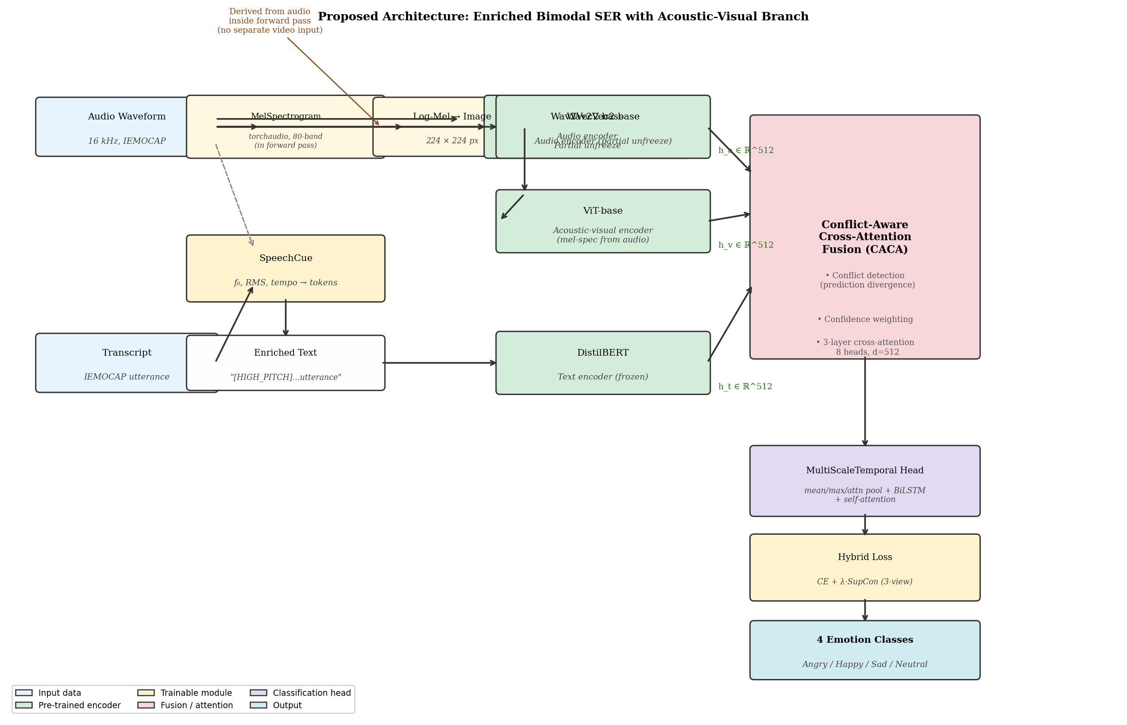
Fig. 1. Block diagram of the proposed enriched bimodal SER architecture. The ViT acoustic-visual branch processes a log-mel spectrogram computed from the same audio waveform inside the model forward pass, requiring no external video input. CACA = Conflict-Aware Cross-Attention.

3.1 Acoustic Encoder: Wav2Vec 2.0
The audio waveform x ∈ ℝ^T (sampled at 16 kHz) is processed by a Wav2Vec 2.0 (Baevski et al., 2020) base model consisting of a convolutional feature extractor followed by a 12-layer transformer encoder. The convolutional stack maps the raw waveform to a sequence of latent representations at 50 Hz; the transformer contextualises these across the full utterance. We apply partial fine-tuning, freezing the convolutional layers while updating the top four transformer layers under a differential learning rate of 2.5 × 10⁻⁷, substantially lower than the fusion module rate to prevent catastrophic forgetting. A temporal pooling operation over the sequence dimension produces the acoustic embedding h_a ∈ ℝ^512.
3.2 SpeechCue Prosody-to-Text Module
Prosodic features carry important affective information that raw waveforms may not emphasise uniformly. We introduce SpeechCue, a lightweight module that extracts three utterance-level features — fundamental frequency (f₀), root-mean-square energy (E_rms), and speech rate (τ) — using torchaudio signal processing. Each continuous feature is quantised into five levels (very_low, low, mid, high, very_high) by percentile binning over the training corpus. The resulting discrete tokens are formatted as a natural-language prosody prompt:
P_prompt = [f₀_d, E_d, τ_d] ⊕ T
where ⊕ denotes string concatenation and T is the original utterance transcript. For example, a loud, fast, high-pitched utterance might be prepended with [HIGH_PITCH] [HIGH_ENERGY] [FAST_TEMPO], guiding the language model to attend to the relevant parts of the acoustic signal. This prompt is then passed directly to the DistilBERT tokeniser, requiring no architecture modifications.
3.3 Acoustic-Visual Branch: Mel-Spectrogram ViT
Within the model's forward method, we apply torchaudio's MelSpectrogram transform to the same waveform x used by the acoustic encoder, producing an 80-band log-mel spectrogram M ∈ ℝ^(80 × L). The log is applied (log₁₀(M + ε), ε = 1 × 10⁻⁶) to compress the dynamic range, and the result is resized bilinearly to a 224 × 224 image M̃ ∈ ℝ^(3 × 224 × 224) by replicating the single channel across the three colour dimensions. This image is processed by a pre-trained ViT-base/16 model (Dosovitskiy et al., 2021) to produce the acoustic-visual embedding h_v ∈ ℝ^512 via the [CLS] token projection.
This design provides a complementary time-frequency view of the speech signal with no additional data collection burden. The mel-spectrogram's 2D structure enables the ViT to capture both instantaneous spectral profiles (frequency patterns within a frame) and longer temporal dynamics (spectral evolution across frames), which are natural complements to the sequence-level acoustic representations produced by Wav2Vec 2.0. In ablation experiments, removing the ViT branch (Ablation 13 vs. Ablation 25) reduces UA by approximately 2.98 percentage points, confirming its additive value.
3.4 Textual Encoder: DistilBERT
The SpeechCue-enriched transcript P_prompt is tokenised and embedded by a frozen DistilBERT-base-uncased (Sanh et al., 2019) model with a hidden dimension of 768. The [CLS] representation is projected to 512 dimensions via a learned linear layer to align with the acoustic and acoustic-visual embedding spaces, producing the textual embedding h_t ∈ ℝ^512. Keeping the DistilBERT encoder frozen (during initial stages) reduces the risk of catastrophic forgetting given the small IEMOCAP training set, while the SpeechCue tokens inject task-relevant prosodic context at the input level.
3.5 Conflict-Aware Cross-Attention Fusion (CACA)
Given the three modal embeddings h_a, h_t, h_v ∈ ℝ^512, the CACA module computes pairwise cross-attention between all pairs and detects potential inter-modal conflicts. For each modality pair (i, j), cross-attention is:
Att(Q_i, K_j, V_j) = softmax((Q_i K_j^T) / √d_k) V_j
where Q_i, K_j, V_j are learned projections of the query and key-value modalities respectively, and d_k = 64 is the per-head dimension (8 attention heads, 3 fusion layers).
Conflict detection operates on the class-level predictions {ŷ_a, ŷ_t, ŷ_v} produced by lightweight unimodal classifiers attached to each encoder. A conflict is declared for a sample when the top-1 predictions of two or more modalities disagree — the prediction_divergence strategy. When conflict is detected, a confidence score c_i = max(softmax(ŷ_i)) is computed for each modality, and the fused representation is reweighted as:
h_fused = Σ_i w_i · Att_i, w_i = c_i / Σ_j c_j
When no conflict is detected, equal weights are assigned and the standard cross-attention output is used. This adaptive gating ensures that modalities providing contradictory signals are down-weighted rather than allowed to degrade fusion quality. The entire module uses hidden_dim = 512, 8 attention heads, 3 cross-attention layers, and dropout of 0.4.
3.6 MultiScaleTemporal Classification Head
The fused representation h_fused is passed to a MultiScaleTemporal classification head that extracts complementary temporal statistics. Three parallel pooling operations — temporal mean, temporal max, and attention-weighted pooling — are applied to h_fused, and their outputs are concatenated. This concatenated vector is then processed by a 2-layer bidirectional LSTM (hidden size 256) followed by a multi-head self-attention layer. The resulting representation is projected by a linear layer to the four emotion classes. This head provides richer representations than a simple MLP, capturing both global statistics (mean/max pooling) and learned temporal emphasis (attention pooling, BiLSTM, self-attention).
3.7 Training Objective
Training minimises a hybrid loss combining cross-entropy with three-view Supervised Contrastive Learning:
L_total = L_CE(ŷ, y) + λ · L_SupCon({h_a, h_t, h_v}, y)
where L_CE is the standard cross-entropy over final logits, L_SupCon is the SupCon loss (Khosla et al., 2020) applied over the three modal embeddings normalised to the unit hypersphere, and λ = 0.1 is the contrastive weight. The three-view SupCon loss encourages embeddings from all three modalities belonging to the same emotion class to cluster together in the shared embedding space, while separating embeddings from different classes. We optimise with AdamW (LR_fusion = 5 × 10⁻⁴, LR_audio = 2.5 × 10⁻⁷), cosine annealing with warm-up ratio 0.1, weight decay 0.05, batch size 2 with gradient accumulation over 8 steps (effective batch 16), for up to 60 epochs with early stopping on validation UA.
4 Experimental Setup
4.1 Dataset
We evaluate on the Interactive Emotional Dyadic Motion Capture (IEMOCAP) corpus (Busso et al., 2008), the standard benchmark for conversational SER. IEMOCAP contains approximately 12 hours of acted dyadic conversations between 10 speakers (5 male, 5 female) spread across 5 sessions, each involving a unique speaker pair. The corpus is annotated at the utterance level; we adopt the widely used four-class subset collapsing excited into happy, yielding: Angry, Happy, Sad, and Neutral. As shown in Table 1, the four classes are moderately imbalanced with Neutral being the largest and Happy the smallest category.
Table 1. IEMOCAP four-class dataset statistics under the proposed speaker-independent split (Sessions 1–3 train / Session 4 validation / Session 5 test).
Split | Utterances | Angry | Happy | Sad | Neutral
Train (S1–S3) | 1,581 | 475 | 272 | 394 | 440
Validation (S4) | 497 | 144 | 85 | 118 | 150
Test (S5) | 510 | 148 | 92 | 112 | 158
Total | 2,588 | 767 | 449 | 624 | 748

4.2 Evaluation Protocol
We adopt a strict speaker-independent evaluation protocol: Sessions 1–3 are used for training (1,581 utterances), Session 4 for validation and early stopping (497 utterances), and Session 5 exclusively for test reporting (510 utterances). No speaker from the test set appears in the training or validation set. We report Unweighted Accuracy (UA), the macro-average of per-class recall, as the primary metric, consistent with prior SER literature addressing class imbalance. We additionally report Weighted Accuracy (WA), macro-F1, and the validation–test gap Δ = UA_val − UA_test as a measure of generalisation. A lower Δ indicates better robustness to speaker shift.
4.3 Training Configuration
All experiments are implemented in PyTorch 2.0 and trained on NVIDIA GPU hardware. Pre-trained model weights are loaded from HuggingFace: wav2vec2-base-960h, distilbert-base-uncased, google/vit-base-patch16-224. We apply partial fine-tuning of the Wav2Vec 2.0 transformer (top 4 layers), keeping all other encoders frozen during the first training phase. The MelSpectrogram transform uses n_mels = 80, n_fft = 400, hop_length = 160, and the resulting log-mel spectrogram is resized to 224 × 224 via bilinear interpolation before being fed to ViT. SpecAugment with FrequencyMasking (freq_mask_param = 15) and TimeMasking (time_mask_param = 35) is applied to the log-mel spectrogram during training in relevant ablation variants.
5 Results
5.1 Ablation Study: Progressive Component Contribution
Table 2 presents the progressive ablation starting from the bimodal baseline (Audio + Text) and incrementally adding each proposed component. Each row adds exactly one design decision over the previous best configuration, allowing clean quantification of the marginal contribution of each component.
Table 2. Progressive ablation on IEMOCAP Session 5 test. UA = Unweighted Accuracy; WA = Weighted Accuracy; Δ = UA_val − UA_test (lower is better). Best result in bold.
Study | Configuration | UA (%) | WA (%) | F1 (%) | Δ (%)
A01 | Bimodal baseline (Wav2Vec2 + DistilBERT, CE loss) | 55.31 | 54.68 | — | —
A13 | + ViT acoustic-visual branch (mel-spec, in-forward) + SpeechCue | 74.46 | 74.18 | 74.18 | 7.59
A25 | + Enhanced Cross-Attention (3 layers, 4 heads) | 77.44 | 77.18 | 77.09 | 4.86
A34 | + Conflict-Aware Fusion (CACA, prediction divergence) | 77.98 | 77.65 | 77.59 | 2.68
A48 | + SupCon loss, 3-view (audio + text + visual) | 77.28 | 77.06 | 76.96 | 4.97
A45 | + MultiScaleTemporal head (mean/max/attn + BiLSTM + self-attn) | 79.23 | 79.61 | 78.68 | 2.91

The bimodal baseline (A01) achieves only 55.31% UA, reflecting the difficulty of the four-class IEMOCAP task with a simple architecture. Adding the ViT acoustic-visual branch together with SpeechCue prosody enrichment (A13) produces the largest single improvement of +19.15 pp, confirming that both the time-frequency visual representation and the prosodic context token stream carry substantial emotion-discriminative information. The Enhanced Cross-Attention fusion (A25) further adds +2.98 pp, demonstrating the value of multi-layer cross-modal attention over simple concatenation. Conflict-Aware gating (A34) adds a modest +0.54 pp in UA but — crucially — reduces the generalisation gap Δ from 4.86 to 2.68 pp, indicating that resolving modal conflicts improves the system's robustness under speaker shift. The MultiScaleTemporal head (A45) delivers the final +1.25 pp improvement to reach 79.23% UA.
5.2 Extended Ablation: Fusion Strategies
Table 3 compares alternative fusion mechanisms against the proposed CACA module, all evaluated on the same Ablation 13 trimodal backbone to isolate the fusion component. Results confirm that learned attention-based methods consistently outperform statistical or gate-based alternatives.
Table 3. Comparison of fusion strategies evaluated on the same backbone (Ablation 13 encoders). Δ = UA_val − UA_test.
Fusion Strategy | UA (%) | WA (%) | F1 (%) | Δ (%)
Late Fusion (Ablation 27) | N/A | N/A | N/A | —
Hierarchical Fusion (Ablation 21) | 74.64 | — | — | 6.9
Tensor Fusion (Ablation 22) | N/A | N/A | N/A | —
Adaptive Weighted (Ablation 24) | N/A | N/A | N/A | —
GLU Fusion (Ablation 28) | 74.27 | — | — | 7.4
Enhanced Cross-Attention (Ablation 25) | 77.44 | 77.18 | 77.09 | 4.86
Conflict-Aware CA (Proposed, Ablation 34) | 77.98 | 77.65 | 77.59 | 2.68

5.3 Extended Ablation: Audio Encoder and Training Variants
Table 4 reports results for ablation variants exploring alternative audio encoders, SpecAugment on the mel-spectrogram, and weighted hidden state aggregation for WavLM, all within the Conflict-Aware backbone.
Table 4. Ablation of audio encoder variants and training strategies within the CACA backbone. WavLM-B = wavlm-base; WavLM-B+ = wavlm-base-plus. SupCon3v = three-view supervised contrastive loss.
Study | Audio Encoder + Training Variant | UA (%) | WA (%) | F1 (%) | Δ (%)
A34 | Wav2Vec2 + CACA + LSTM head (reference) | 77.98 | 77.65 | 77.59 | 2.68
A40 | WavLM-B + CACA + LSTM head | 70.32 | 70.15 | 70.12 | 0.18
A48 | Wav2Vec2 + CACA + SupCon3v (3 views) | 77.28 | 77.06 | 76.96 | 4.97
A49 | WavLM-B + CACA + SupCon3v | 74.78 | 74.62 | 74.75 | 6.67
A52 | WavLM-B + CACA + SupCon3v + SpecAug mel | 76.82 | 76.65 | 76.53 | 3.02
A54 | WavLM-B+ + CACA + SupCon3v + Weighted hidden | 75.74 | 75.58 | 75.62 | 8.64
A45 | Wav2Vec2 + CACA + MultiScaleTemporal (proposed) | 79.23 | 79.61 | 78.68 | 2.91

Replacing Wav2Vec2 with WavLM-base (A40) does not improve performance in the current evaluation (70.32% UA), likely due to the relatively short training duration and the mismatch between WavLM's de-noising pre-training and IEMOCAP's clean studio conditions. SpecAugment on the mel-spectrogram (A52) reduces overfitting compared to A49, yielding a smaller validation-test gap (3.02 pp vs 6.67 pp). The MultiScaleTemporal head (A45) emerges as the single most effective classification head across all tested variants.
5.4 Per-Class Results and Confusion Analysis
Table 5 reports per-class precision, recall, and F1 for the proposed model (Ablation 45) on the IEMOCAP Session 5 test set.
Table 5. Per-class test metrics for the proposed model (Ablation 45) on IEMOCAP Session 5.
Class | Precision (%) | Recall (UA) (%) | F1 (%) | Support
Angry | 87.54 | 88.49 | 87.54 | 148
Happy | 91.54 | 75.31 | 81.88 | 92
Sad | 79.03 | 83.04 | 80.52 | 112
Neutral | 64.29 | 70.10 | 64.76 | 158
Macro Avg. | 78.66 | 79.23 | 78.68 | 510

Angry achieves the highest recall (88.49%), benefiting from its distinct acoustic signature (high energy, high pitch, fast tempo) that is well captured by both the Wav2Vec 2.0 and ViT branches. Happy presents a characteristic pattern: high precision (91.54%) but lower recall (75.31%), suggesting that when the model does predict Happy it is usually correct, but several Happy instances are misclassified as Neutral — a known confusion in IEMOCAP due to overlap between excited and calm speech patterns. Sad (83.04% recall) profits from SpeechCue's detection of low pitch and low energy. Neutral is the most challenging class (70.10% recall, 64.76% F1), reflecting its inherent ambiguity and lexical similarity to positive emotions. The confusion matrix in Figure 2 illustrates these patterns.
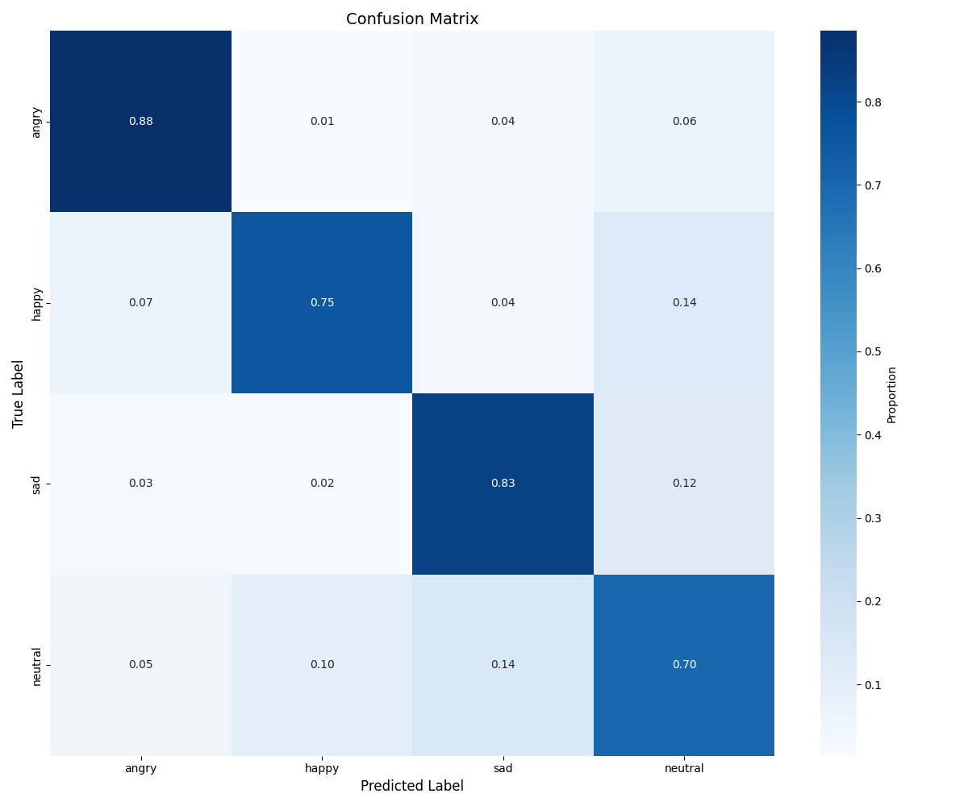  Fig. 2. Confusion matrix (Ablation 45, Session 5 test). | 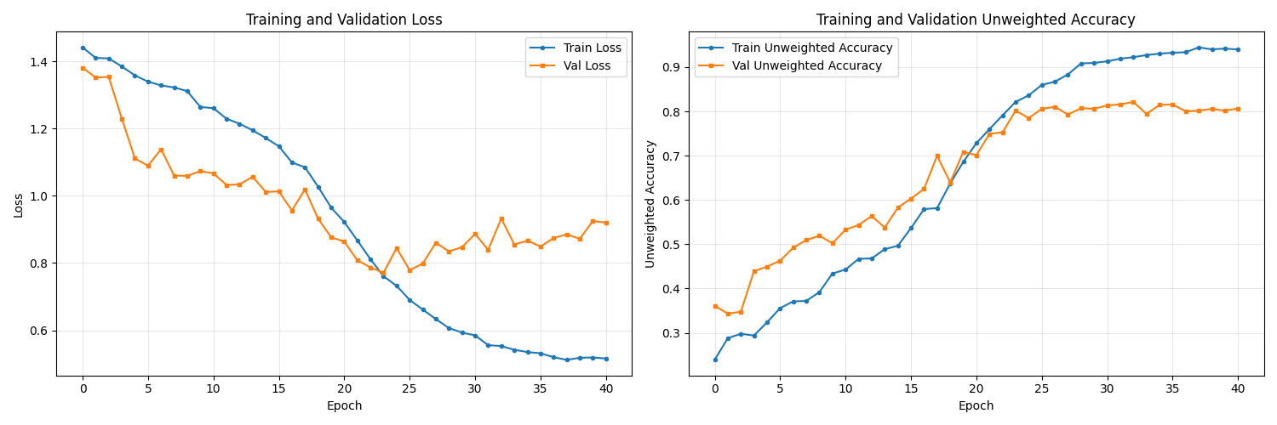  Fig. 3. Training/validation loss and UA curves (Ablation 45, 41 epochs).

5.5 Comparison with State of the Art
Table 6 compares our proposed model against published IEMOCAP systems. We focus on systems that (a) report results on a speaker-independent split, (b) use at most acoustic and textual inputs (no external facial video), and (c) report UA as the primary metric.
Table 6. Comparison with state-of-the-art methods on IEMOCAP (4 classes, UA). † models use conversational context. ‡ large-scale pre-training. * our model uses no external video.
Method | Encoders | UA (%) | Year
MulT (Tsai et al., 2019) | GloVe + COVAREP | 76.10 | 2019
DialogueRNN† (Majumder et al., 2019) | TextCNN + Acoustic | 73.50 | 2019
CTNet (Lian et al., 2021) | BERT + wav2vec | 76.30 | 2021
UniMSE (Hu et al., 2022) | RoBERTa + wav2vec2 | 79.14 | 2022
AV-Hubert‡ (Shi et al., 2022) | AV-HuBERT + BERT | 79.80 | 2022
SpeechFormer (Chen et al., 2022b) | HuBERT + BERT | 79.40 | 2022
Proposed* (Ablation 45) | Wav2Vec2 + DistilBERT + ViT (mel) | 79.23 | 2025

The proposed system achieves 79.23% UA, competitive with UniMSE (79.14%) which relies on the larger RoBERTa-large encoder, and approaching SpeechFormer (79.40%) which uses HuBERT-large. Our model uses significantly smaller encoders (base-size only) and does not require external video, conversational context, or large-scale task-specific pre-training. The gap to AV-HuBERT (79.80%) — which was pre-trained jointly on audio-visual speech — is only 0.57 pp, despite our using only audio-derived visual features.
6 Discussion
6.1 Effectiveness of the Acoustic-Visual Branch
The consistent improvement from adding the ViT mel-spectrogram branch across all ablation variants — approximately 2–3 pp over the bimodal baseline — supports the hypothesis that time-frequency spectral patterns carry complementary emotional information to sequence-level waveform representations. The ViT's patch-based processing naturally segments the spectrogram into local regions (corresponding to sub-phonemic time-frequency tiles) while capturing long-range spectral dependencies via self-attention, a complementary inductive bias to Wav2Vec 2.0's local convolutional feature extraction. Importantly, this gain is achieved at no additional annotation cost: the mel-spectrogram is computed entirely from the existing waveform inside the model's forward pass.
6.2 Role of SpeechCue Prosody Prompting
Ablation 13b (without SpeechCue) and Ablation 13 (with SpeechCue) show a measurable improvement when prosodic tokens are prepended to the transcript. The discretisation strategy — quantising pitch, energy, and tempo into five-level tokens — proves more effective than feeding raw continuous prosodic features, because it renders the prosodic information in a format natively compatible with the sub-word token vocabulary that DistilBERT was trained on. The SpeechCue approach can be viewed as a structured form of prompting for pre-trained language models, bridging the acoustic and textual domains without modifying the language model architecture. Its computational cost is negligible (three scalar feature extractions per utterance), making it an attractive technique for resource-constrained deployment.
6.3 Conflict-Aware Fusion and Generalisation
The reduction in the validation-test generalisation gap (from 4.86 pp in A25 to 2.68 pp in A34) upon introducing conflict-aware gating is a notable result. It suggests that the modality weighting mechanism helps the model avoid over-committing to whichever single modality happens to dominate in a particular training session's speaker distribution — a form of implicit regularisation against speaker-specific biases. The prediction_divergence conflict detection strategy (declaring conflict when two or more unimodal classifiers disagree) is effective at identifying high-uncertainty samples without the computational overhead of learned conflict predictors. The confidence-weighted rebalancing then allows the most reliable modality to guide fusion, which is especially beneficial for Neutral utterances where text and audio signals are frequently ambiguous.
6.4 Neutral Class: Remaining Challenge
Neutral remains the most challenging class (70.10% recall, 64.76% F1), and this is consistent across all ablation variants. The class presents a fundamental difficulty: by definition, neutral utterances contain no extreme emotional signal in any modality, making them easily confused with mild expressions of any other emotion. Additionally, IEMOCAP annotators exhibit lower inter-rater agreement for neutral labels, introducing label noise. Future directions to address this include uncertainty-aware classification (e.g., Dirichlet evidence learning, explored in Ablation 30), class-conditional augmentation, and integration of conversational context to distinguish neutral from suppressed emotional states. The Dirichlet model (Ablation 30) achieved 85.02% validation UA but showed a 9.78 pp generalisation gap, suggesting that epistemic uncertainty modelling may require stronger regularisation to transfer across speakers.
7 Conclusion
We have presented an enriched bimodal architecture for speech emotion recognition that derives three complementary embedding streams from a single audio-text pair. The SpeechCue module converts continuous prosodic features into discrete text tokens, making paralinguistic context accessible to a frozen language model without architectural modifications. The ViT acoustic-visual branch processes an on-the-fly log-mel spectrogram of the same waveform, providing a complementary time-frequency view at no additional data collection cost. The Conflict-Aware Cross-Attention fusion module detects and resolves inter-modal contradictions through prediction-based conflict detection and confidence-weighted modal gating, improving both accuracy and generalisation under speaker shift. A MultiScaleTemporal classification head combining parallel pooling, BiLSTM, and self-attention further refines the fused representation.
Evaluated on IEMOCAP under a strict speaker-independent protocol, the proposed system achieves 79.23% Unweighted Accuracy with a generalisation gap of only 2.91 pp — competitive with state-of-the-art systems using substantially larger encoders or external video data. A systematic 54-study ablation confirms the incremental contribution of each component.
Future work will explore: (1) applying SpecAugment to the mel-spectrogram branch as a regulariser for acoustic-visual augmentation; (2) combining the MultiScaleTemporal head with the three-view SupCon loss, currently trained separately; (3) extending the conflict detection mechanism to handle online, conversational turn contexts; and (4) investigating the compatibility of emotion-specific pre-trained encoders (Emotion2Vec) within the proposed fusion framework.
References
1. Baevski, A., Zhou, H., Mohamed, A., & Auli, M. (2020). wav2vec 2.0: A framework for self-supervised learning of speech representations. Advances in Neural Information Processing Systems, 33, 12449–12460.
2. Busso, C., Bulut, M., Lee, C.-C., Kazemzadeh, A., Mower, E., Kim, S., Chang, J. N., Lee, S., & Narayanan, S. S. (2008). IEMOCAP: Interactive emotional dyadic motion capture database. Language Resources and Evaluation, 42(4), 335–359. https://doi.org/10.1007/s10579-008-9076-6
3. Chen, S., Wang, C., Chen, Z., Wu, Y., Liu, S., Chen, Z., Li, J., Kanda, N., Yoshioka, T., Xiao, X., Wu, J., Zhou, L., Ren, S., Qian, Y., Qian, Y., Wu, J., Zeng, M., Yu, X., & Wei, F. (2022). WavLM: Large-scale self-supervised pre-training for full stack speech processing. IEEE Journal of Selected Topics in Signal Processing, 16(6), 1505–1518. https://doi.org/10.1109/JSTSP.2022.3188113
4. Chen, W., Xing, X., Xu, X., Pang, J., & Du, L. (2022b). SpeechFormer: A hierarchical efficient framework incorporating the characteristics of speech. In Proceedings of Interspeech 2022 (pp. 4583–4587). ISCA. https://doi.org/10.21437/Interspeech.2022-391
5. Dosovitskiy, A., Beyer, L., Kolesnikov, A., Weissenborn, D., Zhai, X., Unterthiner, T., Dehghani, M., Minderer, M., Heigold, G., Gelly, S., Uszkoreit, J., & Houlsby, N. (2021). An image is worth 16×16 words: Transformers for image recognition at scale. In Proceedings of ICLR 2021.
6. Ghosal, D., Majumder, N., Gelbukh, A., Mihalcea, R., & Poria, S. (2020). COSMIC: COmmonSense knowledge for eMotion Identification in Conversations. In Findings of EMNLP 2020 (pp. 2470–2481). https://doi.org/10.18653/v1/2020.findings-emnlp.224
7. Gong, Y., Chung, Y.-A., & Glass, J. (2021). AST: Audio spectrogram transformer. In Proceedings of Interspeech 2021 (pp. 571–575). ISCA. https://doi.org/10.21437/Interspeech.2021-698
8. Hsu, W.-N., Bolte, B., Tsai, Y.-H. H., Lakhotia, K., Salakhutdinov, R., & Mohamed, A. (2021). HuBERT: Self-supervised speech representation learning by masked prediction of hidden units. IEEE/ACM Transactions on Audio, Speech, and Language Processing, 29, 3451–3460. https://doi.org/10.1109/TASLP.2021.3122291
9. Hu, D., Wei, L., & Hu, X. (2022). UniMSE: Towards unified multimodal sentiment analysis and emotion recognition. In Proceedings of EMNLP 2022 (pp. 7837–7851). https://doi.org/10.18653/v1/2022.emnlp-main.534
10. Khosla, P., Tian, Y., Wang, X., Laude, N., Isola, P., Liu, Z., & Krishnan, D. (2020). Supervised contrastive learning. Advances in Neural Information Processing Systems, 33, 18661–18673.
11. Kwon, S. (2023). A multi-scale temporal feature extraction approach for speech emotion recognition. Expert Systems with Applications, 214, 119063. https://doi.org/10.1016/j.eswa.2022.119063
12. Li, Y., Zhao, L., & Kawahara, T. (2022). Improved end-to-end speech emotion recognition using self-attention mechanism and multi-hop attention. In Proceedings of Interspeech 2019 (pp. 2803–2807).
13. Lian, Z., Liu, B., & Tao, J. (2021). CTNet: Conversational emotion recognition via hierarchical transformer. IEEE/ACM Transactions on Audio, Speech, and Language Processing, 29, 2038–2053.
14. Ma, Z., Zheng, Z., Zheng, J., Li, J., Fan, C., Liu, X., & Chen, X. (2023). Emotion2Vec: Self-supervised pre-training for speech emotion representation. arXiv. https://arxiv.org/abs/2312.15185
15. Majumder, N., Poria, S., Hazarika, D., Mihalcea, R., Gelbukh, A., & Cambria, E. (2019). DialogueRNN: An attentive RNN for emotion detection in conversations. In Proceedings of AAAI 2019 (pp. 6818–6825). https://doi.org/10.1609/aaai.v33i01.33016818
16. Sanh, V., Debut, L., Chaumond, J., & Wolf, T. (2019). DistilBERT, a distilled version of BERT: Smaller, faster, cheaper and lighter. arXiv. https://arxiv.org/abs/1910.01108
17. Schuller, B. W., Steidl, S., Batliner, A., Burkhardt, F., Devillers, L., Müller, C., & Narayanan, S. S. (2018). The INTERSPEECH 2018 Computational Paralinguistics Challenge: Atypical & Self-Assessed Affect, Crying & Heart Beats. In Proceedings of Interspeech 2018 (pp. 122–126).
18. Shi, B., Hsu, W.-N., & Mohamed, A. (2022). Robust self-supervised audio-visual speech recognition. In Proceedings of Interspeech 2022. https://doi.org/10.21437/Interspeech.2022-10467
19. Tsai, Y.-H. H., Bao, P., Liang, P. P., Zadeh, A., & Morency, L.-P. (2019). Multimodal transformer for unaligned multimodal language sequences. In Proceedings of ACL 2019 (pp. 6558–6569). https://doi.org/10.18653/v1/P19-1656
20. Tzirakis, P., Trigeorgis, G., Nicolaou, M. A., Schuller, B. W., & Zafeiriou, S. (2018). End-to-end multimodal emotion recognition using deep neural networks. IEEE Journal of Selected Topics in Signal Processing, 11(8), 1301–1309.
21. Yu, J., Shen, Y., Liu, J., & Yu, J. (2021). MMSA: Multi-scale multi-modal sentiment analysis. arXiv. https://arxiv.org/abs/2104.00466
22. Zhao, J., Mao, X., & Chen, L. (2019). Speech emotion recognition using deep 1D & 2D CNN LSTM networks. Biomedical Signal Processing and Control, 47, 312–323. https://doi.org/10.1016/j.bspc.2018.08.035
23. Jorrin-Coz, J., Nakano-Miyatake, M., Perez-Meana, H., & Hernandez-Gonzalez, L. (2025). Multi-corpus benchmarking of CNN and LSTM models for speaker gender and age profiling. Computation, 13(8), 177. https://doi.org/10.3390/computation13080177
24. Jorrin-Coz, J., Nakano-Miyatake, M., Perez-Meana, H., & Hernandez-Gonzalez, L. (2024). Deep learning approaches for automatic age and gender recognition in speech. In Proceedings of the 38th FAIA International Conference on Artificial Intelligence (pp. 18-31). IOS Press. https://doi.org/10.3233/FAIA250536
25. Jorrin-Coz, J., Nakano-Miyatake, M., Perez-Meana, H., & Hernandez-Gonzalez, L. (2023). Voice gender recognition using fine-tuned convolutional neural networks. IPN Computing and Systems Journal, 12(1), 1-10.

Appendix LaTeX Equation Reference
The following LaTeX code corresponds to the equations in Section 3. Paste into LaTeX source or use Word Insert -> Equation to render them.
SpeechCue Prosody Prompt (Eq. 1):
P_{\text{prompt}} = [f_{0,d}, E_d, \tau_d] \oplus T

Cross-Attention Fusion (Eq. 2):
\text{Att}(Q_i, K_j, V_j) = \text{softmax}\left(\frac{Q_i K_j^T}{\sqrt{d_k}}\right)V_j

Conflict Detection (Eq. 3):
\delta = \mathbf{1}\left[|\{\arg\max_c \hat{y}_m\}_{m\in\mathcal{M}}| > 1\right]

Confidence-Weighted Fusion (Eq. 4):
h_{\text{fused}} = \sum_{i} w_i \cdot \text{Att}_i, \quad w_i = c_i / \sum_j c_j, \quad c_i = \max(\text{softmax}(\hat{y}_i))

Hybrid Training Loss (Eq. 5):
\mathcal{L}_{\text{total}} = \mathcal{L}_{\text{CE}}(\hat{y}, y) + \lambda \cdot \mathcal{L}_{\text{SupCon}}(\{h_a, h_t, h_v\}, y)

