OKD 4.18: Uso de OpenShift Internal Registry con Backend S3 (Claro)

✨ Objetivo
Configurar la image-registry en OKD 4.18 para que utilice un bucket S3 como almacenamiento, validar que funciona correctamente y probarlo con una build personalizada.

1. ⚙️ Configuración del bucket S3

✅ Requisitos previos:
- Un bucket llamado lom-mutt accesible vía http://s3hua.claro.amx
- AccessKey y SecretKey configurados como secreto:
oc -n openshift-image-registry create secret generic image-registry-private-configuration-user \
--from-literal=REGISTRY_STORAGE_S3_ACCESSKEY= QzVBNTBDMzI2QUNCN0IzQTgzRUY= \
--from-literal=REGISTRY_STORAGE_S3_SECRETKEY= eWJkYTFCbWk0aXNNRFVRZno0TXFwNnRLckZBQUFBR1hhc3Q3T3NJbw== \
--from-literal=REGISTRY_STORAGE_S3_SECURE=false

🧹 (Opcional) Eliminar PVC antiguo si existía
Si antes usabas almacenamiento local (PVC), eliminá el PVC para que no interfiera con la nueva configuración:
oc delete pvc -n openshift-image-registry image-registry-storage
⚠️ Solo ejecutá esto si estás seguro de que no necesitás las imágenes almacenadas anteriormente.

✅ Patch al config de la registry:
oc patch configs.imageregistry.operator.openshift.io cluster \
--type=merge -p '{
"spec": {
"managementState": "Managed",
"storage": {
"s3": {
"bucket": "lom-mutt",
"region": "us-east-1",
"regionEndpoint": "http://s3hua.claro.amx",
"encrypt": false,
"virtualHostedStyle": false
}
}
}
}'
⚠️ Nota: Si storageManaged: false aparece, es solo un reflejo de que usás S3 externo.

2. 🚀 Validar que la Registry esté funcionando
oc get clusteroperator image-registry
Debés ver: AVAILABLE True / PROGRESSING False / DEGRADED False
Verifica también que el pod de image-registry esté corriendo:
oc get pods -n openshift-image-registry
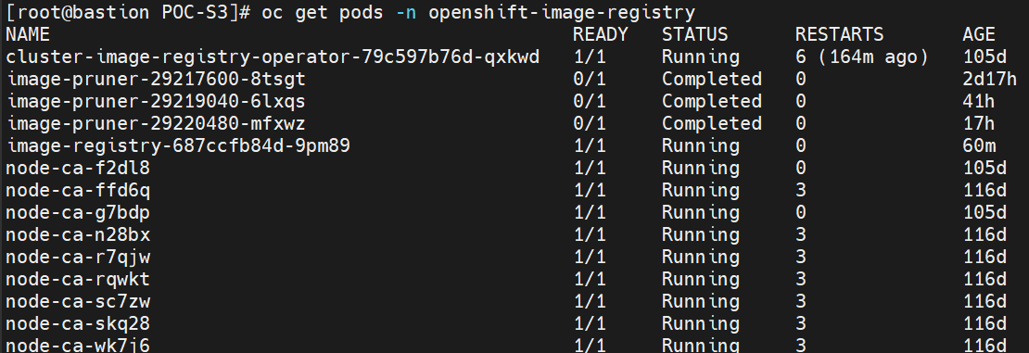

3. 🌍 Acceso externo a la registry
Validar que el route por default esté creado:
oc get route -n openshift-image-registry

4. 🏠 Crear una app para validar uso de la registry

Paso 1: Crear build binaria basada en NGINX
oc new-project test-registry
oc new-build --binary --name=demo-nginx --image-stream=nginx

Paso 2: Crear contenido
mkdir web-content
echo "<h1>Hola desde OpenShift Registry</h1>" > web-content/index.html

Paso 3: Lanzar build
oc start-build demo-nginx --from-dir=web-content –follow
[root@bastion POC-S3]# oc start-build demo-nginx --from-dir=. --follow
Uploading directory "." as binary input for the build ...

Uploading finished
build.build.openshift.io/demo-nginx-1 started
Receiving source from STDIN as archive ...
time="2025-07-23T17:06:52Z" level=info msg="Not using native diff for overlay, this may cause degraded performance for building images: kernel has CONFIG_OVERLAY_FS_REDIRECT_DIR enabled"
I0723 17:06:52.642746 1 defaults.go:112] Defaulting to storage driver "overlay" with options [mountopt=metacopy=on].
Caching blobs under "/var/cache/blobs".
Trying to pull image-registry.openshift-image-registry.svc:5000/openshift/nginx@sha256:f520afb348e0a2a2de8098fdbd7ca56a65065f8b5a97a631c9fdb0496bc90c72...
Getting image source signatures
Copying blob sha256:2071c0e769480e8ab8f2525374ec4954895a023d5847097c864d7d1728c3bafe
Copying blob sha256:e996822e3bf30e4160bdb68906e63c226910f63f161100bf04642f443cb2eeab
Copying blob sha256:dc0ba914e0f1679f69f8986cbf61640c2be663b713dd7add4b29f6152f943c0e
Copying blob sha256:b48553047ca11a94c41af7d2ebbf4b40b9d689b700ebe6c0177dbed6bee17bc5
Copying blob sha256:36b61797c1e3c6d3f23c1aa848e42c0b5e6cc35c534d8d503ffb9bad27ecb239
Copying blob sha256:f1950a7bce72062ee5193c4b2b862500fb2bafc13b457b341d37322a38a315c3
Copying config sha256:d6316668e05ad3ae53b1044e8217c5d1cc6811cd5c20efec0037a967d22c6055
Writing manifest to image destination
Generating dockerfile with builder image image-registry.openshift-image-registry.svc:5000/openshift/nginx@sha256:f520afb348e0a2a2de8098fdbd7ca56a65065f8b5a97a631c9fdb0496bc90c72
Adding transient rw bind mount for /run/secrets/rhsm
STEP 1/9: FROM image-registry.openshift-image-registry.svc:5000/openshift/nginx@sha256:f520afb348e0a2a2de8098fdbd7ca56a65065f8b5a97a631c9fdb0496bc90c72
STEP 2/9: LABEL "io.openshift.build.image"="image-registry.openshift-image-registry.svc:5000/openshift/nginx@sha256:f520afb348e0a2a2de8098fdbd7ca56a65065f8b5a97a631c9fdb0496bc90c72" "io.openshift.build.source-location"="/tmp/build/inputs"
STEP 3/9: ENV OPENSHIFT_BUILD_NAME="demo-nginx-1" OPENSHIFT_BUILD_NAMESPACE="test-registry"
STEP 4/9: USER root
STEP 5/9: COPY upload/src /tmp/src
STEP 6/9: RUN chown -R 1001:0 /tmp/src
STEP 7/9: USER 1001
STEP 8/9: RUN /usr/libexec/s2i/assemble
---> Installing application source
---> Copying nginx start-hook scripts...
STEP 9/9: CMD /usr/libexec/s2i/run
COMMIT temp.builder.openshift.io/test-registry/demo-nginx-1:669c2280
Getting image source signatures
Copying blob sha256:e935f56aee0742019da808d7f8271dd89fbe762c673e72b26a31a9064401a1f7
Copying blob sha256:c1ad92b5465e3078473490d6c201694a83ecd6605fbbb9764f38cd87590379d4
Copying blob sha256:461483d5f23856c59156d4b6dcad01bf185b318ae608cb4524a6e41fee8f4899
Copying blob sha256:a50297cbfa5c715ee43b9415bebb85bf590e95b66bdaf467d221eca4546b323e
Copying blob sha256:4351d877cec4458e25692fb81c2fdb4249322abae11352aaa4473652fb8d7988
Copying blob sha256:4897fa393cdea82c72a951dea98738b29c8aa48f09d70f1cef4f0b532dc00a83
Copying blob sha256:1dfe128ca165f64fe1fed9b5394462b41036381ae985a9d8457990af2167b431
Copying config sha256:8c810aed3cf96a62aae280e4718e7b5dbba3da9d7ee72380d4f2dfd4c5a12b1e
Writing manifest to image destination
--> 8c810aed3cf9
Successfully tagged temp.builder.openshift.io/test-registry/demo-nginx-1:669c2280
8c810aed3cf96a62aae280e4718e7b5dbba3da9d7ee72380d4f2dfd4c5a12b1e

Pushing image image-registry.openshift-image-registry.svc:5000/test-registry/demo-nginx:latest ...
Getting image source signatures
Copying blob sha256:2071c0e769480e8ab8f2525374ec4954895a023d5847097c864d7d1728c3bafe
Copying blob sha256:f1950a7bce72062ee5193c4b2b862500fb2bafc13b457b341d37322a38a315c3
Copying blob sha256:b48553047ca11a94c41af7d2ebbf4b40b9d689b700ebe6c0177dbed6bee17bc5
Copying blob sha256:36b61797c1e3c6d3f23c1aa848e42c0b5e6cc35c534d8d503ffb9bad27ecb239
Copying blob sha256:e996822e3bf30e4160bdb68906e63c226910f63f161100bf04642f443cb2eeab
Copying blob sha256:dc0ba914e0f1679f69f8986cbf61640c2be663b713dd7add4b29f6152f943c0e
Copying blob sha256:1dfe128ca165f64fe1fed9b5394462b41036381ae985a9d8457990af2167b431
Copying config sha256:8c810aed3cf96a62aae280e4718e7b5dbba3da9d7ee72380d4f2dfd4c5a12b1e
Writing manifest to image destination
Successfully pushed image-registry.openshift-image-registry.svc:5000/test-registry/demo-nginx@sha256:129259ca8646b2d9831bb34e4b2a0b076e301550d406a07f69095b25f24fdb71
Push successful
[root@bastion POC-S3]#
[root@bastion POC-S3]# oc new-app demo-nginx
--> Found image 8c810ae (About a minute old) in image stream "test-registry/demo-nginx" under tag "latest" for "demo-nginx"

Nginx 1.24
----------
Nginx is a web server and a reverse proxy server for HTTP, SMTP, POP3 and IMAP protocols, with a strong focus on high concurrency, performance and low memory usage. The container image provides a containerized packaging of the nginx 1.24 daemon. The image can be used as a base image for other applications based on nginx 1.24 web server. Nginx server image can be extended using source-to-image tool.

Tags: builder, nginx, nginx-124

--> Creating resources ...
deployment.apps "demo-nginx" created
service "demo-nginx" created
--> Success
Application is not exposed. You can expose services to the outside world by executing one or more of the commands below:
'oc expose service/demo-nginx'
Run 'oc status' to view your app.
[root@bastion POC-S3]# oc expose svc/demo-nginx
route.route.openshift.io/demo-nginx exposed
[root@bastion POC-S3]# oc get route demo-nginx
NAME HOST/PORT PATH SERVICES PORT TERMINATION WILDCARD
demo-nginx demo-nginx-test-registry.apps.labokdipi.claro.amx demo-nginx 8080-tcp None
[root@bastion POC-S3]# demo-nginx-test-registry.apps.labokdipi.claro.amx^C
[root@bastion POC-S3]# mkdir web-content
[root@bastion POC-S3]# echo "<h1>Hola desde OpenShift Registry</h1>" > web-content/index.html
[root@bastion POC-S3]# oc start-build demo-nginx --from-dir=web-content --follow
Uploading directory "web-content" as binary input for the build ...

Uploading finished
build.build.openshift.io/demo-nginx-2 started
Receiving source from STDIN as archive ...
time="2025-07-23T17:15:03Z" level=info msg="Not using native diff for overlay, this may cause degraded performance for building images: kernel has CONFIG_OVERLAY_FS_REDIRECT_DIR enabled"
I0723 17:15:03.121869 1 defaults.go:112] Defaulting to storage driver "overlay" with options [mountopt=metacopy=on].
Caching blobs under "/var/cache/blobs".
Trying to pull image-registry.openshift-image-registry.svc:5000/openshift/nginx@sha256:f520afb348e0a2a2de8098fdbd7ca56a65065f8b5a97a631c9fdb0496bc90c72...
Getting image source signatures
Copying blob sha256:2071c0e769480e8ab8f2525374ec4954895a023d5847097c864d7d1728c3bafe
Copying blob sha256:dc0ba914e0f1679f69f8986cbf61640c2be663b713dd7add4b29f6152f943c0e
Copying blob sha256:e996822e3bf30e4160bdb68906e63c226910f63f161100bf04642f443cb2eeab
Copying blob sha256:f1950a7bce72062ee5193c4b2b862500fb2bafc13b457b341d37322a38a315c3
Copying blob sha256:b48553047ca11a94c41af7d2ebbf4b40b9d689b700ebe6c0177dbed6bee17bc5
Copying blob sha256:36b61797c1e3c6d3f23c1aa848e42c0b5e6cc35c534d8d503ffb9bad27ecb239
Copying config sha256:d6316668e05ad3ae53b1044e8217c5d1cc6811cd5c20efec0037a967d22c6055
Writing manifest to image destination
Generating dockerfile with builder image image-registry.openshift-image-registry.svc:5000/openshift/nginx@sha256:f520afb348e0a2a2de8098fdbd7ca56a65065f8b5a97a631c9fdb0496bc90c72
Adding transient rw bind mount for /run/secrets/rhsm
STEP 1/9: FROM image-registry.openshift-image-registry.svc:5000/openshift/nginx@sha256:f520afb348e0a2a2de8098fdbd7ca56a65065f8b5a97a631c9fdb0496bc90c72
STEP 2/9: LABEL "io.openshift.build.source-location"="/tmp/build/inputs" "io.openshift.build.image"="image-registry.openshift-image-registry.svc:5000/openshift/nginx@sha256:f520afb348e0a2a2de8098fdbd7ca56a65065f8b5a97a631c9fdb0496bc90c72"
STEP 3/9: ENV OPENSHIFT_BUILD_NAME="demo-nginx-2" OPENSHIFT_BUILD_NAMESPACE="test-registry"
STEP 4/9: USER root
STEP 5/9: COPY upload/src /tmp/src
STEP 6/9: RUN chown -R 1001:0 /tmp/src
STEP 7/9: USER 1001
STEP 8/9: RUN /usr/libexec/s2i/assemble
---> Installing application source
---> Copying nginx start-hook scripts...
STEP 9/9: CMD /usr/libexec/s2i/run
COMMIT temp.builder.openshift.io/test-registry/demo-nginx-2:e976f6e3
Getting image source signatures
Copying blob sha256:e935f56aee0742019da808d7f8271dd89fbe762c673e72b26a31a9064401a1f7
Copying blob sha256:c1ad92b5465e3078473490d6c201694a83ecd6605fbbb9764f38cd87590379d4
Copying blob sha256:461483d5f23856c59156d4b6dcad01bf185b318ae608cb4524a6e41fee8f4899
Copying blob sha256:a50297cbfa5c715ee43b9415bebb85bf590e95b66bdaf467d221eca4546b323e
Copying blob sha256:4351d877cec4458e25692fb81c2fdb4249322abae11352aaa4473652fb8d7988
Copying blob sha256:4897fa393cdea82c72a951dea98738b29c8aa48f09d70f1cef4f0b532dc00a83
Copying blob sha256:ccfd433cf663c4cd696db26c00caec159c98c2abee32a1ce03b33f027be6a5c1
Copying config sha256:396b6129b34e6207b6c47ed4484ab68e16619d073faf26a3f7c1eeee1e212b1e
Writing manifest to image destination
--> 396b6129b34e
Successfully tagged temp.builder.openshift.io/test-registry/demo-nginx-2:e976f6e3
396b6129b34e6207b6c47ed4484ab68e16619d073faf26a3f7c1eeee1e212b1e

Pushing image image-registry.openshift-image-registry.svc:5000/test-registry/demo-nginx:latest ...
Getting image source signatures
Copying blob sha256:2071c0e769480e8ab8f2525374ec4954895a023d5847097c864d7d1728c3bafe
Copying blob sha256:e996822e3bf30e4160bdb68906e63c226910f63f161100bf04642f443cb2eeab
Copying blob sha256:f1950a7bce72062ee5193c4b2b862500fb2bafc13b457b341d37322a38a315c3
Copying blob sha256:dc0ba914e0f1679f69f8986cbf61640c2be663b713dd7add4b29f6152f943c0e
Copying blob sha256:b48553047ca11a94c41af7d2ebbf4b40b9d689b700ebe6c0177dbed6bee17bc5
Copying blob sha256:36b61797c1e3c6d3f23c1aa848e42c0b5e6cc35c534d8d503ffb9bad27ecb239
Copying blob sha256:ccfd433cf663c4cd696db26c00caec159c98c2abee32a1ce03b33f027be6a5c1
Copying config sha256:396b6129b34e6207b6c47ed4484ab68e16619d073faf26a3f7c1eeee1e212b1e
Writing manifest to image destination
Successfully pushed image-registry.openshift-image-registry.svc:5000/test-registry/demo-nginx@sha256:7851386e31d7dcc52fb1df380b1b2d94de550c60ce5f30c1a5742f2403346cb5
Push successful

Verifica que la imagen se empuja a la registry interna:
image-registry.openshift-image-registry.svc:5000/test-registry/demo-nginx:latest

Paso 4: Desplegar la app
oc new-app demo-nginx
oc expose service demo-nginx

5. 🌐 Probar acceso web
Navegá a: https://demo-nginx-test-registry.apps.<cluster>
Deberías ver: Hola desde OpenShift Registry
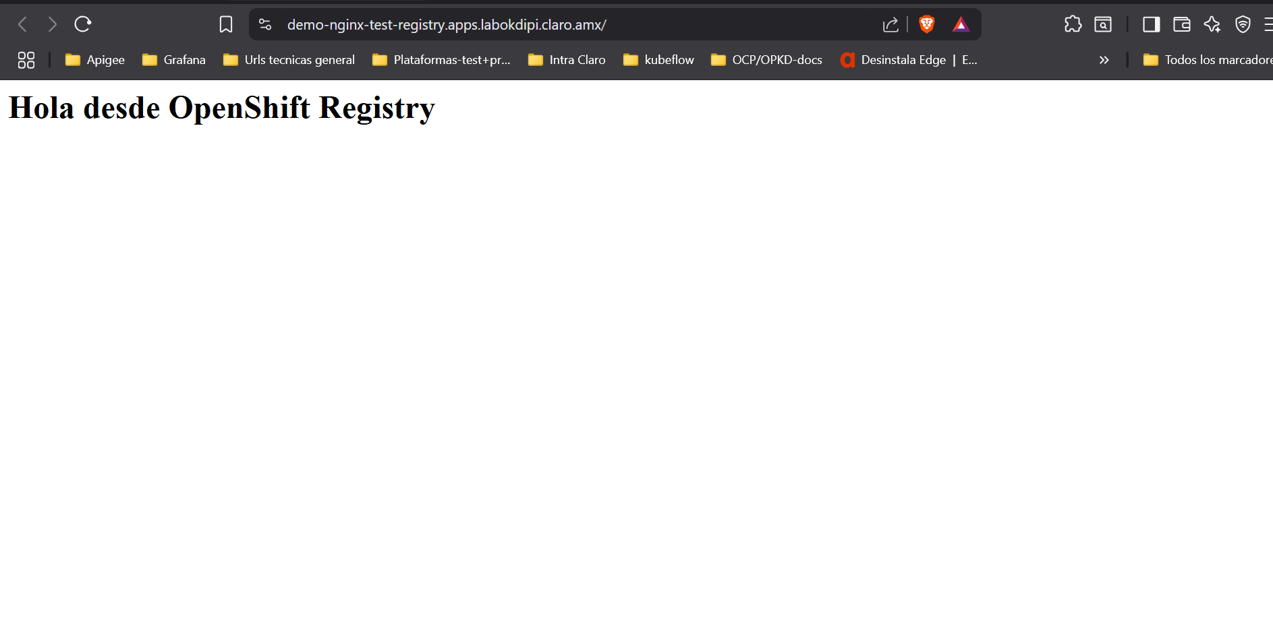

✅ Confirmación del uso de registry
oc get is -n test-registry
Verificar que el tag demo-nginx:latest apunta al registro interno.

[root@bastion POC-S3]# oc get is -n test-registry
NAME IMAGE REPOSITORY TAGS UPDATED
demo-nginx default-route-openshift-image-registry.apps.labokdipi.claro.amx/test-registry/demo-nginx latest 10 minutes ago

✅ Confirmación del uso de registry con S3 browser

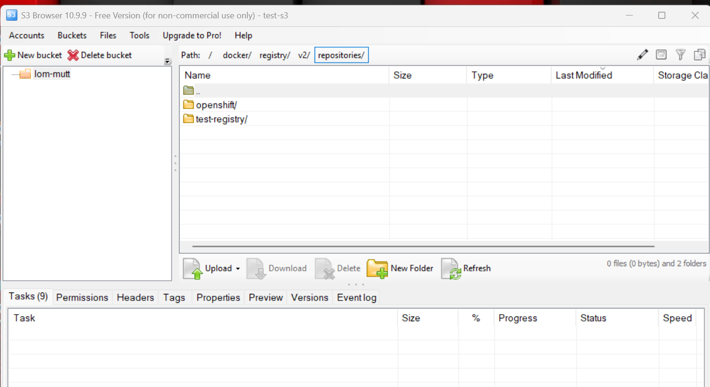

🚀 Conclusión
La registry se encuentra funcionando sobre backend S3 personalizado (Claro), aceptando builds y sirviendo imágenes con acceso a través del router.

