Live, Continuous Energy Auditing of Miscellaneous Electrical Loads: Methodology and Results

Jorge Ortiz, Jason Trager, Gavin Saldanha, David E. Culler, Paul K. Wright

UC Berkeley

ABSTRACT

We present the architecture, implementation, and results from a live, continuous energy auditing system. By combining QR codes and mobile phones, we are able to iteratively collect building plug-load information and couple it with live, streaming meter data. Our methodology includes the deployment of inexpensive tags (QR codes) as well a smartphone-based auditing application. The mobile phone reads a tag to associate an electrical plug load with meter data and deployment information. We deployed our system in a 141,000 square foot, seven-story building, and tagged over 351 items over 139 rooms. We present the architecture of our system and the results of our initial audit. We also describe our application and future directions of this work.

**Introduction**

Miscellaneous electrical loads (MELs) consume about a third of the energy consumed in buildings in the United States [doe]. According to Lanzisera et al. [LBNL_MELS], MELs data are typically collected from national surveys of several thousand homes and commercial buildings. The data is statistically disaggregated to estimate energy use and the residual from these models is classified as “other” and referred to as miscellaneous. It consists of end-use electrical loads that are not accounted for in the traditional heating, cooling, ventilation, and lighting. With the recent rise in MELs, there has been more interest in characterizing the energy use of the equipment in this category. Porter et al. [Porter2006] sampled 50 homes, metering 17 devices per home over the period of a week. Moorefield at al. [Moorefield2008] sampled 47 office buildings, metering 10 devices per building for a period of two weeks. In both studies, data was collected at one-minute intervals and analyzed offline.

Although these initial studies provided more insight than ever before, the per-building deployment scale was limited, largely due to cost and technological limitation of the tools available at the time the studies were done. The last study used a plug-load meter called a ‘Watts-up’ with no networking capabilities, which costs in the range of $200-300. This makes sampling every device in the building cost-prohibitive. Also, these meters are not usually networked and contain a limited amount of local memory, so the sampling and collection frequency must be carefully scheduled and managed. You need to sample frequently and long enough to capture the underlying trends but not so quickly that you have to constantly *walk* over and collect the data from each meter. Lanzisera et al. [LBNL_MELS] used a much cheaper power meter with low-power wireless networking capabilities called ACme [acme]. Although not widely available on the market, they are significantly cheaper than the ‘Watts-up’, costing in the range of $20 in volumes of 10,000. Not only does the cost allow for much large deployments but their wireless networking capabilities remove the need to physically “milk” the meters when space in local memory is exhausted.

Another aspect of deployment setup that makes scaling difficult is the amount of setup work that needs to be done beforehand. Before collecting any meter data, deployment information must be collected and organized; in order to set the context for interpreting them. For example, the analyst must note that power stream X came from meter Y which was attached to device Z of building A, floor B, room C. During this phase, one of the most time-consuming tasks is collecting a list of the each device and categorizing it. This process involves a walk through the building listing each plug-load item, classifying it, and recording some item-specific descriptive information. Typically, this information is written on paper and transferred manually into a database for analysis. The associated database schema should be designed to match the information about the deployment, devices, and meters. It must also capture information about the association between the meter, the item, and its location; allowing the analyst to submit cross-cutting queries for each view.

At large scales, this process also becomes very time consuming and increases with the size of the building and the number of devices that are being metered, since inventory-recording is typically completed by a member of the investigation team; which can only grow so large given a limited budget. The study done by Lanzisera et al. [LBNL_MELS] consisted of a data-collection team of three members, and they deployed over 455 sensors throughout an entire building. However, the information setup and gathering phase took a several weeks and is discussed in great detail in [cmels].

We argue that information technology should be used to scale this process and that the deployment should be used to extract more value for building occupants. The infrastructure, in the aforementioned studies, was only used for the associated study. It provides *no direct value to building occupants*. We believe that ***energy data services***should be offered to building occupants, provided over the deployed infrastructure. For example, occupants should be allowed to directly observe the energy consumption of their devices or see how much they have consumed over a given time period. We also believe that occupants can help track the evolution of the infrastructure (i.e. meters added, removed, replaced) through these services and they should be indirectly tasked with *distributed consistency maintenance of deployment state* as captured in the accounting system, in return for real-time energy data services.

In summary, our work attempts to:

1. Use cheaper, networked sensors and expand the set of acceptable data streams as they become available.
2. Decrease the time it takes to gather and collect MELs information by using “off-the-shelf” information technology, such as mobile phones and QR codes.
3. Provide energy data services to building occupants.
4. Involve occupants in maintaining a consistent view of the deployment as it evolves.

In the rest of the paper, we describe our architecture and explain our design choices for achieving the aforementioned goals. We also describe the energy services we have built on top of our deployment infrastructure, go through the initial energy audit results we obtained through our system, and discuss plans for future work.

**System design goals**

Although sufficient for their specific study, we believe that we can further leverage IT to design a system the has the following properties:

* Cost effectiveness
* Scale
* Generality and Ease of Use
* Incrementally deployable

Our architecture consists of four main components: the sensing tier, the data-management tier, the application tier, and the tagging infrastructure. Figure 1 shows the components of our architecture. The sensing tier is shown the ‘plug-loads’ box. Notice the small acmes with QR codes attached to them. These acmes are placed on plug-loads throughout the building. The data management tier is indicated by the box on the upper left hand corner of the figure. The cloud element represents the fact that our data tier resides in a datacenter as a cloud service that is accessible over the network using the mobile phone. The application tier lives on the mobile phone and any computing client with network access (not shown in the figure). Finally, the tagging infrastructure is indicated by the QR codes spread throughout the physical environment. QR codes bridge the physical world with the data management tier and the application.

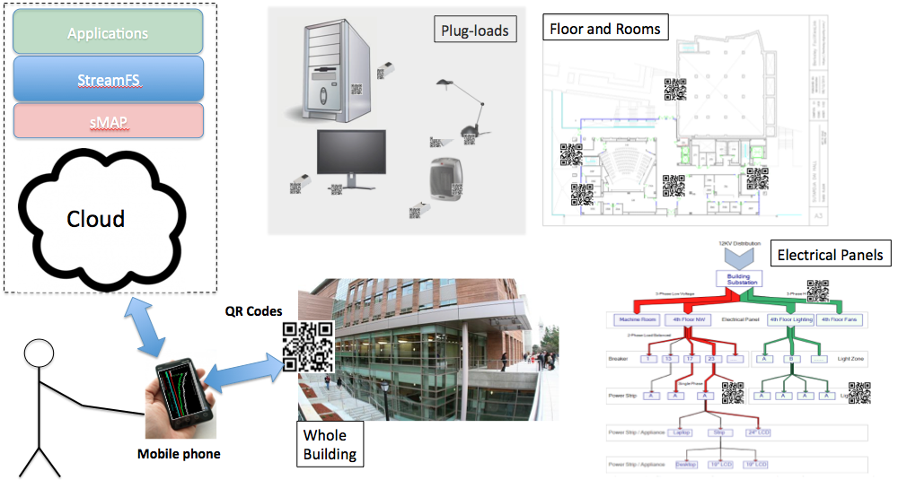

Figure 2. This figure presents the Berkeley mobile auditing system (BMAS) architecture. The figure shows the sensing tier, the data management tier, the application tier, tagging infrastructure that bridge the other three through the application on the mobile phone.

We aim to design a system that provides a general framework for collecting, organizing, feeding, and extracting sensor data and deployment information. Generality is achieved through useful abstractions

In order to achieve scale, we also look to allow many users to simultaneously update the deployment metadata and to add/remove or move sensors from the deployment with relative ease. Fundamentally, we want to parallelize consistency management; whereby many users can help us maintain virtual representation of the physical deployment, which is spread throughout the building. We also want to leverage the pieces that are already in place, for example, the ubiquity of mobile phones and network connectivity. Finally, we hope to design a system that is easy to use and allows for incremental deployment. The systems we have seen deployed are one-time deployments done to collect data for a specific study. We prefer to invest in a deployment infrastructure that can be useful for doing many studies over time and ultimately to help improve the operational efficiency of the building.

In order to achieve these goals we need a system that allows for flexible schema design. Device schemas may change over time and we do not want to adjust our data collection scripts each time we change the schema. We need a system that integrates well with external tools for viewing and analyzing the data. MySQL is not sufficient for handling incoming, streaming data and making that data available to external applications easily. Although much of the analysis is done on historical data, we see lots of value in enabling real-time visibility and analysis. We need a way to parallelize and streamline the data collection task. Taking inventory manually is slow and error-prone. Furthermore, sitting at a desk to input the data is cumbersome. Updating the metadata should be natural and easy to do. Sensors and device move throughout the building and these should be captured along with the data that they produce.

Our solution combines mobile phones, QR codes, and cloud-based technology. We wrote an android application that allows auditors to scan QR codes that are attached to physical items, input information about that item, and bind/attach devices and meters. These functions are performed on the phone, but centrally maintained by a cloud-based service called StreamFS [sfs]. In the next section, we will discuss the system architecture in greater details. We also discuss how we used StreamFS to define application-level semantics for expressing and interpreting the inter-relationships encoded in the StreamFS namespace by the mobile phone application.

**Berkeley mobile auditing system (BMAS)**

We have designed and implemented a mobile auditing application on the Android OS [android] to collect and manage physical deployment data. We call our system the Berkeley mobile auditing system (BMAS). The main constituents are the Android-based auditing application, QR codes, and our cloud-hosted computational stack which mainly include sMAP [smap] and StreamFS [sfs]. Figure 1 gives an overview of the architecture.

The mobile phone application is mainly used to input data about the deployment. The primary operations supported are 1) registration, 2) bind/attach, and 3) scan.

Figure 2 shows a few screen shots of the menu in the mobile application. Before using the application, a user must first generate a QR code. The QR code was specifically designed for this application. It contains a URL that is used by the application look up the item that the QR code is attached to.

**Registration**

To register an item, the user generates, prints, and attaches a QR code to the item and scans it. If the QR code is not associated with an item, the registration screen comes up. The registration screen allows the user to enter information about the item and permanently associats the QR code with the item. Any future QR code scans will display information about the item that was entered during the registration phase. The mobile application also allows the user to edit information by scanning and choosing the “edit information” option on the screen. Every item in the inventory, including devices and meters must be explicitly registered.

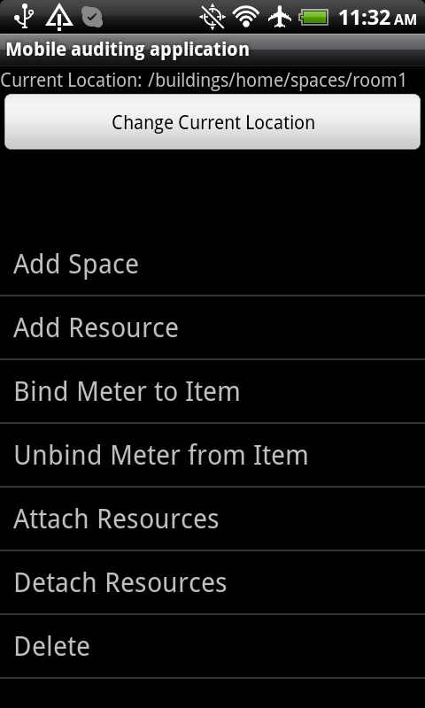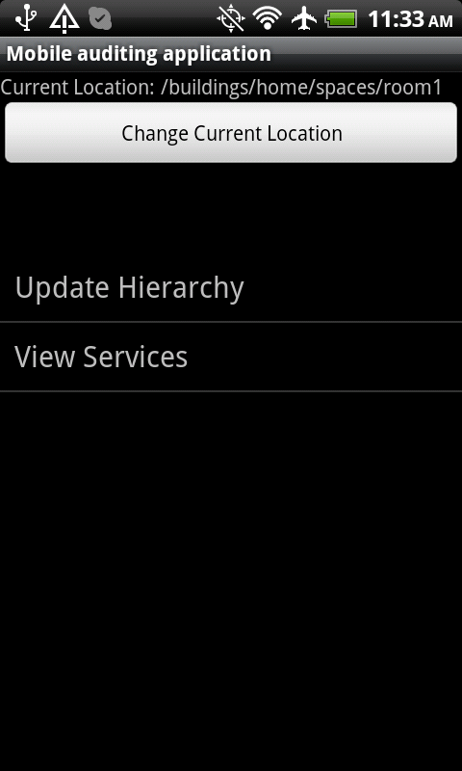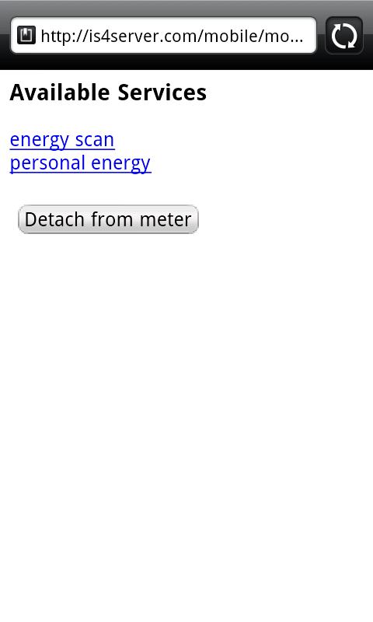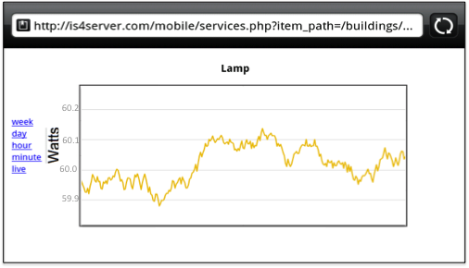

Figure 3. Screen shots from the Berkeley mobile auditing application. The figure on the left shows the menu items that the user chooses from. The figure on the right shows the results of a scan on a Lamp.

**Location management**

We require that all rooms be registered as well. Room registration provides a course-grained mechanism for locating items spread throughout the building. They also simplify the registration process by implicitly associating the “current location” of the user with the current item being registered. Registering a room is similar to registering an item, except no metadata needs to be recorded for a room.

**Categorization**

As previously mentioned, part of the inventory collection processes involves categorizing the item. We used the taxonomy of miscellaneous and lower-power product [tax]. On the registration screen, the user enters the category and the application does a closest match to the text the user is entering.

**Bind/Attach**

Registration performs an implicit binding between the QR code and the item it is attached to. We implemented two explicit associations that are important, *binding* a meter to a device and *attaching* two devices together. The bind operation involves a pair of swipes. 1) Swipe the QR code of the device and 2) swipe the QR code of the meter. This creates an association between the meter and the item so that users can scan the item later and retrieve meter-measurements associated with the item. It also creates an explicit association for detailed accounting after the fact. Attach is very similar to bind, except that you attach two devices together. This is important to capture since there are situations where a meter is actually attached to a power strip which had multiple items attached to it. The association allows you to follow the link path between a meter and an item that has other items attached it.

**Metering tier**

In our deployment we used Acme power meters [acme] to take measurement of devices. Acmes transmit data periodically to a local IPv6 router. We set up a network of Acmes in various parts of the building and coupled the live metering data with the device information that was collected.

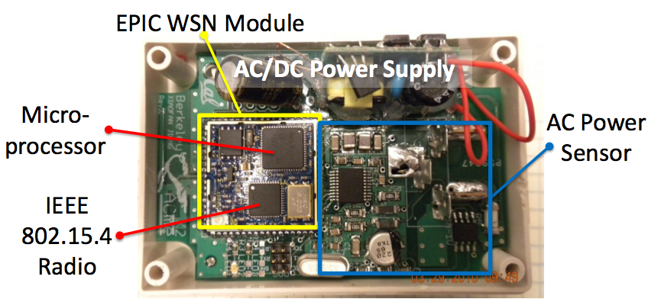

Figure 4. Acme power meter.

Our architecture does not restrict you to using only Acme meters. We have designed a layered stack that allows you to use any metering technology you would like. This decoupling allows for a diverse metering infrastructure to feed information about all kinds of data collected from the deployment.

**Cloud-storage tier**

Our cloud storage tier consists mainly of sMAP and StreamFS. sMAP provides a uniform way to represent and retrieve physical data and StreamFS organizes that information into a common namespace, capturing the inter-relationships that are interpreted by the mobile application. StreamFS manages metadata like a filesystem by organizing the data into a hierarchical namespace and presents both an HTTP RESTful interface as well as a mountable Linux filesystem interface for integration with external tools.

The main benefit of using StreamFS its metadata management features. The namespace is managed hierarchically. We start with a root folder that represents the building and sub-folders that represent the sensors, the QR codes, and spaces. StreamFS also support symbolic linking, similar to a Unix filesystem. This allows us to capture the entity-relationships by symbolically linking nodes from multiple sub-namespaces. For example, we have a folder where all the inventory items are placed. Upon registration, a symbolic link is created from the QR code folder to the item in the inventory directory. The same mechanism is used for linking an item to a space. The spatial hierarchy consists of folders for each room. When an item is registered in a specific space a symbolic link is created from that space folder to the item.

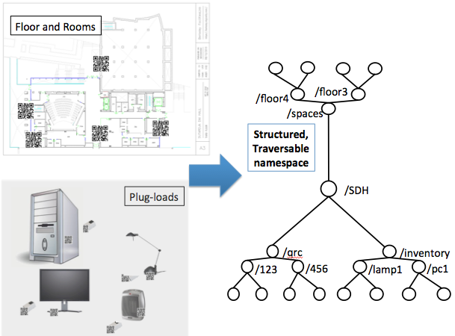

Figure 5. This figure shows how StreamFS is used to manage the deployment in a common namespace. We take items from the building, including the QR codes, and build up the namespace and inter-relationships using the mobile application.

Symbolic links give us a flexible mechanism for naming our items and recording movement. When an item moves from one location to another, the old symbolic link is removed and a new one created from the new location folder. StreamFS also supports tagging on the files and folders for fast search.

**Initial audit results and applications**

With a total of four students, we were able to tag hundreds of items, meters, and spaces throughout a 141,000, seven-story building. We tagged and registered a total of 351 items and 139 rooms. In the item-registration processes, we also recorded power/current rating placed on the item itself, so that we can later compare the actual readings with plated readings. Figure 4 gives a summary of the type of different types of items we collected.

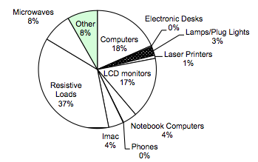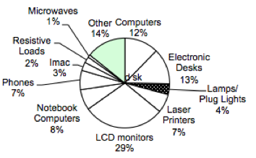

Figure 6. The figure on the left shows the break-down of the various types of devices that we registered in doing the audit. The figure on the right shows the plated power-draw of the various types of devices.

The items were categorized according to the LBNL MELs taxonomy and automatically organized by StreamFS. The vast majority of items were resistive loads, such as space heaters and coffee machines. The next largest category consists of computing equipment, such as laptops, LCD screen, and desktop machines. These were generated directly from the namespace and symbolic links from the taxonomy sub-tree. The first was a simple traversal of that hierarchy and the second was a search on the tags that contain plated power-draw figures.

The BMAS architecture allows you to incrementally deploy live metering and associate it with devices. In our initial iteration, we deployed a set of Acmes in a room and used the bind/attach operations to associate the meter feeds to the specific items inside that room. Instead of using the collected data to query historical data, we used the real-time feed to drive a usage visualization application. Figure 5 shows two screen shots of this visualization. The basic goal of the application is to inform users of which items are on and which are off. Occupants sometimes leave the lab without turning off all the devices, hence causing lots of energy to be used unnecessarily.

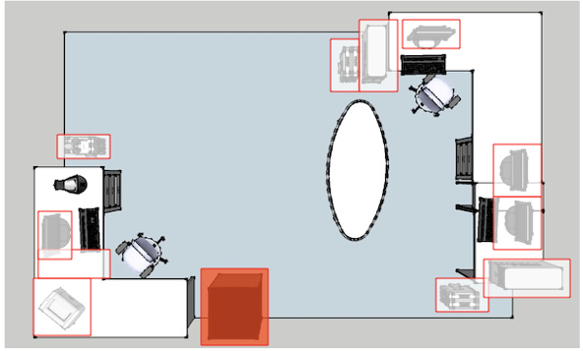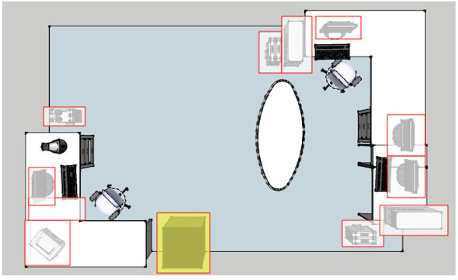

Figure 7. Live data associated with specific device in office. This is an application built on top of the auditing infrastructure. It shows when appliances in the office are active and when they are inactive.

Finally, we wrote a script that queries the real-time feeds associated with power usage by devices in the building a generated a graph showing times of the day when usage was at its peak. Figure 6 shows this graph. The units on the right on not particularly important, however, notice that from this graph we can pick out the weekdays and weekends. The weekdays see the highest power-draw and the weekends see about half the power draw and weekdays. Furthermore, we can see the peak hours of usage during the day. The times correspond to a typical workday between 10am and 8pm. With this visualization we can observe the work habits of the occupants of this particular building.

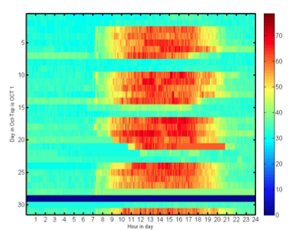

Figure 8. This figure shows the cumulative power draw for plug-load devices a single room in October 2011. We can differentiate between weekdays and weekends and we can see that the typical weekday work hours are between 10am-8pm.

**Continuous auditing, commissioning, iteration**

The applications demonstrate the generalizability of the architecture. We can integrate any kind of sensor feed into a common namespace upon which we can either run multiple studies based on historical data measurement or building applications that display real-time data.

The system is relatively cheap to deploy and can be done incrementally. Sensors can be added when they are available. The registration process is straight forward, since the mobile application is based on QR codes. The QR codes are easily generated and replaceable. They can be printed with any printer and taped on the item of interest. Furthermore, and perhaps to the most important aspect of the architecture, is that it allows the deployment to scale with the number of occupants. Although we chose to have only a small set of students do the deployment, the key take-away is that it could easily be done by the building occupants themselves. We are currently working on a web site that the occupants can use to generate QR codes for their own items and to download the mobile application to register their devices with us. That information alone is quite useful to understand. If those devices are ever metered, those meters can also be registered and bound to the items that were registered.

Hosting a cloud-based instance of sMAP and StreamFS is also quite cheap and only needs to scale with the amount of data that is eventually generated. We are looking to integrate, not only plug-load data, but also building data that is extracted from the building management system. We are also going to add weather feeds and other information to support a number of applications on the infrastructure. The infrastructure that is in place continues to provide benefits to the occupants and application writers. If we continue to provide interesting applications to building occupants we incentivize them into participating in maintaining deployment consistency. This will allow us to continue to provide energy-related visualization and control services and helping us understand how energy is being used throughout the building.

**Conclusion**

Miscellaneous electrical loads consume a large portion of the total building energy and it is on the rise. It is important to understand how MELs are used within buildings, so that we can learn how to better manage the ones that are deployed and potentially even design better electrical loads. In order to understand these more deeply, we must measure loads that fall into this category. Various studies have constructed multi-component instruments in order to collect and analyze data on MELs. However, there are various shortcomings in the design of such systems. They are generally expensive to put together, difficult to manage and maintain, are only useful for conducting the particular study, and do not particularly scale well.

This paper explores the use of IT to minimize the cost of doing such deployments, provides an incrementally deployable infrastructure that is useful for learning more about MELs and potentially integrates with all kinds of building data sources. The Berkeley mobile auditing system also makes use of building occupants to provide input and management scalability. We use mobile phones, QR codes, and cloud-based services to collect and manage the deployment data and metadata. QR codes serve as a cheap tagging mechanism that can be read by phones connected to a network to bridge the physical with the virtual, helping to maintain a consistent view of the deployment so that we can correctly interpret the data in our analysis. We were also able to write several useful applications that not only provide a value to auditors for doing specific studies, but for potentially inducing changes through visualization and control.

**References**

[LBNL_MELS] Steven M. Lanzisera, Stephen Dawson-Haggerty, Xiaofan Jiang, Hoi Ying Cheung, Jay Taneja, Judy Lai, Jorge J. Ortiz, David Culler, Richard Brown. Wireless Electricity Metering of Miscellaneous and Electronic Devices in Buildings. 2011 Future of Instrumentation International Workshop.

[Porter2006] Porter S.F., Moorefield L. and May-Ostendorp P. Final Field Research Report: California Plug-Load Metering Study. Ecos Consulting, 2006.

[Moorefield2008] Moorefield L., Frazer B. and Bendt P. Office Plug Load Field Monitoring Report. Ecos Consulting, 2008.

[smap] Stephen Dawson-Haggerty, Xiaofan Jiang, Gilman Tolle, Jorge Ortiz and David Culler. sMAP – A Simple Measurement and Actuation Profile for Physical Information. 8th ACM Conference on Embedded Networked Sensor Systems (Sensys 2010

[sfs] StreamFS. <http://streamfs.cs.berkeley.edu>

[acme] Jiang X., Ly M.V., Taneja J., Dutta P. and Culler D. Experiences with a High-Fidelity Wireless Building Energy Auditing Network. Proc. of the Seventh ACM Conference on Embedded Networked Sensor Systems (SenSys’09). (Berkeley, CA, Nov. 4-6, 2009). Ed.: Association for Computing Machinery (ACM).

[qrc] ["QR Code Standardization"](http://www.denso-wave.com/qrcode/qrstandard-e.html). *QR Code.com*. Denso-wave.com. Retrieved 23 April 2009.

[doe] US DOE. 2009 Buildings Energy Databook. U.S. Department of Energy, Office of Energy Efficiency and Renewable Energy, 2009. Download at: <http://buildingsdatabook.eere.energy.gov/>

[tax] Nordman B. and Sanchez M. Electronics Come of Age: A Taxonomy for Miscellaneous and Low Power Products. Proc. of the 2006 ACEEE Summer Study on Energy Efficiency in Buildings. (Asilomar, CA, August, 2006). Ed.: American Council for an Energy Efficient Economy, Washington, DC.

[android] <http://www.android.com/>

[cmels] Berkeley National Laboratory, National Renewable Energy Laboratory, Oak Ridge National Laboratory, and Pacific Northwest National Laboratory. Monitoring and characterization of miscellaneous energy and business-process loads: Demonstration of field methods for studying diverse commercial environments. October, 2007. http://endusefiles.lbl.gov/public/CMELs/CMELs_Joint_Interim_Report_2010_10_07.pdf