**INCIDENT RESOLUTION REPORT**

|  |  |
| --- | --- |
| **INCIDENT NO: BPS-0198** | **INCIDENT TYPE: Hardware** |
| **DATE OF EVENT: 8/5/2024** | **DATE CLOSED: 8/7/2024** |
| **REQUESTED BY: WMATA FC (AFC)** | **MAXIMO NO:** **18819959** |
| **ASSIGNED TECHNICIAN:**  **Ryan Douglas (055453)** | **ASSIGNED MANAGER:**  **Jongsung Yoo (055456)** |

|  |
| --- |
| **INCIDENT DETAILS** |
| *Describe the event and include any harm that resulted. Also identify the cause, if known.* |
| B06-028, Fort Totten, BARRIER SHAKING.THE BARRIER OUT OF ITS CORRECT POSITION. SENSORS MISALIGNEMENT. |

|  |
| --- |
| **STATUS** |
| *Describe the incident status* |
| Complete  Waiting for Support  Waiting on Material Complete |

|  |  |
| --- | --- |
| **ROOT CAUSE ANALYSIS** | |
| *Describe the root cause analysis* | |
| Barrier is horizontally misaligned due to vandalism | |
| **Was there a root cause identified?** | Yes  No  Unknown |

|  |  |
| --- | --- |
| **ACTIONS TAKEN** | |
| *Describe resolution actions taken* | |
| • On 8/6/24 12:00PM, technicians visited Fort Totten station with AFC escort  • Technician replaced Motor. (Old:20IL-23A-0338/ New: 20IL-23A-0803)  • Technician replaced BCB. (Old:1000458856/ New: 1000530183)  • Technician downloaded FW, and recalibrated the barrier  • After the replacement, the gate was back to normal operation  • AFC confirmed the issue was resolved.  • Technician discovered alignment issue of this gate and will be back next day with the tool.  • On 8/7/2024 12:00PM, Technician arrived at Fort Totten with AFC escort.  • Technician had sensor testing.  • Technician inspected FG20 and found the passenger sensor #6,#5,4,#17 and #11 were always being detected even with there is no object.  • Technician found the ADA barrier on FG20 was misalignment due to vandalism.  • Technician checked the anchor bolt was loose and it was loose.  • Technician unscrew the bolt and push Gate 20.  • Tightened the bolt. (Using Torque Wrench, 23 ft-lbs )  • Technician had sensor testing and confirmed the passenger sensors were normal functionality.  • Check BCB and GCU LED status on board and working well.  • AFC confirmed the issue was resolved. | |
| **Components** | Swing Barrier X Worked On _ Replaced  Barrier Board ­­_ Worked On _ Replaced  [ ] _ Worked On _ Replaced |

|  |
| --- |
| **PREVENTION PLAN** |
| *List the recommended actions planned to prevent a future occurrence of the adverse event.* |
|  |
|

|  |  |  |
| --- | --- | --- |
| **SIGNATURE OF TEAM MEMBER** | **ID#** | **DATE SIGNED** |
| **Ryan Douglas** | **055453** | 8/7/2024 |

|  |  |  |
| --- | --- | --- |
| **SIGNATURE OF MANAGER** | **ID#** | **DATE SIGNED** |
| **Jongsung Yoo** | **055456** | 8/7/2024 |

Before:

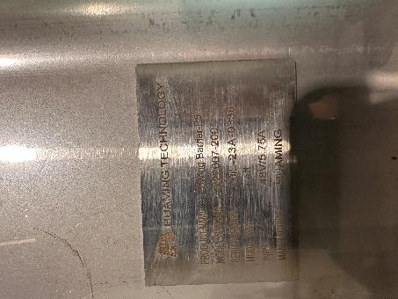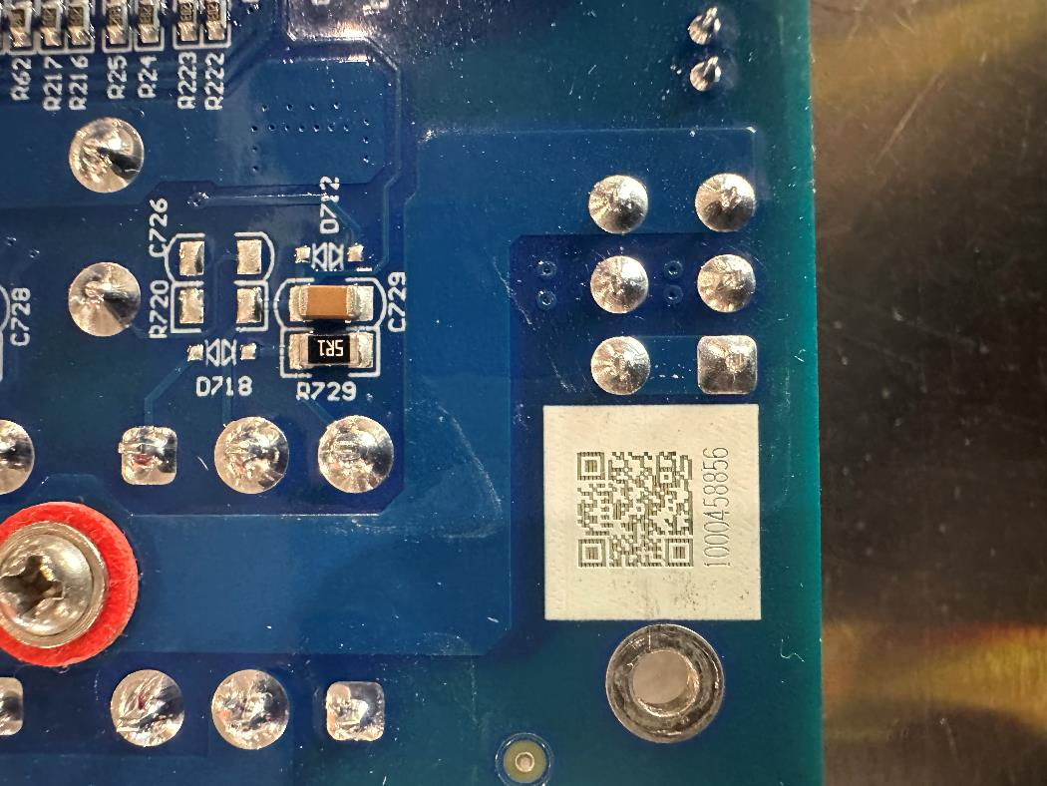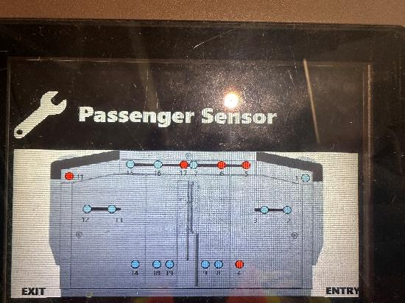

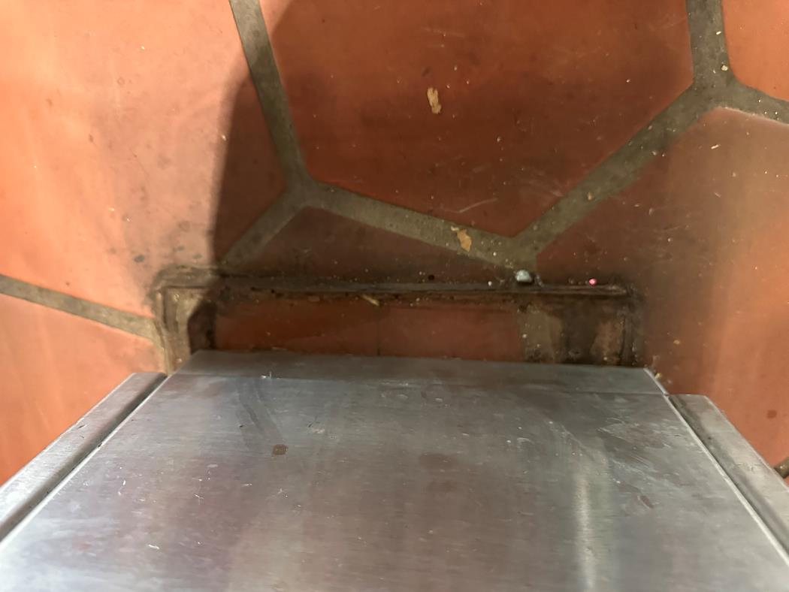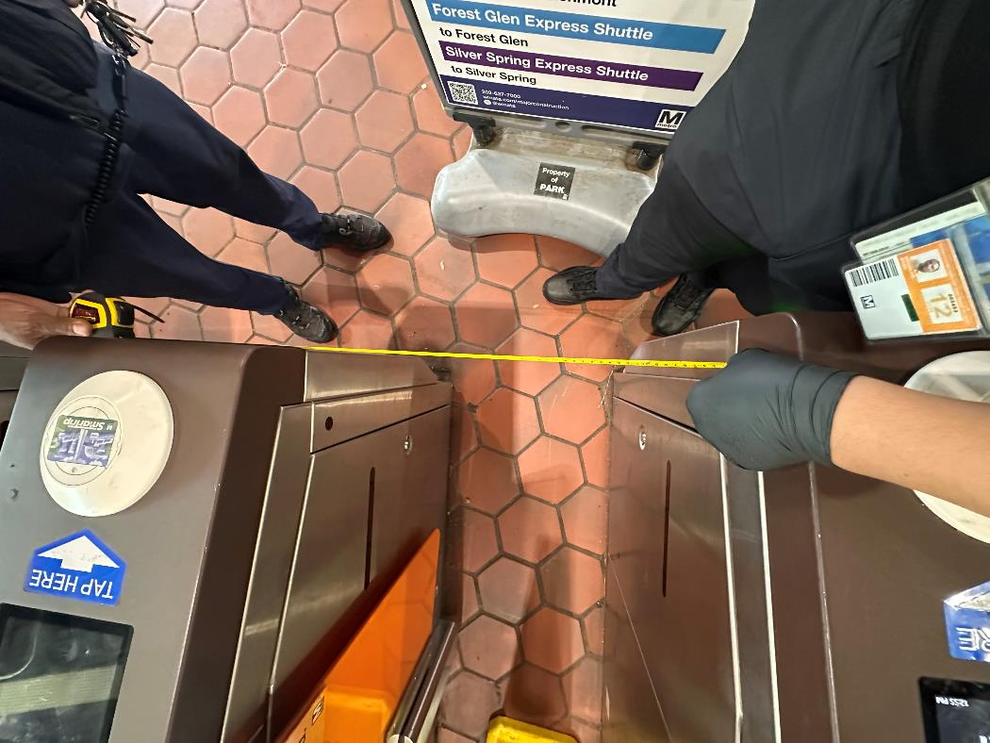

After:

