11

10

01

00

111

110

101

100

11

10

01

00

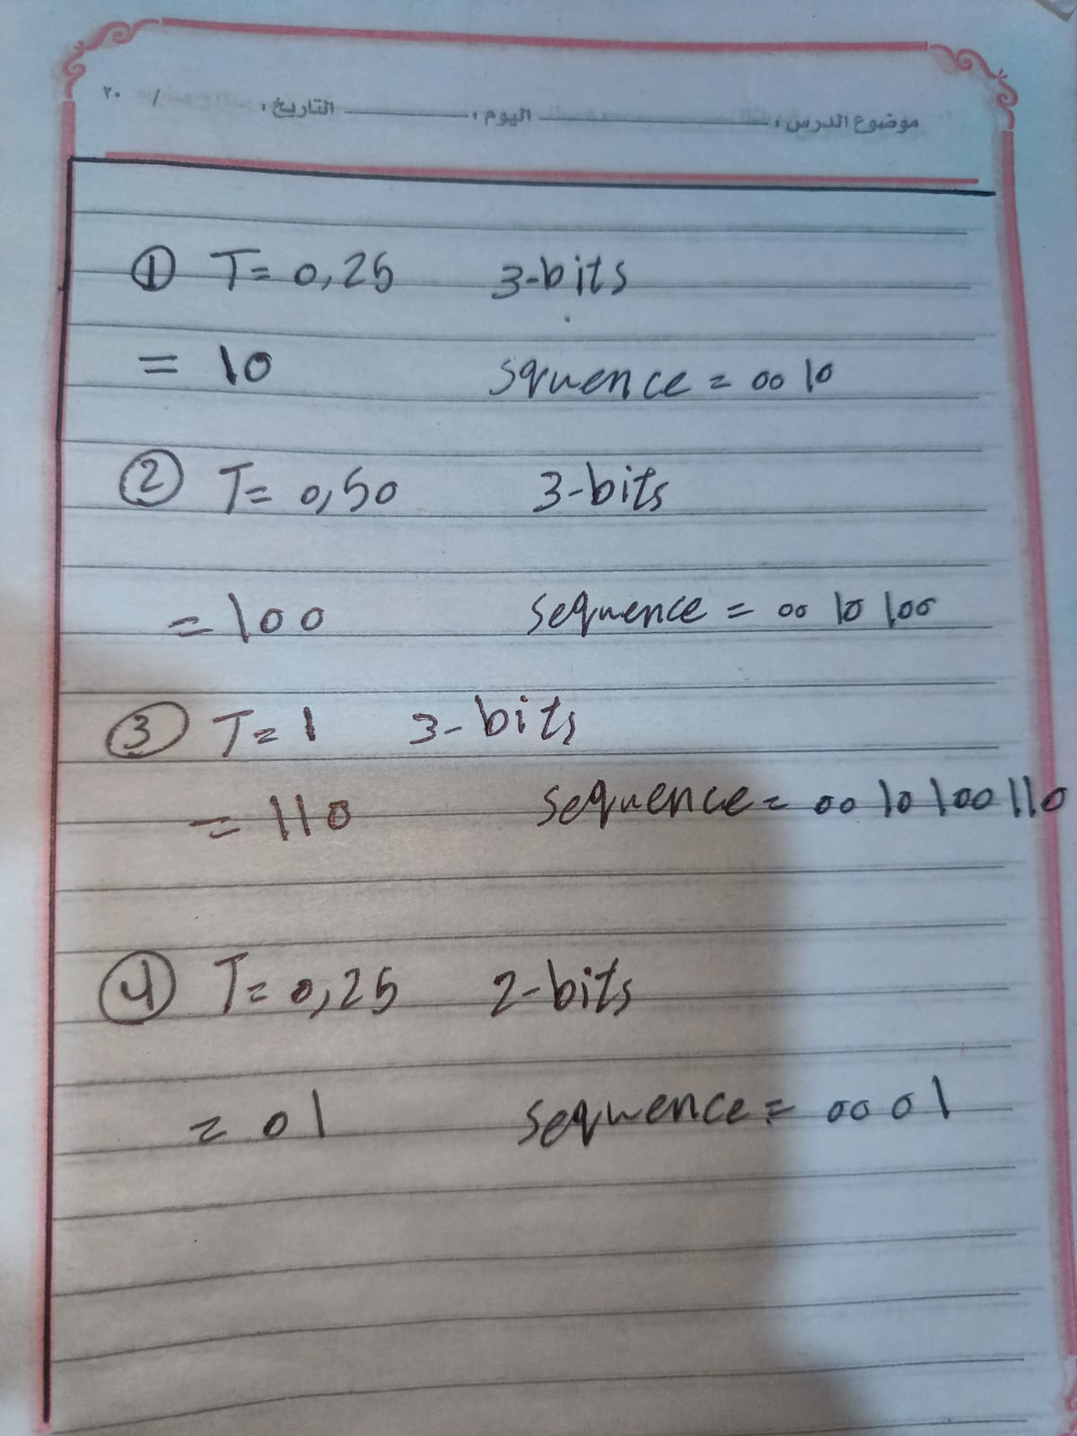

3-bits = 2^3 levels = 8 levels

2-bits = 2^2 levels = 4 levels