
IT342-G4
SYSTEMS INTEGRATION AND ARCHITECTURE 1

FUNCTIONAL REQUIREMENTS SPECIFICATION (FRS)

Project Title: MedLink
Prepared By: Josan B. Sumarago Date of Submission: February 3, 2026 Version:

Table of Contents
- Introduction .......................................................................................................... 3
  - Purpose ....................................................................................................... 3
  - Scope .......................................................................................................... 3
  - Definitions, Acronyms, and Abbreviations .................................................... 3
- Overall Description .............................................................................................. 3
  - System Perspective ..................................................................................... 3
  - User Classes and Characteristics ................................................................ 4
  - Operating Environment ................................................................................ 4
  - Assumptions and Dependencies .................................................................. 4
- System Features and Functional Requirements .................................................. 4
  - Feature 1: .................................................................................................... 4
  - Feature 2: .................................................................................................... 5
- Non-Functional Requirements ............................................................................. 5
- System Models (Diagrams) .................................................................................. 6
  - ERD ............................................................................................................. 7
  - Use Case Diagram ....................................................................................... 8
  - Activity Diagram ........................................................................................... 9
  - Class Diagram ........................................................................................... 10
  - Sequence Diagram .................................................................................... 11
- Appendices ........................................................................................................ 11

1. Introduction

1.1. Purpose
The purpose of this document is to define the requirements for the MedLink System, a healthcare management portal structured around a User-centered data model. This document is intended for project stakeholders, developers, and testers to understand the system's functionality—ranging from Guest User registration to Authenticated User session management—as visualized in the accompanying system diagrams.
+4

1.2. Scope
Based on the system models, the initial scope of the MedLink System includes:
- User Management & Registration: Allowing Guest Users to create accounts with specific attributes including Email, Password, and Role (Patient/Admin/Doctor).
+2
- Secure Authentication: A complete workflow for Login and Logout that validates credentials and manages session state as detailed in the Activity and Sequence diagrams.
+2
- Profile & Dashboard Access: A protected interface where authenticated users can view their unique profile data retrieved from the backend.
+2
- Relational Data Foundation: A database architecture designed to support specialized user classes, specifically Doctors (license and specialization data) and Patients (demographics and medical vitals).
+1

1.3. Definitions, Acronyms, and Abbreviations
- SRS: Software Requirements Specification.
- API: Application Programming Interface (The communication layer between the React UI and Auth Service).
+1
- JWT: JSON Web Token (The secure token generated by the System to validate active sessions).
+2
- UI: User Interface (The frontend component where users interact with Registration and Login forms).
+2
- DBMS: Database Management System (Stores the relational entities defined in the ERD).
+1
- DTO: Data Transfer Object (Objects like RegisterDto and LoginDto used by the Auth Controller to process requests).

.

2. Overall Description
2.1. System Perspective
MedLink functions as a Client-Server application.
- Frontend: A responsive web interface (React.js) accessible via standard web browsers.
- Backend: A RESTful API (Spring Boot) that processes logic and connects to the database.
- Database: A relational database that stores user credentials and profile information.
2.2. User Classes and Characteristics
User Classes and Characteristics
- Guest User: An unauthenticated visitor who can only access public pages (Landing Page, Login, Registration).
- Authenticated User (Patient/Admin): A registered user who has successfully logged in. They have access to protected features like the Dashboard/Profile and Logout functions.
2.3. Operating Environment
- Client Side: Modern web browser (Chrome, Firefox, Edge, Safari) with JavaScript enabled.
- Server Side: Java Runtime Environment (JRE) 17 or higher.
- Database: MySQL or PostgreSQL server.
- Network: Stable internet connection for API communication.
2.4. Assumptions and Dependencies
- Assumption: Users have a valid email address for registration.
- Assumption: The browser supports local storage or cookies for session management.
- Dependency: The system relies on the availability of the hosting server and database connectivity.

3. System Features and Functional Requirements
Describe each major feature of the system and its functional requirements.
3.1. Feature 1:
Description: Allows a Guest User to create a new account by providing necessary personal details.
Functional Requirements:

- FR-01: The system shall provide a registration form requiring Name, Email, and Password.
- FR-02: The system shall validate that the email is in a correct format and does not already exist in the database.
- FR-03: The system shall encrypt the user's password using a hashing algorithm (e.g., BCrypt) before saving it to the database.
- FR-04: Upon successful registration, the system shall redirect the user to the Login page.

3.2. Feature 2: User Authentication (Login)
Description: Allows registered users to access their accounts securely using their credentials.
Functional Requirements:

- FR-05: The system shall validate the user's email and password against stored records.
- FR-06: The system shall generate a secure session token (JWT) upon successful login.
- FR-07: The system shall display an error message for invalid credentials (e.g., "Invalid email or password").
- FR-08: The system shall redirect the user to the Dashboard upon successful login.

3.3. Feature 3: Profile Management & Logout
Description: Allows authenticated users to view their dashboard and securely end their session.
Functional Requirements:

- FR-09: The system shall display the User Dashboard only to users holding a valid active session token.
- FR-10: The Dashboard shall display the user's name and role retrieved from the backend.
- FR-11: The system shall provide a "Logout" button that invalidates the user's session token or clears client-side storage.
- FR-12: Upon logout, the user shall be immediately redirected to the Login page/Landing page.

4. Non-Functional Requirements

Security:
- Passwords must never be stored in plain text; they must be hashed.
- API endpoints for the Profile must be protected against unauthorized access (401 Unauthorized).
Performance:
- The system shall respond to login/registration requests within 2 seconds under normal load.
Reliability:
- The system should be available 99% of the time during business hours.
Usability:
- The user interface shall be responsive and usable on both desktop and mobile screens.
- Error messages shall be clear and user-friendly (non-technical).

5. System Models (Diagrams)
Insert the necessary diagrams for the system:

ERD
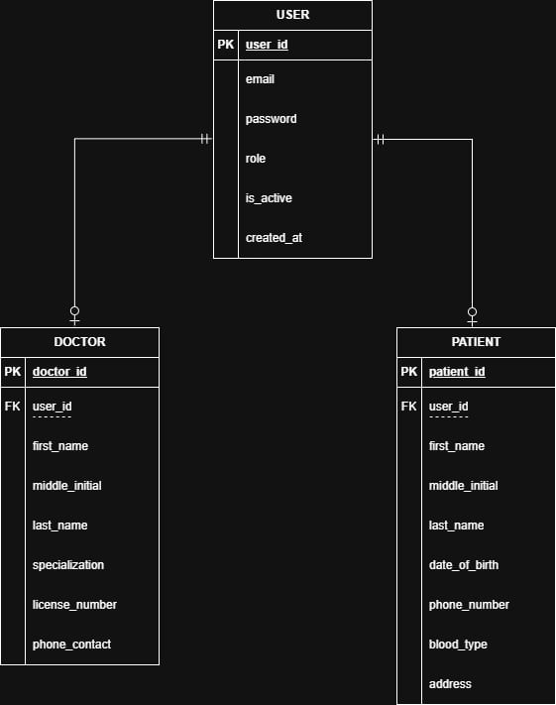
Use Case Diagram
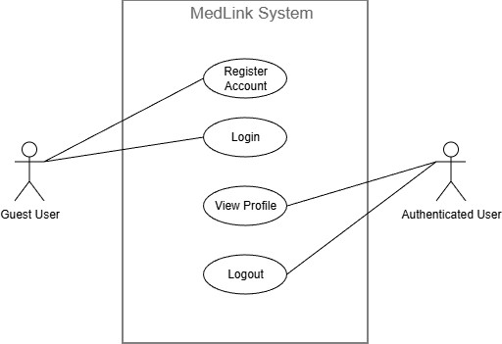
Activity Diagram
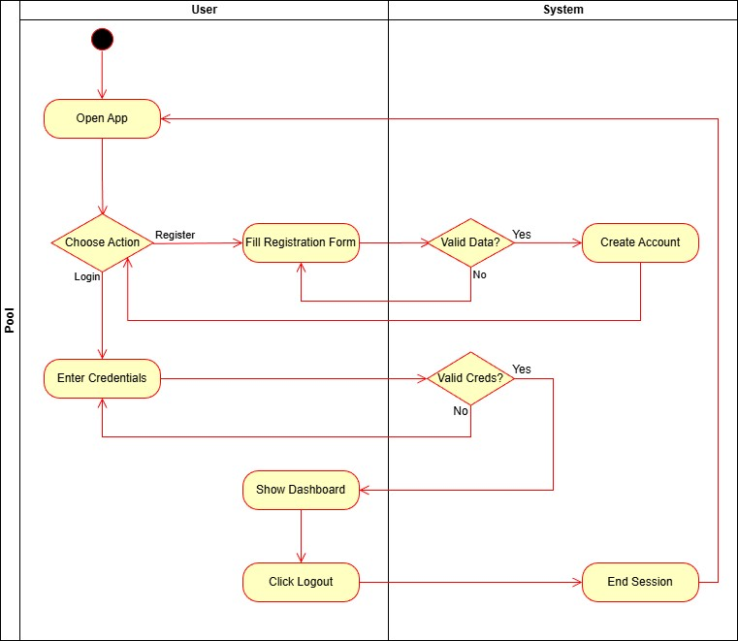
Class Diagram
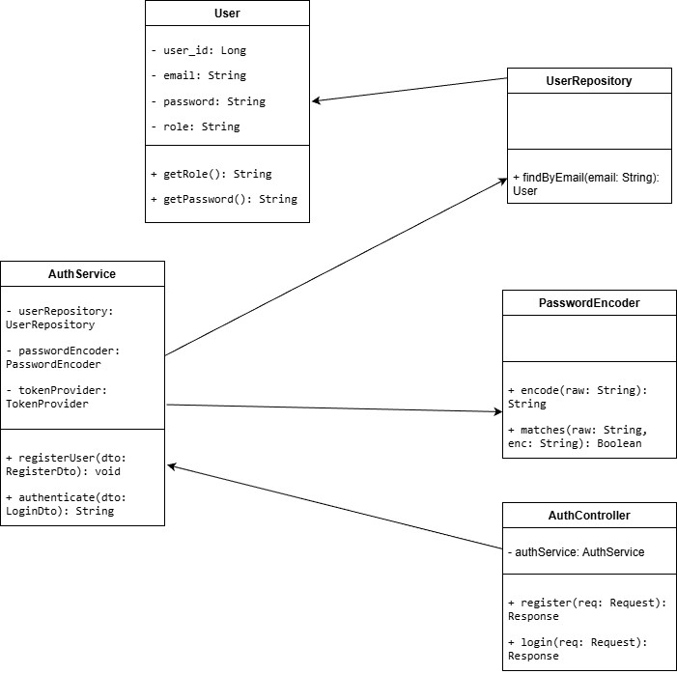
Sequence Diagram
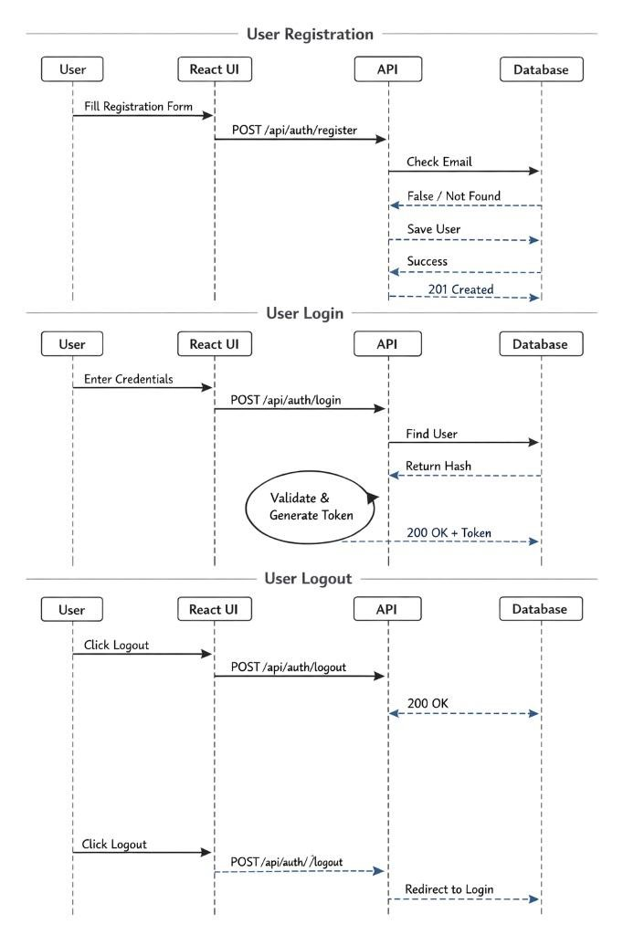

6. Appendices
Include any additional information, references, or support materials.
Login
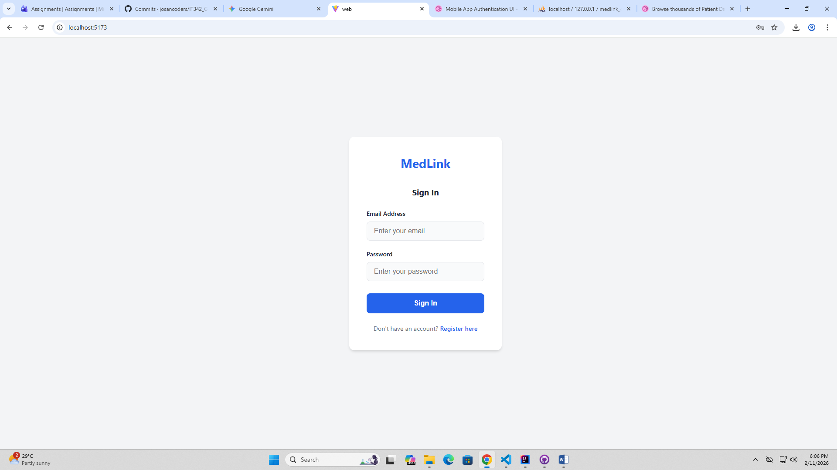

Registration
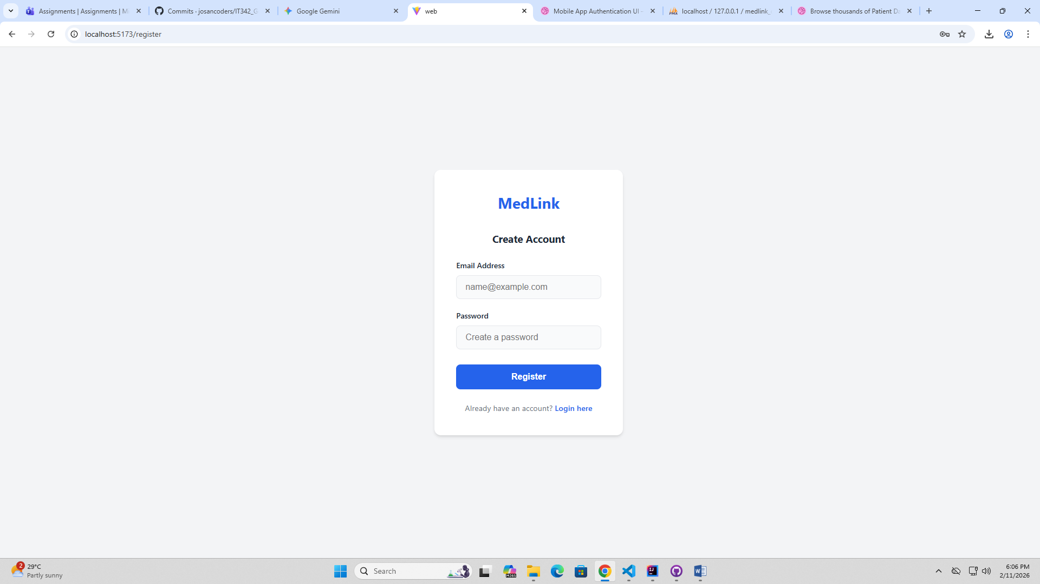

Dashboard
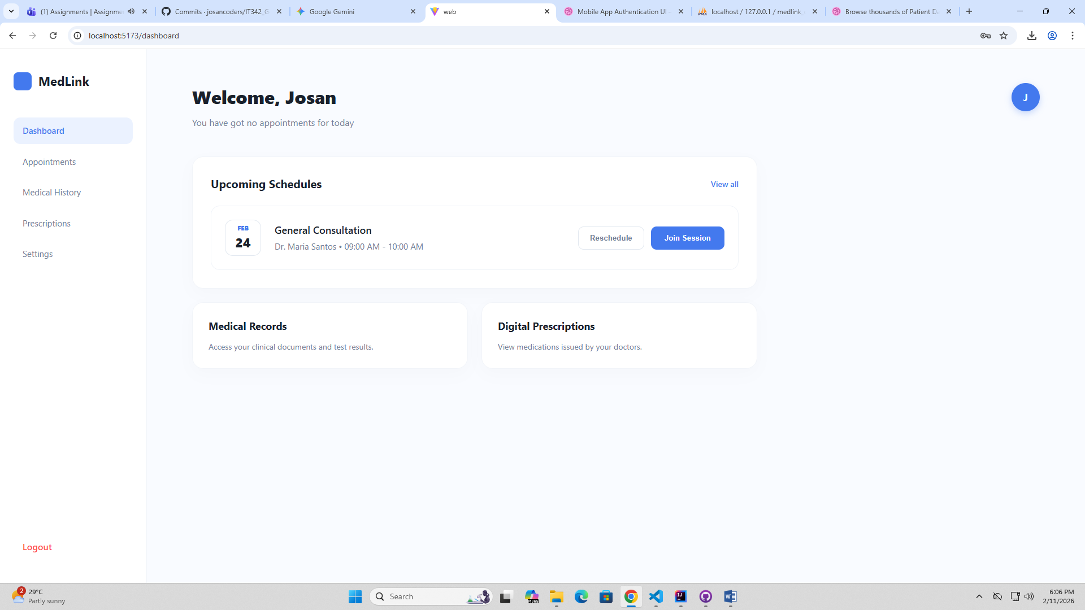

Profile Page
