Jose Estrada

Jose.estrada@aps.edu

12/26/2023

**Relational Databases with MySQL Week 1 Coding Assignment**

1. Show all employees who were born before 1965-01-01.
   1. Query

SELECT * FROM employees WHERE birth_date < '1965-01-01';

* 1. Query Screenshot

* 1. Query Results Screenshot

1. Show all employees who are female and were hired after 1990.
   1. Query

SELECT * FROM employees WHERE gender = 'F' AND hire_date > '1990-01-01';

* 1. Query Screenshot

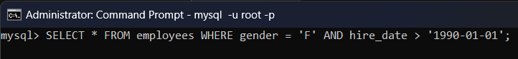

* 1. Query Results Screenshot

1. Show the first and last name of the first 50 employees whose last name starts with F.
   1. Query

SELECT first_name, last_name FROM employees WHERE last_name LIKE 'f%' LIMIT 50;

* 1. Query Screenshot



* 1. Query Results Screenshot

1. Insert 3 new employees into the employees table. Their emp_no should be 100, 101, and 102. You can choose the rest of the data.
   1. Query

INSERT INTO employees VALUES(100,'1991-01-01','Bob','Robertson','M','2001-01-01'),(101,'1992-02-02','Jackie','Jackson','F','2002-02-02'),(102,'1993-03-03','Tom','Thompson','M','2003-03-03');

* 1. Query Screenshot

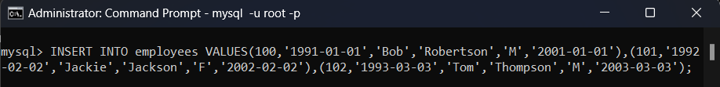

* 1. Query Results Screenshot

1. Change the employee’s first name to Bob for the employee with the emp_no of 10023.
   1. Query

UPDATE employees SET first_name = 'Bob' WHERE emp_no = 10023;

* 1. Query Screenshot

* 1. Query Results Screenshot

1. Change all employees hire dates to 2022-01-01 whose first or last names start with P.
   1. Query

UPDATE employees SET hire_date = '2022-01-01' WHERE first_name LIKE 'P%' OR last_name LIKE 'P%';

* 1. Query Screenshot

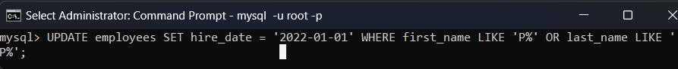

* 1. Query Results Screenshot

1. Delete all employees who have an emp_no less than 10000.
   1. Query

DELETE from employees where emp_no < 10000;

* 1. Query Screenshot

* 1. Query Results Screenshot

1. Delete all employees who have an emp_no of 10048, 10099, 10234, and 20089.
   1. Query

DELETE FROM employees WHERE emp_no IN (10048, 10099, 10234, 20089);

* 1. Query Screenshot

* 1. Query Results Screenshot

**Link to GitHub Repository:**

https://github.com/jose-d-estrada/mysql_week1